Storage

The Storage Component does the functions of storing task data in the file and loading the data to perform displaying tasks or editing the contents of the tasks. When the data is stored, you need to convert the list of tasks into JSON objects to save in the file. Similarly, you have to converts JSON data of the file to tasks while loading the list of tasks.

The below class diagram demonstrates the structure of the Storage component.

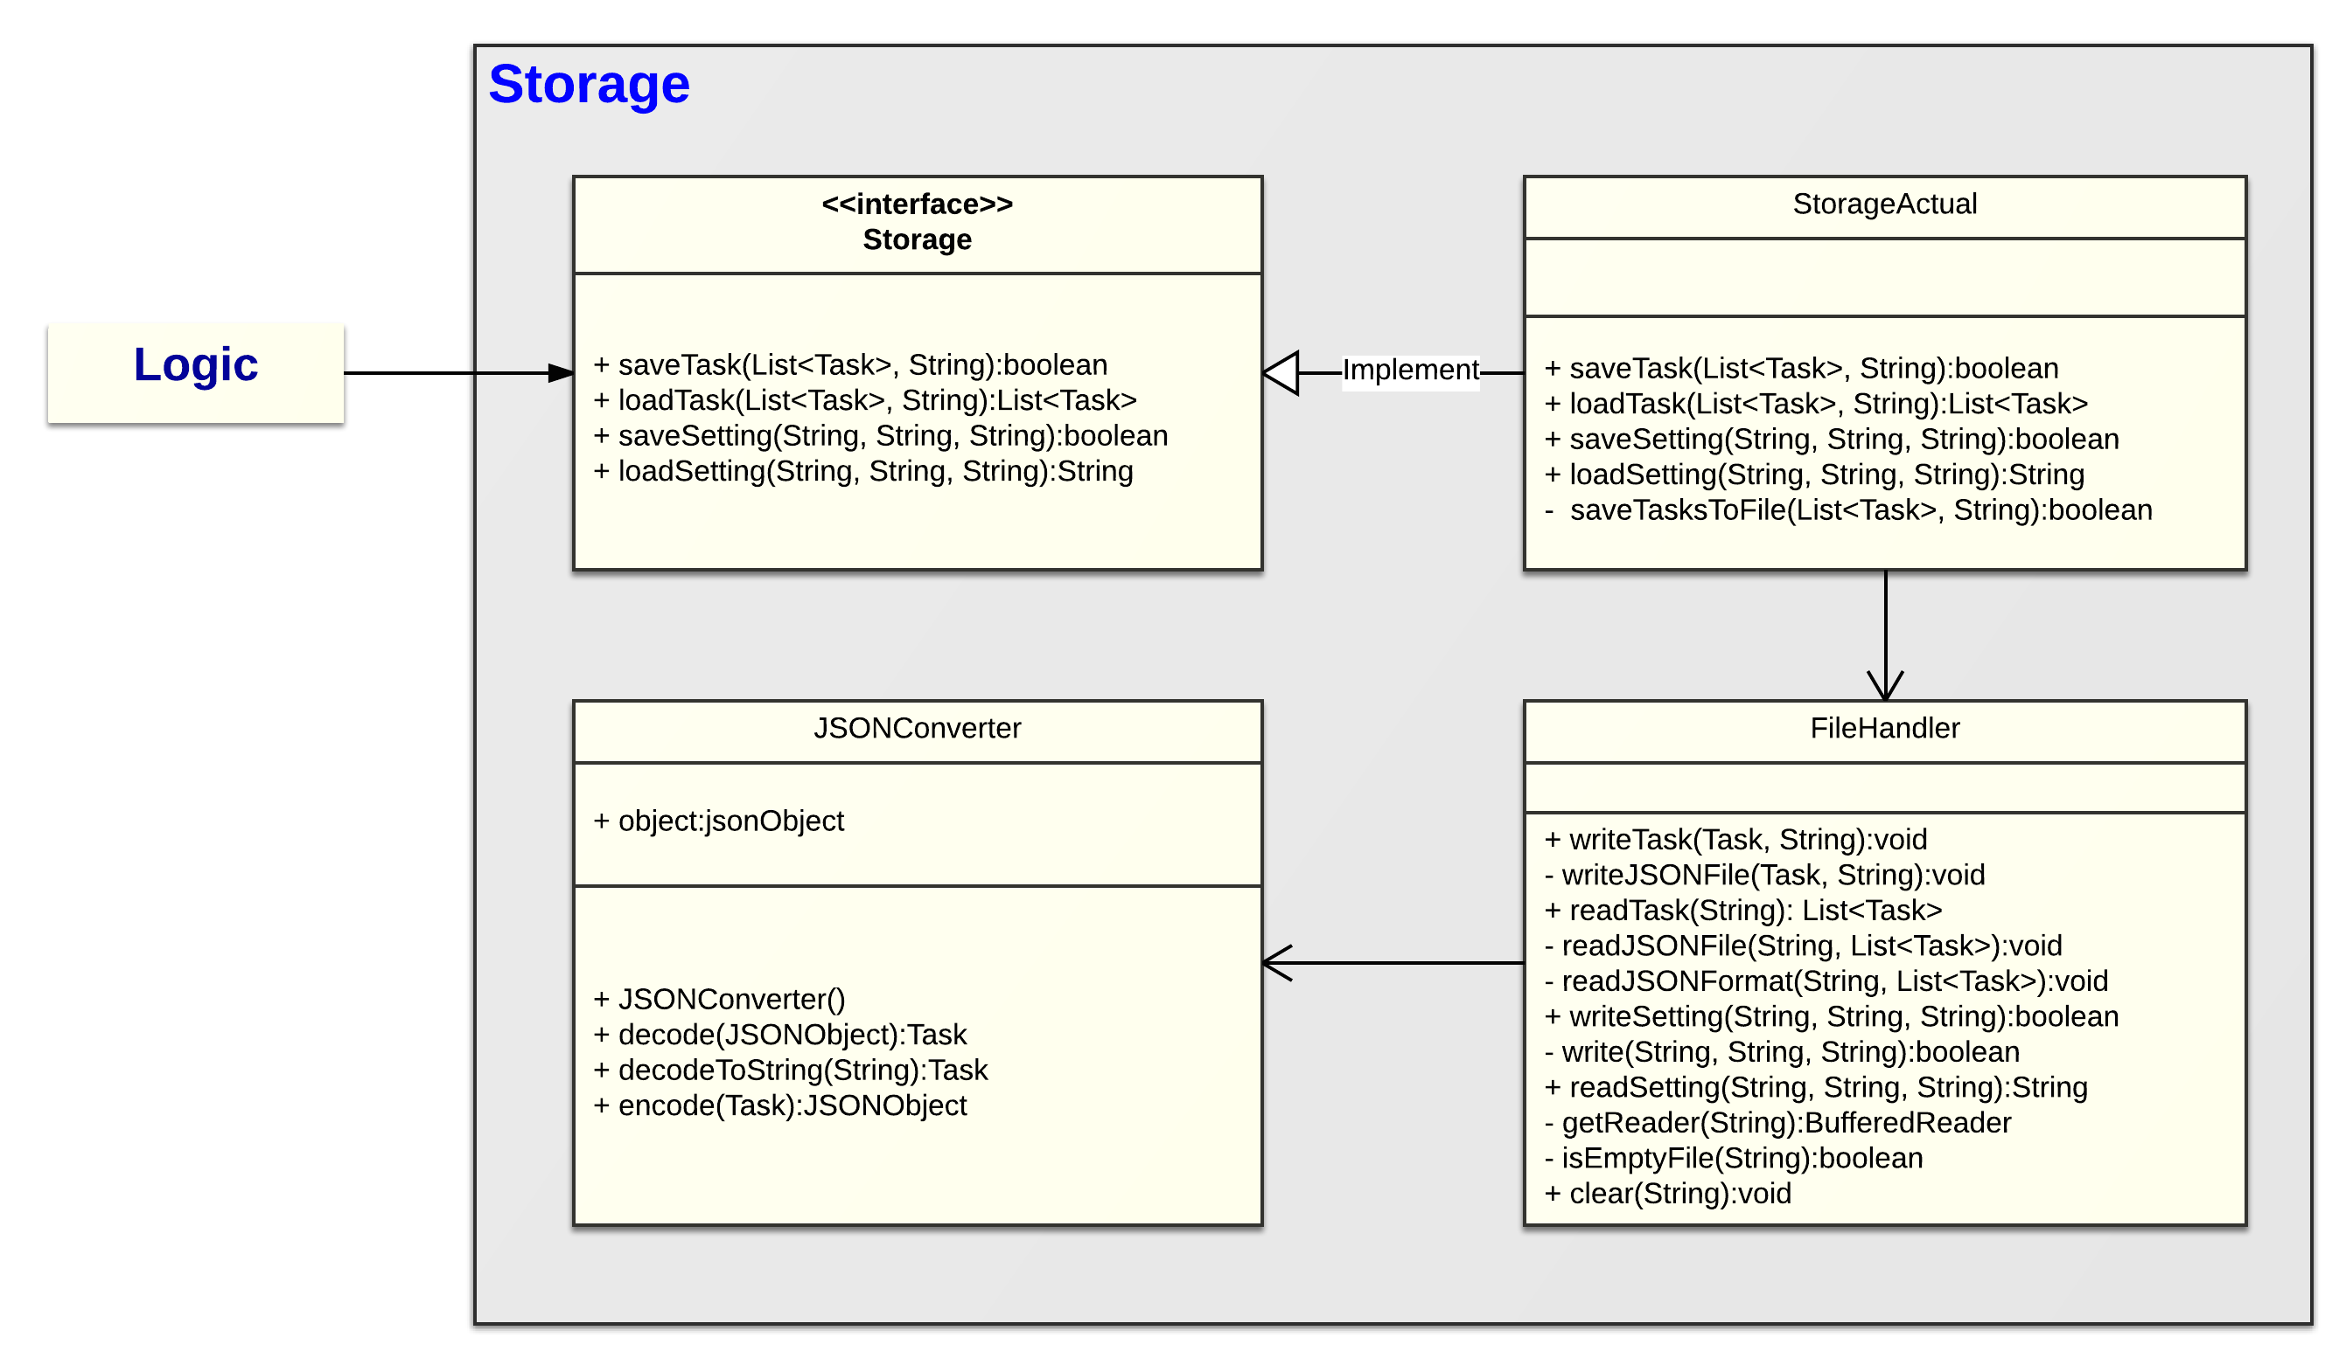

Figure: Class diagram of Storage component

The following sequence diagram shows the main functions of saving and loading tasks.

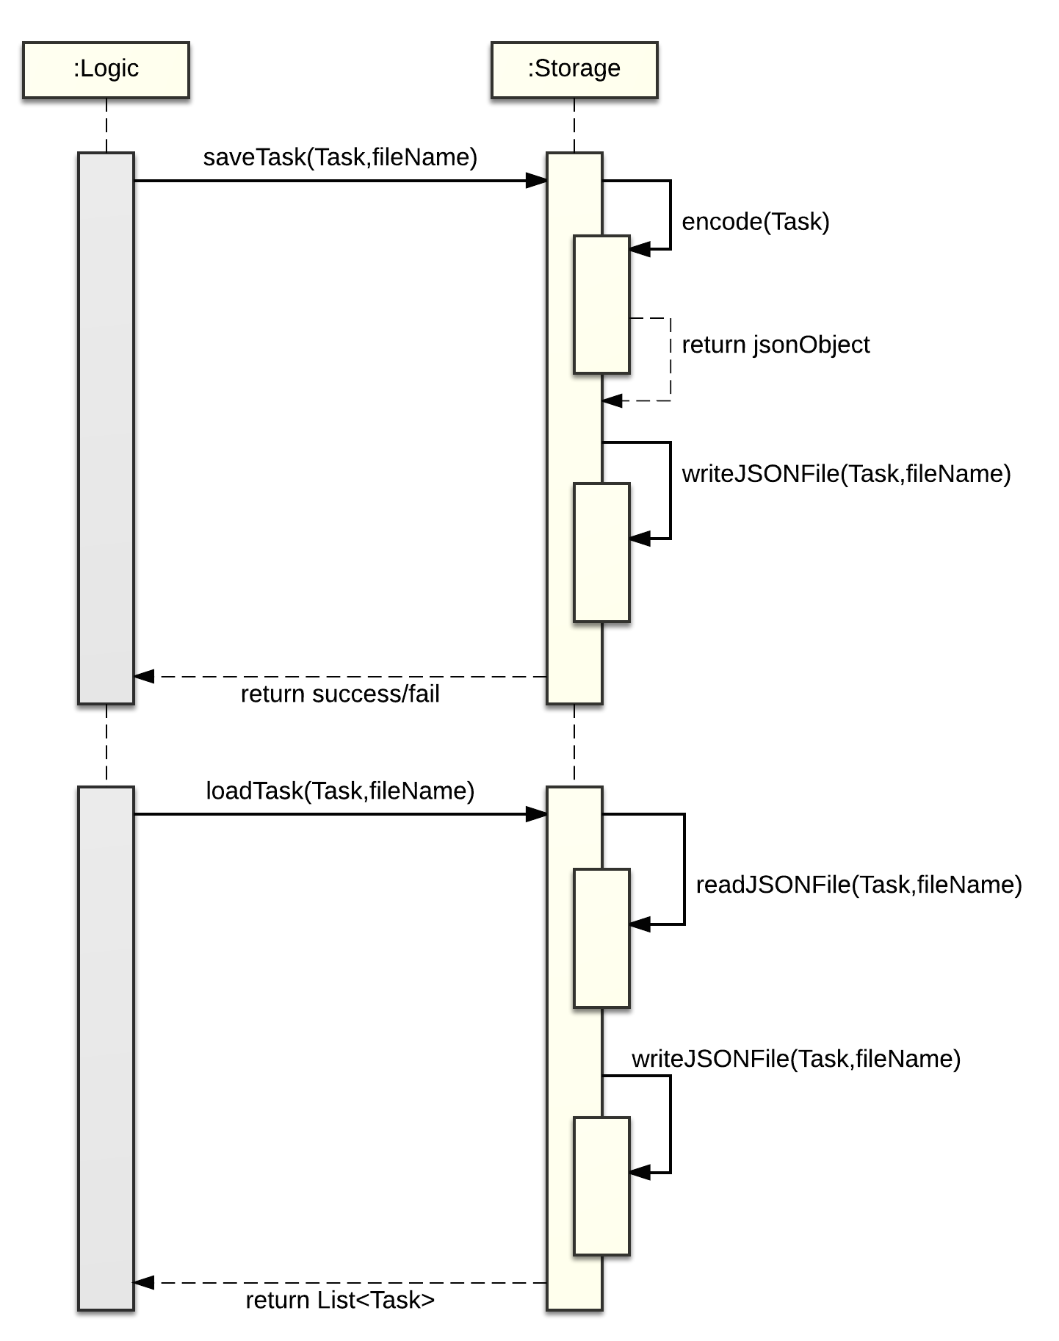

Figure: Sequence diagram of saving task and loading task