**Prerequisites**

Please download the following application:

* Latest [Java JDK 8](http://www.oracle.com/technetwork/java/javase/downloads/index.html) (includes **JavaFX 8**).
* Eclipse 4.3 or greater with e(fx)clipse plugin. The easiest way is to download the preconfigured distro from the [e(fx)clipse website](http://efxclipse.bestsolution.at/install.html#all-in-one). As an alternative you can use an [update site](http://www.eclipse.org/efxclipse/install.html) for your Eclipse installation.
* [Scene Builder 2.0](http://www.oracle.com/technetwork/java/javase/downloads/javafxscenebuilder-info-2157684.html) or greater

### Eclipse Configurations

We need to tell Eclipse to use JDK 8 and also where it will find the Scene Builder:

1. Open the Eclipse Preferences and navigate to Java | Installed JREs.
2. Click Add..., select Standard VM and choose the installation Directory of your JDK 8.

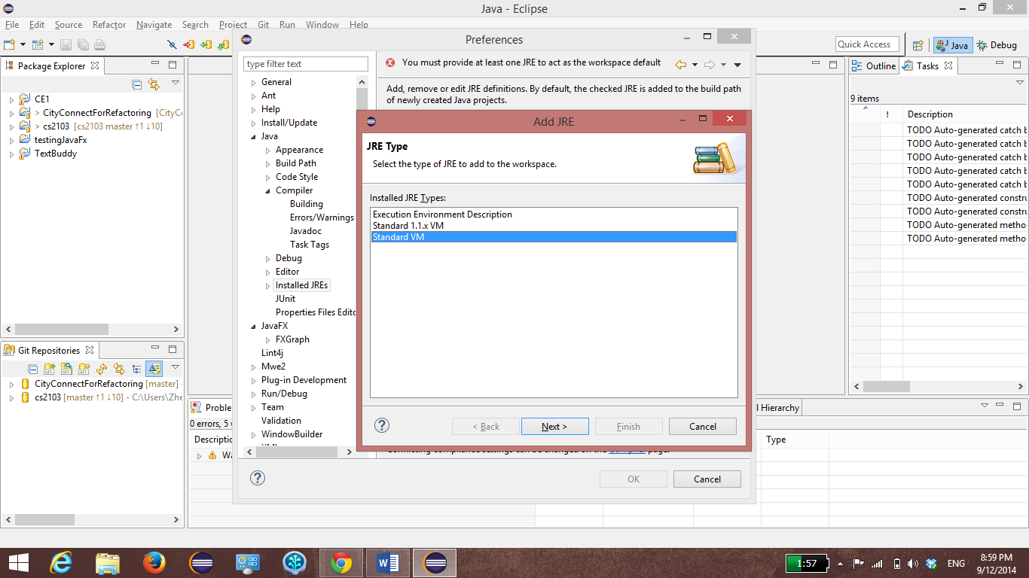

1. Remove the other JREs or JDKs so that the **JDK 8 becomes the default**.

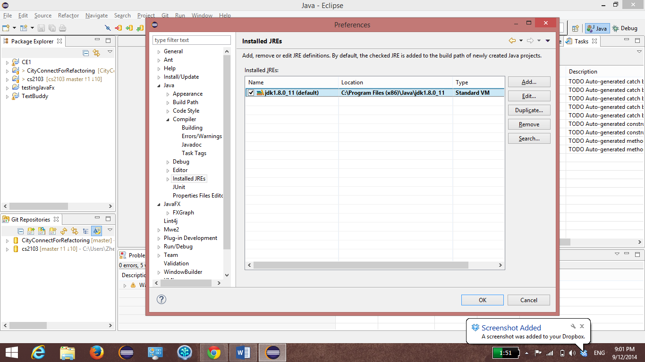

4. Navigate to Java | Compiler. Set the **Compiler compliance level to 1.8**.

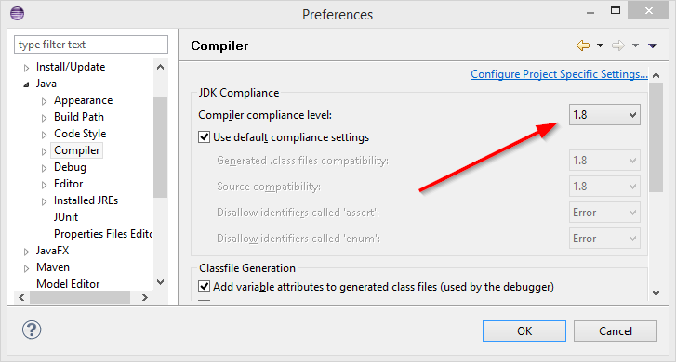

5. Navigate to the JavaFX preferences. Specify the path to your Scene Builder executable.

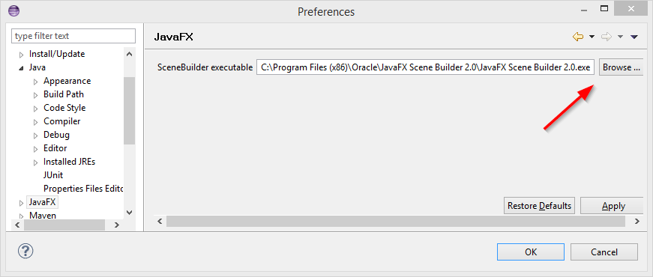

6. After all the steps is done, click on OK and there will be a message box as shown below. Click Yes.

