**Integration Testing**

**Screen Shots of V0.3**

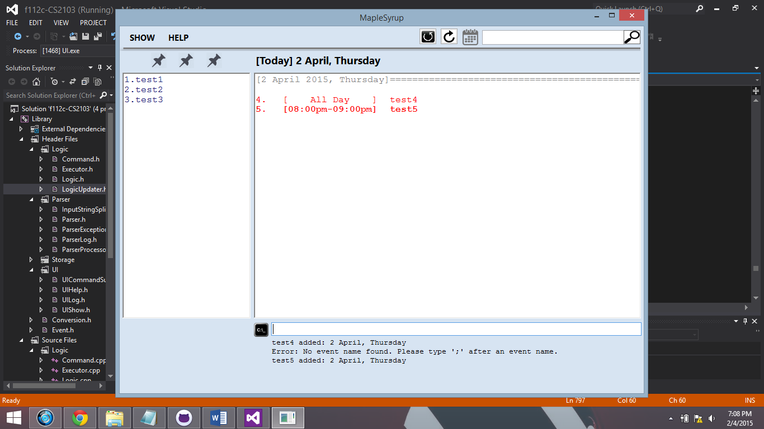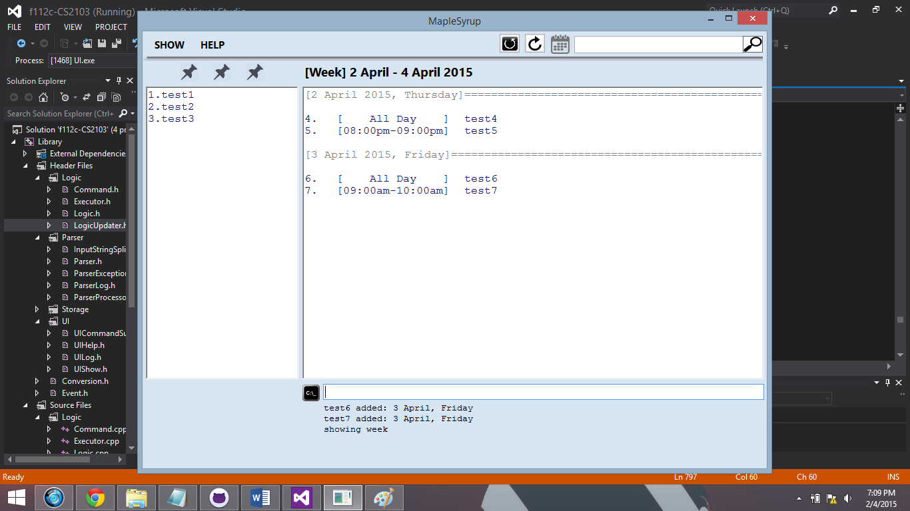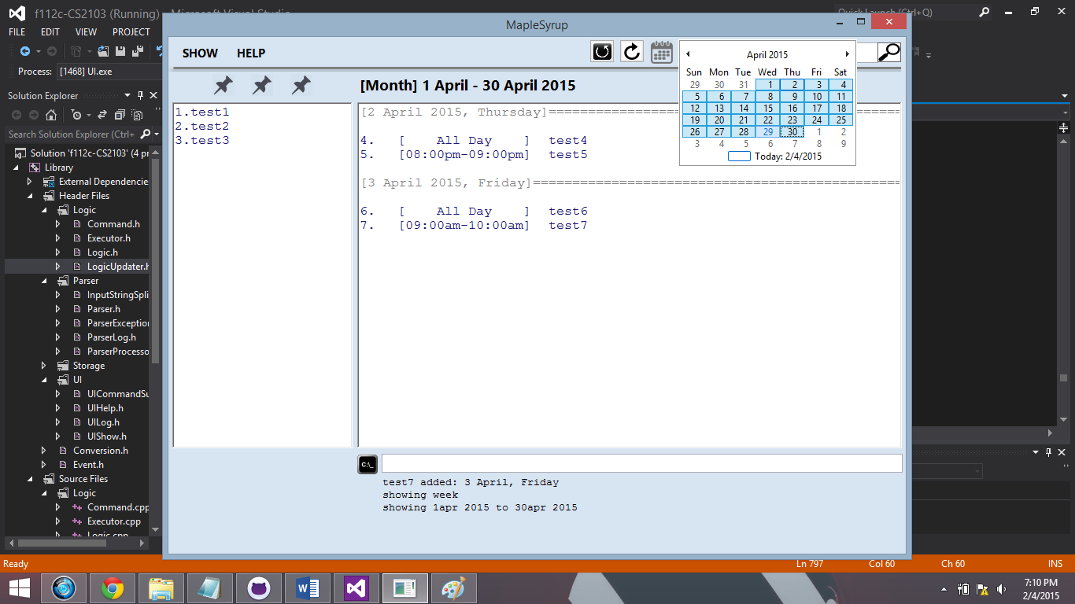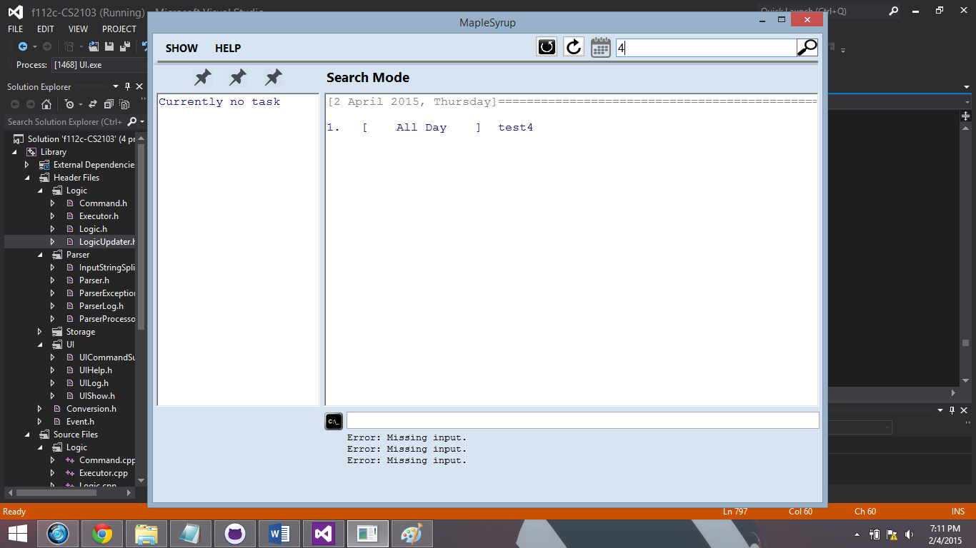

**List of commands it supports**

Word commands

1. Add ------- to add an event
2. Delete ------- to delete an event
3. Edit ------- to edit an event
4. Show ------- to show an event(s)
5. Exit ------- exit the program
6. help ------ display help guide
7. commands ------ display list of commands
8. shortcuts ------ display list of shortcuts
9. completed ------- complete an event, it will be transferred to archive
10. search ------ search mode/bar
11. calendar ----- display & undisplay calendar
12. next------ display next
13. back------ display back

Shortcut Keys

1. Ctrl + D ------ display calendar
2. Ctrl + F ------ search mode/bar
3. Ctrl + Z ------ undo
4. Ctrl + X ------ redo
5. Ctrl + C ------ copy
6. Ctrl + V ------ paste
7. Escape Key ---- Zoom to main display
8. Left arrow ---- display back (only after pressing Escape Key)
9. Right arrow ----- display next (only after pressing Escape Key)
10. Ctrl + Shift ----- Focus to command Box

**Screen Shots of Github Repo**

