### Graphical User Interface

The Graphical User Interface (GUI) provides an interactive and visual indication for the user. By handling the command entered (e.g. add, delete, sort), GUI will update three main fields (task list, overview and feedback) accordingly. *Figure 1* below shows the structure of the GUI component and its dependency.   
  
A sequence diagram shown in *Figure 2* will demonstrate the interaction between the use and the GUI.

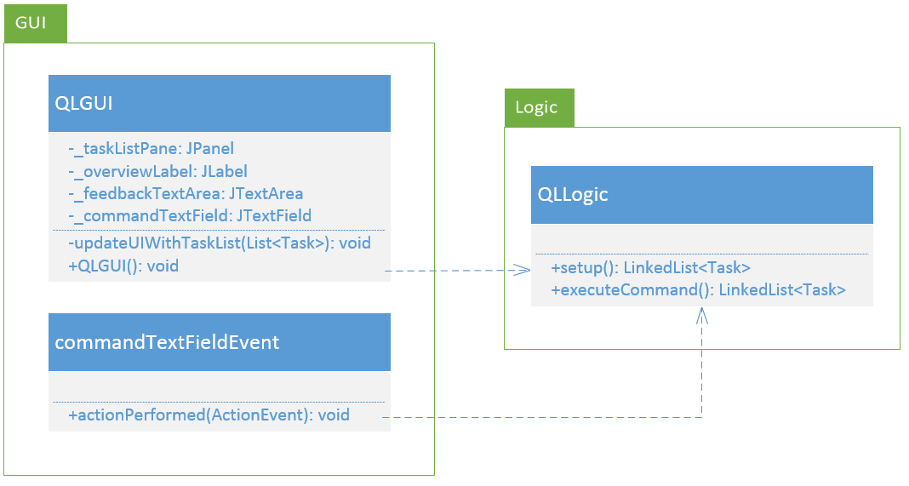

*Figure 1 – Class Diagram of GUI component and dependency*

## API

|  |  |  |
| --- | --- | --- |
| Method | Parameters | Description |
| updateUIWithTaskList (List<Task> taskList) : void | **taskList**: a List<Task> object containing the list of Task to be displayed | Obtain the list of tasks when the user launch the program at the beginning. For each command being processed, the tasklist pane will be updated accordingly. |
| actionPerformed (ActionEvent keyEnter) : void | **keyEnter**: an event that detects   the “Enter” key | Handles the event specified in the command field when the “Enter” key is pressed by user. |

*Time*

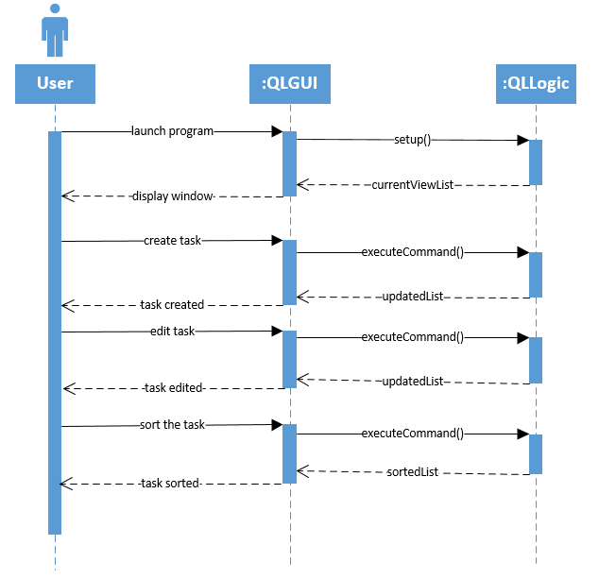  
  
  
  
  
  
  
  
  
  
  
  
  
  
  
  
  
  
  
  
  
  
  
  
  
  
Figure 2 – Sequence Diagram for GUI