## Storage Component

Quicklyst uses jUnit framework to develop unit test for all its components. To run the unit test in the Eclipse IDE, choose the test to be run under Package Explorer, right click to bring up the context menu, Run As, JUnit Test. Figure X depicts the context menu.

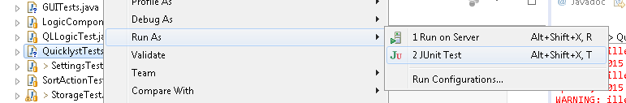

*Figure X. Eclipse screenshot of context menu*

To run unit test on a particular class, choose <Classname>Test.java files. To test a particular component, choose <Component name>Test(s).java files. To run all available unit test, choose QuicklystTests.java. Table X lists the unit test available in alphabetical order.

|  |  |
| --- | --- |
| Class unit tests | Component unit tests |
| AddActionTest.java CommandHistoryTest.java CommandParserTest.java CommandTipsTest.java DateParserTest.java EditActionTest.java FIeldParserTest.java FindActionTest.java LogicTest.java SortActionTest.java | GoogleIntegrationTest.java GUITests.java LogicComponentTests.java SettingsTest.java StorageTest.java |

*Table X. Quicklyst unit test list*