Ideation Phase
Define the Problem Statements

Date | 30 September 2026
Team ID | SWTID-2026-7138
Team Size | 5
Team Leader | Tamilarasan N
Team Members | Saravan M, Gokulnath S, Naveen Kumar M, Barath M
Project Name | AI FAQ Assistant API
Maximum Marks | 2 Marks

Customer Problem Statement Template:
Create a problem statement to understand your customer's point of view. The Customer Problem Statement template helps you focus on what matters to create experiences people will love.
A well-articulated customer problem statement allows you and your team to find the ideal solution for the challenges your customers face. Throughout the process, you’ll also be able to empathize with your customers, which helps you better understand how they perceive your product or service.
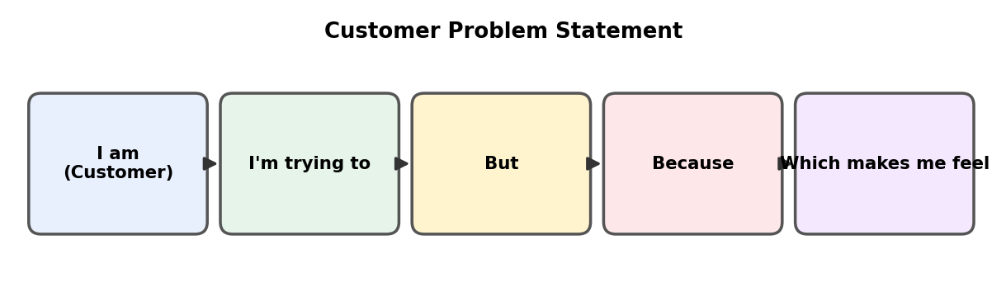
Reference: https://miro.com/templates/customer-problem-statement/
Problem Statement (PS) | I am (Customer) | I’m trying to | But | Because | Which makes me feel
PS-1 | a student / general user | find quick and accurate answers to my common questions | the FAQ pages are scattered, outdated and hard to search | answers are written manually and are not organised by category | frustrated and short of time
PS-2 | a support executive / content owner | create and maintain a large list of FAQs | writing every question and answer by hand takes too long | there is no automation to generate consistent, accurate answers | overloaded and worried about inconsistent answers
PS-3 | a developer / administrator | let only authorised people manage FAQs while offering AI help | open editing and unsecured AI access risk misuse | there are no login and ownership rules on the content | anxious about security and data quality

