Project Planning Phase
Project Planning Template (Product Backlog, Sprint Planning, Stories, Story points)

Date | 30 September 2026
Team ID | SWTID-2026-7138
Team Size | 5
Team Leader | Tamilarasan N
Team Members | Saravan M, Gokulnath S, Naveen Kumar M, Barath M
Project Name | AI FAQ Assistant API
Maximum Marks | 5 Marks

Product Backlog, Sprint Schedule, and Estimation (4 Marks)
Use the below template to create product backlog and sprint schedule
Sprint | Functional Requirement (Epic) | User Story Number | User Story / Task | Story Points | Priority | Team Members
Sprint-1 | Registration | USN-1 | As a user, I can register by entering my name, email and password (minimum 6 characters). | 3 | High | Arasi U
Sprint-1 | Registration | USN-2 | As a user, I am prevented from registering twice with the same email address. | 2 | High | Asitha V
Sprint-1 | Login | USN-3 | As a user, I can log in by entering my email and password. | 3 | High | Arasi U
Sprint-1 | Login | USN-4 | As a user, I can view my profile using my token. | 2 | High | Asitha V
Sprint-1 | Security | USN-5 | As a user, I want protected endpoints to reject requests without a valid token. | 3 | High | Pushpa U
Sprint-1 | Project Setup | USN-6 | As a developer, I can run the API with Express, MongoDB and .env configuration in an MVC structure. | 3 | High | Deepika M
Sprint-1 | Validation | USN-7 | As a user, I get clear messages when registration or login data is invalid. | 2 | Medium | Selvaraj S
Sprint-1 | Error Handling | USN-8 | As a user, I get consistent JSON errors from the API. | 2 | Medium | Selvaraj S
Sprint-2 | FAQ Management | USN-9 | As a content owner, I can create an FAQ with question, answer and category. | 3 | High | Pushpa U
Sprint-2 | FAQ Management | USN-10 | As a user, I can view the list of all FAQs. | 2 | High | Deepika M
Sprint-2 | FAQ Management | USN-11 | As a user, I can view a single FAQ by its ID. | 2 | High | Deepika M
Sprint-2 | FAQ Management | USN-12 | As a content owner, I can update my own FAQ. | 3 | High | Pushpa U
Sprint-2 | FAQ Management | USN-13 | As a content owner, I can delete my own FAQ. | 3 | High | Pushpa U
Sprint-2 | FAQ Management | USN-14 | As a content owner, I must choose a valid category for each FAQ. | 2 | Medium | Selvaraj S
Sprint-2 | Search | USN-15 | As a user, I can search FAQs by keyword. | 3 | Medium | Asitha V
Sprint-2 | FAQ Management | USN-16 | As a developer, I can rely on FAQ and User database models with timestamps. | 2 | Medium | Arasi U
Sprint-3 | AI Services | USN-17 | As a developer, I can call Google Gemini through a service layer. | 3 | High | Arasi U
Sprint-3 | AI Services | USN-18 | As a user, I can ask a question and receive a concise AI-generated answer. | 3 | High | Arasi U
Sprint-3 | AI Services | USN-19 | As a content owner, I can generate an FAQ question-and-answer pair from a topic. | 3 | High | Asitha V
Sprint-3 | AI Services | USN-20 | As a developer, I get a clear error when the Gemini API key is missing or invalid. | 2 | High | Deepika M
Sprint-3 | Validation | USN-21 | As a user, I must send a valid question or topic to the AI endpoints. | 2 | Medium | Selvaraj S
Sprint-3 | AI Services | USN-22 | As a user, I am informed when the AI service is rate limited. | 2 | Medium | Pushpa U
Sprint-3 | AI Services | USN-23 | As a content owner, I can save an AI-generated FAQ to the database. | 3 | Medium | Asitha V
Sprint-3 | AI Services | USN-24 | As a user, I receive plain-text answers without introductory filler. | 2 | Low | Deepika M
Sprint-4 | Testing | USN-25 | As a developer, I can run an automated integration test of every endpoint. | 5 | High | Deepika M
Sprint-4 | Testing | USN-26 | As a tester, I can import a Postman collection to try every endpoint. | 3 | High | Asitha V
Sprint-4 | Documentation | USN-27 | As a new developer, I can set up and use the API from the README. | 3 | Medium | Arasi U
Sprint-4 | Testing | USN-28 | As a project team, we complete user acceptance testing and fix reported bugs. | 5 | High | Selvaraj S
Sprint-4 | Security | USN-29 | As a team, we review secrets and access rules before release. | 2 | Medium | Pushpa U
Sprint-4 | Deployment | USN-30 | As a team, we package the API so it is ready to deploy. | 2 | Low | Arasi U

Project Tracker, Velocity & Burndown Chart: (4 Marks)
Sprint | Total Story Points | Duration | Sprint Start Date | Sprint End Date (Planned) | Story Points Completed (as on Planned End Date) | Sprint Release Date (Actual)
Sprint-1 | 20 | 6 Days | 24 Aug 2026 | 29 Aug 2026 | 20 | 29 Aug 2026
Sprint-2 | 20 | 6 Days | 31 Aug 2026 | 05 Sep 2026 | 20 | 05 Sep 2026
Sprint-3 | 20 | 6 Days | 07 Sep 2026 | 12 Sep 2026 | 20 | 12 Sep 2026
Sprint-4 | 20 | 6 Days | 14 Sep 2026 | 19 Sep 2026 | 20 | 19 Sep 2026

Velocity:
Our sprints are 6 days long and the team velocity is 20 story points per sprint. Average velocity (AV) per iteration unit (story points per day) = Sprint velocity / Sprint duration = 20 / 6 = 3.33 story points per day.


Burndown Chart:
A burn down chart is a graphical representation of work left to do versus time. It is often used in agile software development methodologies such as Scrum. However, burn down charts can be applied to any project containing measurable progress over time.
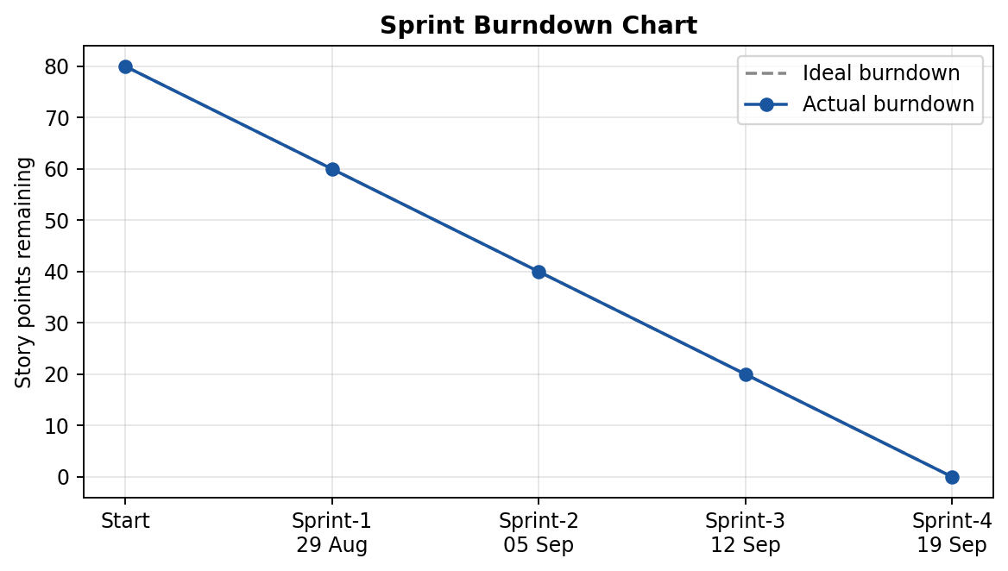

https://www.visual-paradigm.com/scrum/scrum-burndown-chart/
https://www.atlassian.com/agile/tutorials/burndown-charts

Reference:
https://www.atlassian.com/agile/project-management
https://www.atlassian.com/agile/tutorials/how-to-do-scrum-with-jira-software
https://www.atlassian.com/agile/tutorials/epics
https://www.atlassian.com/agile/tutorials/sprints
https://www.atlassian.com/agile/project-management/estimation
https://www.atlassian.com/agile/tutorials/burndown-charts

