Project Design Phase
Solution Architecture

Date | 30 September 2026
Team ID | SWTID-2026-5503
Team Size | 5
Team Leader | Tamilarasan N
Team Members | Saravan M, Gokulnath S, Naveen Kumar M, Barath M
Project Name | AI FAQ Assistant API
Maximum Marks | 4 Marks

Solution Architecture:
Solution architecture is a complex process – with many sub-processes – that bridges the gap between business problems and technology solutions. Its goals are to:
- Find the best tech solution to solve existing business problems.
- Describe the structure, characteristics, behavior, and other aspects of the software to project stakeholders.
- Define features, development phases, and solution requirements.
- Provide specifications according to which the solution is defined, managed, and delivered.

Solution Architecture Diagram:

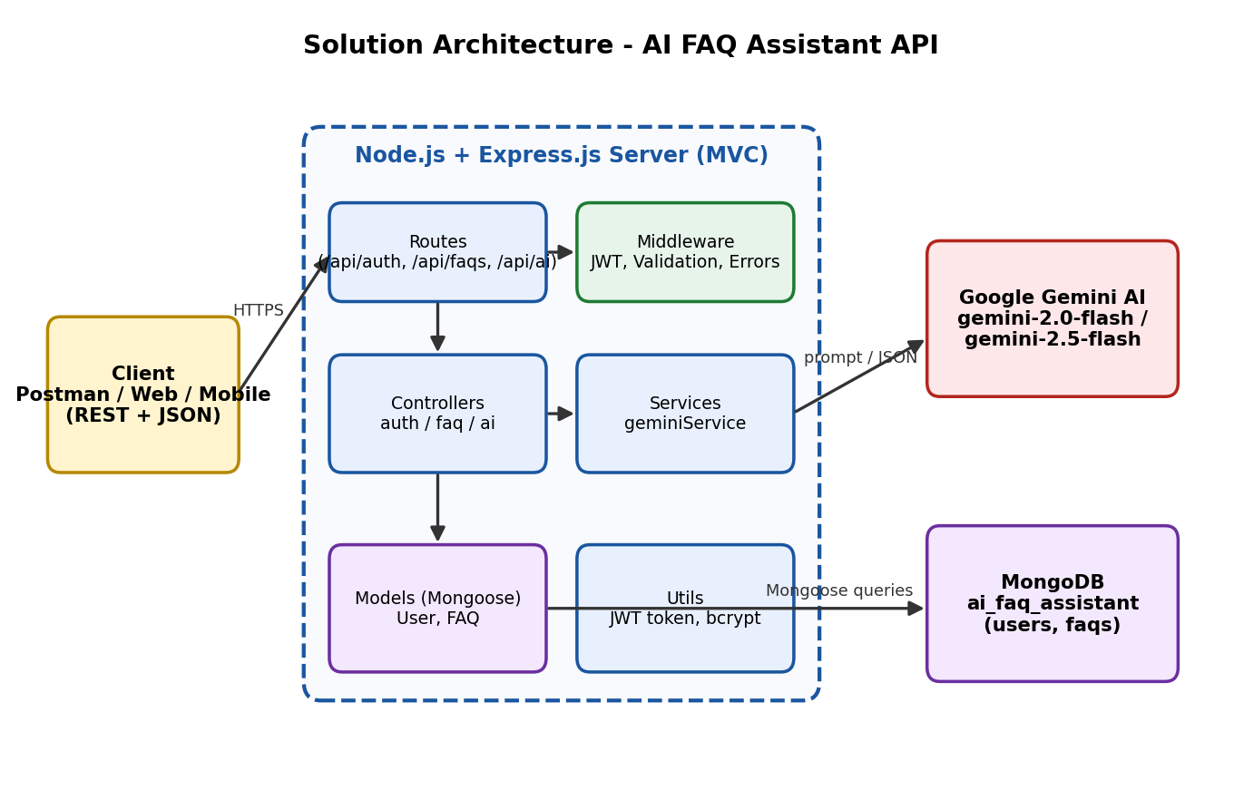
Figure 1: Architecture and data flow of the AI FAQ Assistant API
Flow: A client sends a JSON request over HTTP. The route passes it through validation and JWT authentication middleware, the controller processes it, and the model reads or writes MongoDB. For AI features the controller calls the Gemini service, which sends the prompt to Google Gemini and returns the answer or structured FAQ pair. Errors from every layer are handled by the central error middleware.

