Project Design Phase-II
Data Flow Diagram & User Stories

Date | 30 September 2026
Team ID | SWTID-2026-7138
Team Size | 5
Team Leader | Tamilarasan N
Team Members | Saravan M, Gokulnath S, Naveen Kumar M, Barath M
Project Name | AI FAQ Assistant API
Maximum Marks | 4 Marks

Data Flow Diagrams:
A Data Flow Diagram (DFD) is a traditional visual representation of the information flows within a system. A neat and clear DFD can depict the right amount of the system requirement graphically. It shows how data enters and leaves the system, what changes the information, and where data is stored.
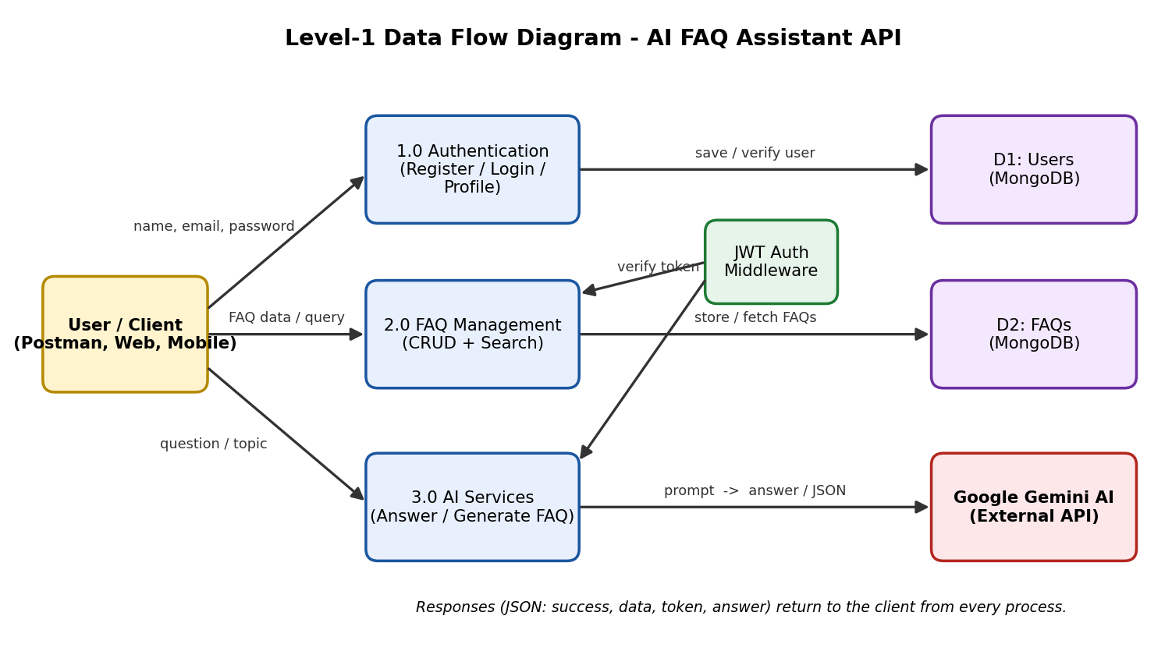
Data Flow Diagram of AI FAQ Assistant API (Level-1)

User Stories
Use the below template to list all the user stories for the product.
User Type | Functional Requirement (Epic) | User Story Number | User Story / Task | Acceptance criteria | Priority | Release
User (API Client) | Registration | USN-1 | As a user, I can register by entering my name, email and password (minimum 6 characters). | Account is created, password stored hashed and a JWT token is returned | High | Sprint-1
 | Registration | USN-2 | As a user, I am prevented from registering twice with the same email address. | API returns 400 "User already exists with this email" | High | Sprint-1
 | Login | USN-3 | As a user, I can log in by entering my email and password. | I receive a JWT token (valid 30 days) and my user details | High | Sprint-1
 | Login | USN-4 | As a user, I can view my profile using my token. | GET /api/auth/profile returns my details without password | High | Sprint-1
 | Security | USN-5 | As a user, I want protected endpoints to reject requests without a valid token. | Missing or invalid token returns 401 Not authorized | High | Sprint-1
 | Project Setup | USN-6 | As a developer, I can run the API with Express, MongoDB and .env configuration in an MVC structure. | Server starts on PORT 5000 and connects to MongoDB | High | Sprint-1
 | Validation | USN-7 | As a user, I get clear messages when registration or login data is invalid. | Invalid email or short password returns 400 with a message | Medium | Sprint-1
 | Error Handling | USN-8 | As a user, I get consistent JSON errors from the API. | All errors return { success:false, message } | Medium | Sprint-1
Content Owner | FAQ Management | USN-9 | As a content owner, I can create an FAQ with question, answer and category. | FAQ is saved and linked to my user; 201 returned | High | Sprint-2
 | FAQ Management | USN-10 | As a user, I can view the list of all FAQs. | GET /api/faqs returns all FAQs, newest first, with count | High | Sprint-2
 | FAQ Management | USN-11 | As a user, I can view a single FAQ by its ID. | Valid ID returns FAQ; invalid ID returns 400; missing returns 404 | High | Sprint-2
 | FAQ Management | USN-12 | As a content owner, I can update my own FAQ. | Owner update succeeds; other users receive 403 | High | Sprint-2
 | FAQ Management | USN-13 | As a content owner, I can delete my own FAQ. | Owner delete succeeds; other users receive 403 | High | Sprint-2
 | FAQ Management | USN-14 | As a content owner, I must choose a valid category for each FAQ. | Only Technology, Education, Health, Banking or General accepted | Medium | Sprint-2
User (API Client) | Search | USN-15 | As a user, I can search FAQs by keyword. | GET /api/faqs/search?q= returns FAQs matching question, answer or category | Medium | Sprint-2
Content Owner | FAQ Management | USN-16 | As a developer, I can rely on FAQ and User database models with timestamps. | Mongoose models enforce required fields and references | Medium | Sprint-2
 | AI Services | USN-17 | As a developer, I can call Google Gemini through a service layer. | geminiService returns text or structured JSON from Gemini | High | Sprint-3
 | AI Services | USN-18 | As a user, I can ask a question and receive a concise AI-generated answer. | POST /api/ai/answer returns { success:true, answer } | High | Sprint-3
 | AI Services | USN-19 | As a content owner, I can generate an FAQ question-and-answer pair from a topic. | POST /api/ai/generate-faq returns question and answer | High | Sprint-3
 | AI Services | USN-20 | As a developer, I get a clear error when the Gemini API key is missing or invalid. | API returns success:false with an error message, no crash | High | Sprint-3
User (API Client) | Validation | USN-21 | As a user, I must send a valid question or topic to the AI endpoints. | Empty or non-string input returns 400 | Medium | Sprint-3
Content Owner | AI Services | USN-22 | As a user, I am informed when the AI service is rate limited. | Gemini status (e.g. 429) is passed through in the JSON error | Medium | Sprint-3
 | AI Services | USN-23 | As a content owner, I can save an AI-generated FAQ to the database. | Generated pair posted to /api/faqs is stored successfully | Medium | Sprint-3
 | AI Services | USN-24 | As a user, I receive plain-text answers without introductory filler. | Answer text is trimmed and returned directly | Low | Sprint-3
User (API Client) | Testing | USN-25 | As a developer, I can run an automated integration test of every endpoint. | test_api.js runs all endpoint tests and cleans up test data | High | Sprint-4
 | Testing | USN-26 | As a tester, I can import a Postman collection to try every endpoint. | Collection saves token automatically after login | High | Sprint-4
 | Documentation | USN-27 | As a new developer, I can set up and use the API from the README. | README covers setup, environment variables and API reference | Medium | Sprint-4
 | Testing | USN-28 | As a project team, we complete user acceptance testing and fix reported bugs. | UAT sign-off obtained; bugs logged and tracked | High | Sprint-4
 | Security | USN-29 | As a team, we review secrets and access rules before release. | Secrets kept in .env; only owners can edit FAQs | Medium | Sprint-4
 | Deployment | USN-30 | As a team, we package the API so it is ready to deploy. | npm start runs the production server | Low | Sprint-4

