- Visualization
  - Appropriate plot for the RQ (50 words)

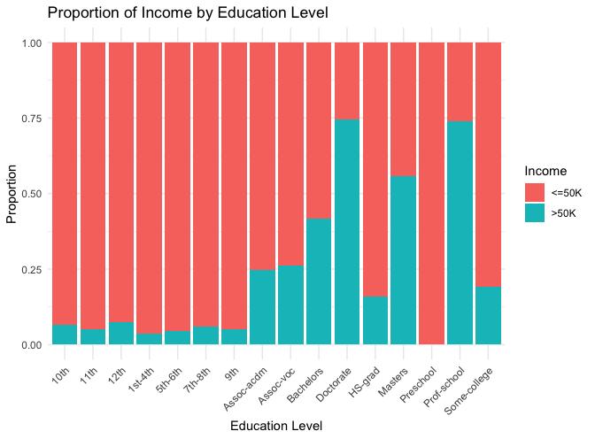
A stacked bar plot is appropriate as it visualizes the difference in proportions of income categories (<=50K and >50K) across education levels. It allows direct comparison within each level, showing relative contributions of each category. The stacked structure highlights income distribution changes, aligning with the research question’s focus on proportions.
  - Additional information relating to understanding the data (50 words)
The plot visually highlights how higher education levels are associated with a larger proportion of individuals earning >50K. For example, individuals with a Doctorate or Master’s degree predominantly fall in the >50K income category, while lower education levels such as 10th, 11th, and Preschool have a majority earning <=50K.
  - Useful information for the data understanding (50 words)
Key observations include a clear upward trend in income with increasing education level. Advanced degrees (e.g., Doctorate, Master’s) show the highest proportions of >50K incomes, whereas lower education levels have minimal representation in this category. Intermediate levels like bachelor's and associate degrees show a more balanced distribution of income.

