**NAME: CHIRAG SATAPATHY**

**REG. No.: 19BEI0107**

**COURSE CODE: CSE2003**

**SLOT: L27 + L28**

**DATA STRUCTURES AND ALGORITHMS**

**DIGITAL ASSIGNMENT - 4**

**1. Menu driven C program to implement depth first search and breadth first search graph traversal algorithms.**

**PSEUDOCODE:**

DFS(graph, start_node, end_node):  
 frontier = new Stack()  
 frontier.push(start_node)  
 explored = new Set() while frontier is not empty:  
 current_node = frontier.pop()  
 if current_node in explored: continue  
 if current_node == end_node: return success  
   
 for neighbor in graph.get_neigbhors(current_node):  
 frontier.push(neighbor) explored.add(current_node)

BFS(graph, start_node, end_node):  
 frontier = new Queue()  
 frontier.enqueue(start_node)  
 explored = new Set()  
   
 while frontier is not empty:  
 current_node = frontier.dequeue()  
 if current_node in explored: continue  
 if current_node == end_node: return success  
   
 for neighbor in graph.get_neigbhors(current_node):  
 frontier.enqueue(neighbor) explored.add(current_node)

**CODE:**

#include<stdio.h>

#include<stdlib.h>

#define MAX 100

int n;

int adj[MAX][MAX];

int state[MAX];

void createGraph();

void DF_Traversal();

void DFS(int v);

int queue[MAX], front = -1, rear = -1;

void enqueue(int vertex);

int dequeue();

bool isQueueEmpty();

void BF_Traversal();

void BFS(int v);

// -------------DFS-------------------

void DF_Traversal(){

int v;

for(int i = 0; i < n; ++i)

state[i] = 0; //initial state

printf("Enter the starting vertex: ");

scanf("%d", &v);

printf("DFS traversal of the given graph is:\n");

DFS(v);

}

void DFS(int v){

state[v] = 1; //visited

printf("%d ", v);

for(int i = 0; i < n; ++i){

if(!state[i] && adj[v][i] == 1)

DFS(i);

}

}

// -------------DFS-------------------

// --------------BFS--------------------

void enqueue(int vertex){

if(rear == MAX - 1)

printf("Queue overflow!\n");

else{

if(front == -1)

front++;

queue[++rear] = vertex;

}

}

int dequeue(){

if(front > rear || front == -1){

printf("Queue underflow!\n");

exit(1);

}

else{

int deleteItem = queue[front];

front++;

return deleteItem;

}

}

bool isQueueEmpty(){

if(front == -1 || front > rear)

return true;

return false;

}

void BF_Traversal(){

int v;

for(int i = 0; i < n; ++i)

state[i] = 0; //initial state

printf("Enter the starting vertex: ");

scanf("%d", &v);

printf("BFS traversal of the given graph is:\n");

BFS(v);

}

void BFS(int v){

enqueue(v);

state[v] = 1; //waiting state

while(!isQueueEmpty()){

v = dequeue();

printf("%d ", v);

state[v] = 2; //visited

for(int i = 0; i < n; i++){

if(adj[v][i] == 1 && state[i] == 0){

enqueue(i);

state[i] = 1;

}

}

}

printf("\n");

}

// --------------BFS--------------------

// -------------Create Graph--------------

void createGraph(){

int max, origin, dest;

printf("Enter the number of vertices: ");

scanf("%d", &n);

max = n * (n - 1);

for(int i = 1; i <= max; ++i){

printf("Enter the edge %d (-1 -1 to quit): ", i);

scanf("%d %d", &origin, &dest);

if(origin == -1 && dest == -1){

break;

}

if(origin >= n || dest >= n || origin < 0 || dest < 0){

printf("Invalid edge!\n");

i--;

}

else{

adj[origin][dest] = 1;

}

}

}

// -------------Create Graph--------------

int main(){

int choice;

printf("Enter a graph\n");

createGraph();

while(1){

printf("Enter the traversal method (1 for DFS and 2 for BFS)\n");

printf("Enter 3 to exit\n");

scanf("%d", &choice);

if(choice == 1){

DF_Traversal();

}

else if(choice == 2){

BF_Traversal();

}

else{

exit(1);

}

}

return 0;

}

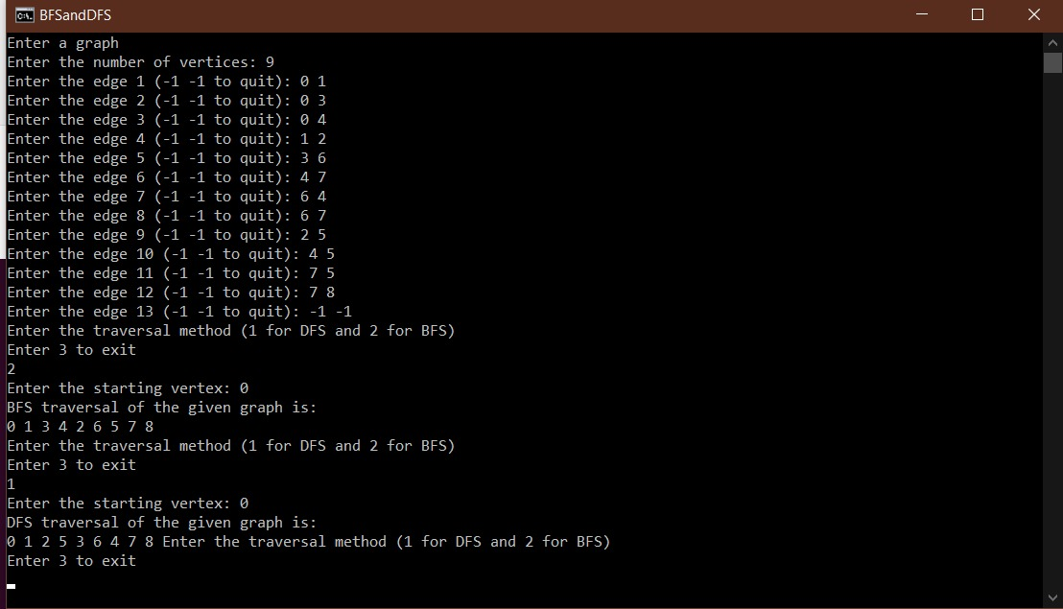

**2. Implement Dijikstra’s algorithm to find shortest path from source node to all other nodes.**

**PSEUDOCODE:**

Let v1 be the origin vertex,

and initialize W and ShortDist[u] as

W := {v1}

ShortDist[v1] :=0

FOR each u in V - {v1}

ShortDist[u] := T[v1,u]

Now repeatedly enlarge W

until W includes all verticies in V

WHILE W <> V

Find the vertex w in V - W at the minimum distance

from v1

MinDist := INFINITE

FOR each v in V - W

IF ShortDist[v] < MinDist

MinDist = ShortDist[v]

w := v

END {if}

END {for}

Add w to W

W := W U {w}

Update the shortest distance to vertices in V - W

FOR each u in V - W

ShortDist[u] := Min(ShorDist[u],ShortDist[w] + T[w,u])

END {while}

**CODE:**

#include<stdio.h>

#include<stdlib.h>

#define MAX 100

#define INT_MAX 10000

int n;

int dist[MAX];

int sptSet[MAX];

int adj[MAX][MAX];

void createGraph(){

int max, origin, dest, weight;

printf("Enter the number of vertices: ");

scanf("%d", &n);

max = n * (n - 1);

for(int i = 1; i <= max; ++i){

printf("Enter the edge %d and it weight (-1 -1 to quit): ", i);

scanf("%d %d %d", &origin, &dest, &weight);

if(origin == -1 && dest == -1){

break;

}

if(origin >= n || dest >= n || origin < 0 || dest < 0){

printf("Invalid edge!\n");

i--;

}

else{

adj[origin][dest] = weight;

}

}

}

void printShortestPath(){

printf("Vertex \t\t Distance from source\n");

for(int i = 0; i < n; i++)

printf("%d \t\t %d\n", i, dist[i]);

}

int minDistance(){

int min = INT_MAX, minIndex;

for(int v = 0; v < n; v++){

if(sptSet[v] == 0 && dist[v] < min){

min = dist[v];

minIndex = v;

}

}

return minIndex;

}

void dijsktra(int n, int src){

for(int v = 0; v < n; v++){

dist[v] = INT_MAX;

sptSet[v] = 0;

}

dist[src] = 0;

for(int i = 0; i < n - 1; ++i){

int u = minDistance();

sptSet[u] = 1;

for(int v = 0; v < n; v++){

if(!sptSet[v] && adj[u][v] && dist[u] != INT_MAX && dist[u] + adj[u][v] < dist[v])

dist[v] = dist[u] + adj[u][v];

}

}

printShortestPath();

}

int main(){

int src;

createGraph();

printf("Enter the source:\n");

scanf("%d", &src);

dijsktra(n, src);

printShortestPath();

return 0;

}

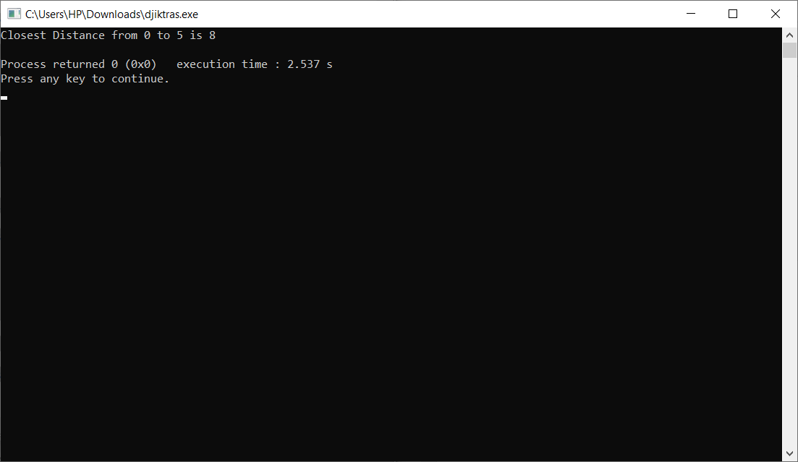

**3. Menu driven C program to implement insertion, selection and bubble sort.**

**PSEUDOCODE:**

Selection sort()

For I = 0 to N-1 do:

Smallsub = I

For J = I + 1 to N-1 do:

If A(J) < A(Smallsub)

Smallsub = J

End-If

End-For

Temp = A(I)

A(I) = A(Smallsub)

A(Smallsub) = Temp

End-For

Insertion sort()

For I = 1 to N-1

J = I

Do while (J > 0) and (A(J) < A(J - 1)

Temp = A(J)

A(J) = A(J - 1)

A(J - 1) = Temp

J = J - 1

End-Do

End-For

Bubble sort()

For I = 0 to N - 2

For J = 0 to N - 2

If (A(J) > A(J + 1)

Temp = A(J)

A(J) = A(J + 1)

A(J + 1) = Temp

End-If

End-For

End-For

**CODE:**

#include<stdio.h>

#include<stdlib.h>

void swap(int *a, int *b){

*a = *a + *b;

*b = *a - *b;

*a = *a - *b;

}

void selectionSort(int arr[], int n){

int minIndex;

for(int i = 0; i < n; ++i){

minIndex = i;

for(int j = i+1; j < n; ++j){

if(arr[minIndex] > arr[j])

minIndex = j;

}

swap(&arr[i], &arr[minIndex]);

}

}

void insertionSort(int arr[], int n){

for(int i = 1; i < n; i++){

int key = arr[i];

int j = i - 1;

while(j >= 0 && arr[j] > arr[key]){

arr[j+1] = arr[j];

j--;

}

arr[j + 1] = key;

}

}

void bubbleSort(int arr[], int n){

for(int i = 0; i < n - 1; ++i){

for(int j = 0; j < n-i-1; ++j){

if(arr[j] > arr[j+1])

swap(&arr[j], &arr[j+1]);

}

}

}

void printArray(int arr[], int n){

for(int i = 0; i < n; ++i)

printf("%d ", arr[i]);

printf("\n");

}

void sort(){

int choice, n;

int arr[50];

printf("Enter the number of numbers you wish to enter: ");

scanf("%d", &n);

printf("Enter the numbers: \n");

for(int i = 0; i < n; ++i)

scanf("%d", &arr[i]);

printf("Select your sorting method:\n");

printf("1. Bubble sort\n");

printf("2. Insertion Sort\n");

printf("3. Bubble sort\n");

scanf("%d", &choice);

switch(choice){

case 1: bubbleSort(arr, n);

printArray(arr, n);

break;

case 2: insertionSort(arr, n);

printArray(arr, n);

break;

case 3: selectionSort(arr, n);

printArray(arr, n);

break;

default: printf("Invalid input!\n");

break;

}

}

int main(){

int choice;

while(1){

printf("1. Sort numbers:\n");

printf("2. Exit\n");

scanf("%d", &choice);

if(choice == 1)

sort();

else if(choice == 2)

exit(0);

else

printf("Invalid input!\n");

}

return 0;

}

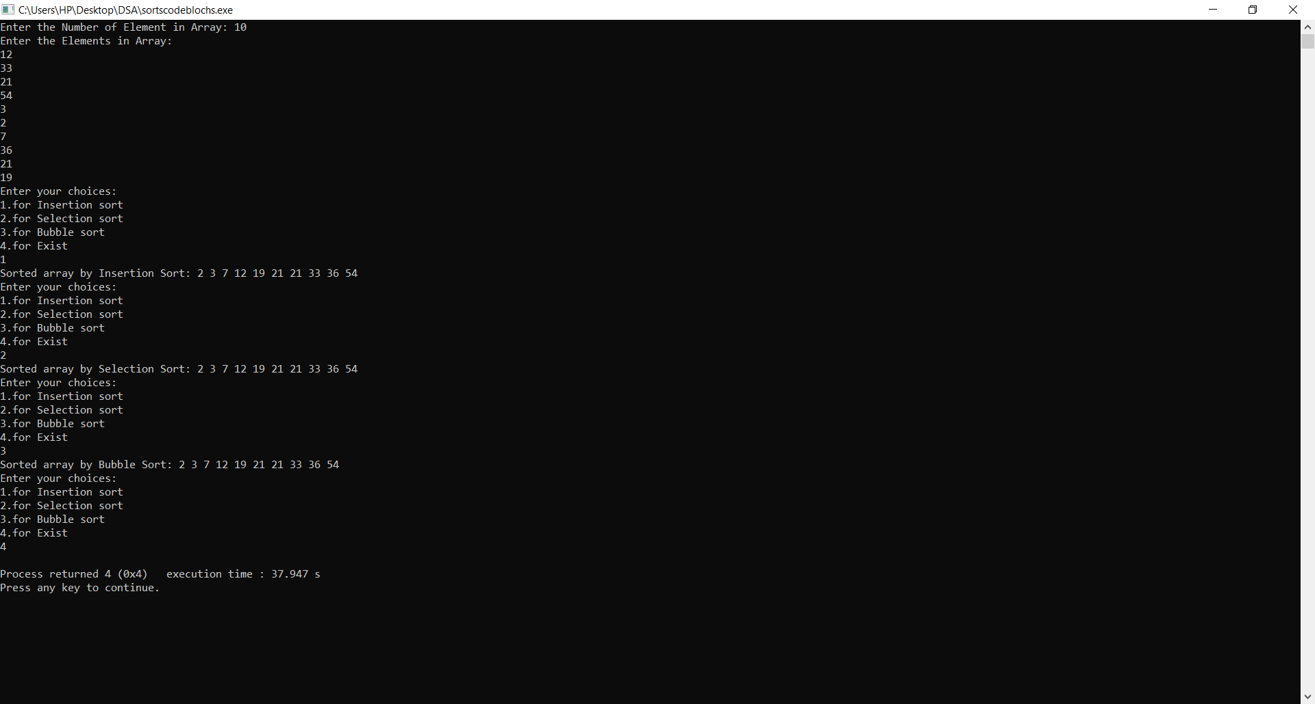

**4. Menu driven C program to implement quick sort and merge sort using divide and conquer method.**

**PSEUDOCODE:**

QuickSort(A, p, r):

if p < r:

q = Partition(A, p, r)

QuickSort(A, p, q-1)

QuickSort(A, q+1, r)

Merge(A,B,C):

i = j = 1

for k = 1 to n:

if A[i] < B[j]:

C[k] = A[i]

i = i + 1

else: (A[i] > B[j])

C[k] = B[j]

j = j + 1

**CODE:**

#include<stdio.h>

#include<stdlib.h>

void swap(int *a, int *b){

*a = *a + *b;

*b = *a - *b;

*a = *a - *b;

}

// --------- Quick Sort ----------------

int partition(int arr[], int low, int high){

int pivot = arr[high];

int i = low - 1;

for(int j = low; j < high; j++){

if(arr[j] < pivot){

i++;

swap(&arr[i], &arr[j]);

}

}

swap(&arr[i+1], &arr[high]);

return i + 1;

}

void quickSort(int arr[], int low, int high){

if(low < high){

int pi = partition(arr, low, high);

quickSort(arr, low, pi - 1);

quickSort(arr, pi + 1, high);

}

}

// -------------- Quick Sort ---------------

// -------------- Merge Sort ---------------

void merge(int arr[], int l, int m, int r){

int i, j, k;

int n1 = m - l + 1;

int n2 = r - m;

int L[n1], R[n2];

for(i = 0; i < n1; ++i)

L[i] = arr[l + i];

for(j = 0; j < n2; ++j)

R[j] = arr[m + 1 + j];

i = 0; j = 0; k = l;

while(i < n1 && j < n2){

if(L[i] <= R[j]){

arr[k] = L[i];

i++;

}

else{

arr[k] = R[j];

j++;

}

k++;

}

while(i < n1){

arr[k] = L[i];

k++;

i++;

}

while(j < n2){

arr[k] = R[j];

k++;

j++;

}

}

void mergeSort(int arr[], int l, int r){

if(l < r){

int m = l + (r-l)/2;

mergeSort(arr, l, m);

mergeSort(arr, m + 1, r);

merge(arr, l, m, r);

}

}

// -------------- Merge Sort ---------------

void printArray(int arr[], int n){

printf("The sorted array is:\n");

for(int i = 0; i < n; ++i)

printf("%d ", arr[i]);

printf("\n");

}

void sort(){

int choice, n;

int arr[50];

printf("Enter the number of numbers you wish to enter: ");

scanf("%d", &n);

printf("Enter the numbers: \n");

for(int i = 0; i < n; ++i)

scanf("%d", &arr[i]);

printf("Select your sorting method:\n");

printf("1. Merge Sort\n");

printf("2. Quick Sort\n");

scanf("%d", &choice);

switch(choice){

case 1: mergeSort(arr, 0, n -1);

printArray(arr, n);

break;

case 2: quickSort(arr, 0, n -1);

printArray(arr, n);

break;

default: printf("Invalid input!\n");

break;

}

}

int main(){

int choice;

while(1){

printf("1. Sort numbers:\n");

printf("2. Exit\n");

scanf("%d", &choice);

if(choice == 1)

sort();

else if(choice == 2)

exit(0);

else

printf("Invalid input!\n");

}

return 0;

}

