MyLLM Pre-2 Project Showcase
Research brief, architecture flow, proof-of-concepts, progress, and execution plan
Generated from repository state on 2026-05-14 | Branch: beta-dev
Executive decision
Pre-2 should ship as a dense decoder-only 1.49B-class foundation baseline trained in BF16, with 1.5T planned tokens and at least 1T as the hard floor. MoE, FP8, INT8/INT4 training, and heterogeneous-tokenizer KD are research tracks, not dependencies for the first serious run.
Area | Current position
Target model | 1B-class foundation model; current config estimates 1.485B parameters.
Training data | 1.5T planned tokens across Stage 1/2/3; 3T stretch only after data/eval gates hold.
Runtime | PyTorch 2.x production path, TorchTitan/FSDP2 target, BF16 training.
Architecture | Dense decoder-only Transformer with RMSNorm, GQA, RoPE, SwiGLU, tied LM head.
Precision | BF16 for training; INT8/INT4 only for post-training inference exports initially.
Validation | Pre-2 local tests pass; packed-corpus Windows metadata bug fixed and verified.

1. Project Flow
The project is moving from a pre-1 research/proof stack into a pre-2 implementation path that can support serious reproducibility, data governance, and distributed training. The primary flow is shown below.
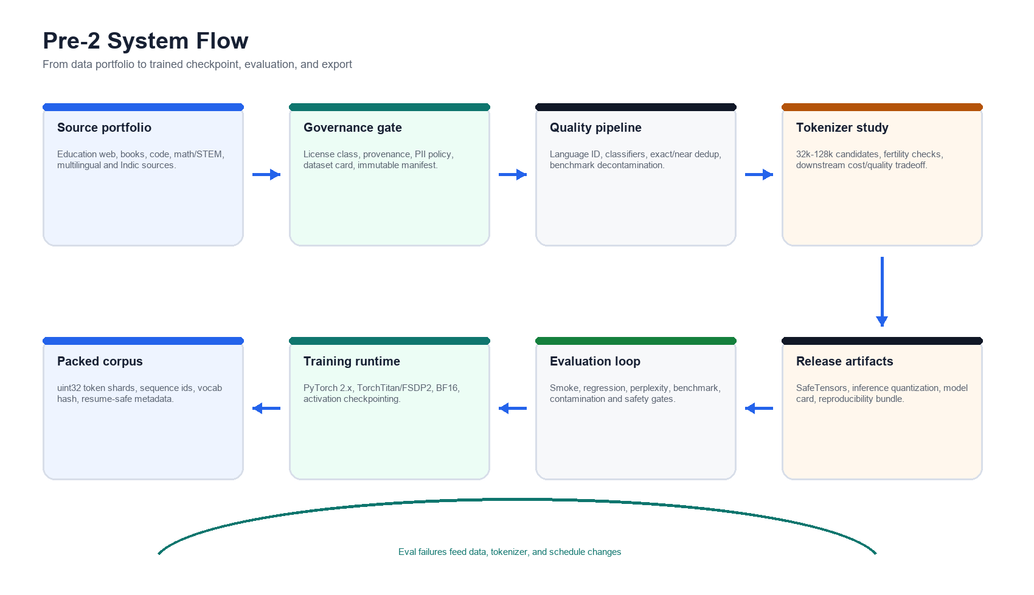
- Data and governance are first-class: license class, provenance, PII policy, dataset card, and immutable manifests are required before a main run.
- The packed corpus is treated as a reproducibility artifact, not a temporary preprocessing output.
- Eval failures feed back into data mixture, tokenizer, training schedule, or architecture only after attribution is clear.

2. Architecture
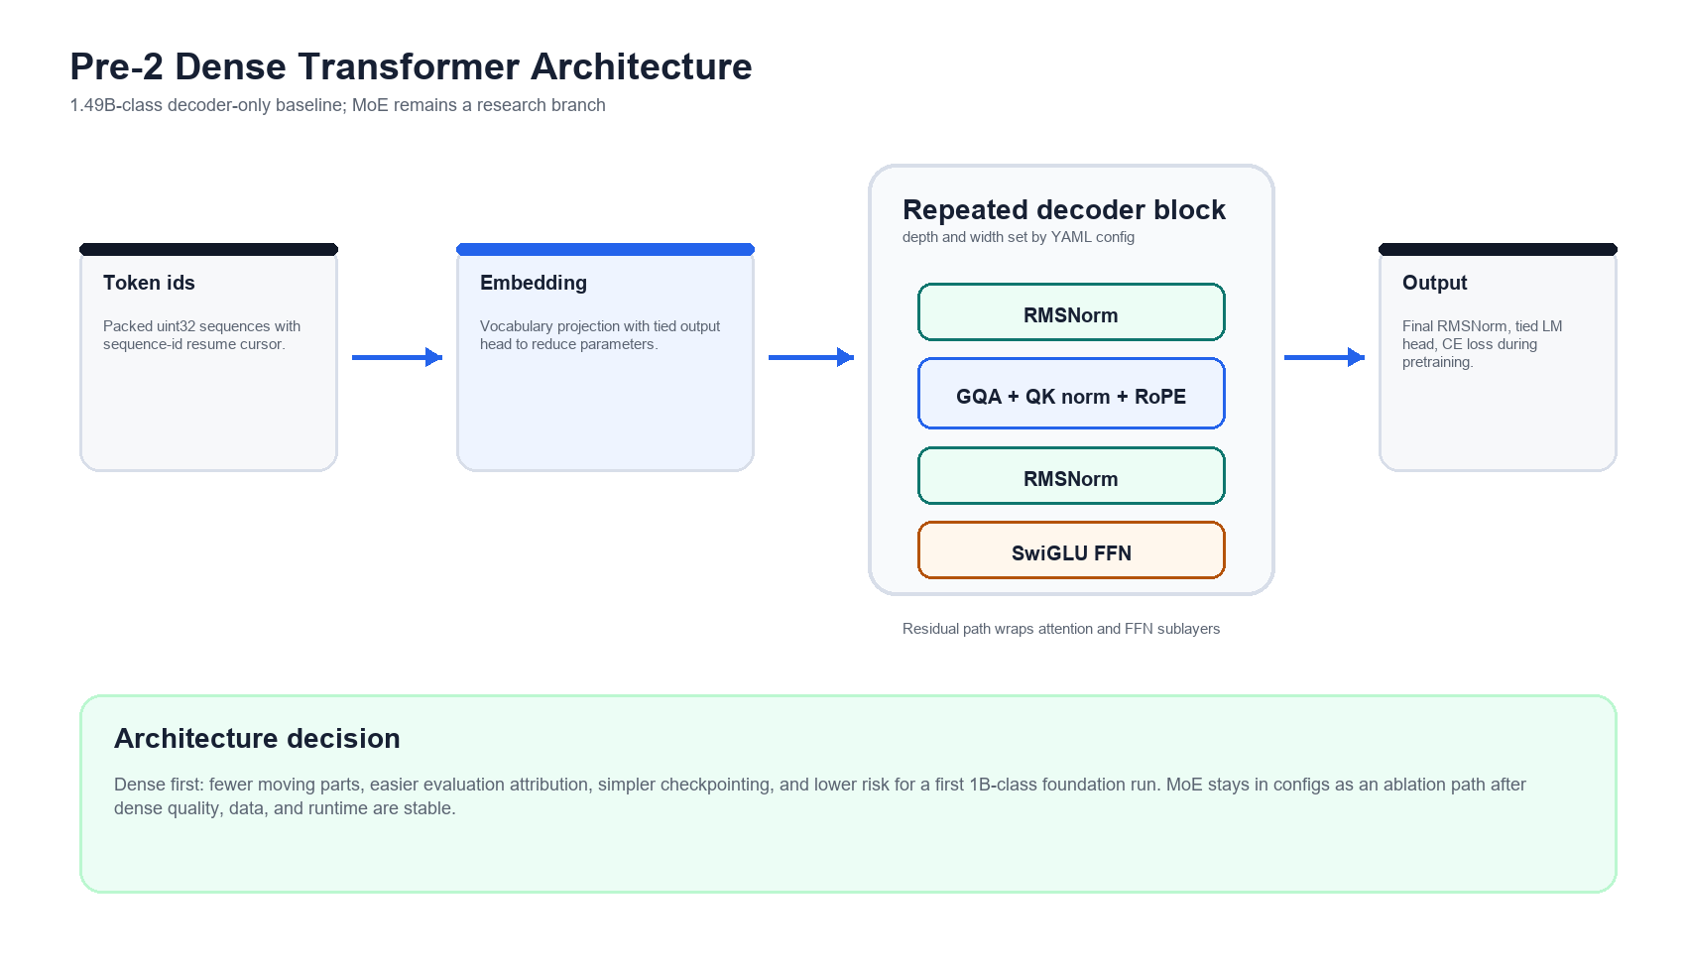
The current pre-2 architecture decision favors a dense Transformer because it reduces debugging entropy during the first 1B-class foundation run. A dense baseline makes data quality, optimizer behavior, checkpointing, eval regressions, and scaling curves easier to attribute.
Algorithm / component | Why it is used
Dense decoder-only Transformer | Lower production risk than MoE for the first 1B-class run; cleaner eval attribution and checkpoint semantics.
Grouped Query Attention | Reduces KV memory and improves serving efficiency while preserving most attention quality for this scale.
RoPE | Mature positional encoding used by many modern decoder models; supports controlled long-context extension work.
RMSNorm + pre-norm | Stable gradient flow and efficient normalization for deep decoder stacks.
SwiGLU feed-forward | Strong quality-per-compute choice for modern LLMs compared with older ReLU/GELU FFNs.
Tied output head | Saves parameters and keeps the parameter target focused on useful depth/width capacity.

3. Precision And Quantization Position
Clarification
A 4-bit or 8-bit model is normally an inference/export format, not the safest base pretraining format. The production baseline should train in BF16, evaluate normally, then export INT8/INT4 variants for serving. FP8 or low-bit training can be ablated later after BF16 quality is known.
Precision path | Decision | Reason
BF16 training | Default | Stable, well-supported on current accelerators, and the right baseline for from-scratch pretraining.
FP8 training | Later ablation | Potential speed/memory win on modern hardware, but requires careful scaling, instrumentation, and quality comparison.
INT8 inference | Export target | Useful for cheaper serving after the base checkpoint is trained and validated.
INT4 inference | Export target | Useful for local/edge serving, but quality loss must be measured per task and context length.
Native 4-bit/8-bit pretraining | Research risk | Not recommended for the first serious run because instability and quality attribution risk are high.

4. Data Strategy
The data plan is staged so the run does not depend on one giant opaque web dump. Each stage has its own quality threshold, mixture target, synthetic cap, and evaluation feedback loop.
Stage | Scale | Purpose
Stage 1 - Foundation | 1.05T tokens | Broad base: high-quality web, books, code, math/STEM, multilingual and Indic. Synthetic cap <= 3%.
Stage 2 - Quality continuation | 300B tokens | Higher-quality continuation with stronger code/math/books share and lower noisy web share. Synthetic cap <= 7%.
Stage 3 - Anneal | 150B tokens | Final quality and instruction-adjacent anneal without turning pretraining into supervised tuning. Synthetic cap <= 10%.
- Every dataset bucket needs a card: source, license, transforms, filtering thresholds, estimated contamination risk, and token contribution.
- Dedup should combine exact hashing and near-dedup methods; benchmark decontamination must run before headline evaluation claims.
- Synthetic data is capped because it can improve coverage but also amplify teacher bias, templating artifacts, and evaluation leakage.

5. Math And Compute Model
A first-order dense pretraining compute estimate is training FLOPs ~= 6 * parameters * tokens. For 1.49B parameters and 1.5T tokens, this is about 1.34e22 FLOPs before overhead, retries, evals, and checkpoint costs.
Quantity | Planning value
Parameter target | 1.485B estimated by current config; 0.34% from the 1.49B target.
Token budget | 1.5T planned; 1T minimum; 3T stretch only after data quality and eval gates are stable.
Main-run compute | ~1.34e22 dense training FLOPs for 1.49B x 1.5T.
Storage | Plan for raw data, normalized text, packed shards, metadata, checkpoints, logs, eval artifacts, and backup copies.
Batching | Use packed fixed-length sequences with sequence-id cursoring so exact resume is testable.

6. Hardware And Timeline
Tier | Hardware | Rationale
Minimum serious run | 8x H100/H200-class GPUs | Useful for pilots and smaller main-run attempts; wall clock and operational risk are higher.
Recommended | 16x H200/B200-class GPUs | Practical class for 1.5T tokens with checkpoint/eval overhead and iteration budget.
Strong target | 32x H200/B200-class GPUs | Better for faster iteration, larger ablations, and lower risk if restarts/evals consume time.
Storage | Multi-TB fast local + object storage | Packed data, checkpoints, optimizer state, logs, and immutable manifests need throughput and durability.
A realistic 16-GPU project timeline is 10-13 weeks end to end: data/tokenizer gates, proxy runs, distributed runtime hardening, main run, evaluation, export, and release packaging. The actual main run is only one part of the schedule; data and validation dominate the risk.

Training timeline (16-GPU planning case)
Week 0-1 - lock dataset governance, source cards, license gates, and contamination policy.
Week 1-2 - run tokenizer ablations, choose production vocab, and validate packed-shard metadata.
Week 2-4 - run 400M proxy experiments, harden exact resume, and compare data mixture options.
Week 4-5 - complete distributed launch rehearsals, DCP restore tests, and failure-drill checkpoints.
Week 5-9 - execute the 1.5T dense main run, with scheduled evals and checkpoint audits.
Week 9-11 - run decontaminated evaluations, regression analysis, safety checks, and model-card draft.
Week 11-13 - export SafeTensors, produce INT8/INT4 serving variants, and package reproducibility artifacts.

7. Proofs Of Concept And Progress
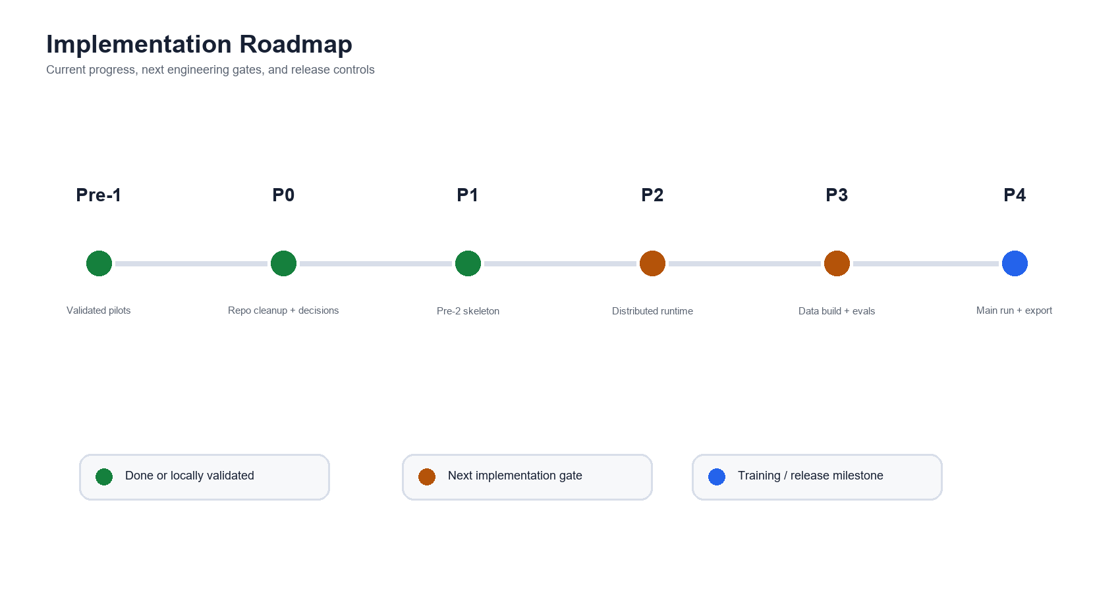
Track | Status | Evidence / next gate
Pre-1 foundations | Done | Tokenizer, streaming data path, packed corpus, local training, exact resume, checkpointing, R2/object-store paths, and FSDP proof points were established.
Docs cleanup | Done | Stale pre-1 review/teacher/math/playbook documents were removed; canonical pre-2 docs now describe current decisions.
Pre-2 configs | Done | Dense 1.5B target, proxy 400M, MoE research config, and three-stage data mixture configs are present.
Pre-2 code skeleton | Done | Pydantic config schema, PyTorch dense model, KD guard, packed loader, checkpoint payload, and smoke trainer were added.
Validation | Done | 23 pre-2 tests pass; 56 packed-corpus tests pass; one-step CPU smoke training produces finite loss.
Distributed runtime | Next | Add TorchTitan/FSDP2 trainer integration, DCP checkpoints, launch configs, and multi-GPU smoke tests.
Data production | Next | Build governed dataset manifests, tokenizer ablations, packed shards, and contamination reports.
Release | Pending | Export SafeTensors, quantized inference variants, model card, eval card, and reproducibility bundle.

8. Current Repository Anchors
Artifact | Role
docs/PRE2_FINAL_PLAN_2026-05-14.md | Canonical pre-2 plan: goal, decisions, hardware, timeline, risks.
docs/PRE2_ARCHITECTURE_DECISION.md | Architecture record for dense baseline, MoE research branch, and precision choices.
docs/PRE2_STACK_MIGRATION_PLAN.md | Migration path from pre-1 JAX/Keras to pre-2 PyTorch/TorchTitan.
configs/pre2_dense_1_5b.yaml | Production candidate configuration for the 1.49B-class baseline.
configs/data/pre2_mix_stage*.yaml | Staged data mixture plans for foundation, continuation, and anneal.
src/myllm_pre2/model.py | Minimal dense Transformer implementation used by tests and smoke training.
src/myllm_pre2/guards.py | Fail-closed guard against invalid heterogeneous-tokenizer KD.
src/myllm_pre2/data/packed_loader.py | Packed token loader skeleton with resume-oriented sequence ids.
src/myllm_pre2/checkpoint.py | Checkpoint payload with model, optimizer, scheduler, RNG, and data cursor fields.

9. Open TODOs
Priority | Task
P0 | Finalize dataset governance template and require it for every source bucket.
P0 | Add full config validation for tokenizer identity, vocab hash, context length, and packed-shard metadata.
P1 | Replace the single-process checkpoint path with distributed checkpoint wrappers and restore tests.
P1 | Integrate TorchTitan/FSDP2 launcher and run a multi-GPU smoke suite.
P1 | Build tokenizer ablation report and choose production vocab before large data packing.
P2 | Implement real evaluation harness with contamination-aware reports; do not rely on mock metrics.
P2 | Add SafeTensors export and INT8/INT4 inference conversion after base checkpoint validation.
P3 | Run proxy scaling experiments, lock mixture, and approve the 1.5T main run.

10. Risk Register
Risk | Severity | Control
Data quality | High | Weak data makes architecture experiments meaningless; mitigate with cards, filters, decontam, and eval attribution.
Runtime maturity | High | Distributed failures are expensive; mitigate with proxy runs, DCP restore tests, and launch rehearsals.
Tokenizer choice | Medium | Bad fertility or vocab size hurts quality and cost; mitigate with ablations before packing 1.5T tokens.
MoE complexity | Medium | Routing, load balance, and checkpointing can hide data/model bugs; keep MoE research-only until dense is stable.
Quantization expectations | Medium | 4-bit/8-bit is serving work, not a shortcut to cheap pretraining; measure task-level degradation after export.
Evaluation leakage | High | Headline numbers are unreliable without decontamination and transparent eval cards.

11. Bottom Line
Recommended path
Treat pre-2 as an engineering-grade dense baseline program. Finish the data governance and distributed runtime gates first, then run proxy scaling experiments, lock tokenizer and mixture, execute the 1.5T main run, and only then produce INT8/INT4 serving variants and MoE/FP8 research comparisons.

