The testing procedures with screenshots

1) After deployed the contact to jungle3 testnet:: URL= “ [https://jungle3.cryptolions.io](https://jungle3.cryptolions.io/) ”

2) Tokens contracts are deployed under the name of “tokenfactory”

3) and the depositnlock contract under the same name which has no actions. Just one payable action defined like this: [[eosio::on_notify(“tokenfactory::transfer”)]].

4) after a actions it seems work fine.

5) using [1-5]test2tester, 5 accounts for testing.

Steps:

1) then the mutlti_index table deposits as below:

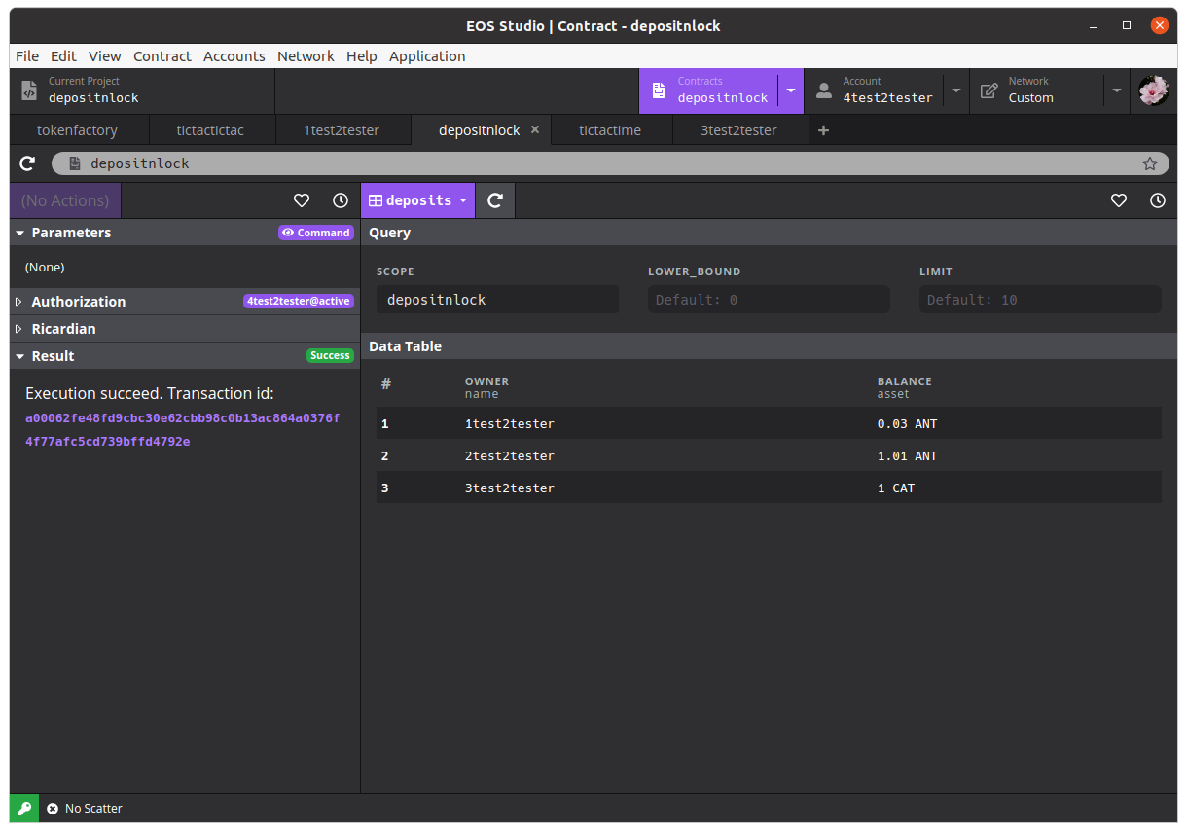

2)check the tokens for 4test2tester

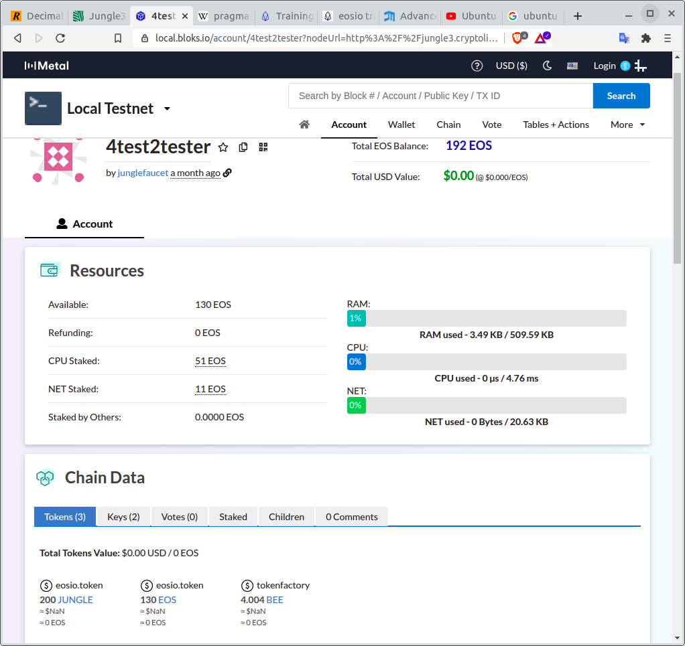a

3) transfer 1.004 BEE to the depositnlock

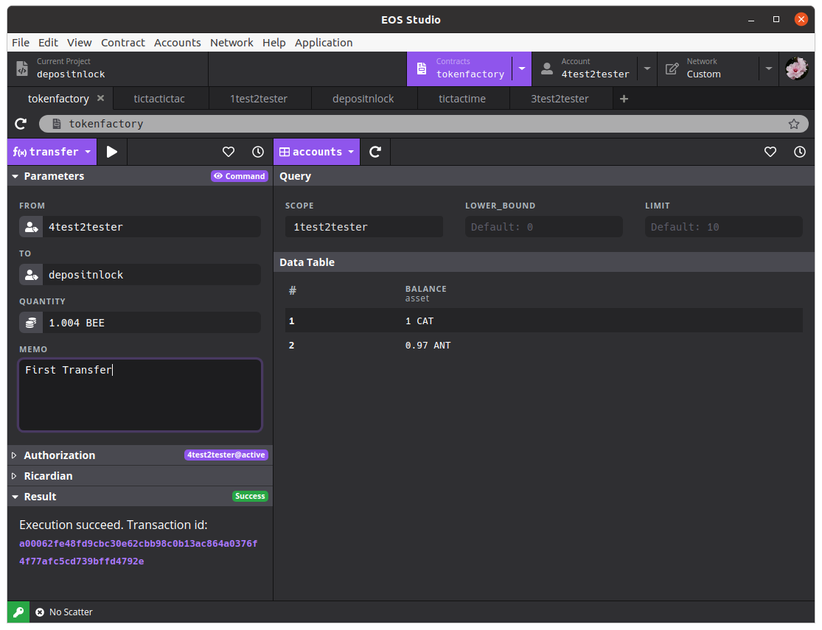a

4) check the depositnlock’s deposits table balance:

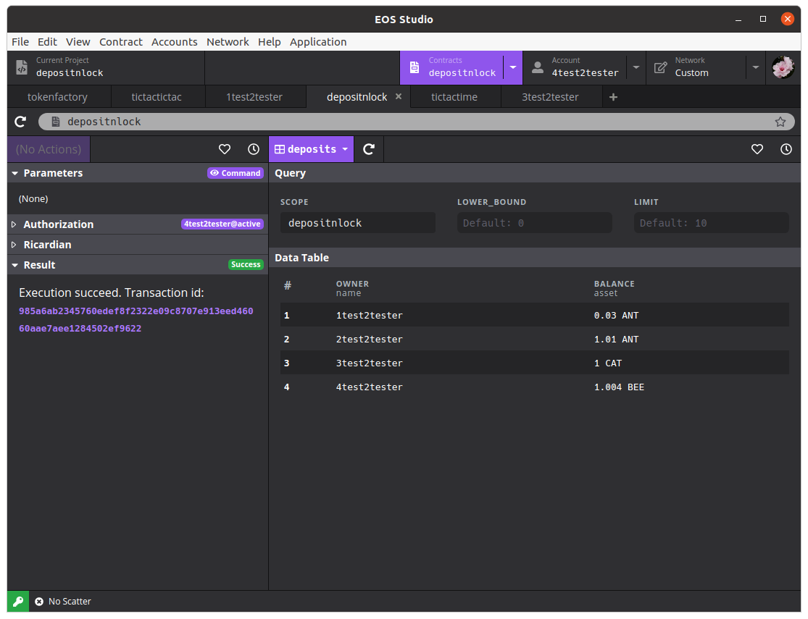a

5) transfer 2.000 BEE to it

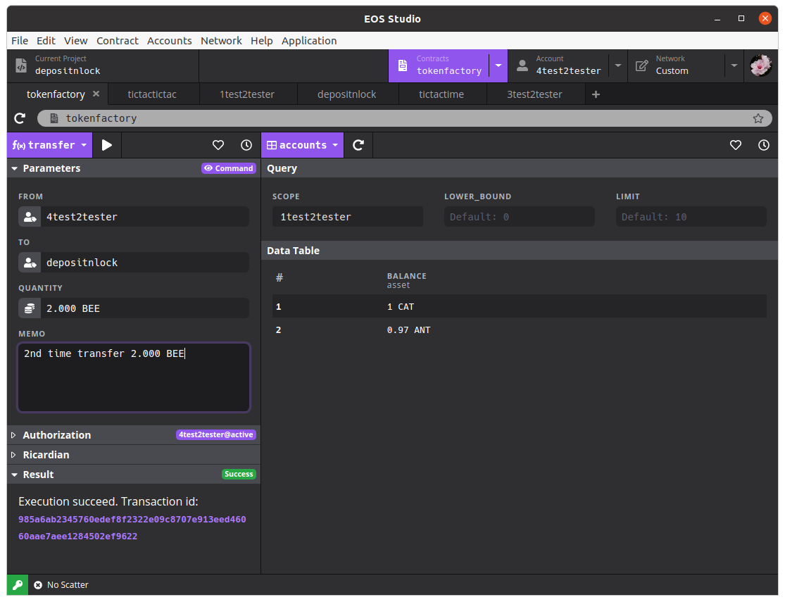a

6) check the depositnlock’s table again

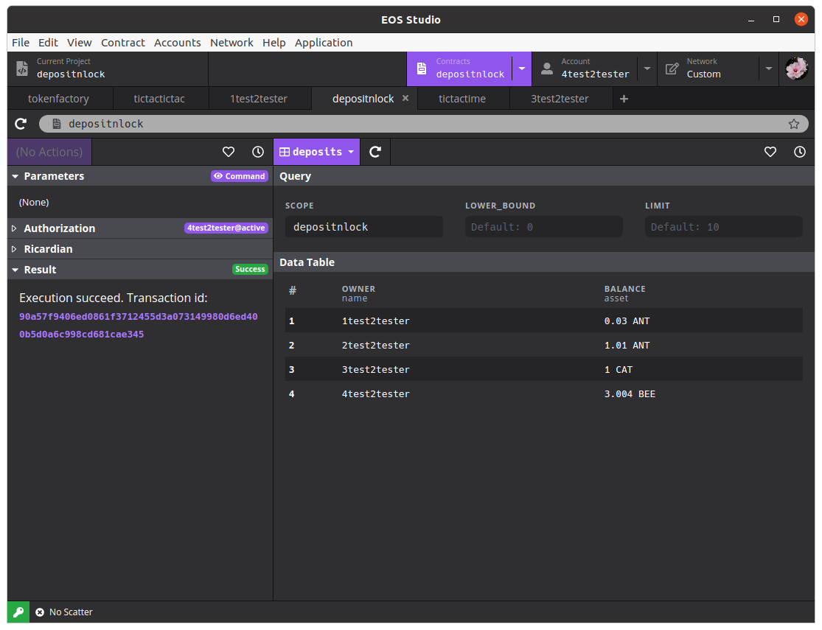a

the balance of 4test2tester is added to 3.004 BEE, OK!

-- END --

2021 Apr. 26