Smart Contract 201

Lab 3

Assignment

### Lab 3, Staking Contract: Adding a withdraw action

Add an action users can call to withdraw their stake (deposits), using an inline action to call tokenfcatory::transfer.

Submit a screenshot of the withdraw action being pushed and the resulting output (in your terminal or GUI).

Check the source code

Test Screenshots:

Begin to withdraw 1.004 4test2tester

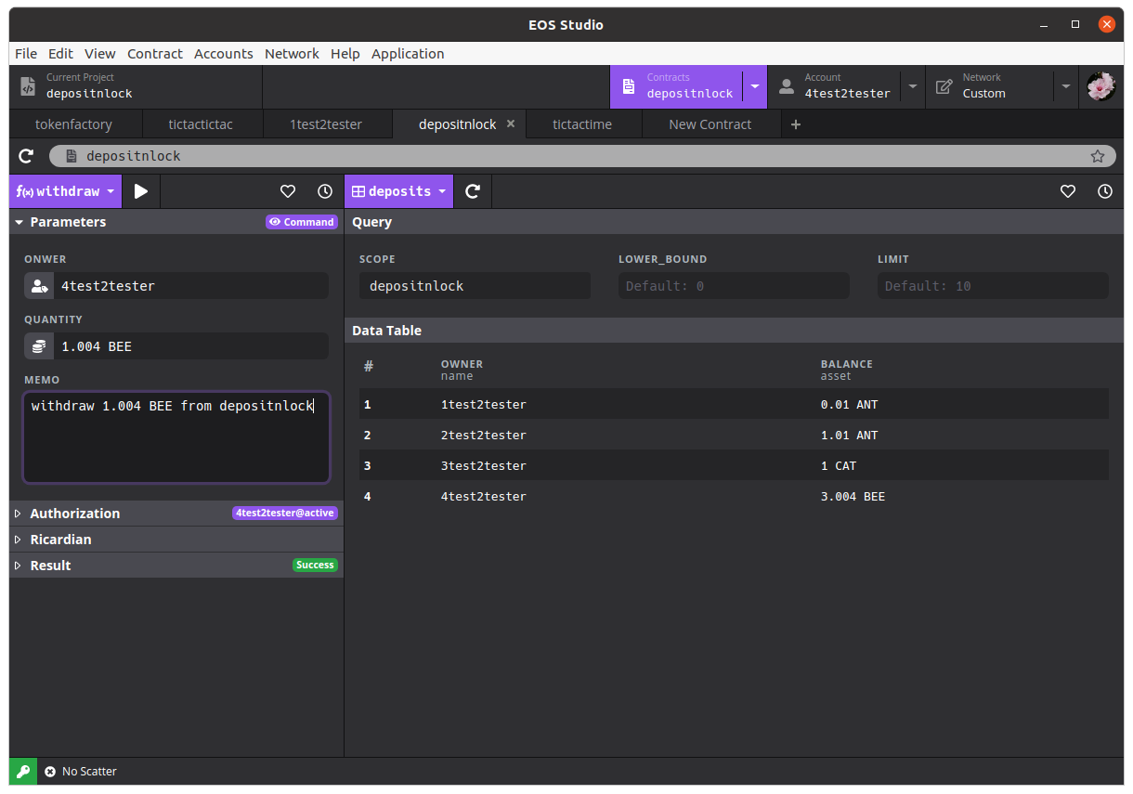after the action, there should be: 2.000 BEE left

Here is the screenshot after the action:

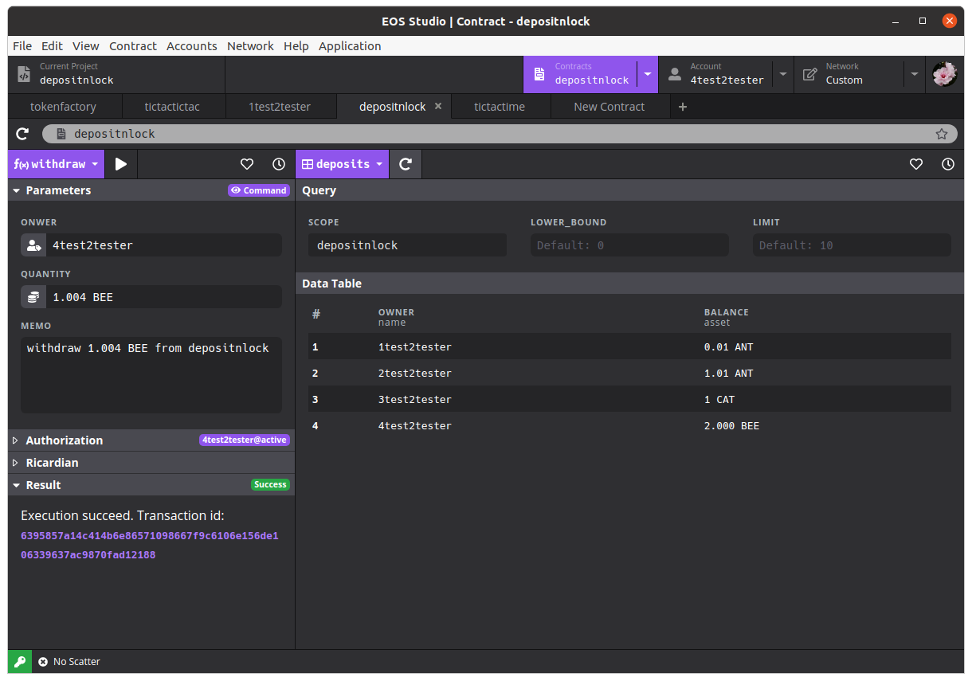yes it is 2.000 BEE left.

Prepare to withdraw 1 CAT from 3test2tester

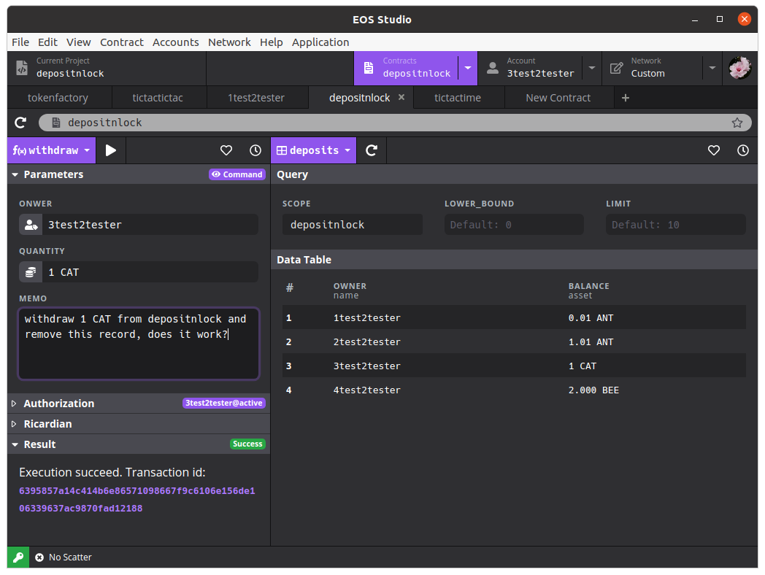When 1 CAT is withdrawn, record 3 should be removed as it is 0 CAT value.

Here is the screenshot after the withdraw is done:

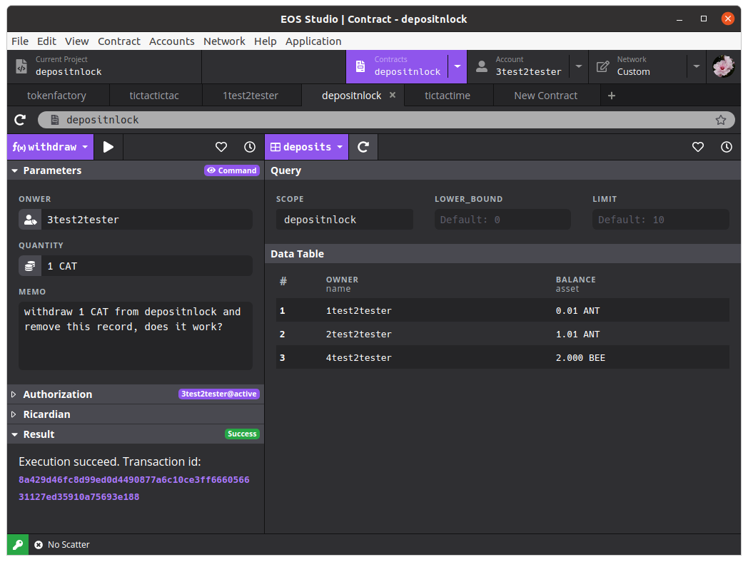

The CAT record for 4test2tester is removed, OK...

Also check the transactions from depositnlock’s view:

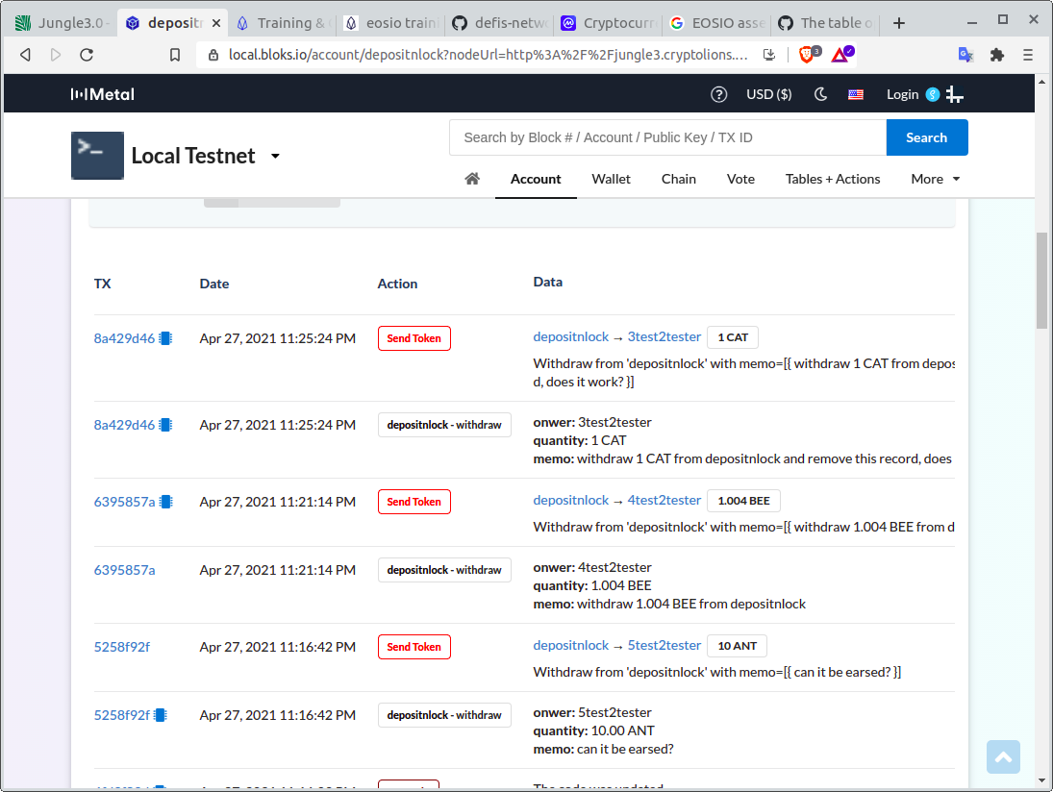inline actions worked fine.