**BlueJ Tips Guide**

1. Use the Auto-layout feature (often) to automatically align (indent or un-indent) your code properly.

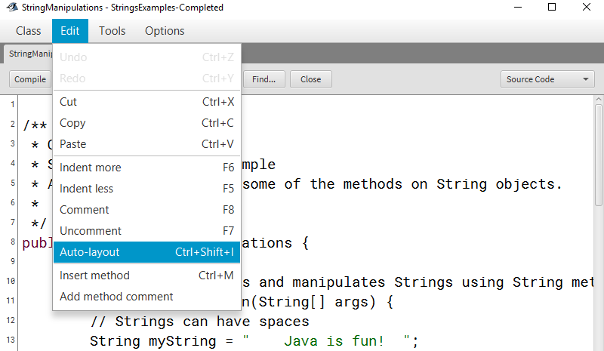

1. You can highlight several lines of code and then select Comment or Uncomment from the Edit menu, or use the shortcuts F8 or F7, respectively.   
     
   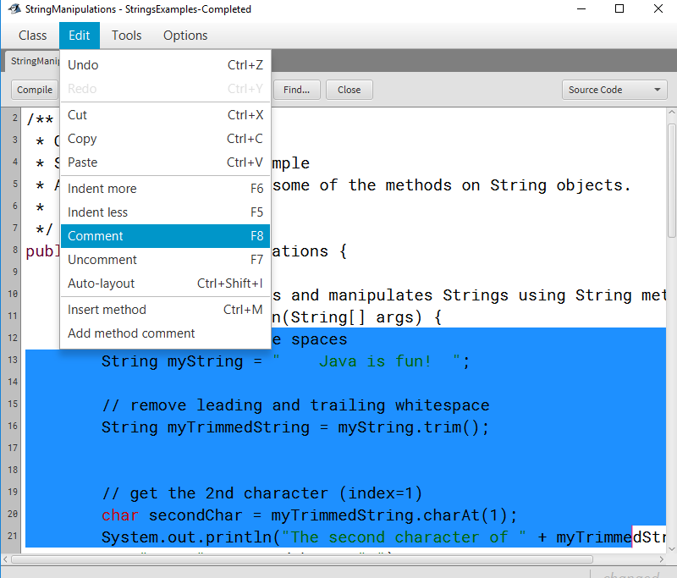
2. Enable line numbers under Options > Preferences > Display line numbers.

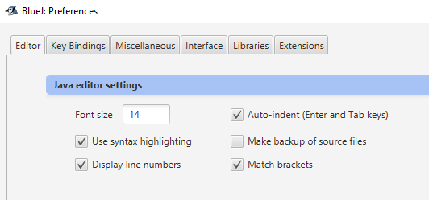

1. In the output window, make sure Unlimited buffering is checked. This will make sure that all of your output is visible. If this is not checked and you have a program with a lot of output, the upper portion of your output might not be visible.

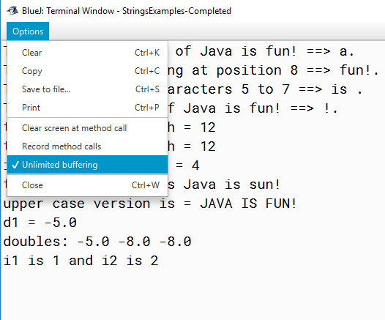

1. Clear your output window as needed while you’re working. Ctrl + K is the shortcut.   
     
   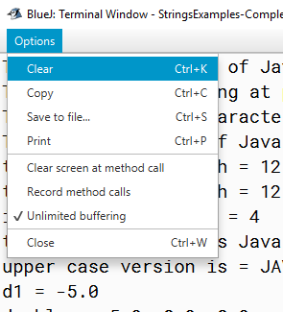
2. If you have multiple classes open in the editor, you can move one or more of them to separate windows, in case you want to see them side by side.

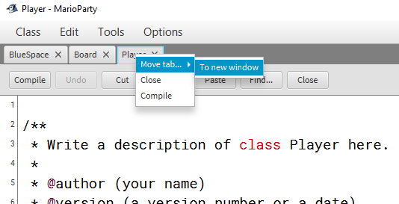

1. If you need to terminate your program, click the backwards arrow highlighted by the red outline in the picture below.   
     
   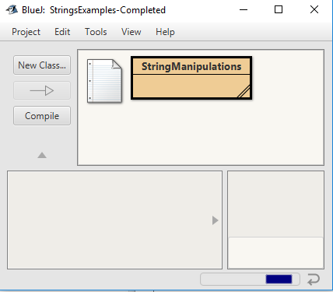
2. Use Toggle Documentation View to switch between the Javadocs documentation view and the code view.   
     
   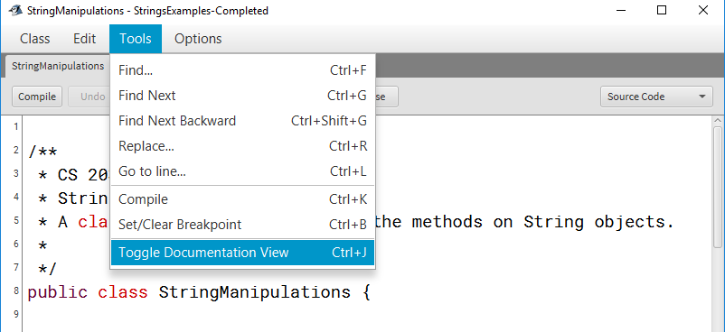
3. Occasionally you’ll open a BlueJ project and try to edit a class, but it looks like the window won’t open. If you hover over BlueJ in your Windows taskbar (I’ve only seen this issue on Windows), you’ll see the editor window open, but it doesn’t show up when you select it. To fix the issue, right-click on the editor in the taskbar and choose Maximize.