**Annotation for Subjective Bias Classification**

**Dear User**, here is the tutorial I wrote for you to start on the Bias Classification Task.

Note:

1. This tutorial is assuming that you are using a unix machine. (MAC or Linux)
2. All data here are just for training and the goal to help you get familiar with the task.
3. Feel free to send me any feedback on improving the interface.

**Software Setup.**

1. Currently, in the shared folder, you should see two files and a folder.
   1. Dev_160_sample.tsv
   2. 160dev folder
   3. Task_config.txt
2. Visit <https://github.com/heartexlabs/label-studio>
3. Following the Quit Start and install label-studio in your computer.

1. You may want to use Finder or something to locate the realpath of the installed package.
   1. What I did is typing “label_studio” in Finder and the results is like this.

* 1. Opening the folder in terminal, we can get the current real path by typing “pwd”.

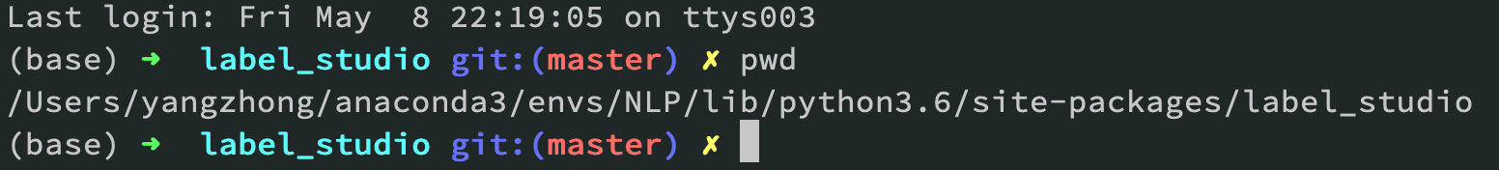

* 1. You need to copy the 160-dev folder into a subfolder of the label_studio.

In my case, the command would be

*cp 160_dev/ /Users/yangzhong/anaconda3/envs/NLP/lib/python3.6/site-packages/label_studio/static/samples/*

1. Recap that we have already started the server in step 3. Now you can open a web browser and visit <http://localhost:8200/> or <http://localhost:8080/>
   1. The interface should look like the following screenshot, but all 3 green check icon here should be grey as you are starting a new project.

* 1. **Setup the label config** by clicking the icon. All you need to do is to Copy the contents in task_config.txt into the text box in the Labeling Config box, then Save.

* 1. **Import the task!** Click “Import” icon in the top bar.
     1. Draging or importing the dev_160_sample.tsv file provided in this Tutorial folder. A screenshot of a cell phone

        Description automatically generated



* + 1. A successful loading will give you feedback as shown below.



* 1. **Start Labelling. Content goes in the next section.**

**Interface Design.**

**PAPERS:**

<https://arxiv.org/pdf/1911.09709.pdf>

<https://www.aclweb.org/anthology/P13-1162.pdf>



1. Annotation Goal:
   1. In this task, we are trying to check whether a phrase-pair change is related to the removal of subjective bias or not.
   2. I highly recommend you read the two papers I sent you weeks before carefully and thoroughly to understand different kinds of subjective bias and use them as references while doing annotation.
   3. The quality of your annotation is the most important thing and we cannot afford it to pay you to re-do everything again.
2. This is the big picture of the interface.
   1. You can see two pictures above representing two sentences. The highlighted section would be our focus. (sometimes there will be no highlights in both sentences due to technical issues, thus we need step B’s help in identifying the phrases)
   2. **Pre-change phrase** and **post-change phrase** should be consistent with the highlighted part in Source sentence and Target Sentence.
      1. There are in total three conditions: Both phrases have contents, either side is empty.

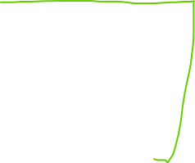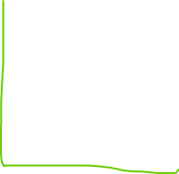

1. The task is a one-choice classification problem.
   1. In the Green circle above, you are provided with 4 categories.
   2. The first three bias categories come with a short description and some examples to keep you refreshing your memory on the categories’ difference.
   3. If you still find it not clear, do not hesitate, ask me or go back to the two papers.
   4. Pick the most fit answer.
   5. Click “Submit” to go to the next question.
2. Play with it and check your own progress in **Tasks Tab**.

1. Once you are satisfied with all annotations, go to Export Tab, select the export format as **tsv**, downloading the output and send it back to me.

