|  |
| --- |
| bilkent-logoBilkent University  CS353 – Database Systems Term Project  Department of Computer Engineering  Project Proposal Documentation  Airline Company Data Management System  Website: <http://cs353group20.github.io/>  Group 20:   * İrem Ergün * Nihat Eren Ekici * Ömer Eren * Turan Kaan Elgin |
|  |
|  |
|  |

1. **Problem Definition**

The purpose of the airline company data management system is to provide a means to store and keep track of the services provided by an airline company. For keeping information about the staff, schedule of flights, passenger reservations and additional resources of the company, a database system is necessary. In the system, the information of the airports and planes will be kept in order to keep history of each flight that is organized by the company. The system will provide the options for reserving and purchasing tickets (economy or business class) to the passengers. The flight history of all the passengers will be kept separately so that promotions can be given to customers based on that information. Promotions are associated with either flights, food or stores. Also, information of the crew assigned to each flight will be accessible from the system. In addition to these, the information of luggage belonging to each passenger will be stored in the system so as to assign an extra fee to that passenger if the weight of his/her luggage exceeds some specific limit.

User interface of the system will be web-based and passengers and airline staff (ticket staff, store staff, pilots and flight attendants) will be able to access the system from the particular website.

1. **Requirements and Limitations**
   1. **Functional Requirements**

* Passengers will be able to browse flights.
* Passengers will be able to make reservations for flights and choose their seats.
* Passengers will be able to cancel their reservations.
* Passengers will be able to purchase tickets either with or without reservation.
* Passengers will be able to cancel their tickets by paying some penalty.
* Passengers will be able to change their seats after reservation.
* Passengers will be able to make reservations for connecting flights.
* Passengers will be able to see their flight histories.
* Passengers will be able to see food menus of flights and stores of airports.
* Ticket staff will be able to give promotions to passengers according to their flight histories.
  + Flight promotions will be as the following: 200 TL promotion with 5 months deadline for 1000 TL expenditure, 400 TL promotion with 8 months deadline for 1500 TL expenditure, 600 TL promotion with 1 year deadline for 2000 TL expenditure.
  + Food promotions will be as the following: 20 TL promotion with 5 months deadline for 200 TL flight expenditure, 40 TL promotion with 8 months deadline for 400 TL flight expenditure, 60 TL promotion with 1 year deadline for 600 TL flight expenditure.
  + Store promotions will be as the following: 50 TL promotion with 5 months deadline for 200 TL flight expenditure, 90 TL promotion with 8 months deadline for 400 TL flight expenditure, 150 TL promotion with 1 year deadline for 600 TL flight expenditure.
* Ticket staff will be able to record the ticket sales to the system.
* Ticket staff will be able to make and cancel reservations.
* Flight attendants and pilots will be able to view their scheduled flights.
* Flight attendants and pilots will be able to view their flight history.
* Flight attendants will be able to record usage of food promotions of the passengers to the system.
* Store staff will be able to record usage of store promotions of the passengers to the system.
  1. **Nonfunctional Requirements**
* The system will have a user-friendly web interface.
* The system will be scalable to support many users at the same time.
* The system will have a low response time.
  1. **Pseudo-requirements**
* The system must have a web interface in the front end, and Java implementation in the back end.
* The system must not be open source.
  1. **Limitations**
* A reservation can be associated with only one passenger.
* In a flight, the number of pilots must be 2, the number of flight attendants must be between 3 to 5.
* Promotions must have deadlines such that after the deadline, they are removed from the system.
* Passengers cannot make a change in their flights or seats when the remaining time for the flight is less than or equal to one day.
* Passengers can see the flight histories which only belong to them.
* Crew staff cannot see the information about passengers.

1. **Conceptual Design**

Figure 1 represents the conceptual design of the system.

The entity set “person” is the generalization of all users of the system. The users are passengers and airline staff which are pilots, flight attendants, ticket staff and store staff. Users have unique ids and their information (names, phone numbers, addresses and emails) are kept in the system. Phone number and email are multi-valued attributes and address is a composite attribute. Passengers are associated with the flights by the “reservation” relationship which maps many flights (considering connecting flights) into one passenger. Another relationship between passengers and flights is “pass_history” which is for giving promotions. Also, the flight history of flight personnel is kept in the system for their salaries. In each flight, there are 2 pilots and 3 to 5 flight attendants. Ticket sale is associated with a reservation, ticket staff and ticket. If passengers choose to purchase their tickets from the website, the system will automatically make a reservation and associate it with the particular sale. However, value of the ticket staff will be null in this case. Each flight is associated with two airports and airports have stores. Store staff are associated with these stores. Each flight is also associated with a plane and each plane has many seats which passengers can reserve while making reservations. In addition to those, each passenger is associated with promotions which have three types: Store promotions are related to stores in the airport, food promotions are related to menu options in the flights and flight promotions are related to flight sales. The attribute “deadline” in the entity set “promotion” is a derived attribute which can be determined by the amount of promotion since they are fixed.

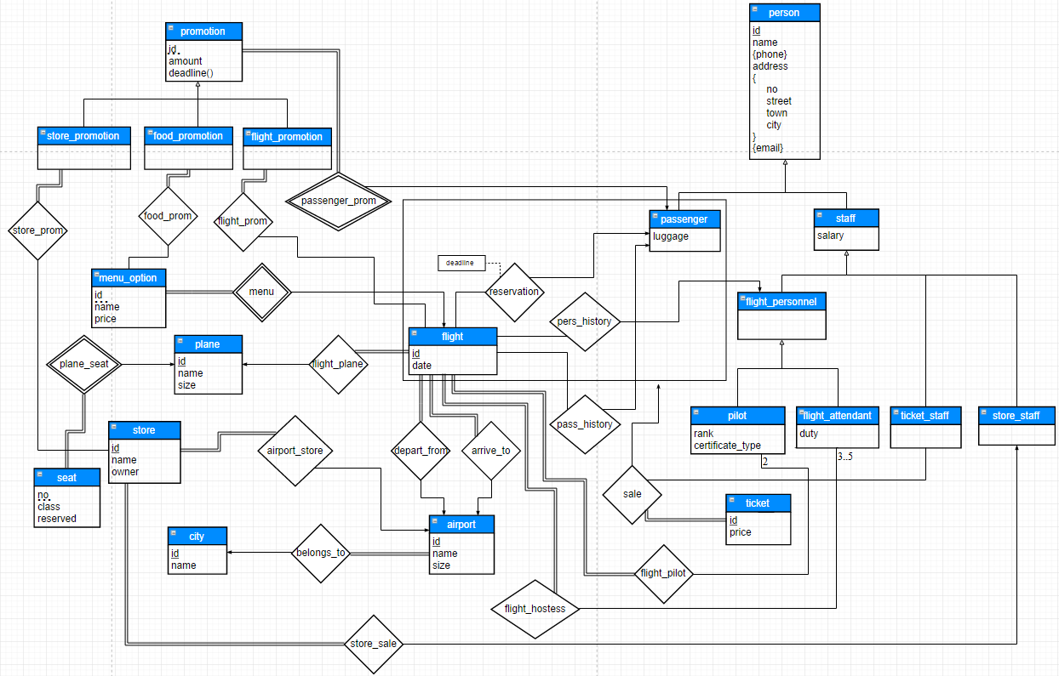Figure 1 – Conceptual design