CS 362 Random Testing Quiz Write Up

Yang Yang

10/25

After observing the if statements inside the while loop:

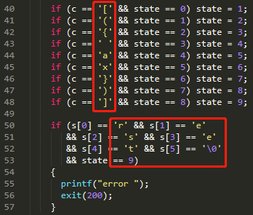

I notice that the characters we care are:  and the characters in “reset”. Randomly select one character from the list and eventually, the state will be increased to 9. Then randomly generate a combination of strings using {r, e, s, t}.

Ultimately, if the random string is “reset”, the coverage is complete.

So for inputChar(), I just randomly return a char from the list of characters we care;

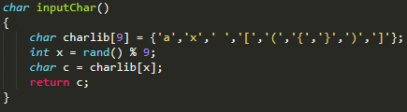

Similar method for inputString:

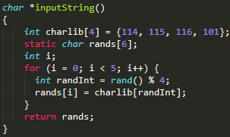

Then I ran following scripts:





Error occurs:



Then use gcov:

