**Lifestyle**

* weight management
  1. - list of meals
  2. - description (under 200 calories)
* dietary restrictions
  1. - list of meals
  2. - description (???)
* gluten-free
  1. - list of meals
  2. - description (doesn’t have any gluten)
* carb-free
  1. - list of meals
  2. - description (no carbs???)
* vegetarian/vegan
  1. - list of meals
  2. - description (no meat, fish, poultry)

**Recipe**

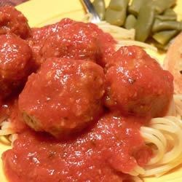

* name: Spaghetti and Meatballs
* price: $7
* category: Italian/high carb
* origin: Italy
* cook_time: 12 mins
* nutritional_info:
* Ingredients: water, sugar, pasta, tomato paste, ground beef, parmesan cheese

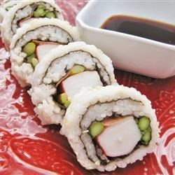

* name: California roll sushi
* price: $8
* category: vegan, weight management
* origin: Japan
* cook_time: 18 mins
* nutritional_info: ???
* Ingredients: rice, water, sugar, mayonnaise, avocado, cucumber, sesame seeds

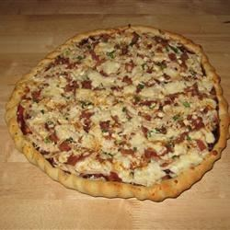

* name: Chicken pizza
* price: $6
* category: American
* origin: USA
* cook_time: 10 mins
* nutritional_info: ???
* Ingredients: onion, bbq sauce, cheese, tomato sauce, chicken

**Ingredient**

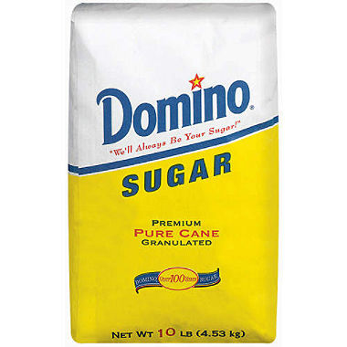

* name: sugar
* price: 1.79
* ratios: 1 pound?
* Products: ???
* nutritional_info: ???
* list of meals that use sugar…

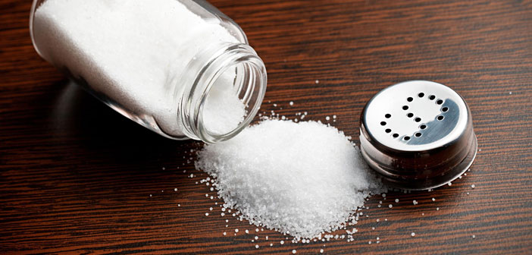

* name: salt
* price: 2
* ratios: 1 pound?
* Products: ???
* nutritional_info: ???
* list of meals that use salt…

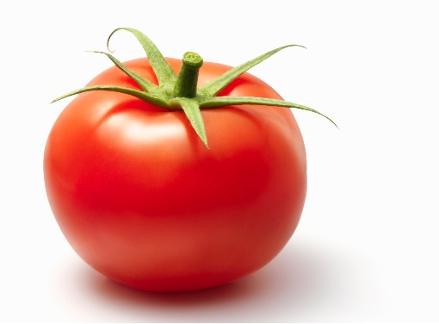

* name: tomato
* price: .50 per tomato
* ratios: ???
* Products: ???
* nutritional_info: ???
* list of meals that use tomato…

**Food Product**

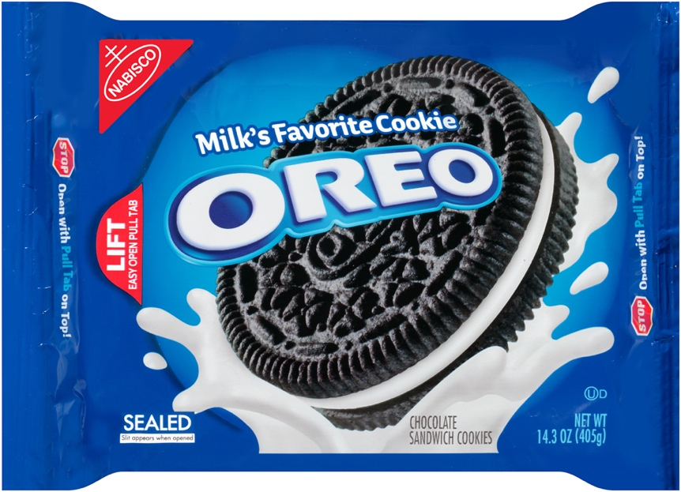

* name: Oreos
* price: 4.29
* description: Two chocolate wafers with a sweet crème filling
* similiar_foods: chips ahoy! Blue bell ice cream
* nutritional_info: 7g fat 140 calories per serving
* Ingredients: sugar…

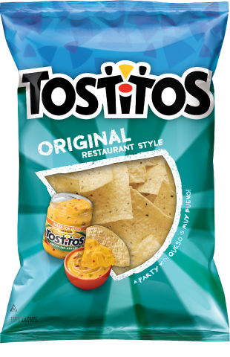

* name: tostitos
* price: 3.99
* description: Restaurant style tortilla chips
* similiar_foods: Doritos, Fritos
* nutritional_info: 7g fat 140 calories per serving
* ingredients: salt …

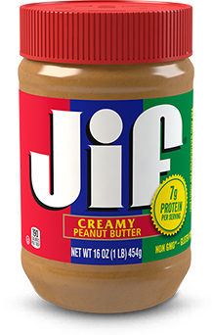

* name: jiffs peanut butter
* price: 2.48
* description: peanut flavored paste
* similiar_foods: Nutella, jelly
* nutritional_info: 16 g fat 190 calories per serving
* ingredients: salt, sugar