课程名称： 面对象程序设计与应用 |  | 指导教师： 张潇
班级： 信工16-2班 | 姓名： 王璐 |  | 学号： 1610480214
实验项目名称：

实验四 多态性
实验目的及要求：

1. 掌握友元的概念，理解友元函数和友元类。
2. 掌握运算符重载，掌握运算符重载为成员函数和友元函数的方法。
3. 理解多态的概念，理解函数的静态联编和动态联编。
4. 掌握虚函数的定义，理解虚函数在类的继承层次中的作用、虚函数的引入对程序运行时的影响。
5. 理解纯虚函数的概念并掌握它的使用方法，了解并应用抽象类。
实验原理：

C++面对象程序设计的原理，友元函数的实现方法，运算符重载的原理，虚函数的定义和使用方法等
实验内容（方法和步骤）：
验证性题目：
1.（1）源代码:
#include <iostream>
#include <string>
using namespace std;
class Employee{
public:
Employee(string Name,string id){name=Name; Id=id;}
string getName(){return name;}
string getID(){return Id;}
float getSalary(){return 0.0;}
void print(){cout<<"姓名："<<name<<"\t\t编号："<<Id<<endl;}
private:
string name;
string Id;
};
class Manager:public Employee{
public:
Manager(string Name,string id,float s=0.0):Employee(Name,id){
weeklySalary=s;
}
void setSalary(float s){weeklySalary=s;}
float getSalary(){return weeklySalary;}
void print(){
cout<<"经理："<<getName()<<"\t\t编号："<<getID()<<"\t\t周工资"<<getSalary()<<endl;
}
private:
float weeklySalary;
};
int main(){
Employee e("黄春秀","NO0009"),*pM;
Manager m("刘大海","NO0001",128);
m.print();
pM=&m;
pM->print();
Employee &rM=m;
rM.print();
return 0;
}

（2）源代码：
#include<iostream>
#include <cstring>
using namespace std;
class Sales{
private:
char name[10];
char id[18];
int age;
public:
Sales(char *Name,char *ID,int Age);
friend ostream &operator<<(ostream &os,Sales &s);
friend istream &operator>>(istream &is,Sales &s);

};
Sales::Sales(char *Name,char *ID,int Age){
strcpy(name,Name);
strcpy(id,ID);
age=Age;
}
ostream& operator<<(ostream &os,Sales &s){
os<<s.name<<"\t";
os<<s.id<<"\t";
os<<s.age<<endl;
return os;
}
istream &operator>>(istream &is,Sales &s){
cout<<"输入雇员的姓名，身份证号，年龄"<<endl;
is>>s.name>>s.id>>s.age;
return is;
}
int main()
{
Sales s1("杜康","214198012111711",40);
cout<<s1;
cout<<endl;
cin>>s1;
cout<<s1<<endl;
return 0;
}

（3）源代码：
#include <iostream>
using namespace std;
class Base{
protected:
int n;
public:
Base(int m){n=m++;}
virtual void g1(){cout<<"Base::g1()..."<<n<<endl; g4();}
virtual void g2(){cout<<"Base::g2()..."<<++n<<endl; g3();}
virtual void g3(){cout<<"Base::g3()..."<<++n<<endl; g4();}
virtual void g4(){cout<<"Base::g4()..."<<++n<<endl; }
};
class Derive:public Base{
int j;
public:
Derive(int n1,int n2):Base(n1){j=n2;}
void g1(){cout<<"Deri::g1()..."<<++n<<endl;g2();}
void g3(){cout<<"Deri::g2()..."<<++n<<endl;g4();}
};
int main()
{
Derive Dobj(1,0);
Base Bobj=Dobj;
Bobj.g1();
cout<<"-------------------------"<<endl;
Base *bp=&Dobj;
bp->g1();
cout<<"-------------------------"<<endl;
Base &bobj2=Dobj;
bobj2.g1();
cout<<"-------------------------"<<endl;
Dobj.g1();
return 0;
}

（4）第一题，修改后的源代码：（增加了拷贝构造函数）
#include <iostream>
#include <cstring>
using namespace std;
class X{
private:
char *s;
public:
X(const char *b){
s=new char[sizeof(b)+1];
strcpy(s,b);
}
X(const X &p);
~X(){delete s;}
void display(){cout<<"s="<<s<<endl;}
};
X::X(const X &p){
s=new char[strlen(p.s)+1];
strcpy(s,p.s);
}
int main(){
X x1("ok");
X x2(x1);
X x3=x1;
x2.display();
x3.display();
return 0;
}
（4）第二题，修改后的源代码：（修改了返回值为引用）
#include <iostream>
using namespace std;
class Number{
int n;
public:
Number(int x):n(x){};
Number& operator++(){++n;return *this;}
Number& operator++(int){n++; return *this;}
friend Number &operator--(Number &o);
friend Number &operator--(Number &o,int);
void display(){cout<<"This Number is:"<<n<<endl;}
};
Number &operator--(Number &o){--o.n;return o;}
Number &operator--(Number &o,int){o.n--; return o;}
int main(){
Number N1(10);
++ ++ ++N1;
N1.display();
N1++;
N1.display();
--N1;
N1.display();
N1-- -- --;
N1.display();
return 0;
}

2.设计性题目
（1）源代码:
Shape.h:
#ifndef SHAPE_H
#define SHAPE_H
class Shape{
public:
virtual double area() const=0;
virtual double volume() const=0;
virtual void printShapeName() const=0;
virtual void print() const=0;
};
#endif

Point.h:
#include <iostream>
using namespace std;
#include "Shape.h"
#ifndef POINT_H
#define POINT_H
class Point : public Shape{
public:
Point(int = 0,int = 0);
void setPoint(int,int);
int getX() const{return x;}
int getY() const{return y;}
virtual double area() const;
virtual double volume() const;
virtual void printShapeName() const{cout<<"Point :";}
virtual void print() const;
private:
int x,y;
};
#endif

Point.cpp:
#include "Point.h"
double Point::area()const{return 0;}
double Point::volume()const{return 0;}
Point::Point(int a,int b){setPoint(a,b);}
void Point::setPoint(int a,int b){x=a;y=b;}
void Point::print() const{cout<<"["<<x<<","<<y<<"]";}

Cylinder.h:
#ifndef CYLINDE_H
#define CYLINDE_H
#include "Circle.h"
class Cylinder:public Circle{
public:
Cylinder(double h=0.0,double r=0.0,int x=0,int y=0);
void setHeight(double);
double getHeight();
virtual double area() const;
virtual double volume() const;
virtual void printShapeName() const{cout<<"Cylinder:";}
virtual void print() const;
private:
double height;
};
#endif

Cylinder.cpp:
#include "Cylinder.h"
Cylinder::Cylinder(double h,double r,int x,int y):Circle(r,x,y){setHeight(h);}
void Cylinder::setHeight(double h){height=h>0?h:0;}
double Cylinder::getHeight(){return height;}
double Cylinder::area() const{
return 2*Circle::area()+2*3.14159*getRadius()*height;
}
double Cylinder::volume()const{return Circle::area()*height;}
void Cylinder::print() const{
Circle::print();
cout<<";Height="<<height;
}

Circle.h:
#ifndef CIRCLE_H
#define CIRCLE_H
#include "Point.h"
class Circle:public Point{
public:
Circle(double r=0.0,int x=0,int y=0);
void setRadius(double);
double getRadius() const;
virtual double area() const;
virtual void printShapeName() const{cout<<"Circle:";}
virtual void print() const;
private:
double radius;
};
#endif

Circle.cpp:
#include "Circle.h"
Circle::Circle(double r,int a,int b):Point(a,b){setRadius(r);}
void Circle::setRadius(double r){radius=r>0?r:0;}
double Circle::getRadius()const{return radius;}
double Circle::area() const{return 3.14159*radius*radius;}
void Circle::print()const{
Point::print();
cout<<";Radius="<<radius;
}

Main.cpp:
#include <iostream>
#include <iomanip>
#include "Shape.h"
#include "Point.cpp"
#include "Circle.cpp"
#include "Cylinder.cpp"
using namespace std;
void vpf(const Shape *bptr){
bptr->printShapeName();
bptr->print();
cout<<"\nArea="<<bptr->area()<<"\nVolume="<<bptr->volume()<<endl<<endl;
}
void vrf(const Shape &bref){
bref.printShapeName();
bref.print();
cout<<"\nArea="<<bref.area()<<"\nVolume="<<bref.volume()<<endl<<endl;
}
int main(){
cout << setiosflags(ios::fixed|ios::showpoint)<<setprecision(2);
Point point(7,11);
Circle circle(3.5,22,8);
Cylinder cylinder(10,3.3,10,10);
Shape *array0fShapes[3];
array0fShapes[0]=&point;
array0fShapes[1]=&circle;
array0fShapes[2]=&cylinder;
cout<<"-----通过基类指针访问虚函数-----"<<endl;
for(int i=0;i<3;i++)
vpf(array0fShapes[i]);
cout<<"-----通过基类引用访问虚函数-----"<<endl;
for(int j=0;j<3;j++)
vrf(*array0fShapes[j]);
return 0;
}

(2)源代码：
#include <iostream>
using namespace std;
class Calculator {
unsigned short int count;
public:
void display(){cout<<"count:"<<count<<endl;}
Calculator(unsigned short int x):count(x){};
Calculator(){count=0;}
Calculator &operator++(){
++count;
return *this;
}
Calculator operator++(int){
Calculator t(*this);
count++;
return t;
}
Calculator &operator--(){
--count;
return *this;
}
Calculator operator--(int){
Calculator t(*this);
count--;
return t;
}
Calculator operator+(const Calculator p){
unsigned short temp;
temp=p.count+count;
return temp;
}
Calculator operator-(const Calculator d){
unsigned short temp;
temp=count-d.count;
return temp;
}
Calculator &operator=(const Calculator &s){
count=s.count;
}
};
int main()
{
Calculator door1,door2(20);
for(int i=0;i<100;i++)
door1++;
door2++;
door1.display();
door2.display();
for(int i=0;i<5;i++)
door1--;
door2--;
door1.display();
door2.display();
--door1;
door1.display();
--door2;
door2.display();
Calculator door3;
door3=door1+door2;
door3.display();
door3=door1-door2;
door3.display();
return 0;
}

实验结果与分析：

在写程序的过程中遇到了一些问题，最终经过查资料，解决了问题。

图片结果：

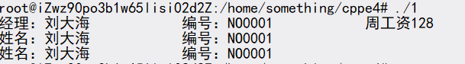
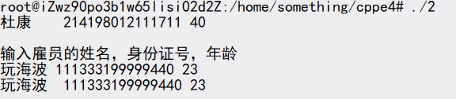

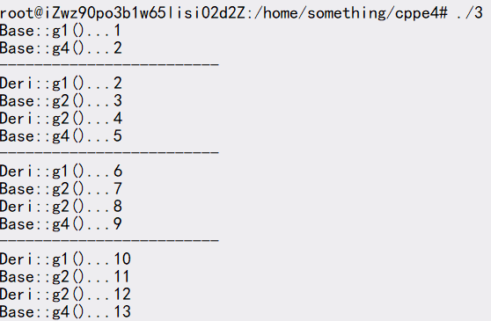

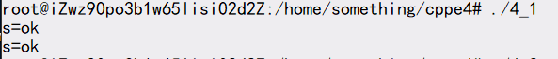

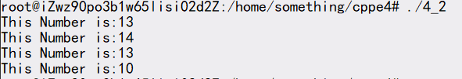

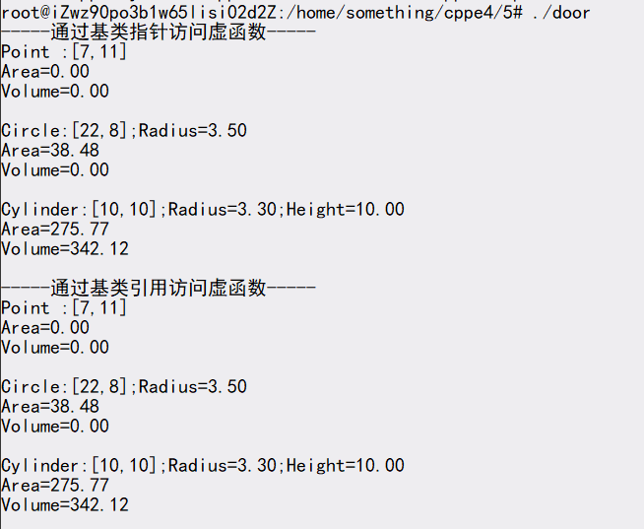

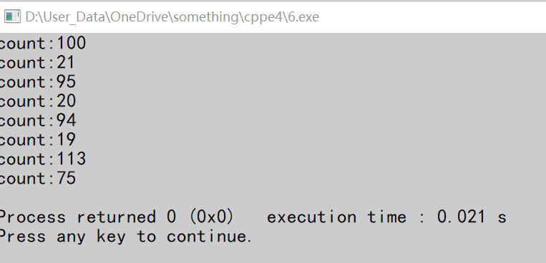

成绩： | 批阅教师签名： |  |  | 年 月 日

