课程名称： 面对象程序设计与应用 |  | 指导教师： 张潇
班级： 信工16-2班 | 姓名： 王璐 |  | 学号： 1610480214
实验项目名称：

实验三 类的继承与派生
实验目的及要求：

1.理解继承的含义，掌握派生类的定义方法和实现。
2.理解和掌握公有继承、私有继承和保护继承对基类成员的访问机制。
3.深刻理解在各种继承方式下构造函数和析构函数的执行顺序。
4.理解虚基类的目的和作用。
实验原理：

C++面对象程序设计的原理，类的派生的实现方法，公有继承、私有继承、保护继承等访问机制，构造函数析构函数执行顺序，虚基类的目的和作用
实验内容（方法和步骤）：
验证性题目：
1.（1）源代码:
#include <iostream>
using namespace std;
class A {
int x;
public:
A(int i=0):x(i) {cout<<"Construct A----"<<x<<endl;};
~A() { cout<<"Des A----"<<x<<endl;};
};
class B {
int y;
public:
B(int i):y(i) {cout<<"Construct B----"<<y<<endl;};
~B(){cout<<"Des B----"<<y<<endl;};
};
class C{
int z;
public:
C(int i):z(i) {cout<<"Construct C----"<<z<<endl;};
~C() {cout<<"Des C----"<<z<<endl;};
};
class D : public B{
public:
C c1,c2;
A a0,a4;
D():a4(4),c2(2),c1(1),B(1){
cout<<"Construct D----5"<<endl;
};
~D(){cout<<"Des D----5"<<endl;};
};
int main(){
D d;
return 0;
}

（2）源代码：
#include <iostream>
using namespace std;
class A{
int a;
public:
A(){ cout<<"Constructing B"<<endl;};
};
class B{
public:
B(){cout<<"Constructing B"<<endl;};
};
class B1:virtual public B,virtual public A{
public:
B1(int i){cout<<"Constructing B1"<<endl;};
};
class B2:public A,virtual public B{
public:
B2(int j){cout<<"Constructing B2"<<endl;};
};
class D:public B1,public B2{
public:
D(int m,int n):B1(m),B2(n){cout<<"Constructing D"<<endl;};
A a;
};
int main(){
D d(1,2);
return 0;
}
（3）第一个源代码：
#include <iostream>
using namespace std;
class A{
public:
A(int a,int b):x(a),y(b) {cout<<"A constructor..."<<endl;};
void Add (int a,int b) { x+=a; y+=b;};
void display(){cout<<"("<<x<<","<<y<<")";};
~A() {cout<<"destructor A..."<<endl;};
private:
int x,y;
};
class B :private A {
private:
int i,j;
A Aobj;
public:
B(int a,int b,int c,int d):A(a,b),i(c),j(d),Aobj(1,1)
{cout<<"B constructor..."<<endl;};
void Add(int x1,int y1,int x2,int y2){
A::Add(x1,y1);
i+=x2;
j+=y2;
};
void display(){
A::display();
Aobj.display();
cout<<"("<<i<<","<<j<<")"<<endl;
};
~B(){cout<<"destructor B..."<<endl;};
};
int main()
{
B b(1,2,3,4);
b.display();
b.Add(1,3,5,7);
b.display();
return 0;
}

（3）第二个源代码：
#include <iostream>
using namespace std;
class A {
public:
A(int a):x(a) {cout<<"A constructor..."<<x<<endl;}
int f() {return ++x;}
~A(){cout<<"destructor A..."<<endl;}
private:
int x;
};
class B:public virtual A{
private:
int y;
A Aobj;
public:
B(int a,int b,int c):A(a),y(c),Aobj(c) {cout<<"B constructor..."<<y<<endl;}
int f(){
A::f();
Aobj.f();
return ++y;
}
void display() {cout<<A::f()<<"\t"<<Aobj.f()<<"\t"<<f()<<endl;}
~B() {cout<<"destructor B..."<<endl;}
};
class C:public B{
public:
C(int a,int b,int c):B(a,b,c),A(0) {cout<<"C constructor..."<<endl;}
};
class D:public C,public virtual A{
public:
D(int a,int b,int c):C(a,b,c),A(c){cout<<"D constructor..."<<endl;}
~D(){cout<<"destructor D..."<<endl;}
};
int main(){
D d(7,8,9);
d.f();
d.display();
return 0;
}

2.设计性题目
（1）源代码:
#include <iostream>
#include <string>
using namespace std;
class Course{
public:
void setCno(int cNumber){cno=cNumber;}
void setCredit(double crd){credit=crd;}
void setCname(string cname){courseName=cname;}
int getCno(){ return cno;}
double getCredit(){return credit;}
string getCourseName(){return courseName;}
Course (int Cno=0,double cre=0,string cName=""){setCourse (Cno,cre,cName);}
void display(){
cout<<"课程号："<<cno<<"\t课程名称："<<courseName<<"\t学分："<<credit<<endl;}
void setCourse(int Cno=0,double cre=0,string cName=""){
cno=Cno; credit=cre; courseName=cName;
}
private:
int cno;
double credit;
string courseName;
};
class Student{
public:
void setSno(int Snumber){sno=Snumber;}
void setStudentName(string Sname) {stuName=Sname;}
int getSno() {return sno;}
string getStudentName(){return stuName;}
Student(int Sno=0,string SName=""){setStudent(Sno,SName);}
void display(){cout<<"学号："<<sno<<"\t姓名："<<stuName<<endl;}
void setStudent(int Sno=0,string Sname=""){sno=Sno;stuName=Sname;}
private:
int sno;
string stuName;
};
class SelectCourse {
public:
SelectCourse(){maxNum=10;curNum=0;stu=new Student[maxNum];}
SelectCourse(Course c,int mNum,int cNum,Student s[]):course(c),maxNum(mNum),curNum(cNum),stu(new Student[maxNum]){
for(int i=0;i<cNum;i++)
stu[i]=s[i];
}
~SelectCourse(){delete []stu;}
SelectCourse(const SelectCourse &o):course(o.course),maxNum(o.maxNum),curNum(o.curNum){
stu=new Student[o.maxNum];
for(int i=0;i<o.curNum;i++)
stu[i]=o.stu[i];
}
SelectCourse& operator=(const SelectCourse o){
course=o.course;
maxNum=o.maxNum;
curNum=o.curNum;
for (int i=0;i<o.curNum;i++)
stu[i]=o.stu[i];
return *this;
}
void setCourse(Course c){course=c;}
void setMaxNum(int n){maxNum=n;}
void setCurNum(int n){curNum=n;}
int getMaxNum(){return maxNum;}
int getCurNum(){return curNum;}
Course getCourse(){return course;}
Student *getStudent(){return stu;}
void setStudent(Student s[]) {stu=s;}
Student getAt(int n) {return stu[n];}
void appenStudent(Student s){
if(curNum<maxNum)
stu[curNum++]=s;
}
void display(){
course.display();
cout<<"最多选课人数："<<maxNum<<"\t实选人数："<<curNum<<endl;
cout<<"选课学生名单："<<endl;
for (int i=0;i<curNum;i++)
stu[i].display();
}
private:
int maxNum,curNum;
Course course;
Student *stu=0;
};
int main(){
Course course;
course.setCourse(101,3.5,"哲♂学的基本素养");
Student s[2],s1;
s[0].setStudent(1610480212,"万海波");
s[1].setStudent(1610480213,"王汇峰");
cout<<endl<<endl;
SelectCourse sc(course,10,2,s);
cout<<"------------------------sc------------------------"<<endl;
sc.display();
cout<<endl;
SelectCourse sc2,sc1=sc;
s1.setStudent(1610480214,"王璐");
sc1.appenStudent(s1);
cout<<"----------------------sc1(sc)---------------------"<<endl;
sc1.display();
cout<<endl;
sc2=sc1;
cout<<"----------------------sc2=sc1---------------------"<<endl;
sc2.display();
cout<<endl;
return 0;
}

(2)源代码：
#include <iostream>
#include <string>
using namespace std;
class Publication{
private:
string title;
string name;
float price;
string date;
public:
Publication(){
title="none";
name="none";
price=0;
date="2019/4/04";
cout<<"Publication构造...."<<endl;
}
Publication(string t,string n,float p,string d){
title=t;
name=n;
price=p;
date=d;
cout<<"Publication构造...."<<endl;
}
~Publication(){cout<<"Publication析构...."<<endl;}
void inputData(){
cout<<"标题:";cin>>title;
cout<<"出版社名称:";cin>>name;
cout<<"单价:";cin>>price;
cout<<"出版日期:";cin>>date;}
void display(){
cout<<"标题:"<<title<<" "<<"出版社名称:"<<name<<" "<<"单价:"<<price<<" "<<"日期:"<<date<<" ";}
};
class Book:private Publication{
private:
int page;
public:
Book(string t="none",string n="none",float p=0,string d="2019/4/04",int pa=0):Publication(t,n,p,d),page(pa){cout<<"Book构造...."<<endl;}
~Book(){cout<<"Book析构...."<<endl;}
void inputData(){
Publication::inputData();
cout<<"page:";cin>>page;
}
void display(){
Publication::display();
cout<<"page:"<<page<<" "<<endl;
}
};
class CD :private Publication{
private:
int playtime;
public:
CD(string t="none",string n="none",float p=0,string d="2019/4/04",int pl=0):Publication(t,n,p,d),playtime(pl){cout<<"CD构造...."<<endl;}
~CD(){cout<<"CD析构...."<<endl;}
void inputData(){
Publication::inputData();
cout<<"playtime:";cin>>playtime;
}
void display(){
Publication::display();
cout<<"playtime:"<<playtime<<" "<<endl;
}
};
int main(){
Book book1("哲♂学的基本操作","新日暮里出版社",10.88,"2019/4/10",88);
cout<<"直接构建书1："<<endl;
book1.display();
cout<<"设置书1的内容:"<<endl;
book1.inputData();

cout<<endl<<"************************************************************************"<<endl;
book1.display();
cout<<"************************************************************************"<<endl;
CD cd1("摔跤基本指南","新日暮里出版社",88.99,"2019/4/10",100);
cout<<"直接构建CD1："<<endl;
cd1.display();
cout<<"设置CD1的内容:"<<endl;
cd1.inputData();
cout<<endl<<"************************************************************************"<<endl;
cd1.display();
cout<<endl;
return 0;
}

（3）源代码：
#include <iostream>
#include <string>
using namespace std;
class Person{
private:
string name;
int age ;
string sex;
public:
Person(string n="none",int a=0,string s="male"):name(n),age(a),sex(s){cout<<"构造Person..."<<endl;}
~Person(){cout<<"析构Person..."<<endl;}
void inputdata(){
cout<<"姓名:";cin>>name;
cout<<"年龄:";cin>>age;
cout<<"性别:";cin>>sex;
}
void display(){
cout<<"姓名:"<<name<<" "<<"年龄:"<<age<<" "<<"性别:"<<sex<<" ";}
};
class Teacher:private Person{
private:
string id;
string title;
string type;
public:
Teacher(string n="none",int a=0,string s="无",string i="0",string ti="普通教师",string ty="通信"):Person(n,a,s),id(i),title(ti),type(ty){cout<<"构造Teacher..."<<endl;}
~Teacher(){cout<<"析构Teacher..."<<endl;}
void inputdata(){
Person::inputdata();
cout<<"教师编号:";cin>>id;
cout<<"职称:";cin>>title;
cout<<"系别:";cin>>type;
}
void display(){
Person::display();
cout<<"教师编号:"<<id<<" "<<"职称:"<<title<<" "<<"系别:"<<type<<" "<<endl;
}
};
class Student:private Person{
private:
int number;
int grade;
string type;
public:
Student(string n="none",int a=0,string s="无",int nu=0,int g=2016,string ty="通信"):Person(n,a,s),number(nu),grade(g),type(ty){cout<<"构造Student..."<<endl;}
~Student(){cout<<"析构Student..."<<endl;}
void inputdata(){
Person::inputdata();
cout<<"学号:";cin>>number;
cout<<"年级:";cin>>grade;
cout<<"系别:";cin>>type;
}
void display(){
Person::display();
cout<<"学号:"<<number<<" "<<"年级:"<<grade<<" "<<"系别:"<<type<<" "<<endl;
}
};
int main(){
Teacher t1("兰西柱",40,"男","161111","高级教师","信息工程");
cout<<"直接构建老师1："<<endl;
t1.display();
cout<<"设置老师1的内容:"<<endl;
t1.inputdata();
cout<<endl<<"************************************************************************"<<endl;
t1.display();
cout<<"************************************************************************"<<endl;
Student s1("万海波",21,"gay",1610480214,2016,"信息工程");
cout<<"直接构建学生1："<<endl;
s1.display();
cout<<"设置学生1的内容:"<<endl;
s1.inputdata();
cout<<endl<<"************************************************************************"<<endl;
s1.display();
cout<<endl;
return 0;
}

实验结果与分析：

在写程序的过程中遇到了一些问题，必须类的各种继承的区别和访问机制等，最终经过查资料，解决了问题。

图片结果：

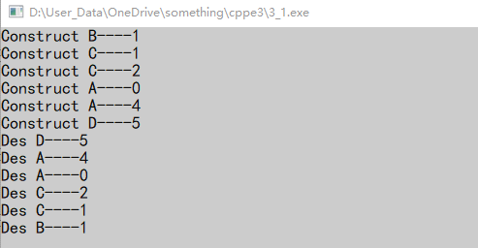
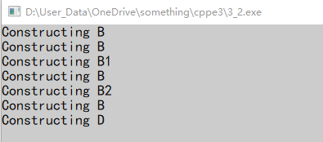
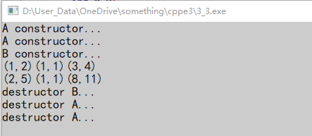
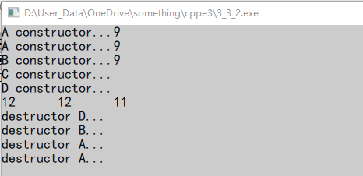
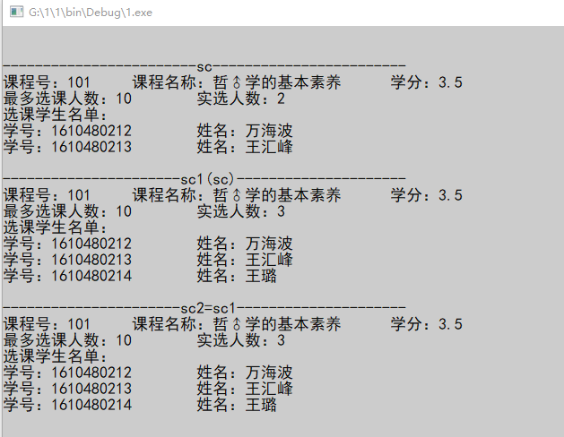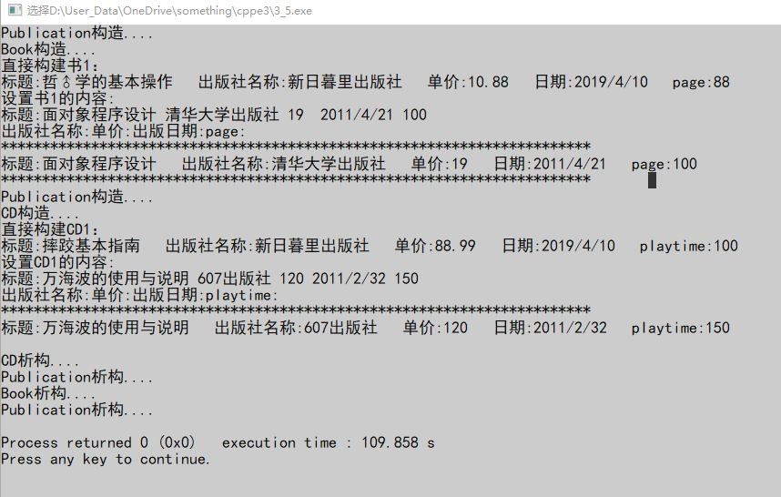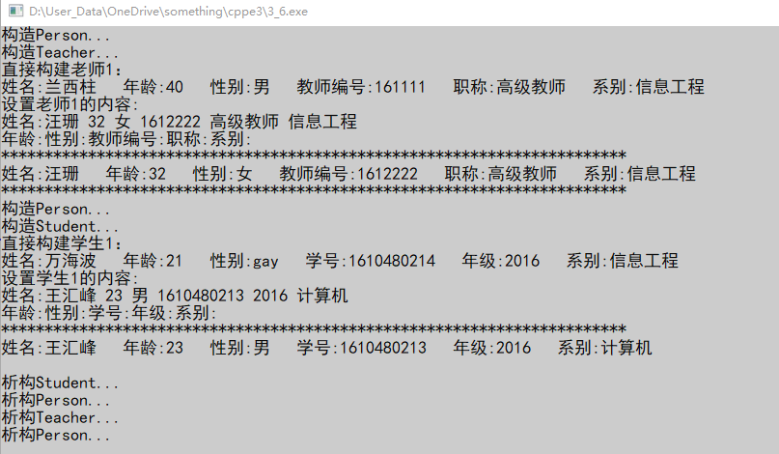

成绩： | 批阅教师签名： |  |  | 年 月 日

