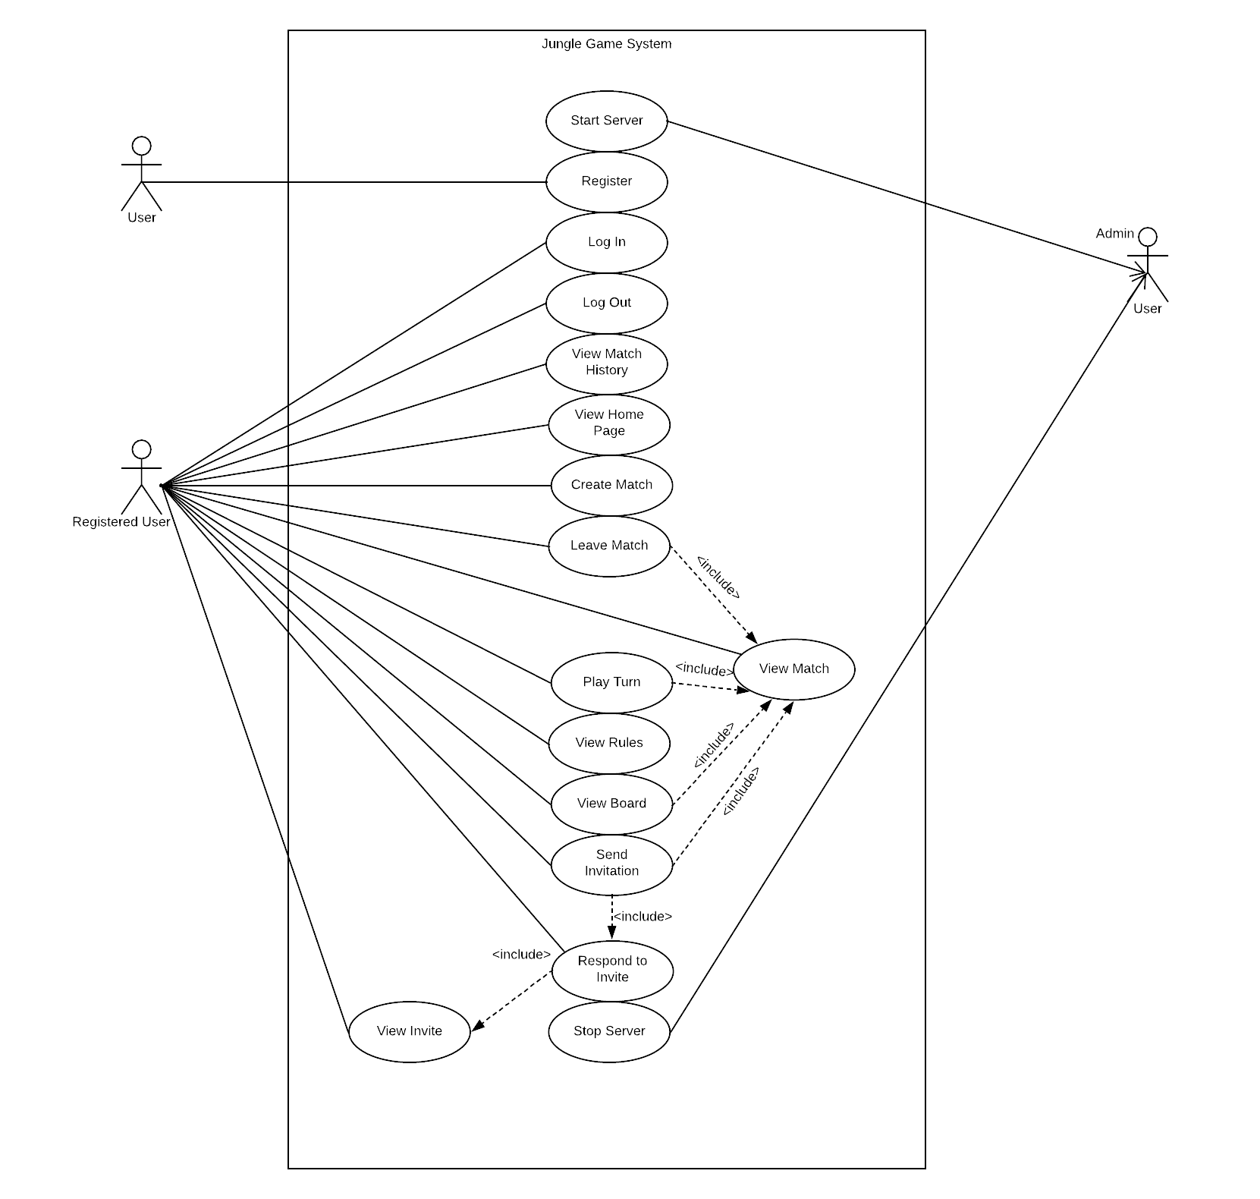

**Use Case ID**

1

**Use Case Name**

Start Server

Server Connection is done to integrate all activities done by users and ensure processed information is stored in the database

**Overview**

Admin

**Primary Actors**

**Pre-conditions**

**Main Flow**

**Alternate Flow 1**

Admin has access to the server

1. Connects the server to the game.

Game is connected to the server

1. If server connection fails due to some reason, the admin needs to reconnect before any further activities take place.

**Post Conditions**

**Use Case ID**

2

**Use Case Name**

Register

New users can register an account on the game system.

**Overview**

User

**Primary Actors**

**Pre-conditions**

**Main Flow**

**Alternate Flow 1**

User has valid email address format.

1. User selects “Register New Account”

2. System prompts user for email address, unique nickname, and unique password.

3. User enters information.

4. System validates information and registers user to the system.

1. User can login to their new account with their nickname/email-id and correct password.

4. System displays error message that information is invalid.

5. Return to Main Flow step 2.

**Post Conditions**

4

**Use Case ID**

**Use Case Name**

Log In

Registered users can enter their credentials and log in the system. After logging in, users are automatically redirected to a home page unique to their account.

**Overview**

Registered User

**Primary Actors**

1. User is registered.

**Main Flow**

**Pre-conditions**

1. User selects “Log In”.

2. System prompts user for email/nickname and password.

3. User enters credentials.

4. System verifies credentials and logs the user in.

5. System redirects user to home page.

4. System displays error message that information is invalid.

5. Return to Main Flow step 2.

**Alternate Flow 1**

**Post Conditions**

1. User has access to the system until they log out from their home page.

5

**Use Case ID**

**Use Case Name**

Log Out

Registered and logged in users can log out of their account from their home page.

**Overview**

Registered User

**Primary Actors**

**Post Conditions**

**Main Flow**

**Pre-conditions**

1. User is logged in

2. User is on the home page.

1. User closes game window.

2. System logs the user out.

1. User is logged out of the game.

6

**Use Case ID**

**Use Case Name**

View Match History

Registered users can view the history of matches they have played. It displays wins and losses of each player.

**Overview**

Registered User

**Primary Actors**

**Pre-conditions**

1. User is logged in.

2. User is on their home page.

**Main Flow**

1. User selects “View Match History” from their home page

2. System displays match history to user.

7

**Use Case ID**

**Use Case Name**

Create Match

Registered users can create a match (instance of the Jungle game) from their home page.

**Overview**

Registered user

**Primary Actors**

**Pre-conditions**

1. User is logged into the system.

2. User is on their home page.

1. User selects “Create New Match” from their home page.

2. System creates a new match and adds it to the list of matches associated with the player.

**Main Flow**

**Post Conditions**

1. The created match is present in the user’s match list.

8

**Use Case ID**

**Use Case Name**

Leave Match

Registered users can leave a match they are participating in from the match overview, resulting in an end to the match

**Overview**

Registered User

**Primary Actors**

**Pre-conditions**

1. User is participating in an active game.

2. User player is logged into the system.

1. Match is no longer listed as “Active”

2. Match information and result was logged to the profiles of the leaving player and second player

**Post Conditions**

1. Include (View Match)

2. User selects “Leave Match” from the match overview.

3. System removes player from the match.

4. System ends the match.

**Main Flow**

9

**Use Case ID**

**Use Case Name**

Play Turn

Registered users in an active match are assigned turns by the system. The user can play their turn by viewing the match, selecting a move if there is an available valid move, and submitting their turn.

**Overview**

Registered User

**Primary Actors**

1. System has assigned a new turn to the user.

2. User is logged into the system.

**Pre-conditions**

**Main Flow**

1. System notifies the user that is their turn in an active match.

2. Include(View Match)

3. User selects “Play Turn” from match overview.

4. User makes a valid move for one of their game pieces.

5. User submits turn.

6. System prompts user for confirmation

7. User confirms submission.

8. System records turn.

**Alternate Flow 1**

4. User makes an invalid move for one of their game pieces.

5. User is notified that the move is invalid, and must make a different move.

6. Return to step 5 in Main Flow.

**Alternate Flow 2**

9. The move results in a win or loss for the users.

10. System ends the game.

**Post Conditions**

**Alternate Flow 3**

4. User cannot make a valid move for any of their game pieces.

5. Return to step 5 in Main Flow.

1. User’s move is reflected on the game board.

2. It is no longer the current user’s turn.

3. Opposing player is notified of the result of the turn.

10

**Use Case ID**

**Use Case Name**

View Rules

Registered users can view the game rules from their home page or from the match overview.

**Overview**

Registered User

**Primary Actors**

1. User is logged into the system.

**Pre-conditions**

**Main Flow**

1. Include(View Home Page)

2. User selects “View Jungle Rules” from home page.

3. System displays rules to the user

**Alternative Flow 1**

1. Include(View Match)

2. User selects “View Jungle Rules” from match overview.

3. System displays rules to the user

11

**Use Case ID**

**Use Case Name**

View Board

Registered users can view the current board of an active game they are participating in from the match overview.

**Overview**

Registered User

**Primary Actors**

1. User is logged into the system.

**Pre-conditions**

1. Include(View Match)

2. User selects “View Board” from match overview.

3. System displays current board to the user.

**Main Flow**

12

**Use Case ID**

**Use Case Name**

Send invitation

Users can invite other users to a match they have created from the match overview, and users that receive an invite can accept or deny the invite. Multiple invites can be sent to different users, and the first to accept joins the match.

**Overview**

**Primary Actors**

Registered User

1. Include(View Match)

2. User selects “Invite Users” from match overview

3. User enters nickname/email of user to invite.

4. System sends invitation to recipient.

1. User and recipient are registered in the system.

2. User has created a match.

3. User is logged into the system.

3. User enters multiple nicknames/emails to invite.

4. System sends invitations to recipients.

1. Recipient is notified of a new invite pending their response.

**Post Conditions**

**Alternate Flow 1**

**Pre-conditions**

**Main Flow**

13

**Use Case ID**

**Use Case Name**

Respond to Invite

After receiving an invite, a registered user can accept or decline the invite. If the user accepts, the match automatically begins, and the first turn is assigned to the sender. If the user declines, the match does not begin. In either scenario, the sender is notified of the response and the invite is removed from the user’s invite list.

**Overview**

Registered User

**Primary Actors**

1. User is logged into the system.

2. User has received a match invite.

**Pre-conditions**

**Main Flow**

1. Include(View Invite).

2. User accepts invite.

3. System adds user to match.

4. System starts match and assigns first turn to sender.

5. System notifies both users that the invite has been accepted and the match has started.

6. System removes invite from user’s invite list.

**Alternate Flow 1**

2. User declines invite.

3. System notifies sender that the user has declined the invite.

4. System removes invite from user’s invite list.

**Alternate Flow 2**

3. If multiple invites were sent, and the user is the first to accept, all other invites are automatically declined.

4. Return to step 3 in Main Flow.

**Post Conditions**

1. User cannot view or submit another response to the invite.

14

**Use Case ID**

**Use Case Name**

View Invite

Registered users can view invites sent to them from their home page.

**Overview**

Registered User

**Primary Actors**

1. User is logged into the system.

2. User has received an invitation to join a match.

3. User is on their home page.

**Main Flow**

Invitation is displayed to the user(recipient).

1. User is notified of the invitation.

2. User selects “View Invitations” from home page.

3. User selects invitation

4. System displays invitation details and options to user.

**Pre-conditions**

**Post Conditions**

15

**Use Case ID**

**Use Case Name**

View Home Page

User can return to their home page at any time while they are logged in to the system. The home page is the view users are given immediately after they log in.

**Overview**

Registered User

**Primary Actors**

**Pre-conditions**

1. User is logged into the system.

2. User is not currently viewing their home page.

**Main Flow**

1. User selects return to home page.

2. System redirects user to their home page.

16

**Use Case ID**

**Use Case Name**

View Match

Registered users can see an overview of a match by selecting the match from a list of matches they are associated with. The overview shows the match status and includes options to view the board, rules, play a turn, or leave the match.

**Overview**

Registered User

**Primary Actors**

**Pre-conditions**

1. User is logged into the system.

2. User is on their home page.

1. User selects “View Matches” from their home page.

2. System displays match list to user.

3. User selects match from the list.

4. System displays match overview to user.

**Main Flow**

17

**Use Case ID**

**Use Case Name**

Stop Server

Disconnects the server and game

**Overview**

Admin

**Primary Actors**

**Pre-conditions**

Game is connected onto the server

1. Admin disconnects server connection.

**Main Flow**