**The Other Alex**

Devin Kadillak, Alex Malott, Alex Shellum, Aaron Thompson, Lucas Wilson

**Domain Model**

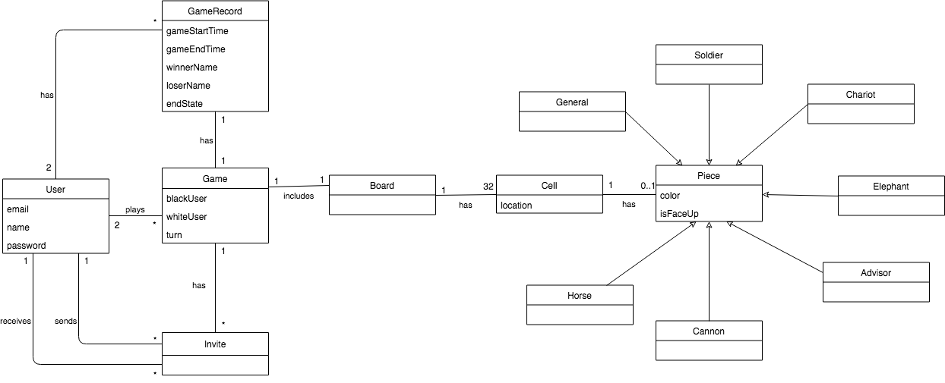

**Glossary**

**Advisor**: A type of piece within the game. An advisor can capture another advisor, a soldier, a horse, a chariot, an elephant, and a cannon. Can be captured by another advisor, a general or a cannon.

**Board**: The board which the game is played. It is a 4x8 grid of 32 cells.

**Cannon**: A type of piece within the game. A cannon can capture any piece if they jump over another piece on the way. Can be captured by another cannon, a horse, a chariot, an elephant, an advisor, or a general.

**Cell**: Represents an area on the board that can house a piece.

* **location**: The position of a cell relative to the board’s 4x8 grid.

**Chariot**: A type of piece within the game. A chariot can capture another chariot, a soldier, a horse, and a cannon. Can be captured by another chariot, a cannon, an elephant, an advisor, or a general.

**Elephant**: A type of piece within the game. An elephant can capture another elephant, a cannon, a chariot, a horse, and a soldier. Can be captured by another elephant, a cannon, an advisor, or a general.

**Game**: An instance of Banqi created by a user.

* **turn**: Keeps track of which player is to make the next move.
* **whiteUser**: When the first white piece is flipped, the user that flipped that piece gains ownership of all white pieces unless they already have ownership of a color. whiteUser keeps track of which user maintains this ownership of white pieces.
* **blackUser**: When the first black piece is flipped, the user that flipped that piece gains ownership of all black pieces unless they already have ownership of a color. blackUser keeps track of which user maintains this ownership of black pieces.

**GameRecord**: A long-lasting record that displays the results of a finished game.

* **endState**:Defines the state of the game at the time the game has ended. Can be ‘draw’, ‘forfeited’, ‘abandoned’, or ‘complete’. A complete state means that a player has won by playing the game.
* **loserName**: The userName field of the user who lost the game. This field is not defined if endState is draw.
* **winnerName**: The userName field of the user who won the game. This field is not defined if endState is draw.
* **gameStartTime**: A date-time group representing when the associated game was started.
* **gameEndTime**: A date-time group representing when the associated game was finished.

**General**: A type of piece within the game. A general can capture another general, a soldier, a horse, a chariot, an elephant, an advisor, and a cannon. Can be captured by another general or a soldier. Death of general does not end the game.

**Horse**: A type of piece within the game. A horse can capture another horse, a soldier, and a cannon. Can be captured by another horse, a cannon, a chariot, an elephant, an advisor, or a general.

**Invite**: A pending invitation from one user to another to join a game.

**Piece**: An object which is used to play the game. A piece can be 1 of 7 types.

* **color**: The color of the piece. Players are not assigned a color until the first move has been made.
* **isFaceUp**: Represents whether the piece been flipped by a user yet.

**Soldier**: A type piece within the game. A soldier can capture another soldier or a general. Can be captured by another soldier, a cannon, a horse, a chariot, an elephant, and an advisor.

**User**: A person interacting with the system.

* **name**: a unique identifier defined by the user during registration.
* **password**: a secret word or phrase used to log the user into the system.
* **email**: the users valid email used for registration.