Functional Requirements

For all the users (whether logged-in or not):

1. The website should display the current time prominently on the homepage.
2. The website should provide links to popular websites.
3. The website should have news recommendation links that direct users to different types of news websites.
4. The website should have a search bar that allows users to search on Google.

For users who are not logged in:

1. The website should have a login and sign-in button for users who want to create an account.
2. The website should provide a link for users to sign up and select their interests for news recommendations

For users who are logged in:

1. The website should allow logged-in users to customize their news recommendations.
2. The website should allow logged-in users to upload links and images for the news recommendation section.
3. The website should allow logged-in users to log out of their account.

Use Case Diagram

Use Case Diagram for Users who are Not Logged In: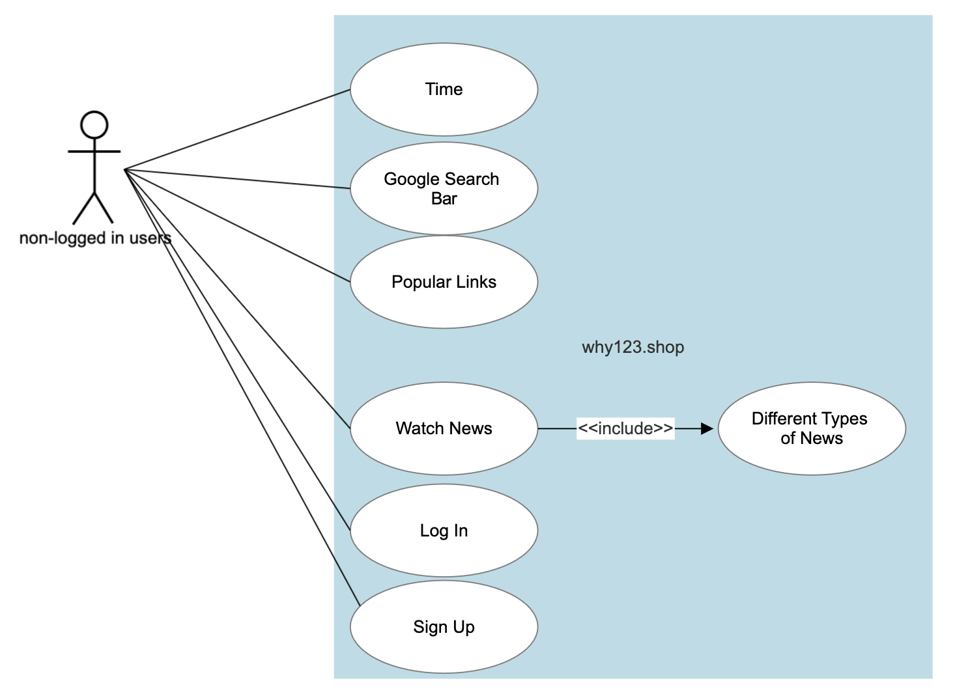

Use Case Diagram for Users who are Logged In: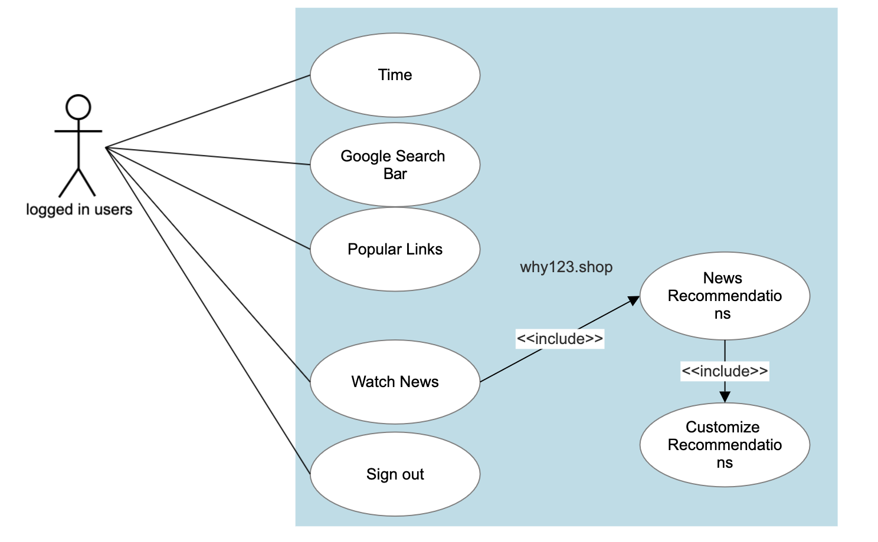

Use Case Activity Diagram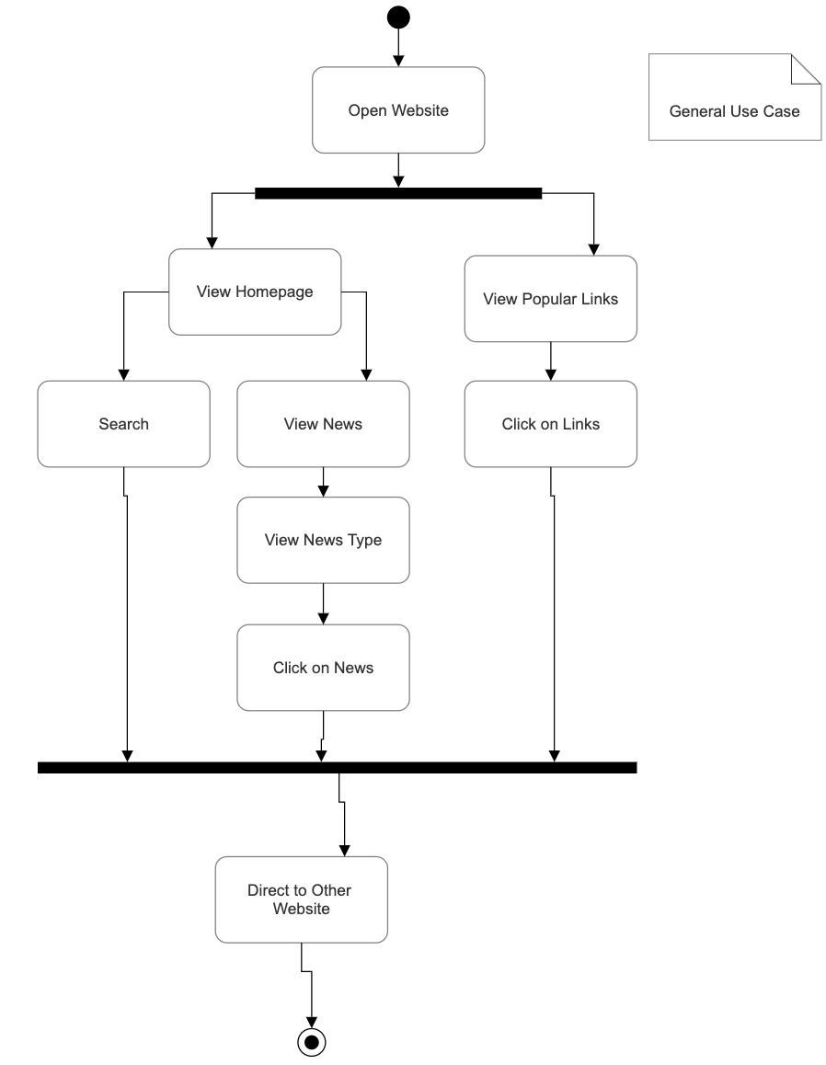

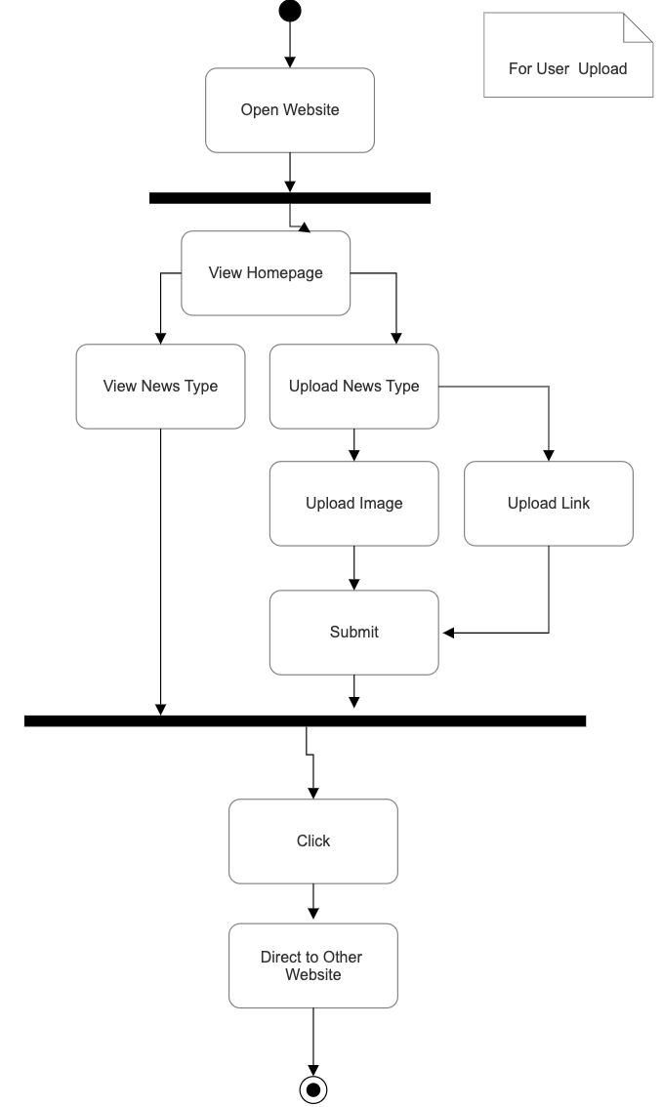

Correctness:

Non-Logged-In User:

* The search bar should return accurate results based on the user's input.
* The links to popular websites should be up-to-date and correct.

Logged-In User:

* The Customize news feature should properly display the uploaded news article with correct images and descriptions.
* The news recommendations should be based on the user's selected interests and should display accurate news articles.

Time-Efficiency:

Non-Logged-In User:

* The website should load quickly, with minimal lag time.
* The popular website links should load quickly to ensure a fast browsing experience.

Logged-In User:

* The Customized news feature should allow for quick and easy uploading of news articles.
* The news recommendations should load quickly, allowing the user to quickly and easily browse relevant news articles.

Robustness:

Non-Logged-In User:

* The website should be able to handle a large amount of traffic without crashing.
* The popular link should still be accurate and functional even if there are server or connection issues.

Logged-In User:

* The Customized news feature should be able to handle a large file of image.
* The news recommendations should still be accurate and functional even if there are server or connection issues.