I verify that I am the sole author of the programmes contained in this archive, except where explicitly stated to the contrary.

Signature:

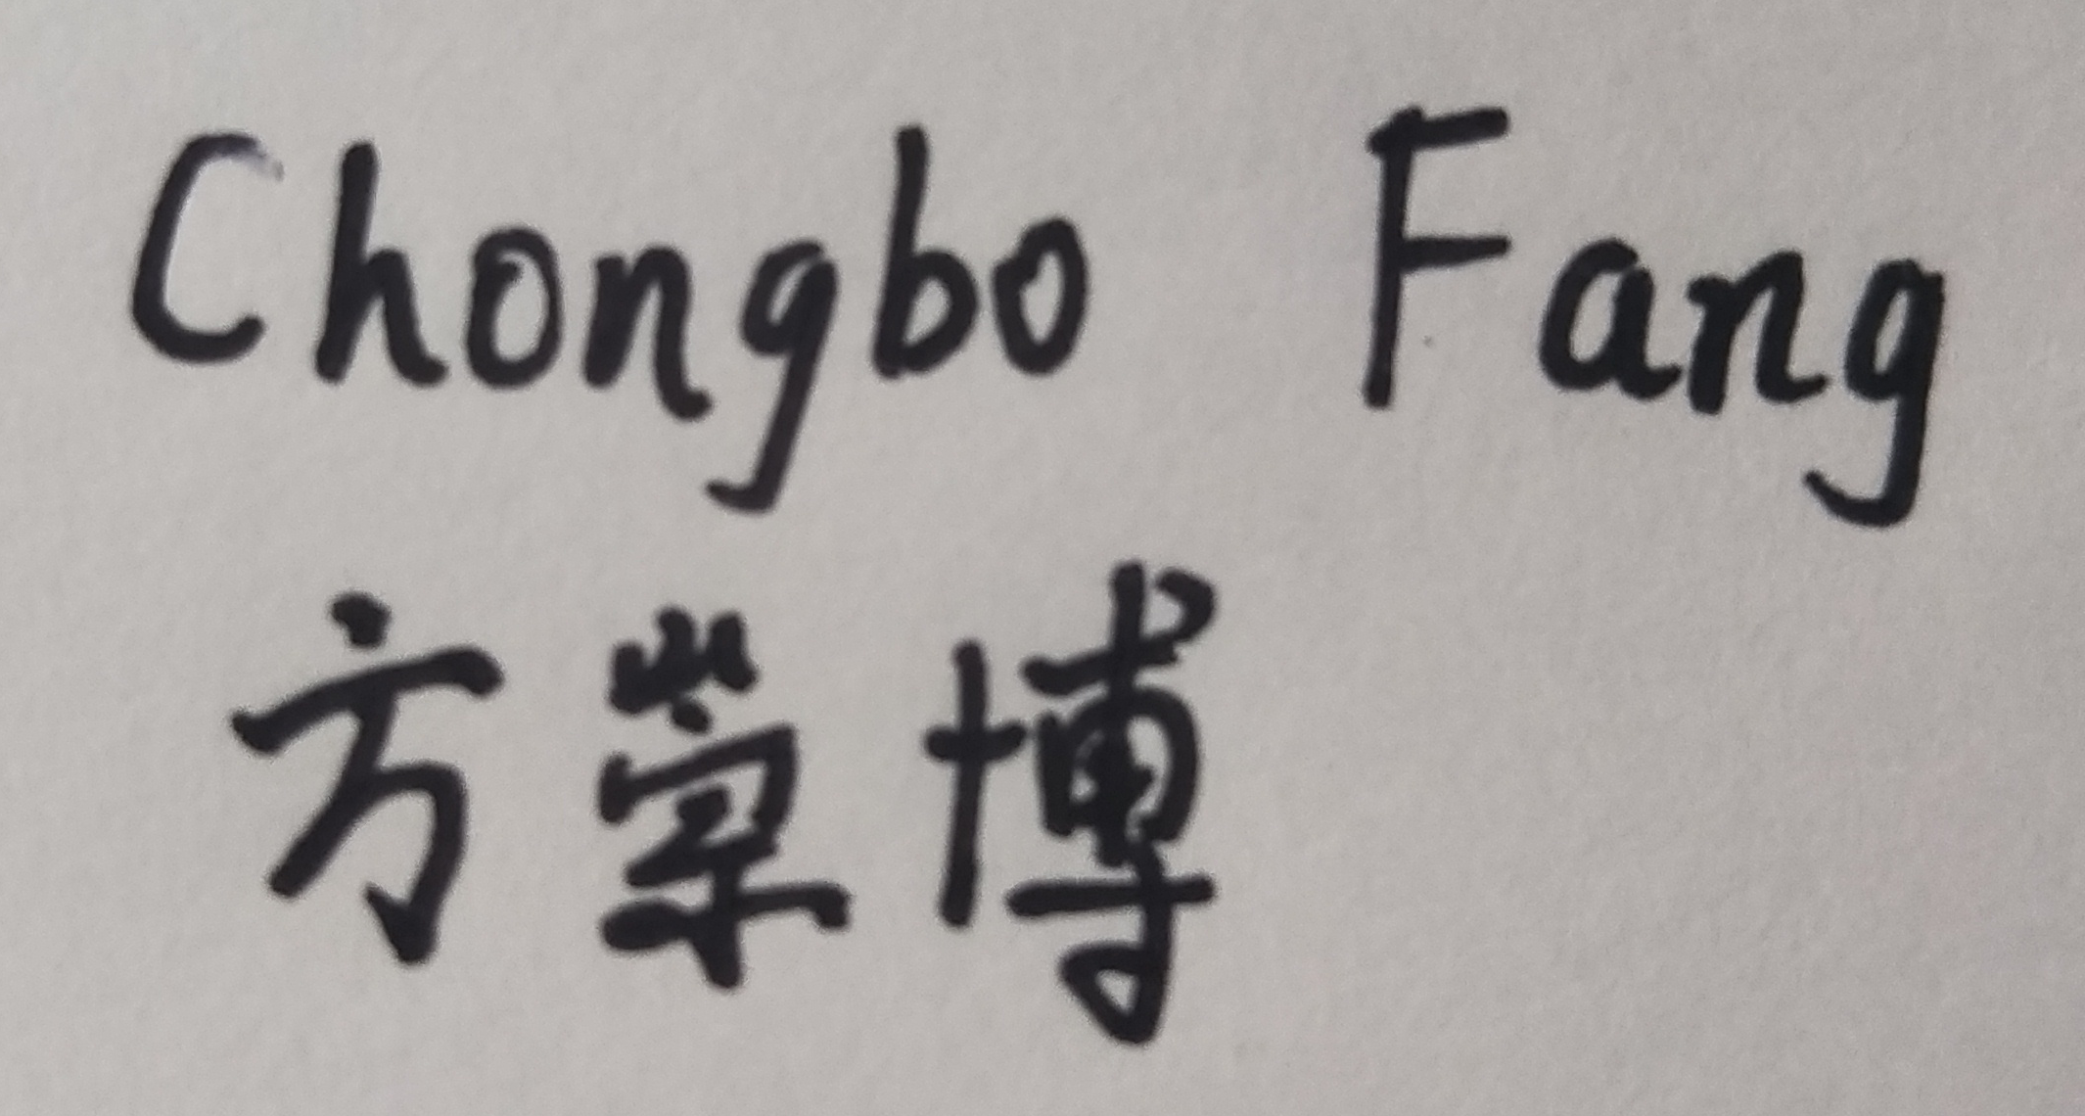

Date:

20/08/2020