Your key is: domestic

Each guest has been provided a key and an encrypted message. The QR code below links to a max.gov website that will let you decode the message. Your key cannot decode your message. To find the message you must mingle with other guests and try their key against your message and vice versa.

To try and decode the message, open the camera app in your phone and focus it on the QR code. Your phone should ask if you want to open the link in Safari. Once the link opens the encrypted message will be populated for you. You will need to enter the correct key and click press the decrypt button. If you have the right key the message will be displayed below the button.

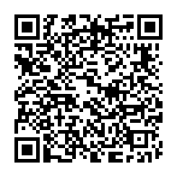

https://webserver.myhhgttg.com/AES/?q=eSkimH0uhincGUqFrr67Gw7ttgho/KcDBrV1X21QlxgzA0H59vJ6q//Yb7VasblhieV/V1%2BkHLBeBMYj7qt3yg%3D%3D

The key for this cyphertext is: insure