Acknowledgment of Citizen Scientists on Research Outputs

## Abstract

**Providing credit where it’s due, and how to achieve the ‘Reuse’ principle with information on data provenance.**

By Georgia Ward-Fear, Macquarie University, ORCID iD: [0000-0002-4808-1933](https://orcid.org/0000-0002-4808-1933), e-mail: [georgia.ward-fear@mq.edu.au](mailto:georgia.ward-fear@mq.edu.au) Article DOI: [10.25815/rkzw-z561](https://doi.org/10.25815/rkzw-z561)

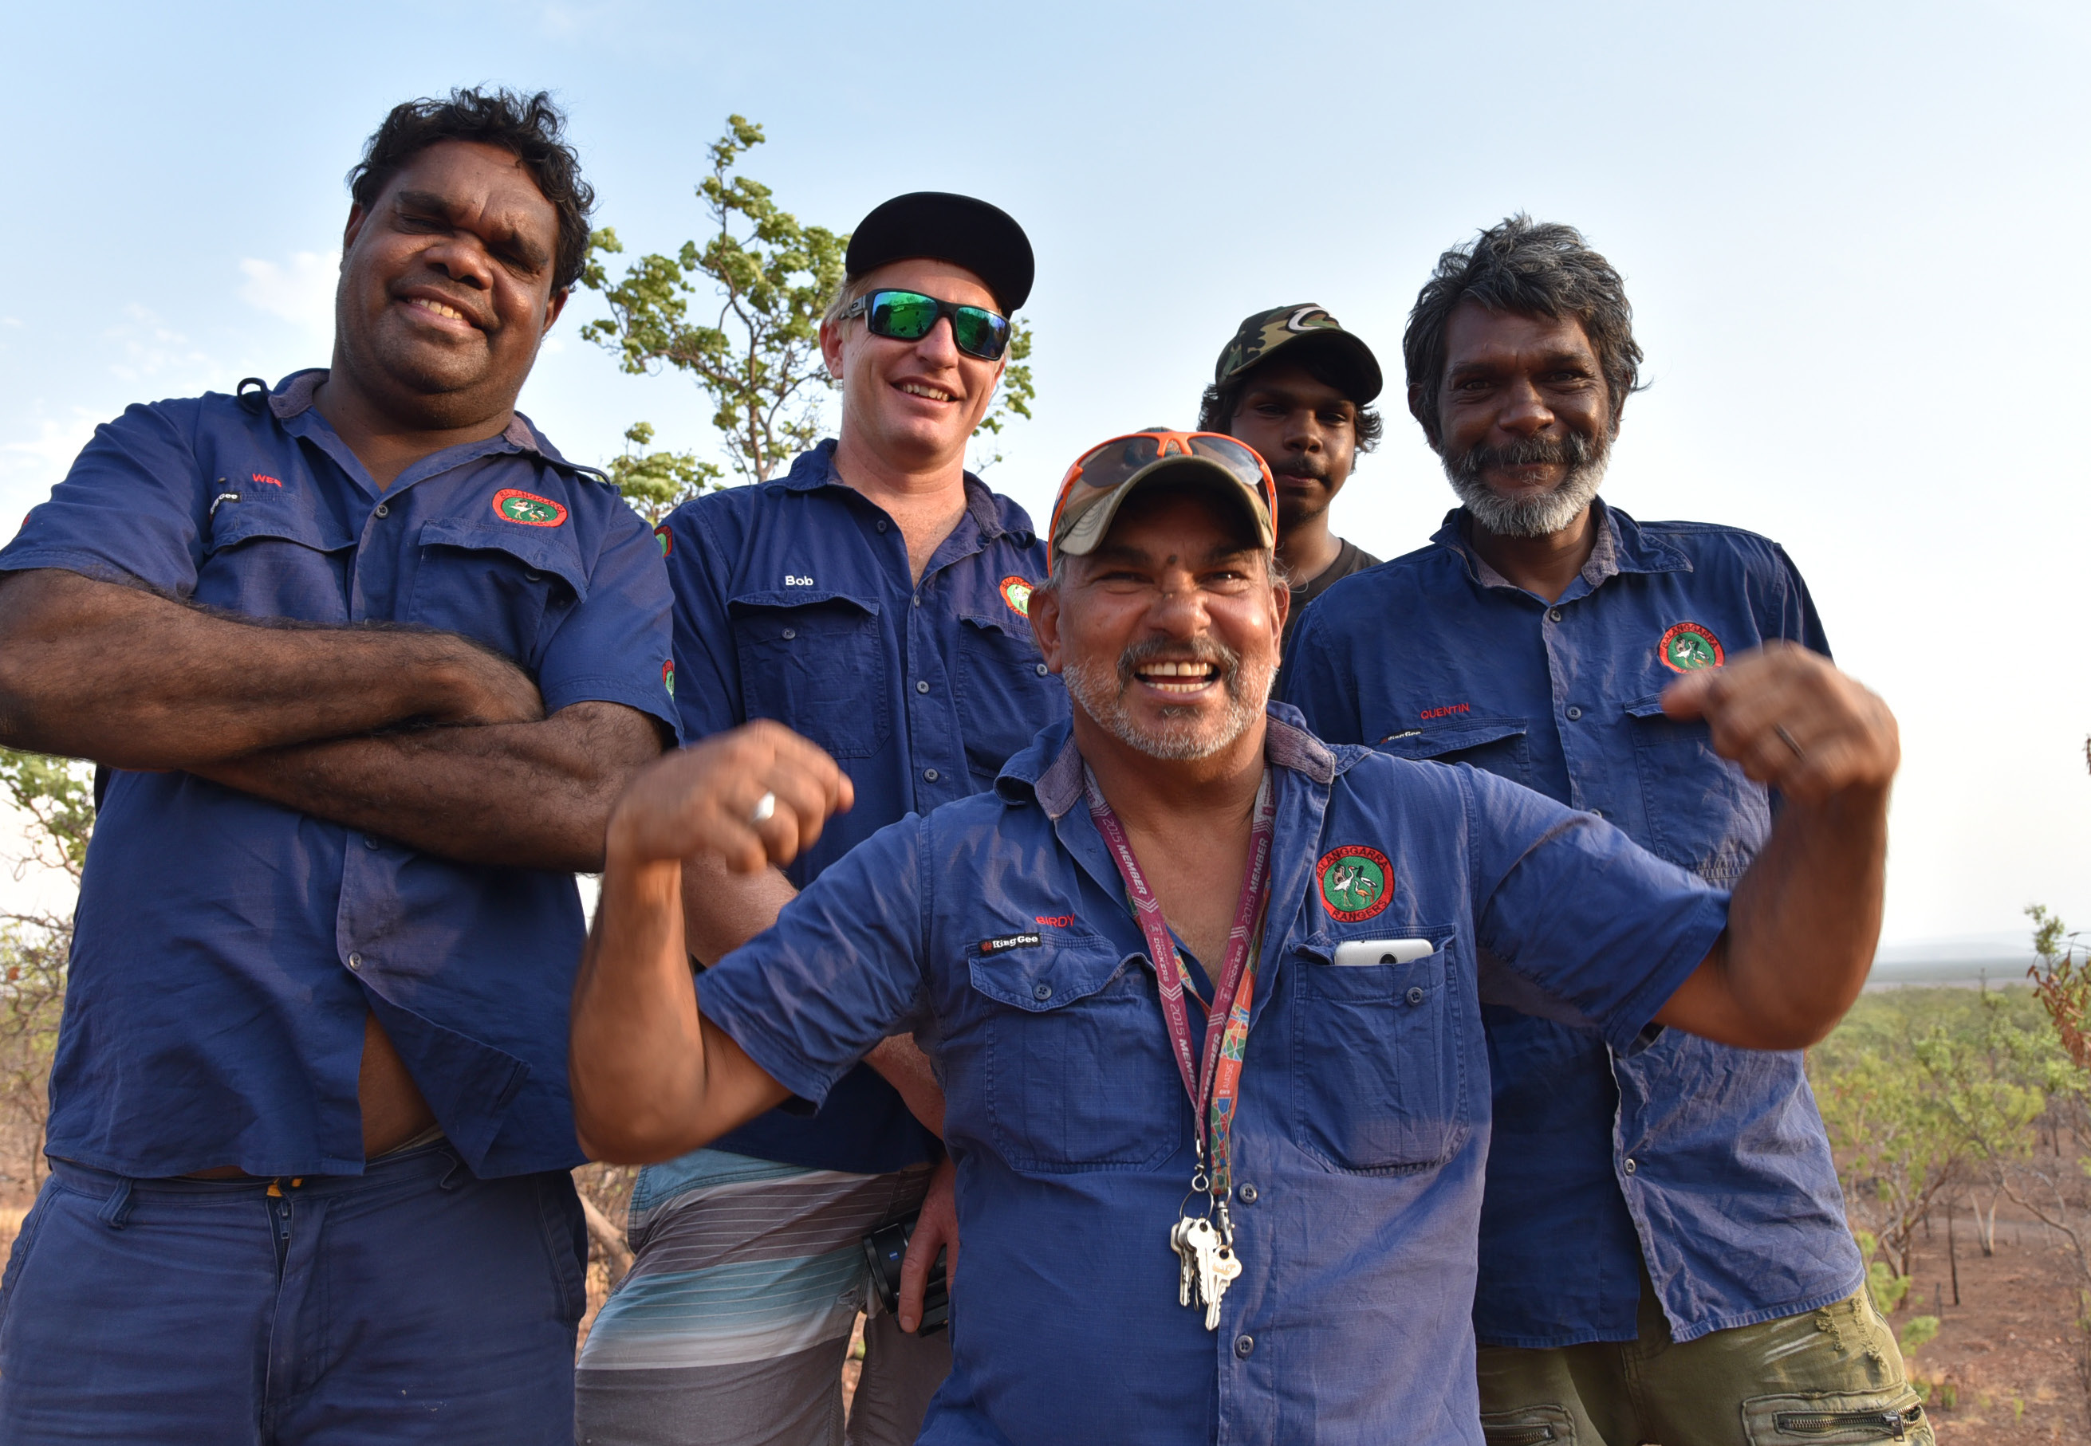

Image: The Balanggarra Rangers from the East Kimberley region of Northern Australia. Image courtesy of Kimberley Land Council.

The ‘Reuse’ component of the FAIR principles dictates that data should maintain its initial complexity and have clear provenance information on how and with whom the data was formed. This, coupled with discipline-specific data and metadata standards, allows for data reuse in the future. Citizen science projects present unique challenges for accommodating the Reuse principle. This is because there is currently no single or standardised way for crediting citizen science collaborators on publications or datasets, citing collaborative works or providing Intellectual Property (IP) rights to the citizen scientists involved. Depending on the methodology used by the authors (or imposed by research journals), data provenance can thus be a subjective and sometimes mis-represented aspect of research involving citizen scientists.

Official acknowledgment for contribution to research is a cornerstone of academia and researchers should strive always to credit citizen scientists in appropriate ways. There are myriad benefits to official acknowledgment, some of which may only apply to the citizen science groups (e.g., unique funding opportunities; support to create formal structures around the citizen science group). In a collaborative project, citizen scientists/groups can be credited via the official acknowledgements, or via authorship on manuscripts/datasets. The latter often requires justification that citizen scientists have met the International Committee of Medical Journal Editors (ICMJE) standards which warrant academic authorship. Citizen science does not always lend itself to meeting these rigorous academic criteria. The case study below outlines a common situation in this respect and the diversity of considerations (cultural, legal, ethical) when deciding the best form of acknowledgement for citizen science collaborators.

## Project Highlight: Lizard Conservation with the Balanggarra Rangers in Australia

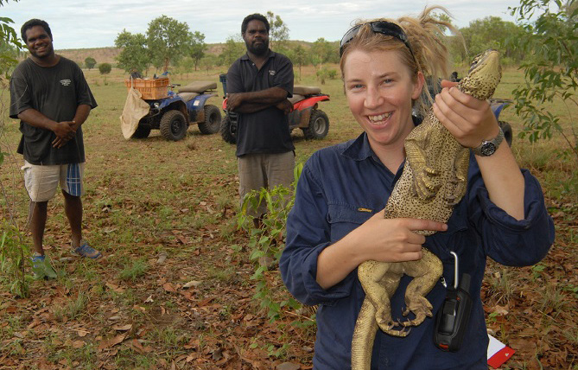

Image: Herbert and Wesley Alberts with Georgia Ward-Fear. Photo by Georgia Ward-Fear.

To mitigate the impact of an invasive toad on a native apex predator in tropical Australia, a collaboration between conservation researchers and indigenous Traditional Owners (the Balanngarra Rangers, of the Balanggarra people) was formed. Each group brought their unique skills, experience, and knowledge to the project; an excellent example of the synergy between ‘Western science’ and Traditional Ecological Knowledge and skills. The research was highly successful and culminated in the development of a new national and international conservation strategy. The Balanggarra Rangers were pivotal to the success of this project in unique ways, yet crediting the Rangers was not simple. The group consisted of many individuals with varying degrees of input, and the group wanted to be identified collectively by their cultural name. However, adding the ‘Balanggarra Rangers’ to the author byline was rejected by some scientific publishing outlets due to editorial or ethical protocols, or because the Rangers’ lacked academic affiliation. Even those that did, reduced the author name to ‘B. Rangers’ in citations, an unintended but nevertheless culturally inappropriate practice. This experience motivated the researchers to petition for more inclusive academic authorship protocols that keep pace with the changing socio-political nature of research. ‘Group co-authorship’ is an option for including citizen science groups as authors, providing strong public acknowledgment and Intellectual Property rights. It also avoids some of the ethical pitfalls for adding individuals by name, who have not met ICMJE guidelines (which can be viewed as academic fraudulence). A summary of the suggested qualifiers for citizen science group authorship can be found in the infobox.

Research programs that engage with citizen scientists should identify the most appropriate method for credit at the outset. Not only is this ethical, but also helps to explore and achieve legal interoperability early on, i.e., the ability of organisations with different legal frameworks to work together. This may be especially pertinent in citizen science projects where disparate organisations, industry sectors or subsets of the community come together in a research setting. When assessing the best way to credit citizen scientists in a project, these are some of the questions to consider:

1. What are the wishes of the citizen scientists involved in the program?
2. Is the citizen science group readily identifiable by a collective name or could they create one?
3. Is the dataset in use ‘static’ (i.e., finished, whole and attributable to one group), is this a ‘living’ dataset and/or is only a portion of it being used?
4. Is it ethical or appropriate to identify individual citizen scientists by name?
5. Which form of citizen scientist identification will best support the ‘Reuse’ principle?

### References

Ward-Fear, Georgia, Balanggarra Rangers, David Pearson, Melissa Bruton, and Rick Shine. “Sharper Eyes See Shyer Lizards: Collaboration with Indigenous Peoples Can Alter the Outcomes of Conservation Research.” Conservation Letters 12, no. 4 (July 2019). <https://doi.org/10.1111/conl.12643>.

Ward-Fear, Georgia, Gregory B. Pauly, Jann E. Vendetti, and Richard Shine. “Authorship Protocols Must Change to Credit Citizen Scientists.” Trends in Ecology & Evolution 35, no. 3 (March 2020): 187–90.  
<https://doi.org/10.1016/j.tree.2019.10.007>.

Hunter, Jane, and Chih-Hsiang Hsu. “Formal Acknowledgement of Citizen Scientists’ Contributions via Dynamic Data Citations.” In Digital Libraries: Providing Quality Information, edited by Robert B. Allen, Jane Hunter, and Marcia L. Zeng, 9469:64–75. Lecture Notes in Computer Science. Cham: Springer International Publishing, 2015.  
<https://doi.org/10.1007/978-3-319-27974-9_7>.

## Group Co-authorship for Citizen Scientists: Recommendations for Using, Listing, and Citing

Group co-authorship should be used:

* When the group in question expresses a desire for authorship.
* When groups cannot meet ICMJE or journal specific standards but their contribution was deemed essential to the success of the project. For citizen science projects, this should include ‘data acquisition’, which would not normally warrant authorship alone.
* Only for established groups (e.g., the ‘Balanggarra Rangers’) not for amorphous groups who engage with generic surveys or medical studies. Such groups are best recognised in the Acknowledgment section.

Group co-author names should:

* Be as short as possible, and
* be listed in full at all times (e.g., ‘Balanggarra Rangers’ not ‘B. Rangers’) i.e., both in the author byline and also when citing and indexing in references. This is also the responsibility of the publisher and indexing programs/institutions.

All authors collectively decide:

* On the best form of acknowledgment and whether it meets the ‘Reuse’ principle.
* The most appropriate order of authorship (groups co-authors can be anywhere in that order).
* Whether to list individual citizen scientist names elsewhere in the text (e.g., supplementary materials or appendices), remembering that some citizen scientists may be eligible for individual authorship independent of the group. Group co-authorship doesn’t replace this option.

Adapted from Ward-Fear et al. 2020

## Bibliography