# Project Highlight: FAIR Data in a Citizen Science Project

Article DOI: [10.25815/tnrh-zg50](https://doi.org/10.25815/TNRH-ZG50)

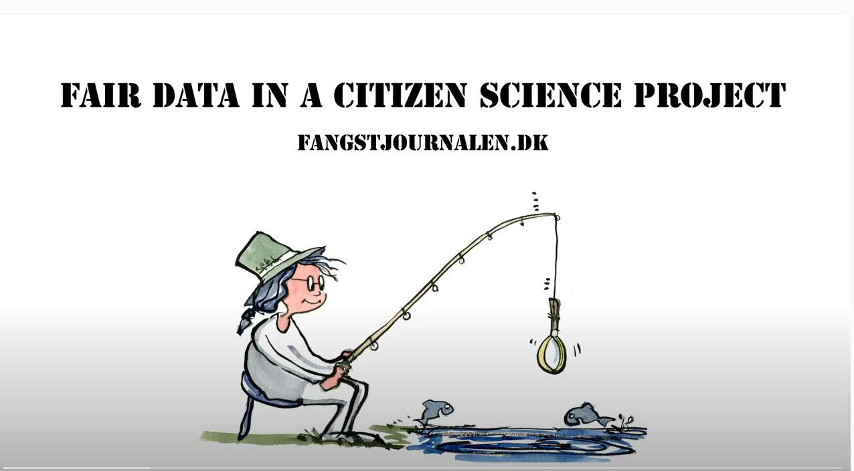

Fangstjournalen is a citizen science project highlighting several of the points from this section: it demonstrates how good communication, project and data management create value to citizen scientists and also to scientific data. Learn how the project manager makes his data FAIR and share data with the citizens in this short video (Holmstrand et al. 2020). The collected data are relevant for reuse in projects about biodiversity, behavior and recreation, but also for national fishery regulation and policy development. Due to the content of personal data, the database is not shared openly but via a metadata record (Skov 2021).

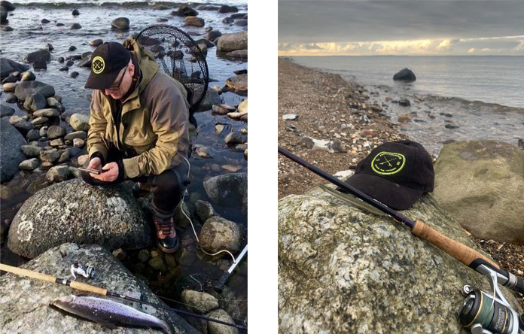

Image: Fangstjournalen – registration of catches by recreational anglers. Photo by Christian Skov, ORCID iD: [0000-0002-8547-6520](https://orcid.org/0000-0002-8547-6520) CCBY- SA 2.0.

### References

Holmstrand, Katrine Flindt, Asger Væring Larsen, Signe Gadegaard, Jitka Stilund Hansen, Karsten Kryger Hansen, and Gertrud Stougård Thomsen. “FAIR Data in a Citizen Science Project ‘Fangstjournalen,’” 2020. <https://doi.org/10.11581/DTU:00000092>.

Skov, Christian. “Database from Citizen Science Project ‘Fangstjournalen.’” Technical University of Denmark, 2021. <https://doi.org/10.11583/DTU.13795928>.