# HelloPurr

Building Mobile Apps

# Acknowledgements

This example has been adapted from the HelloPurr tutorial on the MIT AppInventor website: <http://appinventor.mit.edu/explore/content/hellopurr.html>

The example in the link above contains more details than this tutorial, and we would recommend reading it after, or during, the workshop for more information about the different components of *AppInvento*r.

# Resources

The resources for this activity can be downloaded from the workshop website, from the “Hello Purr Resources (zip)” link on the *Building Mobile Apps with AppInventor* session page.

Extract the zip folder (right click on the file, and select *Extract here*) to the *Downloads* folder or *My Documents* folder on the lab computer once it has finished downloading. Note that all of the work you do and files you upload today will be available on the *AppInventor* site, as your projects are stored “in the cloud”.

# Activity

This tutorial aims to be a quick, simple example to get some familiarity with the *AppInventor* software.

Firstly, navigate to the *Projects* screen by clicking *My Projects* in the browser window, as highlighted in blue below. You should see a list of projects similar to that shown below.

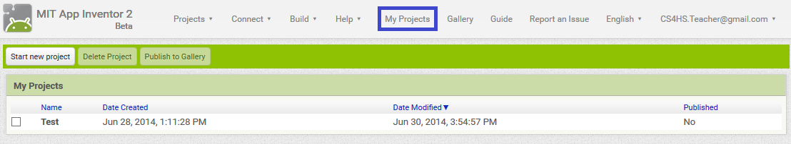

Click the *Start new project* button and name the project “HelloPurr”. After a few seconds the project should load and you will see a screen similar to that below.

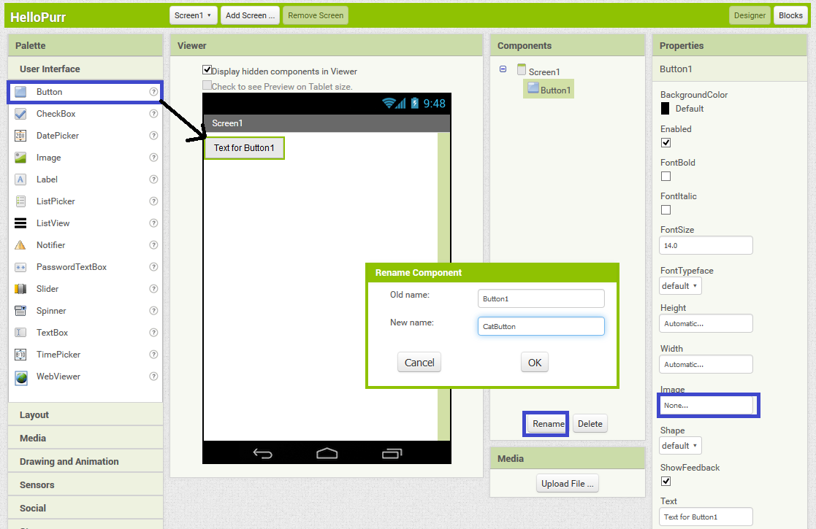

Drag a *Button* over to the screen as shown above.

Now we’ll rename **Button1** to **CatButton** by:

1. Clicking the Rename button highlighted in blue in the above image
2. Filling in the “New name” textbox with “CatButton”
3. Clicking the OK button

Now click the textbox below the *Image* heading highlighted in blue in the above image.

Click the *Upload File …* button and you will be presented with a dialog similar to that shown below. Click the Browse… button, which will open a file upload dialog. In the file upload dialog navigate to where you extracted the Resources .zip and select *kitty.png.*

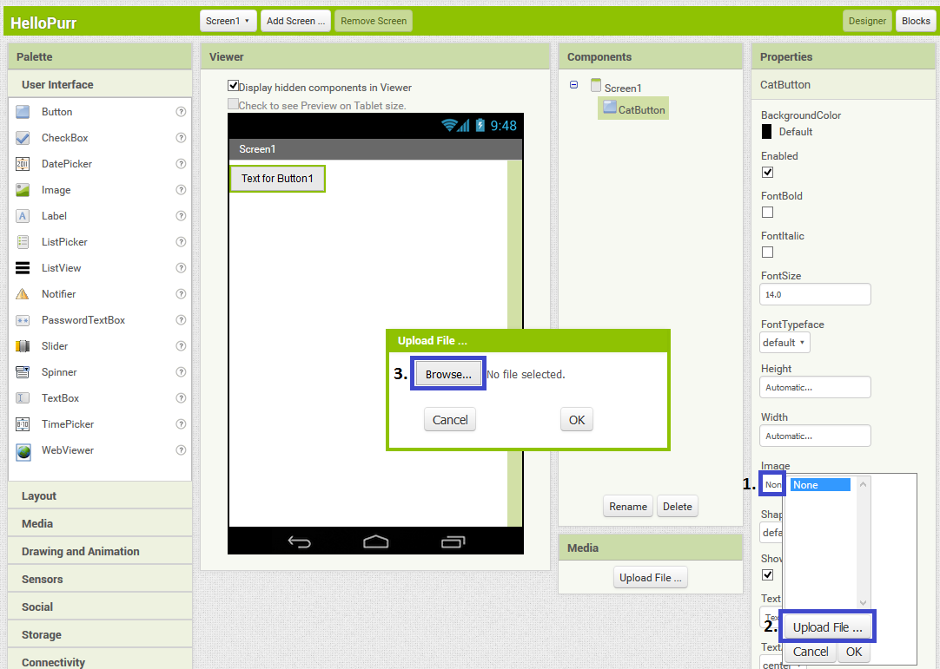

Your app layout should now look like this:

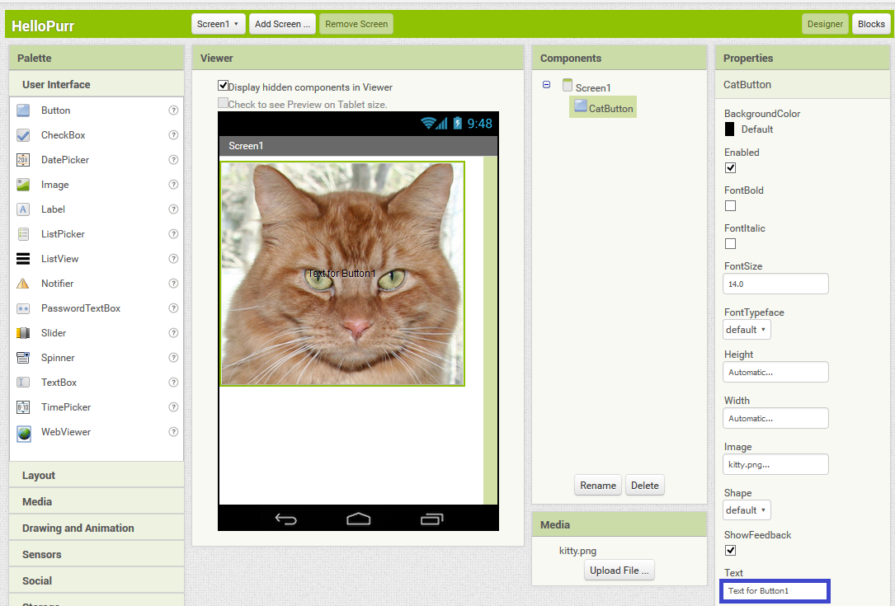

It looks like we’re making progress! But we really should get rid of that text in the middle of the cat image. To do this, highlight the text in the *Text* textbox highlighted in blue above and delete this text.

Now we’re going to add a label that displays the text “Pat the Kitty”. Start by dragging a label from the left across to the page, as shown in the image below.

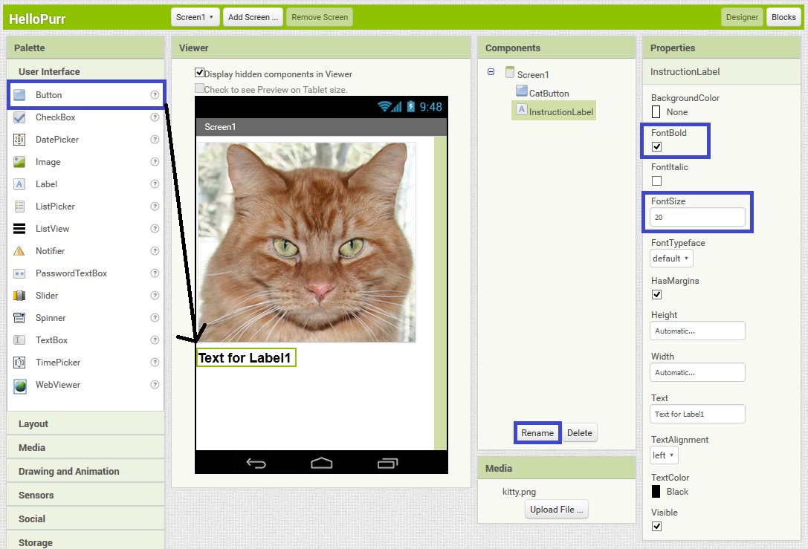

Rename the label to **InstructionLabel** by clicking the *Rename* button.

Make the label font bold by ticking the *FontBold* checkbox, as highlighted in the blue in the above image.

Make the label font bigger by setting the font-size to 20 in the *FontSize* box highlighted in blue in the image above.

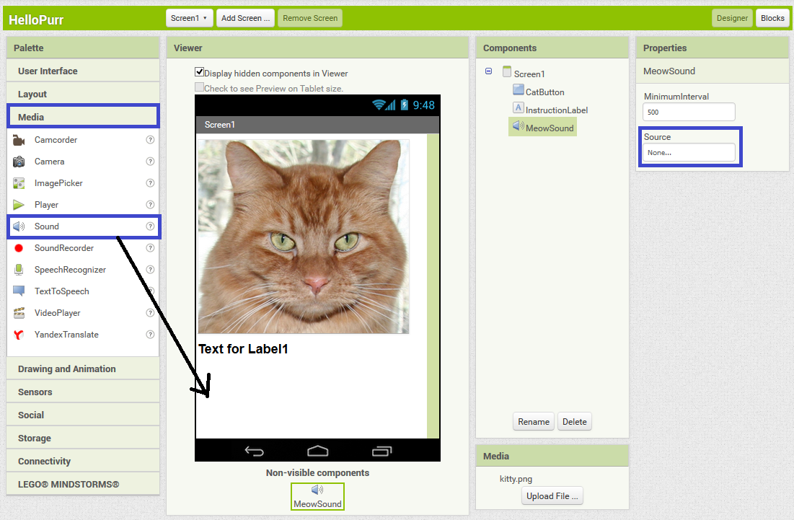

Now click on the *Media* section on the left, and drag a *Sound* block over to the canvas. Once it has been added you should see it listed in the *Non-visible components* section below the canvas. Rename the Sound to **MeowSound** by using the *Rename* button.

Next we have to upload the sound to play when you pet the cat. To do this click on the box below the *Source* heading highlighted in blue above. Click on *Upload File …* then click *Browse…* and navigate to where you extracted the Resources .zip and select *meow.mp3*. Click *OK* and the file will upload.

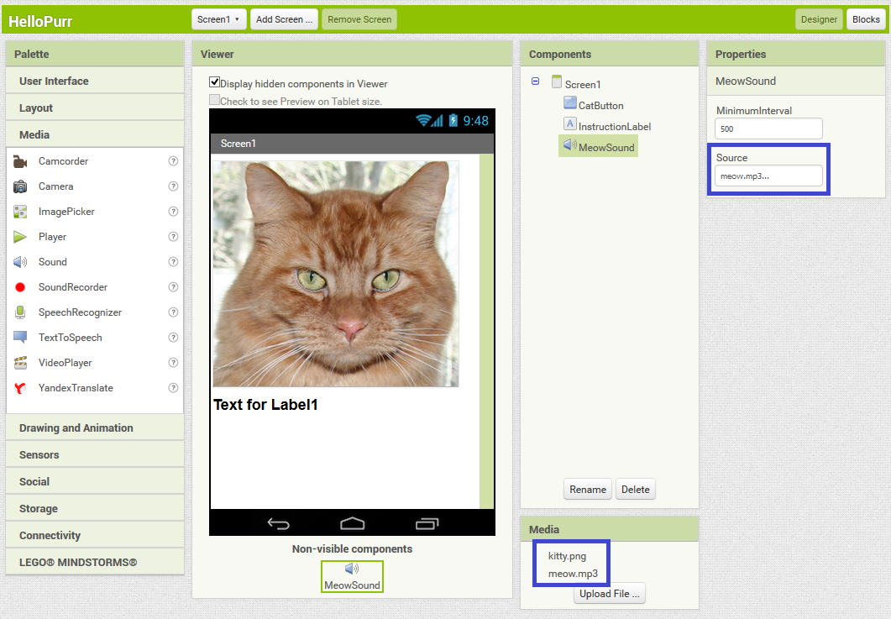

Once the file has uploaded, it should be listed in the Media section on the bottom right and the filename (“meow.mp3”) should be in the *Source* textbox, as shown above.

Before we start coding with blocks, we should update the **InstructionLabel** text. To do this, select the **InstructionLabel** in the *Components* section and then change the Text to “Pet the Kitty!” as shown below:

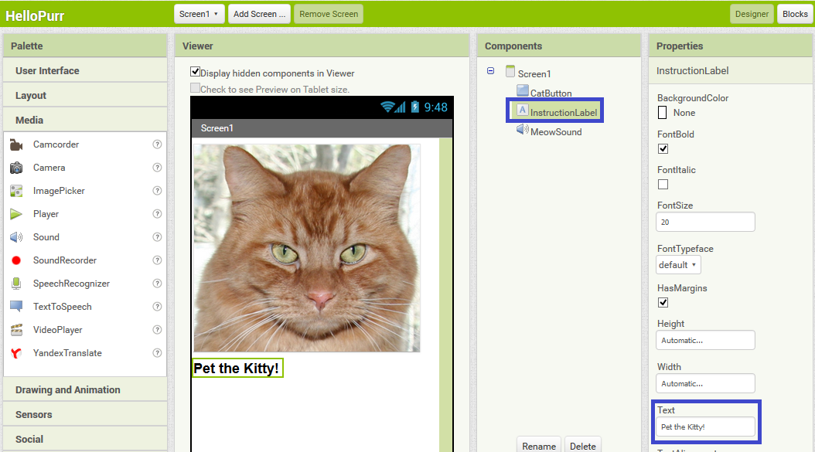

Now it’s time to start using the *Blocks Editor*. Click on the *Blocks* button on the top right of the screen, next to the *Designer* button, as highlighted in blue below. The screen should change to look something like is shown below.

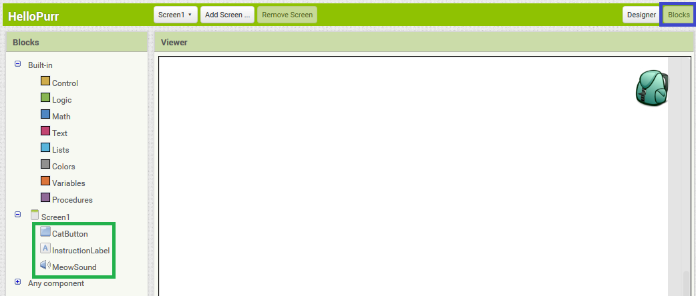

Once the *Blocks Editor* is open, you should see the Label, Button and Sound that you added to the canvas in this tab, as highlighted in green in the image above.

Now click on the **CatButton** block, and you will get a list of available blocks for the **CatButton** *Button*. Drag and drop the “when *CatButton.Click do”* block onto the canvas as shown below:

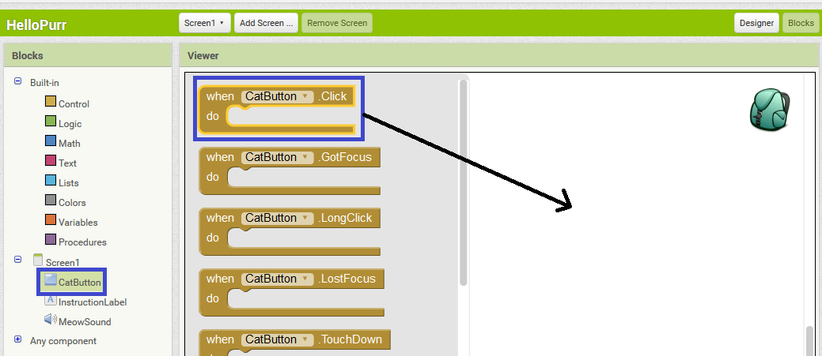

All command blocks that are put inside this “when *CatButton.Click do”* block will be run when the button is clicked.

We now need to add a command to play the meow noise when the **CatButton** is clicked. To do this, click on the **MeowSound** block. Drag the *“call MeowSound.Play*” block inside the “when *CatButton.Click do”* block and it should click into place as shown below:

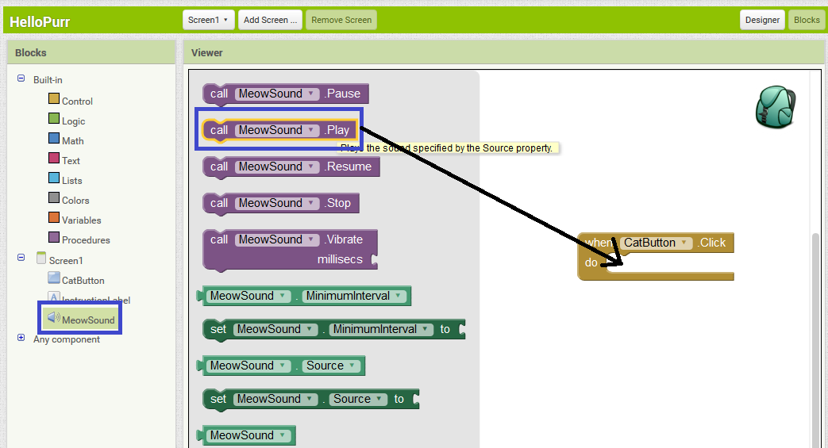

Now we’ll give the App a run by clicking the *Connect* button at the top of the screen and selecting *USB*. Once the app is running, tapping on the image of the Cat should play the meow sound (make sure the tablet is not muted).  
  
Good work, you completed the HelloPurr tutorial!