Connecting and Running an Android Tablet

Building Mobile Apps

**Please note:** the instructions in this tutorial are specifically written to show someone how to get *AppInventor* working in one of the computer labs at the University of Newcastle. If you are trying to connect Android tablets at your school or are using WiFI to connect to *AppInventor*, the process will likely be a bit different. In that case, you should consult the *AppInventor* website for the instructions on getting the Android tablets connected at your school and/or home network.

# Before Going to the AppInventor Website

The first step, before going to the *AppInventor* website is to go to the *Building Mobile Apps* session page (you can find this on the *Day 2* page of the workshop website). Next, download the **AppInventor Setup Script** file from the link in the *File* section of the page. If you are asked where to save the file, choose to save it to somewhere easy to find (such as the *Desktop* or *Downloads* folder).

Next, close any web browsers (e.g. *Mozilla Firefox* or *Google Chrome*) that you have open.

Now, find where you saved the **AppInventor Setup Script** file and double-click on it. Once you do this, a program should open on your lab computer, that will look like this:



Do not close this program! We need it to be running for the tablet to connect with *AppInventor*.

The script that you just clicked on performs two actions:

1. Opens the *aiStarter* program, which is pictured above
2. Changes some Network settings in *Mozilla Firefox*, that will allow our Android tablets to work with the *AppInventor* website

Once you can see that the *aiStarter* program is opened, you are ready to move onto the next section.

# Connecting and Running an Android Tablet

Open a web browser on the lab computer (today we’ll be using *Mozilla Firefox*).

Go to <http://appinventor.mit.edu/>

Click on the orange **Create apps!** button in the top-right corner



Log in to the website using your Google / Gmail account.

You may receive a message about Google accounts, similar to the one showed below:

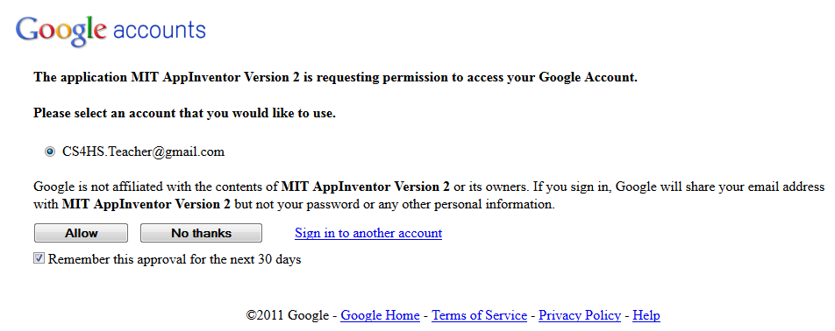

You’ll be prompted with a popup welcoming you to *AppInventor*. Click continue and you will be presented with a screen like the following:

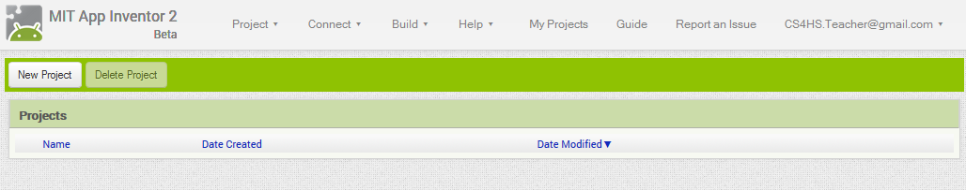

Click on *New Project*, enter a Project name for the Project and click *OK*.

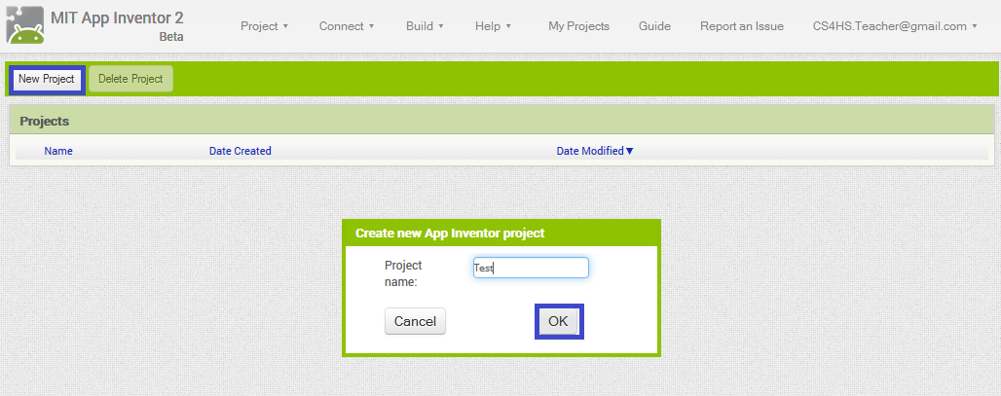

Once you click *OK*, there will be a couple of seconds delay before a screen like this is displayed:

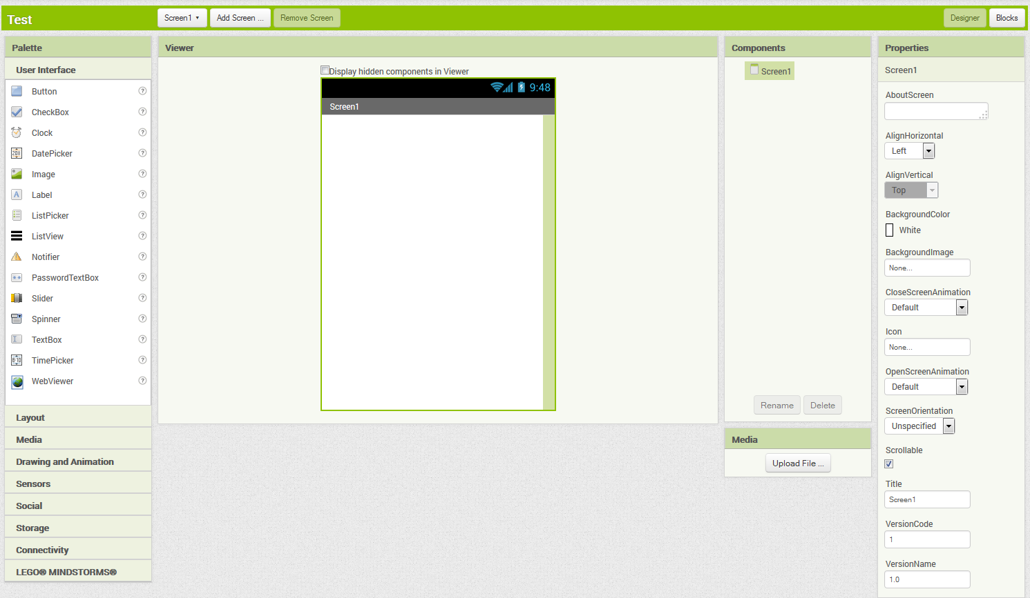

**Note: to return to the previous screen at any time, click “My Projects”.**

On the menu on the left, click and drag a *Label* over to the screen.

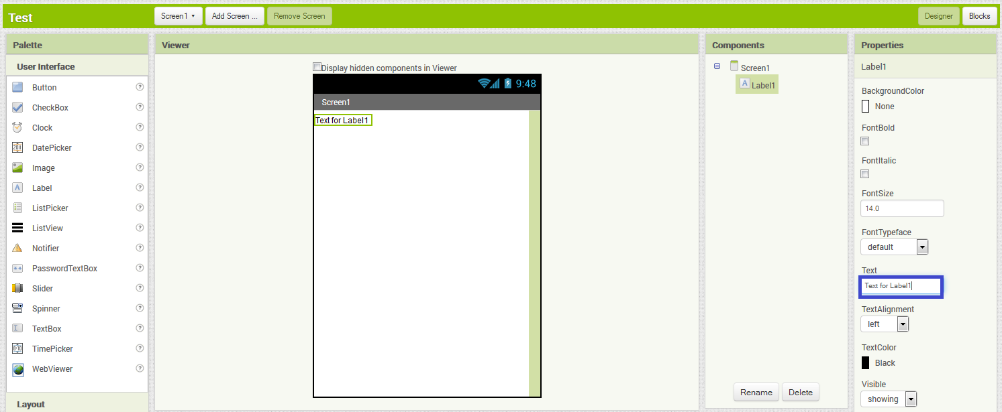

Now, change the text of the label to some other text (for example “Hello World”) by editing the text in the blue square above.

Now it’s time to run the app. To run the app, select *USB* from the *Connect* menu as pictured below:

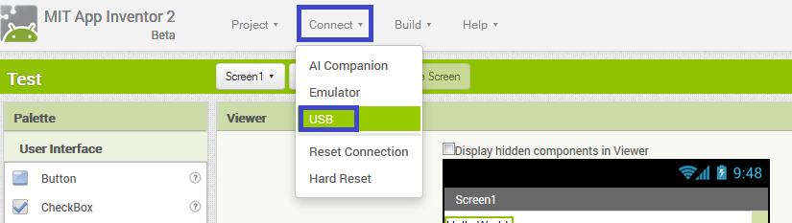

If you get a prompt on the tablet that asks if you would like to *Allow USB Debugging* just tap *OK*.

If you get a message instructing you to *“Launch the aiStarter program on your computer and then try again*.” Follow the very first step outlined in this tutorial again, and select the *Connect to USB* option again. If the problem continues let me know as there may be another issue.

A popup with a *“Connecting via USB Cable”* message will be displayed. If this doesn’t disappear after a few seconds and show a USB Connected message then make sure *aiStarte*r is running. If *aiStarter* is running and the “*Connecting via USB Cable”* does not disappear, let us know as there might be another issue.

The dialog will now show a message about the Companion App running. If this message does not disappear after 10 or so seconds, then the tablet probably doesn’t have the *AppInventor* Companion App installed. In that case, let us know and we will install it for you.

If all goes well, you will be presented with a screen like the one shown below:

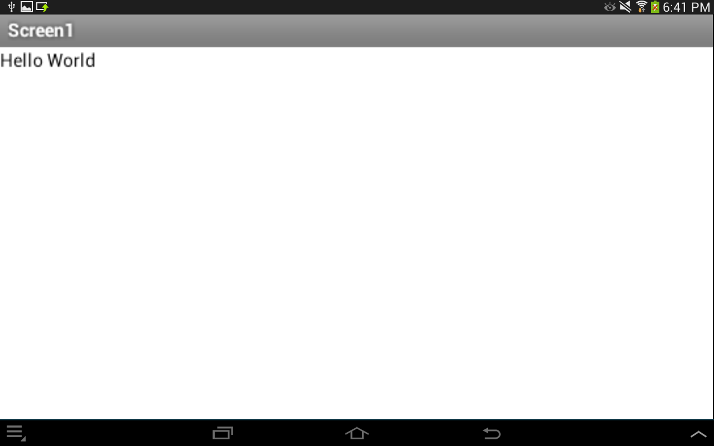

If you make some changes to the application, for example changing the text in the label, the app will update automatically with these changes without needing to reconnect to the tablet. Notice that if you drag and drop other elements (for example: a *Checkbox*) from the *User Interface* section they will appear almost instantaneously on the tablet.