Making an Interactive Badge with BBC micro:bit

Physical Computing

# Getting Started

The purpose of this activity is to introduce you to the BBC micro:bit, which is a type of device that can be used for teaching Physical Computing and Making.

In this activity we will make an interactive badge with the BBC micro:bit. We recommend you work in pairs during this activity, working from one lab computer. This activity and a copy of the finished micro:bit program will be available on the CS4S website after the workshop.

## BBC micro:bit

The diagram below shows the key components of the BBC micro:bit. During this tutorial we will be using the *2 programmable buttons* (red circles) as our input and the *25 individually programmable LEDs* (blue square) as the output. Later, once we have had some practice programming the micro:bit, we will use some of the other inputs and outputs.

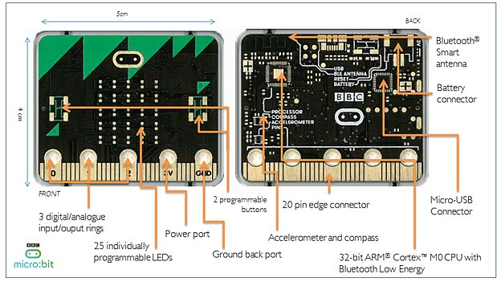



## Microsoft MakeCode editor

If you want to write a program that you can load onto the BBC micro:bit you can use the Microsoft MakeCode editor (<https://makecode.microbit.org/#>).

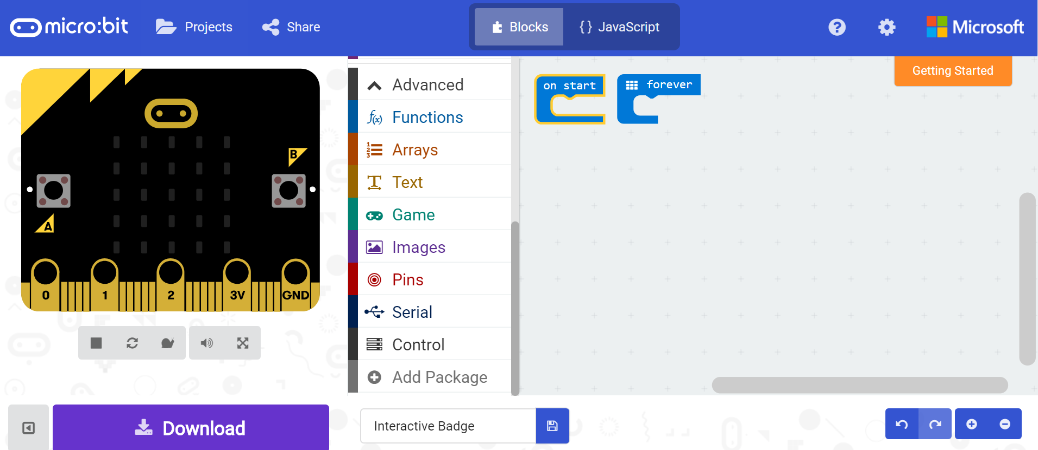

The editor window has three key panels as shown above:

* Emulator (left) - simulates how the project will look and run when it is transferred to the micro:bit
* Toolbox – contains code blocks that can be dragged and dropped into the workspace
* Workspace – this is where you will write your code by joining together blocks

You may notice that you can switch between Blocks and JavaScript. This tutorial uses Blocks, which is very similar to the block coding you have been doing in Scratch. However, if you would like to use the JavaScript editor you may. You may either type the script if you are familiar with the language, or you can use the same drag and drop functionality as in the Blocks editor.

You don’t need an account to save your projects. They are automatically saved in the browser. However, if you would like to save a copy of the .hex file you can do so by clicking on the save icon next to your project name (more on this below). To load your project on another computer, click ‘Projects’ and then ‘Import file’ and select your .hex file.

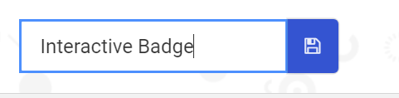

# Creating the Code

In this section we will use Microsoft MakeCode editor to create an interactive badge that can be used to display the weather outside.

To get started open a new window in ***Google Chrome*** and go to <https://makecode.microbit.org/#> name your project ‘Interactive Badge’.



## Displaying an image

Click on the Basic button in the *toolbox* menu and drag a show leds block inside the on start block already displayed in the *workspace*.

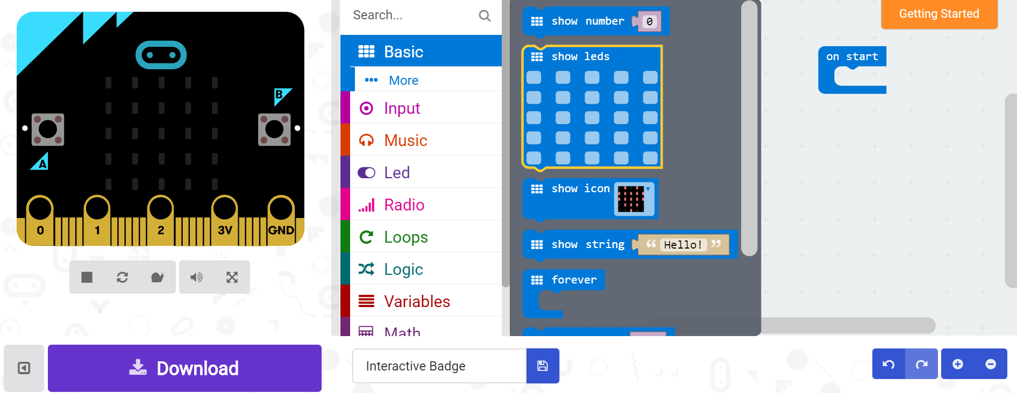

Once the show leds block is in place, click the leds that you would like to have light up (you can create any shape you like).

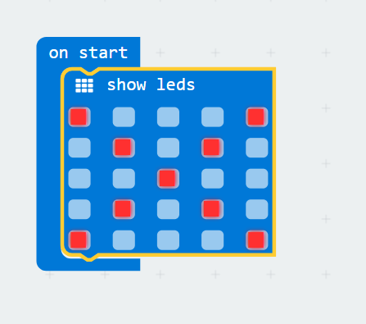

Your code will run automatically in the *emulator*.

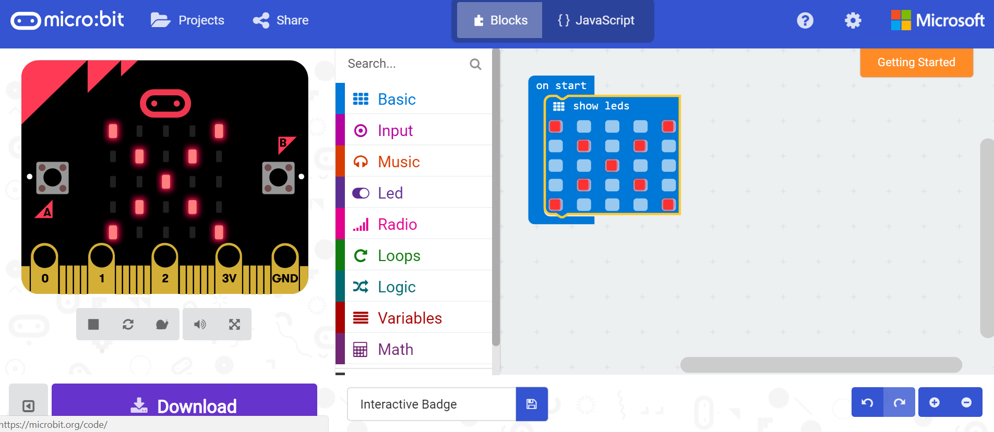

Now we will test the code on the micro:bit itself. To do this we need to download a .hex file by clicking on the big purple download button at the bottom left of the screen.

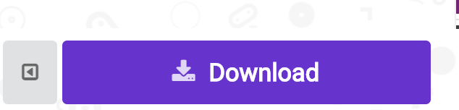

Next we need to transfer the .hex file from the computer’s downloads folder to our micro:bit. To do this use the USB cable to plug your micro:bit into the computer. You should then see your micro:bit appear in the computer’s file manager as a USB drive.

Once the file is downloaded click on the arrow after the downloaded file and choose ‘Show in folder’ and then drag the highlighted file to the micro:bit drive.

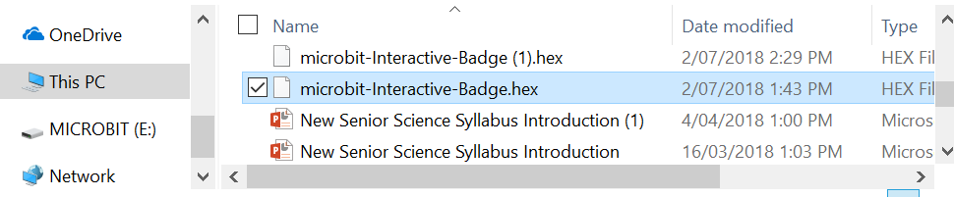

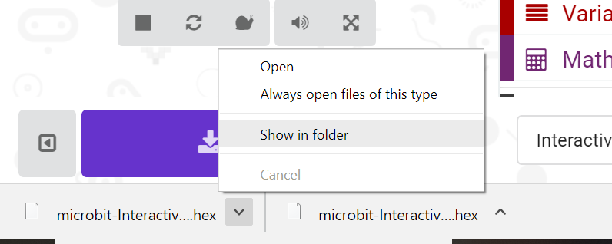

A small led on the back of your micro:bit (next to where you plugged the USB cable) will flash while the file is being transferred. Once this has stopped your program will run.

Turn over your micro:bit to see the image you created. The program is now saved on the micro:bit. You could unplug the microbit and attach the battery pack for portability. However, we are going to create a more complex program so we will leave it plugged in for now.

## Displaying a Y and an N

We are now going to write a program to make micro:bit display either a Y for ‘yes’ or an N for ‘no’ when a button is pressed.

First we will write the code to display the letter Y when a button is pressed.

To do this click on the Input button in the *toolbox* menu and drag a on button A pressed into the *workspace*.

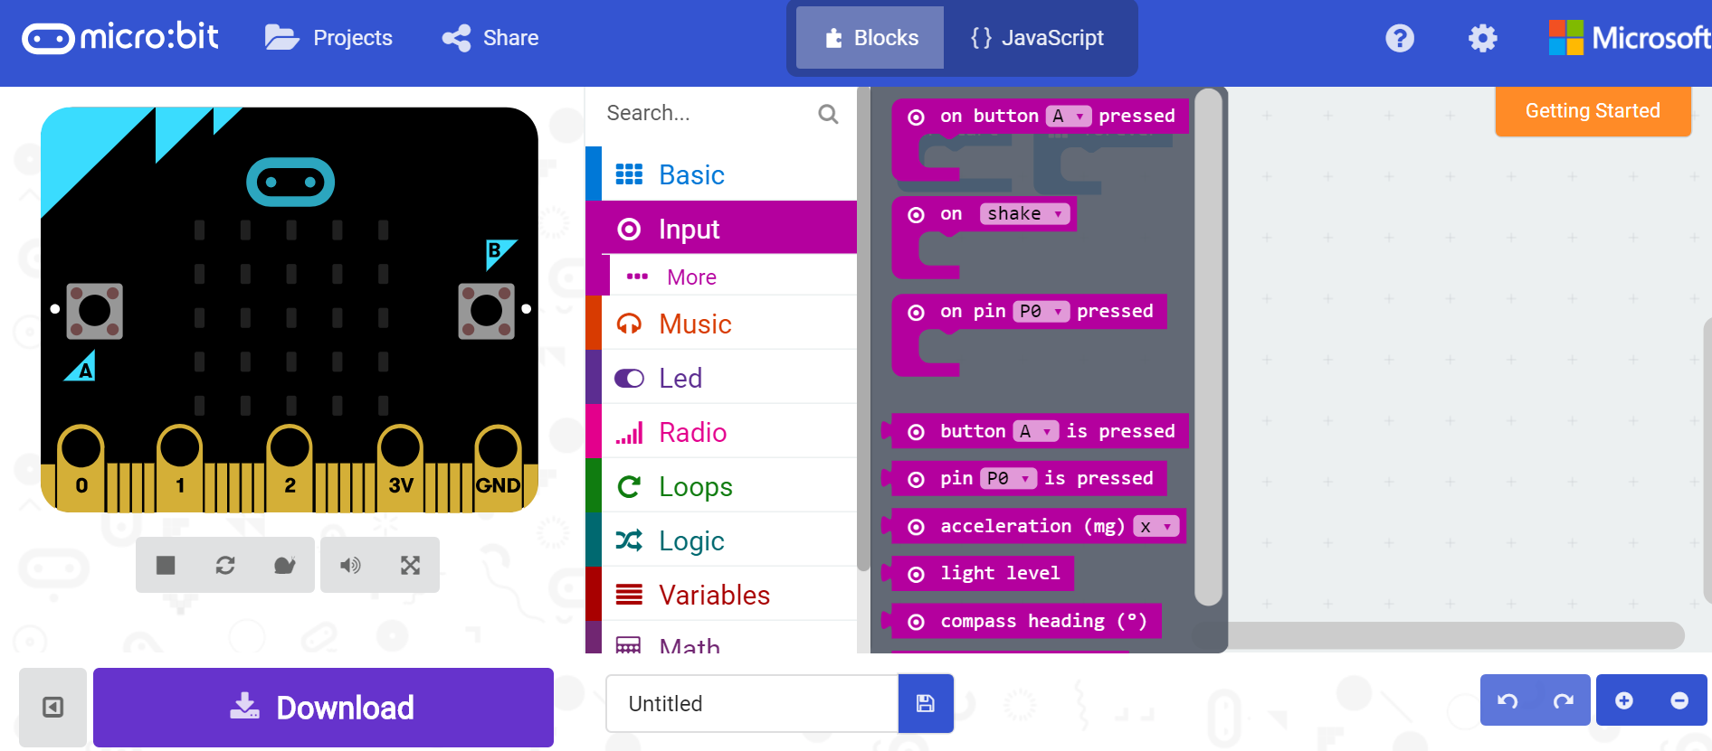

Then drag another show leds block inside the on button A pressed block that you placed in the *workspace.* Click the led squares to display the letter Y.

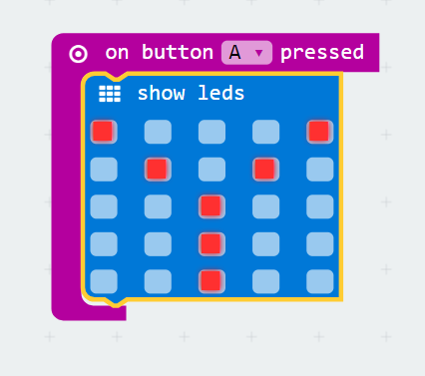

To test your new code in the emulator, click the A button. It should display a Y on the led output.

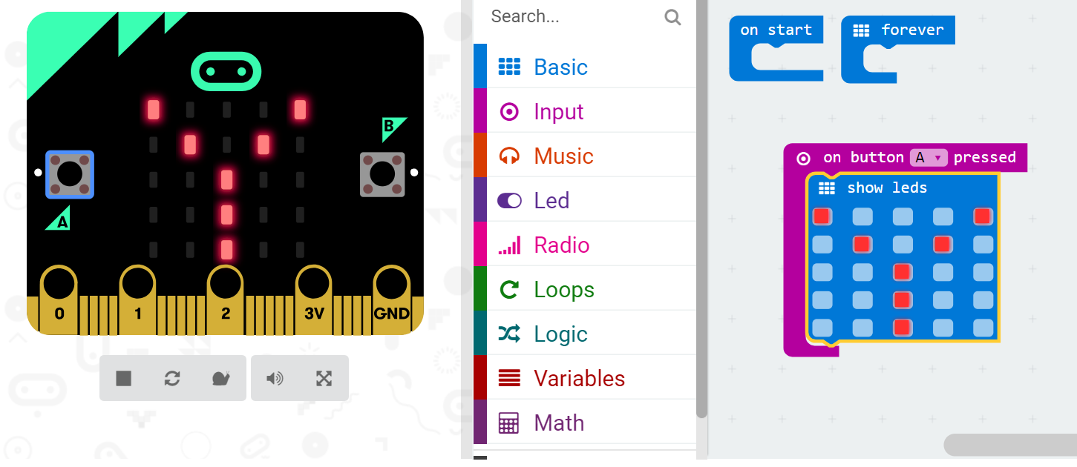

Now, see if you can get the emulator to display an ‘N’ when you click the B button on the emulator.

Once you have successfully displayed a Y when the A button is clicked on the emulator, and an N when the B button is clicked you need to load the program onto your micro:bit. ***Use the same process that we practiced in 2.1.***

## Making a Simple Animation

Now we will make a third option to represent an ‘unsure’ response. But we want to make it a little more interesting than just displaying a ‘U’.

First we need to tell our micro:bit our desired input. In this case it will be pressing button A and B simultaneously. To do this we need to drag a on button A+B pressed block into the *workspace*. Then open the loops menu in the *toolbox* and drag a repeat 4 times do block inside the on button A+B pressed block.

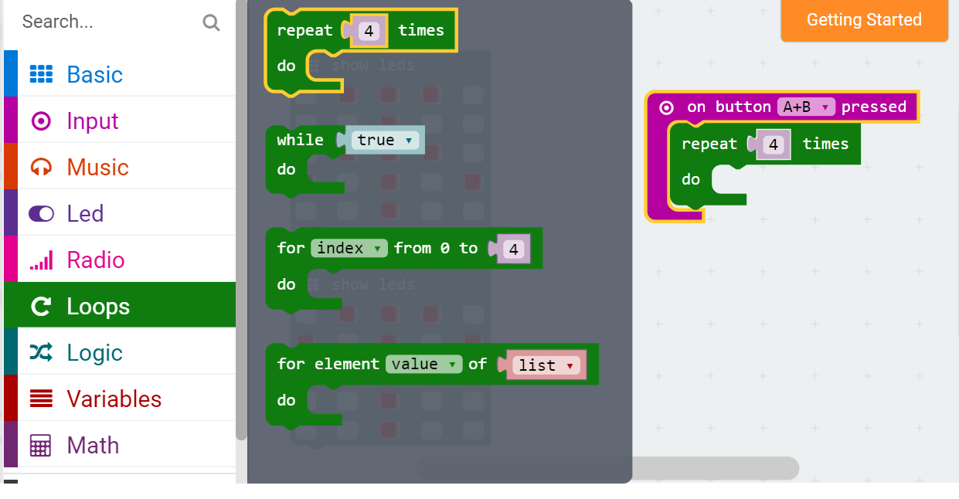

Place two show leds blocks inside the repeat 4 times block making sure that each is followed by a pause (ms) block. The pause (ms) block can be found in the basics menu of the *toolbox.*

Below is an example sequence. However, you can design your own if you like. You can make it more complex by adding more show leds and pause (ms) blocks, creating a longer sequence.

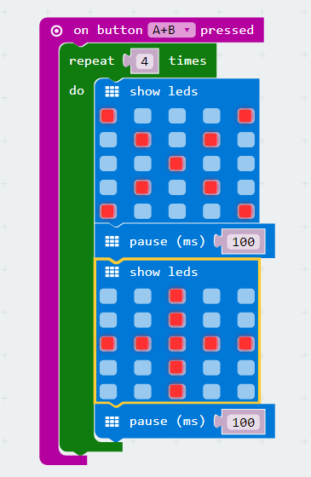

Once you are done, test your animation using the emulator and load your updated program onto your micro:bit. Make sure you still have your code for the ‘Y’ and ‘N’.

# Acknowledgements

The above tutorial is based on one available at <https://codeclubprojects.org/en-GB/microbit/interactive-badge/>

The following images were used in this tutorial:

* BBC micro:bit diagram: <https://codeclubprojects.org/en-GB/resources/microbit-intro/>