Making a Piano, with Scratch & MaKey MaKeys

Physical Computing

# Getting Started

The purpose of this activity is to introduce you to MaKey MaKeys, which is a type of device that can be used for teaching Physical Computing and Making.

In this activity we will make a piano with Scratch and MaKey MaKeys. We recommend you work in pairs during this activity, working from one lab computer. You will need a bit of space on your desk as well, to make room for the MaKey MaKey, piano keys and wires. This activity and a copy of the finished Scratch program will be available on the CS4S Primary School website after the workshop.

## MaKey MaKey

The illustration below shows a simple explanation of how to use a MaKey MaKey. When the person touches the banana, they complete a circuit. This triggers one of the actions on the MaKey MaKey (e.g. the Up arrow), which then happens on the connected computer.

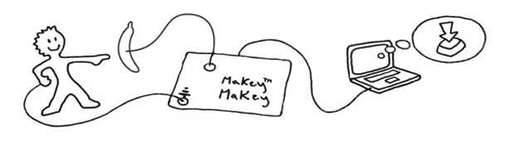

To get started, connect the grey USB cable from the MaKey MaKey to your PC. The lights on the MaKey MaKey will flash, to indicate that it has received power.

To test that the MaKey MaKey works correctly, put your thumb on the *earth bar* (the silver metal rectangle at the bottom) and touch one of the buttons (e.g. the *SPACE* or *CLICK*). When you do this, the green light near the button should light up and the action you tapped (e.g. the *CLICK*) will be performed on the connected computer.

You can clip alligator clips to whatever objects you can think of, and it will work with the MaKey MaKeys (as long as the object is conductive). For example, MaKey MaKeys have been used to make a piano with bananas, and game controllers with playdoh.

## Scratch

If you want to make a program that interacts with a MaKey MaKey, you can use any programming language you’d like. We’ll use Scratch in this session, because we don’t have to install anything and it’ll be straightforward for us to write code that reacts to different keys being pressed.

To get started in Scratch, create a new project (in Scratch, go to *File* > *New Project*).

# Coding a Piano

In this section we will create a piano that can be played on your computer’s keyboard, using Scratch.

## Playing a Note

First, make sure the cat sprite (**Sprite1**) is selected. If a sprite is selected, there will be a blue rectangle around it in the Sprites area.

From the **Events** block section, drag the  block into the Scripts editor.

Click the dropdown arrow next to *“space”* on the  block and select *“up arrow”*.

Next, drag a  block from the **Sound** sectionunder the  block, so that it clicks in place.

Change the note from *“60”* to *“65”* by clicking the dropdown arrow next to *“60”* and clicking on *F* from the keyboard that appears. These numbers (60 and 65) are MIDI notes, which are a way of representing musical notes that are commonly used when composing music on computers.

You should now have code blocks that look similar to the following:

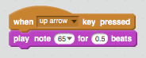

Now, press the up arrow on your computer’s keyboard – you should hear a note (*F*) play when you do this.

## Adding other Notes

We are now going to add another three notes to our Scratch piano. To do this, you will have repeat the steps given in Section 2.1 for the following three keyboard presses and notes:

* Pressing the **right arrow** should play the MIDI note **64** **(E)**
* Pressing the **down arrow** should play the MIDI note **62 (D)**
* Pressing the **left arrow** should play the MIDI note **69 (A)**

After adding these blocks your Scripts Editor should look like this:

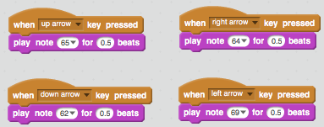

Now, try pressing the different arrow keys – each of these should now play a different note.

# Making the Piano Keys

In this section we will make four piano keys using cardboard and aluminium foil, then connect these to our MaKey MaKey.

## Constructing the Keys

To interact with our Scratch piano program, we will build four piano keys.

The piano keys that we made for this activity are shown in the image below:

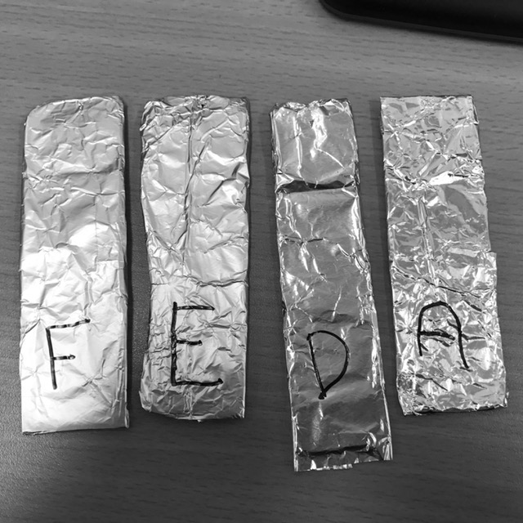

To make the piano keys, cut out some long and thin rectangular pieces of cardboard, cover them in aluminium foil, and draw the appropriate note letter on them (F, E, D and A). You may have a more creative approach to make them than this, so feel free to make them in a different way to above.

Next, connect up the piano keys to the MaKey MaKey, using the alligator clip wires. We want to connect each key up to the following buttons on the MaKey MaKey:

* **F** to the **Up Arrow**
* **E** to the **Right Arrow**
* **D** to the **Down Arrow**
* **A** to the **Left Arrow**

Then attach one of the ends of another alligator clip wire to one of the slots on the MaKey MaKey’s earth bar. The person that plays the piano will have to hold the other end of this wire (to complete the circuit).

Now, try touching each of the keys, to make sure that the correct arrow button lights up on the MaKey MaKey. Note that the person pressing the keys will also have to be holding the end of the alligator clip connected to the earth bar on the MaKey MaKey.

If the buttons don’t light up, double check that the clips are clipped to foil on the piano keys and that the alligator clips are clipped into place on the MaKey MaKey.

Now, go back to Scratch and try pressing the keys. You should hear different notes while playing the different piano keys.

Good work! You have created a piano using Scratch and a MaKey MaKey. You are now ready to move onto the next activity in the Physical Computing session.

# Acknowledgements

The following image has been used as part of this activity:

* The MaKey MaKey Diagram is from: <https://wiki.scratch.mit.edu/wiki/How_to_Connect_to_the_Physical_World>