Connecting and Running an Android Tablet

CS4S High School - AppInventor Session

# Connecting and Running an Android Tablet

Open up a browser (today we’ll be using Mozilla Firefox).

Go to <http://appinventor.mit.edu/>

Click on the orange **Create** button in the top-right corner

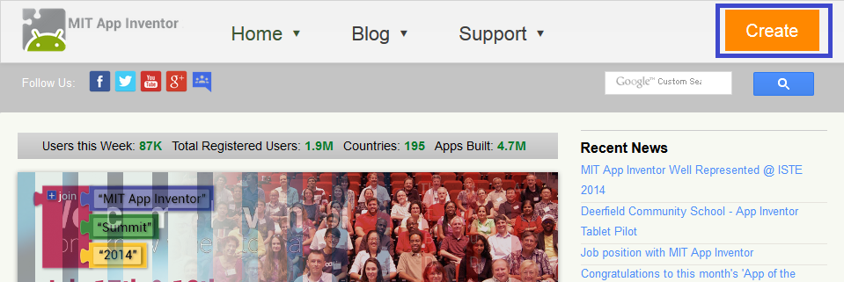

Log in using your Google / Gmail account.

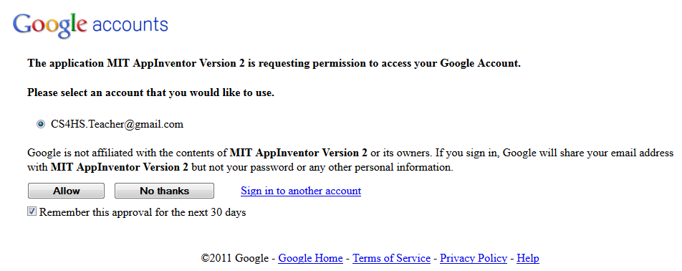

Click Allow, and keep “Remember this approval for the next 30 days” ticked.

You will be presented with this screen:

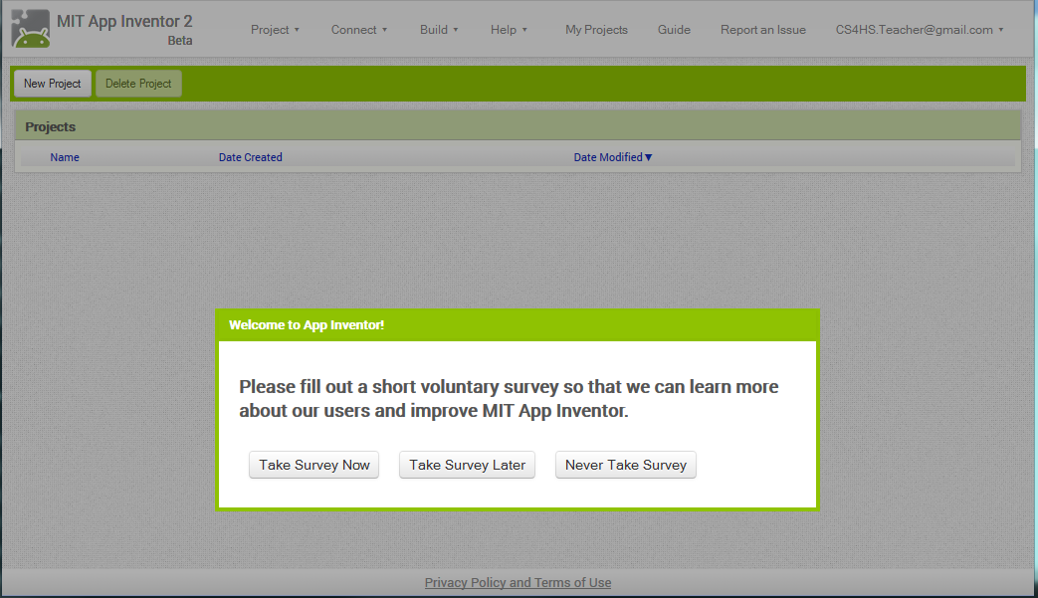

Feel free to select “Take Survey Now” and fill it in. If you’re itching to get an app running as soon as possible then just select “Take Survey Later”.

You’ll be prompted with a popup welcoming you to App Inventor. Click continue and you will be presented with a screen like the following:

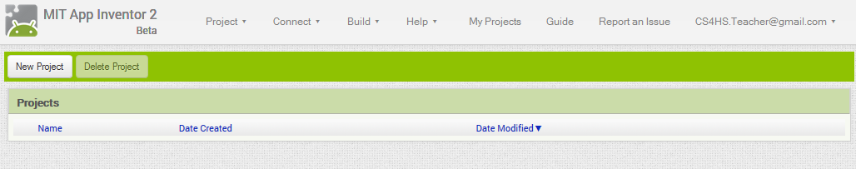

Click on New Project, enter a Project name for the Project and click OK.

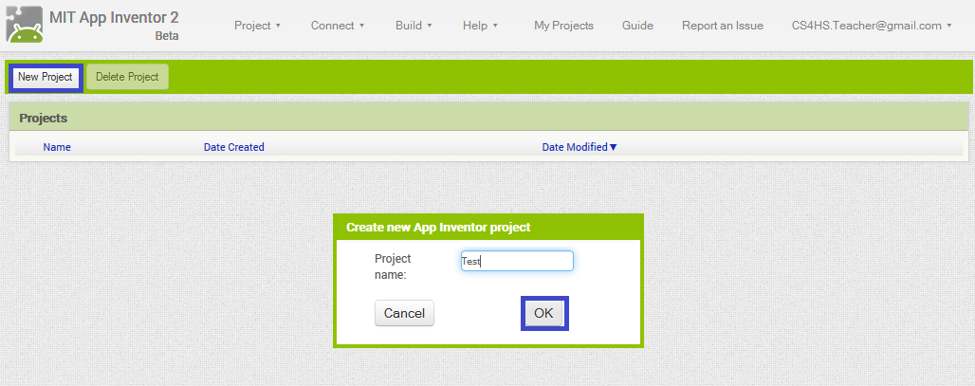

Once you click OK, there will be a couple of seconds delay before a screen like this is displayed:

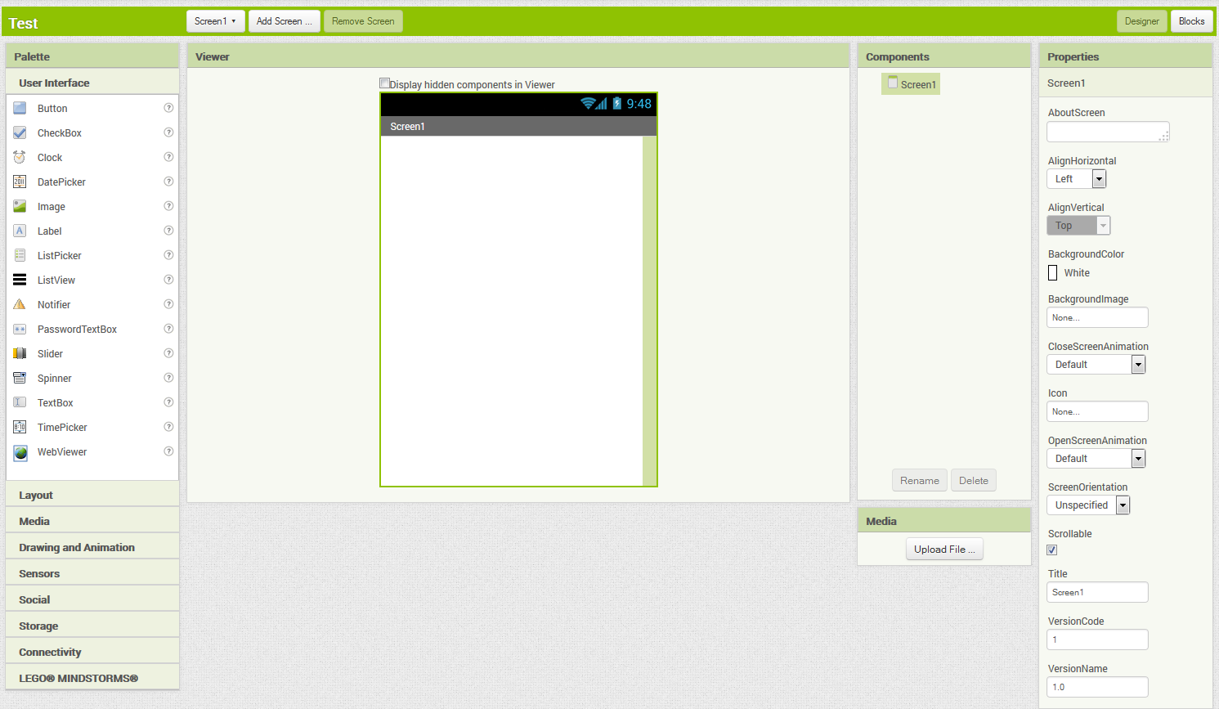

**Note: to return to the previous screen at any time, click “My Projects”.**

On the menu on the left, click and drag a Label over to the screen.

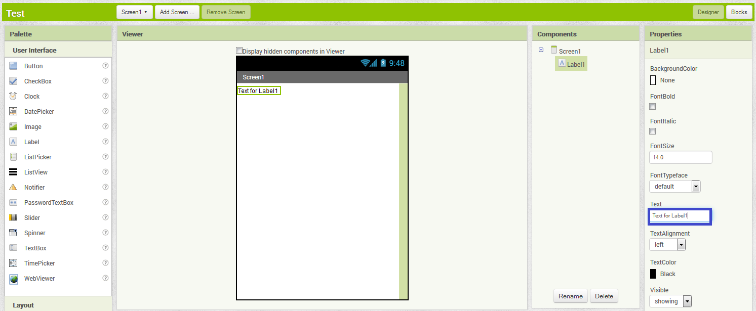

Now, change the text of the label to some other text (for example “Hello World”) by editing the text in the blue square above.

Now it’s time to run the app. To run the app select USB from the Connect menu as pictured below:

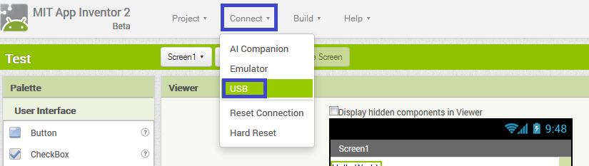

If you get a prompt on the tablet that asks if you would like to Allow USB Debugging just click OK.

If you get a message instructing you to “Launch the aiStarter program on your computer and then try again.” Follow the very first step outlined in this tutorial, and select the Connect to USB option again. If the problem continues let me know as there may be another issue.

A popup with a “Connecting via USB Cable” message will be displayed. If this doesn’t disappear after a few seconds and show a USB Connected message then make sure aiStarter is running. If aiStarter is running and the “Connecting via USB Cable” continues let me know as there might be another issue.

The dialog will now show a message about the Companion App running. If this message does not disappear after 10 or so seconds, then the tablet probably doesn’t have the App Inventor Companion App installed. Let me know and I’ll install it.

If all goes well, you will be presented with a screen like so.

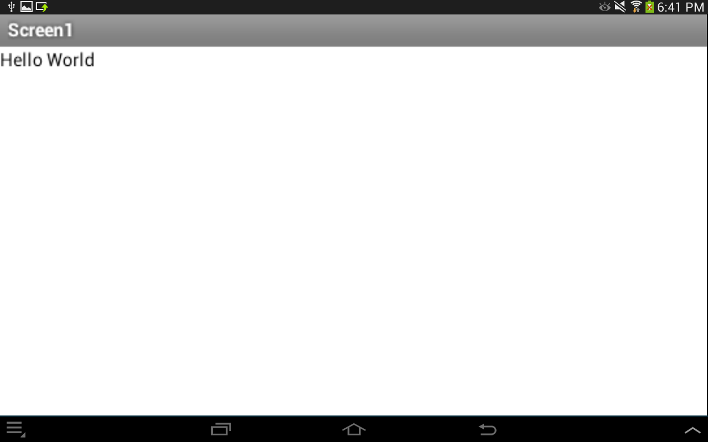

If you make some changes to the application, for example changing the text in the label, the app will update automatically with these changes without needing to reconnect to the tablet. Notice that if you drag and drop other elements from the User Interface section they will appear almost instantaneously on the tablet.