An Introduction to General-Purpose Programming, with Sonic Pi

UoN CS4S – High School 2016

# Getting Started

This tutorial introduces the following essential programming concepts: Sequencing, Looping, Branching and Conditionals, and Threads. We will use a program call Sonic Pi in this tutorial. Sonic Pi is a program that can be used to create music by writing code. This program is a musical instrument, educational tool and a programming environment, all in one.

This tutorial includes parts from a few existing different Sonic Pi tutorials, produced by Dr Sam Aaron and members of the Raspberry Pi Foundation. These tutorials are available here: <https://goo.gl/CzE8sK> and <https://goo.gl/Mwb4RP>

To open Sonic Pi on your lab computer, go to the Start Menu, then All Apps, and look for Sonic Pi. The program may take 30 seconds to 1 minute to finish launching.

# The Sonic Pi Interface

Once Sonic Pi opens, you should see an interface similar to the one below:

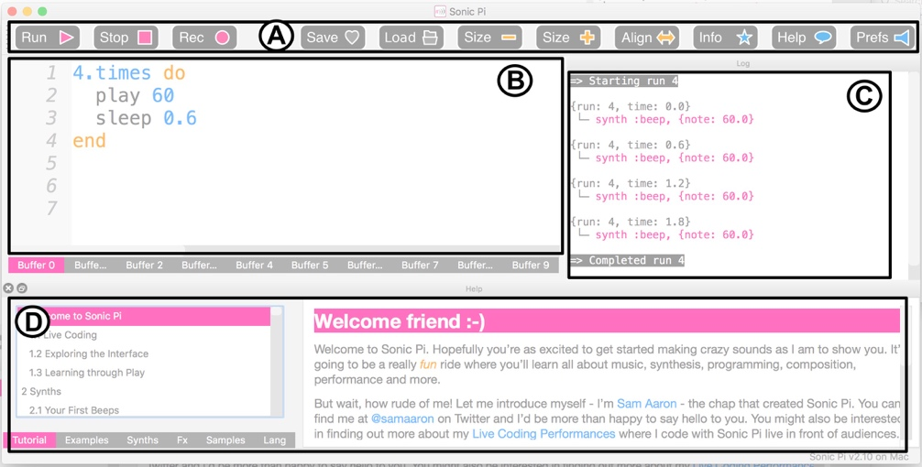

**A** is a bar with all of the different controls. The pink controls are for controlling the playback of your program. The grey controls allow you to save and load your program. The yellow controls allow you to adjust the size of the program’s text. The blue controls allow you see information about Sonic Pi, the help documentation and change the program’s preferences.

**B** is the **Code Editor**. This is the area where you’ll write your code and compose/perform music.

**C** is the **Log Viewer**. When your song is playing, this will show all of the notes being played. This is useful when trying to figure out what’s going in your program and fixing errors (debugging).

**D** is the **Help Viewer.** This area contains help and information about all aspects of Sonic Pi, and includes a series of tutorials and example music.

# Your First Ruby Program

Many tutorials that introduce programming start with a program called “Hello, World!”. In Sonic Pi, you can create this program by typing the following code into the Code Editor:

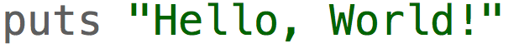

After typing this, and clicking the **Run** button, you should see a message like this in the *Log Viewer* (on the right side of the screen):

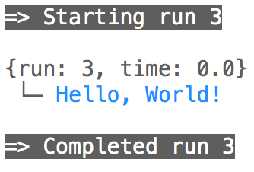

Congratulations! You just wrote a program in Sonic Pi.

Sonic Pi uses a subset of the Ruby programming language. This means that, although not all Ruby’s features are available in Sonic Pi, writing Sonic Pi code is writing Ruby code. So, when you are learning how to use Sonic Pi, you are learning Ruby.

If you found an online tutorial for Ruby, the steps in the tutorial would likely work in Sonic Pi. The real strength of Sonic Pi, however, is as a musical instrument.

Next, remove the line you wrote in the *Code Editor* and write this instead:



After typing this, and clicking the *Run* button, you should see hear a note play.

What’s happening here? The **play** command tells Sonic Pi that it needs to play a note. The 60 is the note that should be played. Sonic Pi uses numbers, as well as note names, for representing notes. 60 is a note that is called Middle C.  
  
What happens when you change the 60 to a different number? Try numbers like 30 and 90. What do you notice?

As the number increases, the pitch of the note gets higher. Conversely, when you decrease the number the note becomes lower in pitch.

In the next section, we will create and play our first song, while learning some programming concepts along the way.

# Your First Songs

## Sequences

**Sequences** are an essential concept in programming. When you run a program, the computer will follow each instruction you give it in order, as a sequence, from top to bottom. We’ll investigate sequences in this section, by writing a melody.

Replace the code you have written in the Code Editor, with this below:

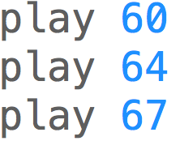

When you click *Run*, you should hear 3 notes play at the same time. Is this what you expected? You may have expected 3 notes to play separately, one after the other. In Sonic Pi, we have to write code that will affect how long the notes last. To do this, we use the **sleep** command.

Next, change your code so it looks like the code shown below:

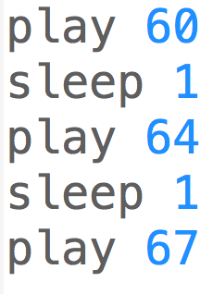

Now when you run the program, you should hear a melody playing.

The **sleep** command tells Sonic Pi to wait a certain amount of time before playing the next note. The 1 used in the example above, is not 1 second, it means 1 beat. If you are familiar with musical notation, you may know of bpm (beats per minute). The default bpm in Sonic Pi is 120, so when you **sleep** 1 beat this means the program waits for around half a second, before playing the next note.

If you put the following code above the melody code, and run the program again, it should sound different:

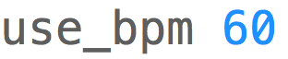

The sleeping will take longer, as the beats per minute is lower. Conversely, if you change the 60 to 240 and run the program again, the melody will play more quickly because the sleeping will take less time.

## MIDI and Notation

When you are writing numbers (e.g. 60 and 64), you are using numbers that represent MIDI notes. MIDI is a technology standard that is used for computer generated (electronic) music and instruments like synthesizers.

You may be familiar with musical notation. You don’t need to know any musical notation to complete this tutorial, but this section may be a little confusing if you don’t.

The image below shows how the MIDI notes map to notes on the treble and bass clefs. For example, Middle C = 60 in MIDI. In Sonic Pi this can be played by using **:C** and **:C4**, as well.



We used **sleep** in the last section, to leave time between notes. By using **sleep** 1, the note played for 1 beat, before the next note played. In Sonic Pi, we can make notes play different durations, by changing the number we put after the **sleep** command. For example, see the images below with the different note lengths:



In the next section, we’ll look at how we could write a song in Sonic Pi, by mapping musical notation to code.

Variables are another concept essential to programming. We will not go into much detail about these in this tutorial, but we will look at some variables that are built-in to Sonic Pi.

Sonic Pi allows you use to use variables, named after different notes, instead of writing a MIDI number. For example, the two play lines in the code below will play the same note twice:

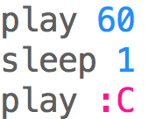

When you use a name (e.g. **:C)** for a note, when the song is playing, you will be able to see the MIDI number this represents in the *Log Viewer.* For example, in the image below, you can see that the note being played is 60, even though the code said “**play :C**”:

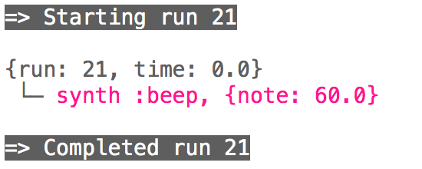

In the following sections, we will use a combination of MIDI numbers (e.g. 60) and the note names (e.g. C).

## Loops

Loops are another essential concept in programming. Loops are used to repeat instructions.

For example, to repeatedly play the same note over and over, we would use a loop. Write this code and run it:

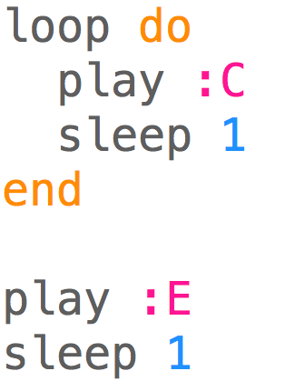

When you Run the code above, you will hear the same note (C) play repeatedly. The code between **do** and **end** will run over and over again (in the loop). The E note will never be played. This is because we have not said how many times the loop should run, or when the loop should stop.

Let’s change the code so that the C note 4 times and then plays 1 E note. We would change the program to look like the code below:

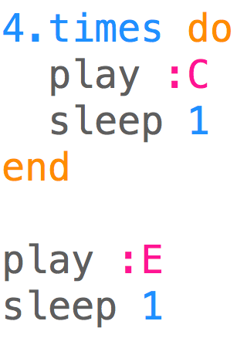

After running the code above, you will hear 5 notes – 4 Cs, followed by an E.

You may know of some songs that have repeating melodies. An example of a song that does have repeating melodies is the nursery rhyme, Frère Jacques. The notation for this song is shown below.

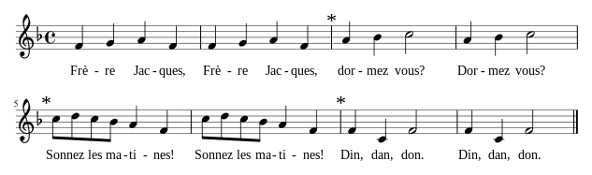

You may notice patterns of notes that repeat themselves. For example, the 2nd bar is a repeat of the 1st bar, the 4th bar is a repeat of the 3rd bar, and so on.

The first bar of this song could be written in Sonic Pi as:

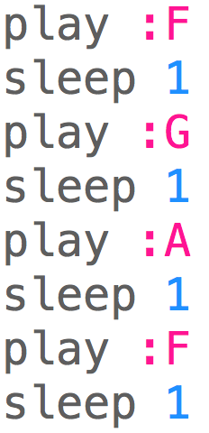

Now, if we put this code in a loop that runs two times, like below, we get the first two bars of Frère Jacques:

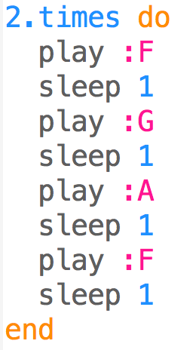

If you’re familiar with musical notation, you may be able to write the rest of the song. If you were to program the rest of the song, how would you use loops?

The full song is written out in code here: <https://goo.gl/49WtFt>

If you copy, paste and run this code in Sonic Pi, you will hear the whole song.

In the next section, we’ll look at selection, conditionals and randomisation.

## Selection, Conditionals & Randomisation

Selection is another important concept in programming. You may have seen this mentioned in relation to branching, which means running different code based on different conditions. To demonstrate selection, we will combine two concepts, conditionals and randomisation, to play a song.

If/else statements are an example of conditionals in programming. There is an if and else statement in the code below:

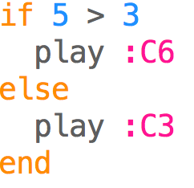

When you run the code, you should hear a high note (C6). The if statement checks if the condition (in this case, if 5 is greater than 3), and runs the code in the if block if it’s true. The line “**play :C3**” does not run at all in the example above.

Now, change the 5 to a 2, so it looks like the code below:

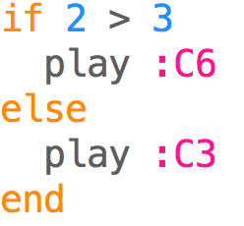

When running this code, you’ll hear a low note (C3) play instead. The if statement checks if the condition (in this case, if 2 is greater than 3), and runs the code in the if block if it’s true. In the example above, the code in the else block (the line “**play :C3**”) is run, because 2 is not greater than 3.

Now we’ll use randomisation to create a melody. In Sonic Pi, you can create a random number by using the command rand. For example, if you run the following code, you will see a random number (between 0 and 10) appear in the *Log Viewer*.



To create a random melody, we will write the following code, and run it:

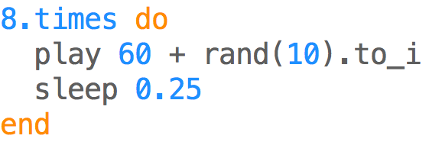

This code will play 8 random notes, each a quarter a beat apart. The **to_i** command turns the generated number into a whole number (e.g. 5, instead of 5.2323).

Next, we’ll combine the use of conditionals and randomisation. In the following code, we have two melodies, which we will play randomly. You could say we have simulated a coin toss, as there are two outcomes.

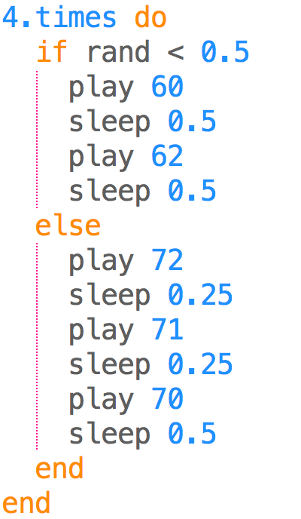

The first melody has 2 notes that ascend in pitch, the second has 3 notes that descend in pitch. When you run this code, the following will happen four times:

* A random number between 0 and 1 will be generated
* If the number generated is less than 0.5, the ascending pitch melody will play
* If the number generated is greater than 0.5, the descending pitch melody will play

In the next section we will learn about threads.

## Threads

Threads allow you to run two or more sequences of code at the same time. In Sonic Pi this could mean playing a bass line and melody at the same time.

The code below shows an example of the use of threads. When you run the code you will hear the main melody, and a simple bass line play at the same time. That is, the music in the first **in_thread** block will play at the same time as the music in the second **in_thread** block.

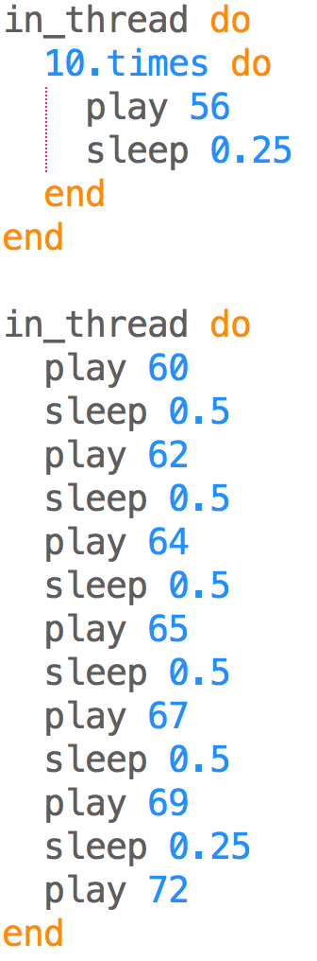

Congratulations! You’ve learned how to make simple songs in Sonic Pi, using some essential programming concepts. In the next section we explore some of the extra features that Sonic Pi offers.

# Extra Features

In this section we will explore some extra features of Sonic Pi briefly. The *Help Viewer* in Sonic Pi will provide more in-depth content and examples about these topics, if you are interested in finding out more.

## Samples

Sonic Pi can be used to play samples, which can then be used as part of your compositions. For example, you can play a drum loop sample, by writing the following code:



We can speed the sample up, by changing the rate:



Or slow it down, by decreasing the rate:



Samples can be used to compose different songs, and can be run in threads. The code below plays two samples at the same time:

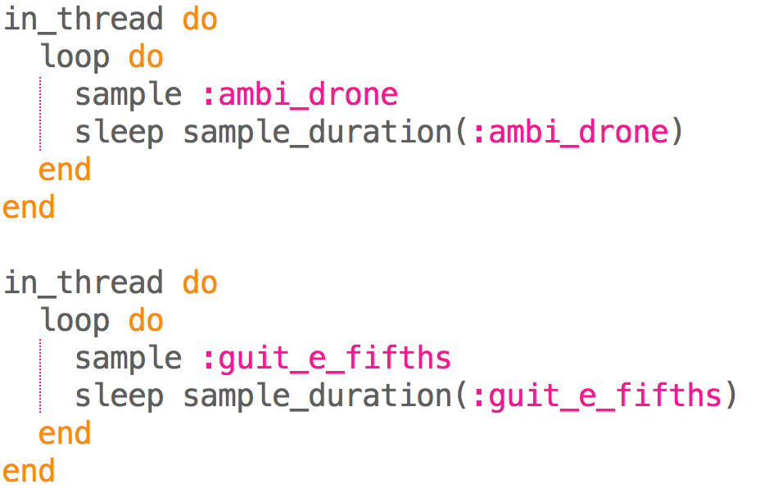

Samples have different lengths. In the example above we used the **sample_duration** command to make Sonic Pi sleep for the appropriate time. There are many different samples available in Sonic Pi, and you can even use your own custom ones.

## Synths

In Sonic Pi, you can change the synth used for playing notes. There a variety of different synths available, that can make very different sounds. The default synth is called “beep”. One way of changing which synth is being used, is by using the **use_synth** command. For example, the code below plays the E note, using the dsaw synth:

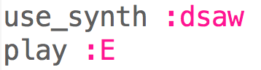

For a full list of different synths available, see Sonic Pi’s *Help Viewer*.

## Lists

A list is a type of data structure, common in many languages. One of the useful ways they can be used in Sonic Pi, is to play multiple notes. A list can have 1 or more elements, which are separated by commas and these must be wrapped in brackets. An example of a list of notes (as MIDI numbers) is shown below:



You can put a command in front of a list to play some notes. If you put **play** before the list and run the code, what happens? Now try with **play_pattern** instead. You’ll notice that with **play**, all of the notes are played at the same time. When using **play_pattern**, each of the 3 notes will play for a beat, before the next one plays.

The use of lists with commands like **play_pattern** can make writing code for songs shorter. For example, the first bar of Frere Jacques could be written using the following code:



See this code for Frere Jacques, using Lists: <https://goo.gl/Eq9NjP> This has the full song, written in a much more compact way than we had before.

## Chords

You can also write music in Sonic Pi by using chords. In the Lists section we wrote a list of notes (52, 56, 59), which also happen to be the notes that make up the E major chord.

We could play the E major chord by writing and running the following code:



We can write chord progressions now, like in the code below:

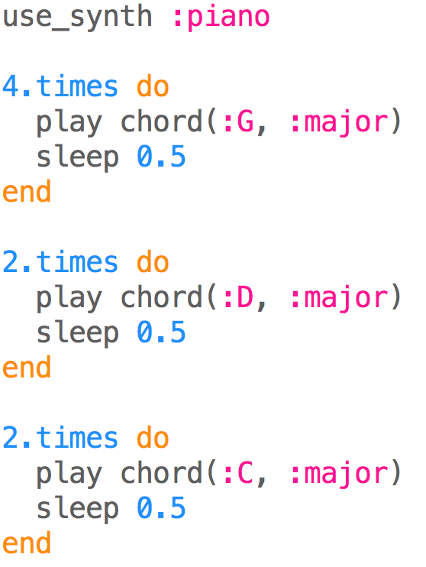

# Live Coding

One of the main purposes of Sonic Pi, is for it to be used for Live Coding. Live Coding mixes live music and coding, by allowing you to change your music (code) without stopping the music completely. You can view some Live Coding examples and performances on the Sonic Pi website.

To hear an example of Live Coding in action, write the following code:

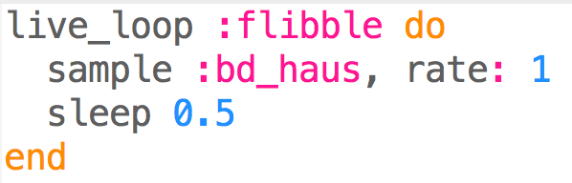

Now adjust the time the song sleeps (0.5) to another number (e.g. 0.2) and run the code again. The music won’t stop, and the speed of the drum will increase. Try adjusting this number again, running the code again and see how the music changes.

Live loops allow you to use Sonic Pi like you would with a live instrument (e.g a guitar). Sonic Pi has been used with these live loops, to perform real music gigs by students and professionals, all over the world.

Good work, you have now completed this tutorial! Now that you are finished, you may want to look at the Help Viewer in Sonic Pi, experiment with your own compositions or move onto the next activity.

# Acknowledgements

The following images have been included in this tutorial:

* MIDI notation, from <http://www.theoreticallycorrect.com/Helmholtz-Pitch-Numbering/>
* Note durations, from, <http://sonic-pi.mehackit.org/>
* Frère Jacques notation, from <https://en.wikipedia.org/wiki/File:Fr%C3%A8re_Jacques.svg>