# University of Newcastle: Coding & STEAM 2019

## Week 1 Homework Tasks

In this document, we have included the Homework Tasks for Week 1 of the Coding & STEAM program. Please note that there will be 2 hours of homework each week of the program. The time you spend doing these homework tasks will count towards the total number of accreditation hours (32) for participating in the program.

There are four main tasks that we would like you to complete before next week’s session. Further details about each of these tasks are given in the *Homework Tasks Detail* section. These tasks are:

1. Request a Scratch Teacher Account [using the form on the Scratch website](https://scratch.mit.edu/educators/register) – if you have not already
2. Work through the *Week 1 Homework Exercises* on the workshop website
3. Create a Scratch project with a Sprite that introduces your Teacher Account
4. Share the completed project in Scratch

Please email me at [Daniel.Hickmott@uon.edu.au](mailto:Daniel.Hickmott@uon.edu.au) with the subject line *“Coding & STEAM: Week 1 Homework”* before the Week 2 session and let me know whether you have completed the tasks and/or have any questions about them. Once I have received this email and have checked that you have shared the completed project, I will record that you have completed the Week 1 Homework.

## Homework Tasks Detail

In this section, we explain each of the homework tasks in more detail.

### Request a Scratch Teacher Account

In the Week 2 session of the program you will learn about Scratch Teacher Accounts, which are a special type of Scratch account that can make viewing and managing students’ projects easier. If you have not already requested a Scratch Teacher Account, you can request one completing [an online form on the Scratch website](https://scratch.mit.edu/educators/register). There is an approval process for teacher accounts, which typically takes a day but can take longer. We recommend that you request one as soon as you can, to ensure that the account is approved before the Week 2 session.

### Week 1 Homework Exercises

We have also included some homework exercises for you to complete. You can use these exercises to check your understanding of some of the *computational concepts* that you have learned about in the Week 1 session (*sequences*, *loops* and *events*). You view these exercises, and see their solutions, by following the *Week 1 Homework Exercises* link under the *Homework* heading on the Week 1 session page, or by going to this link: <https://cs4s.github.io/steam-2019/week-1/exercises>.

We recommend that, when you work through these exercises, you:

1. Read the stack of blocks in the question
2. Predict what the stack of blocks in the question will do
3. Put the stack of blocks into Scratch and see if your prediction was correct
4. Try and answer the question that is asked in the exercise
5. Check your answer against the answer on the *Exercises* webpage of the program website

If you have any questions about these exercises or would like some further explanation about them, then please let Daniel know when emailing him about the homework tasks for Week 1.

### Create a Scratch project with a Sprite that introduces your Teacher Account

We have included some steps to help you create a Scratch project. In this project, we would like you to have a Sprite (such as the Cat) introduce your Teacher Account name when the green flag is clicked. If you already know how to make a Sprite say something, feel free to skip the steps in this section and create the project your own way. However, if you do create your own project, please be sure to share the project (as explained in the next section) and email me.

The first step is to create a new Scratch project. There are a few different ways to create new projects in Scratch. If you are on Scratch homepage, you can click on the *Create* button at the top screen of the menu, as highlighted in the image below.



Alternatively, if you are already in a Scratch project, you can click the *New* button in the *File* menu at the top, as shown in the image below.

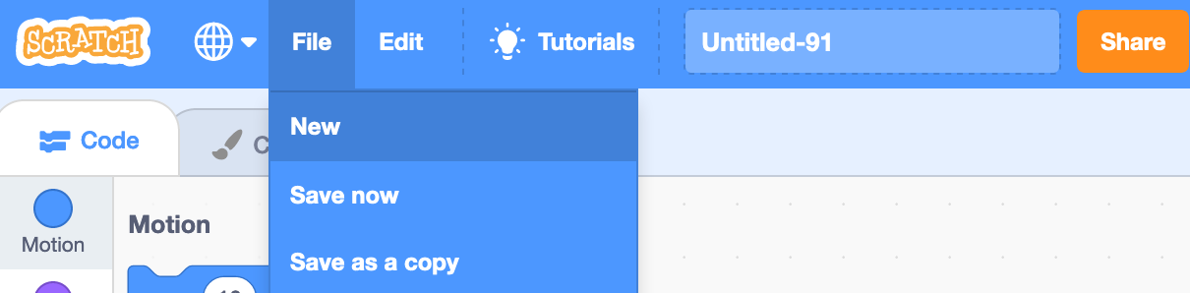

After creating the project, change the project name by typing “Week 1 Homework” into the project name text box, which is highlighted in red in the image below.

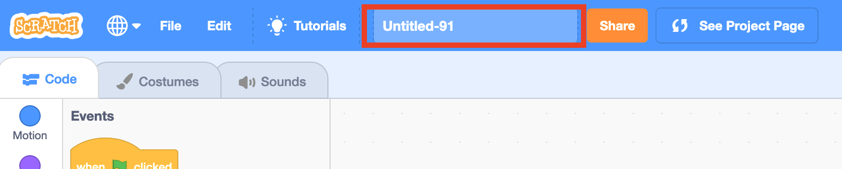

Next, drag the 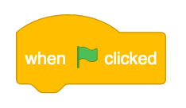block from the *Events* section into the Scripts area.

Then, drag a 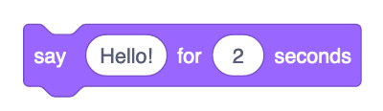 block from the *Looks* section into the Scripts area and snap it under the block.

When you click the green flag, the Cat Sprite should say *Hello!*

Next, you will make the Cat Sprite introduce your Teacher Account. To do this, double click the text box in the block, that is highlighted in red below. Change the text to say “Hi! My teacher account is <Teacher Account Name>”, with <Teacher Account Name> replaced with your teacher account username.

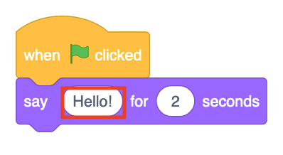

An example of a finished project, using my own teacher account username (*hckm*), is shown in the image below.

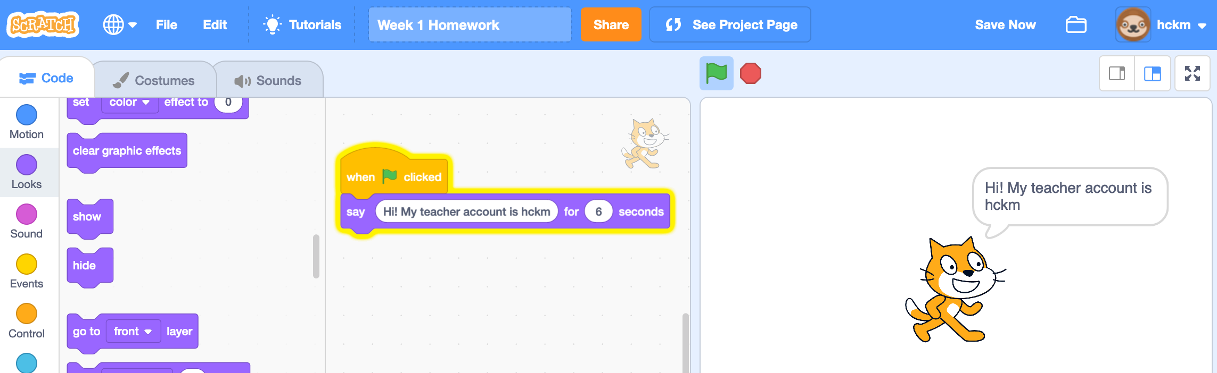

### Share the Completed Project

Once you have completed your project where a Sprite introduces your Teacher Account, you should share this project. By sharing a project in Scratch, you allow everyone in the Scratch community to see the project, as well as all of the Sprites and blocks within that project.

There are a few different ways to share Scratch projects. We have included a couple of examples of how to share Scratch projects below. **Please note that: you need to be logged into a Scratch account to share a project.**We recommend that you share from the Scratch Account that we created for you as part of the first session of the Coding & STEAM program. If you use your own personal or Teacher Scratch account, please let me know this when you send me an email about the Week 1 homework.

#### Example 1: Sharing Within the Scratch Editor

If you are working in the Scratch editor and would like to share from within the editor, you can click the *Share* button, which is in the top-centre of the screen, next to the “*See project page”* button.

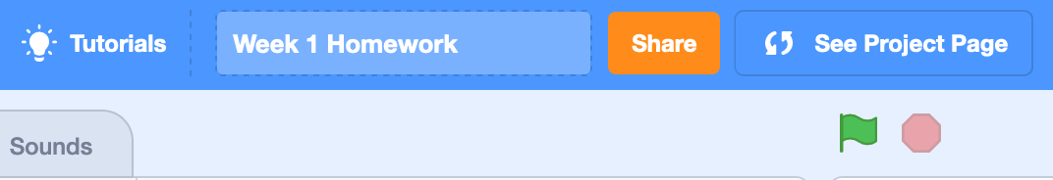

#### Example 2: Sharing from a Project Page

An alternative way to share a Scratch project is from its project page. To get to a project page from the Scratch homepage, you can click on your username at the top-right of the screen, and then click on *“My Stuff”*, as shown in the image below.

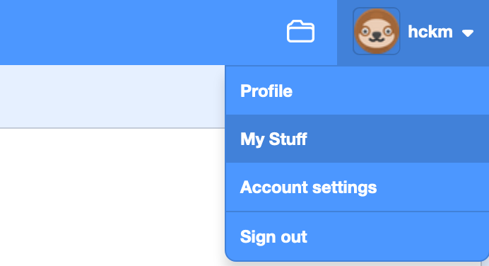

Within the *“My Stuff”* page, you can see your projects. If you click *“Unshared Projects”*, then you will see a list of all of your projects that are currently not shared.

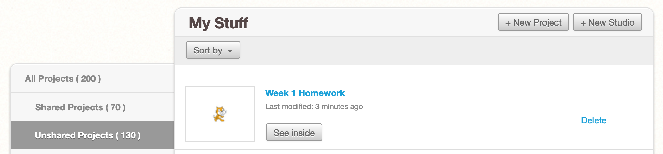

In the example, we want to share the *“Week 1 Homework”* project. So, we would click the *“Week 1 Homework”* link to go to its project page.

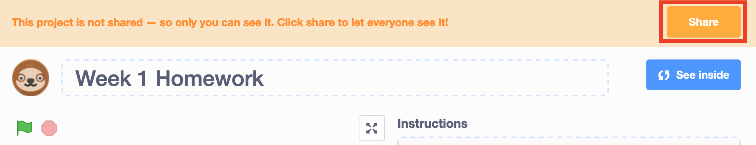

To share from the project page, click the **Share** button (which is highlighted by a red rectangle in the image above).

#### Checking Whether a Project has been Shared

Once you have shared a project, the project should appear in the *“Shared Projects”* part of the *“My Stuff”* page*.* You will also notice that there will be some new icons (as well as an *Unshare* link) next to the project title, as highlighted by a red rectangle in the image below.

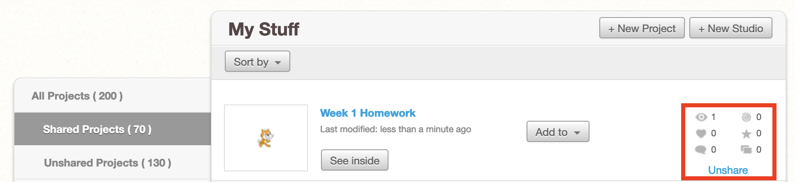

Once you have made sure the project has been shared, please email me at [Daniel.Hickmott@uon.edu.au](mailto:Daniel.Hickmott@uon.edu.au) with the subject line *“Coding & STEAM: Week 1 Homework”* before the Week 2 session. Once I have received this email and have checked that you have shared the completed project, I will record that you have completed the Week 1 Homework.