Performing Scripts Activity

# Introduction

In this activity, you will take the following Script for a Scene and create this in a Scratch project. In this scene, there are two Characters (Sprites): The Cat and Dog. When you create a new Project in Scratch, the first Sprite will always be the Scratch Cat. To add the Dog Sprite, you can click the *Choose a Sprite button*, which is highlighted in red in the image below, and then choose the Dog Sprite from the library.

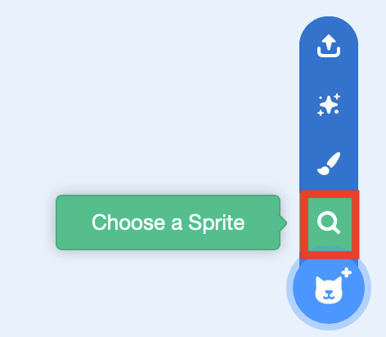

The Script for this activity is written below. You can use the *say* block (which is in the *Looks* blocks section) to make the Characters speak. The Scene should begin when you click on the *Green Flag*. Note that, to create this Project in Scratch you will have to have the two Sprites follow instructions at the same time (which we call *Parallelism*). You can see what the Scene looks like by downloading the video from the *Performing Scripts - Playground Scene Video* link on the Week 3 session webpage or by going to this web address: [hckmd.com/script](http://hckmd.com/script)

# The Script

*[Begin Scene]*

*(The Cat and Dog begin standing at the centre of the Stage)*

***Cat:*** *Hey Dog!*

***Dog:*** *Hey Cat!*

***Cat:*** *Are you going back to the classroom?*

***Dog:*** *Yep! Let’s go!*

*(Both the Cat and the Dog both walk over to the right of the Stage)*

*[End Scene]*

# Questions and Reflection

Some questions to consider for this activity and for reflection are:

* Did both of your Characters follow instructions at the same time?
* How do you make sure that the two Characters don’t talk at the same time?
* How did you move the Characters to the right of the Stage?
* Did you have a “reset”? What happens when you start the Scene again?
* Do the Characters stay on the right side of the Stage when you start the Scene again?

# Extensions to the Project

If you finish the activity quickly, you can investigate the following questions before we move onto the next activity. Please let us know if you have any questions about these extension questions.

* Can you add a backdrop to the Scene, so that the backdrop is a picture of a Playground?
* How would you add another Scene to the Script? For example, you could add a scene where the Dog and Cat enter the classroom and say hello to another student
* What is Broadcasting in Scratch and how could this be used in this Project instead of using *wait* blocks?