# University of Newcastle: Coding & STEAM 2019

## Week 5 Homework Task

In this document, we explain the homework task for Week 5 of the Coding & STEAM 2019 program. Please note that, in each week of the program, there will be 2 hours of homework, which will count towards the total number of NESA accreditation hours (32) for participating in the program.

**We would prefer that you complete this activity while logged in your Student Account (the account name and password that I sent to you).** If you do complete the homework with your personal or Teacher Account, that is okay – but please let me know this in the email that you send me about completing the homework task.

**Your task this week is to create a slideshow in Scratch**, which can be about a topic of your choosing (**but not about Sydney!)**. For example, you may choose to create a slideshow about:

* A historical figure (for example, [Captain Arthur Phillip](https://scratch.mit.edu/projects/113932908/))
* A city (for example, [Sydney](https://scratch.mit.edu/projects/228937329/#player))
* A tv or book series (for example, [Doctor Who](https://scratch.mit.edu/projects/3299351/#player))

You are welcome to choose any topic for the Slideshow, but you should have at least three different Slides (backdrops) in the project. Additionally, when the green flag is clicked, the Slideshow should return to the first “slide” before it moves onto the next slide. You may also want to add some interaction to your Slideshow. For example, you may add blocks that make the Slideshow switch between Slides every time the space bar is pressed. You could also add some Sprites that move around the Stage and explain what is on the Slides – it is up to you.

A video of an example slideshow about Sydney, which was created in Scratch, is available to view online from this link: [hckmd.com/show-homework](http://hckmd.com/show-homework) and this video is also available to download from the “*Homework Slideshow Video”* link on the Week 5 session page, which is under the **Homework** heading. This video shows the Slideshow about Sydney play from start to finish 2 times. Note that, the slideshow begins when the *green flag* is clicked, that the Cat moves back to it starting position when the *green flag* is clicked, and that the *backdrop* changes back to the first image (the picture of the Sydney Opera House during the night).

After you have created the scene in Scratch, please share the project and add it to the “*STEAM 2019 Week 5 Homework”* Class Studio. Then, please email me at [Daniel.Hickmott@uon.edu.au](mailto:Daniel.Hickmott@uon.edu.au) with the subject line *“Coding & STEAM Week 5 Homework”* before the Week 6 session and let me know whether you have completed the tasks and/or have any questions about them. Once I have received this email and have checked that you have shared the completed project in the “*STEAM 2019 Week 5 Homework”* Class Studio, I will record that you have completed the Week 5 Homework.

## Homework Task Detail

In this section, we have split the Homework task into subtasks, which explain one set of steps for creating a Slideshow in Scratch. Please note that you do not have to follow these steps and that you can use your own approach for creating the Slideshow. For example, you may want to add some interactivity, such as changing slides when the space bar is pressed, rather than having the slides change after a few seconds automatically.

1. **Create a Project Titled “Homework Slideshow” and Move the Cat to the Bottom-Left Corner**

Please note that you should be logged into a Scratch account (preferably the username that I sent you), when performing these tasks.

To create a new Project from within the Scratch editor (the screen that has all of the Sprites and blocks in it), you can go to the *File* menu and then click on the *New* button, as demonstrated in the image below:



Another way to create a Project, if you are on the Scratch homepage or on a Project page, is through the Create link at the top of the page. This link is highlighted in red in the image below:



Once you have a new Project open, you can change the title of this through the Editor or on the Project page. In the Editor, you can edit the text in the box at the top of the stage to change the name of the Project. This text box is highlighted in red in the image below:



Next, you should change the text in that box to “Homework Slideshow” so that this becomes the Project’s title.

The Cat Sprite will automatically be created and be positioned at the centre of the Stage. When our Slideshow is playing, we don’t want the Cat to be in the centre of the Stage, so you can click and drag the Cat Sprite to the bottom-left corner of the Stage, as pictured below.

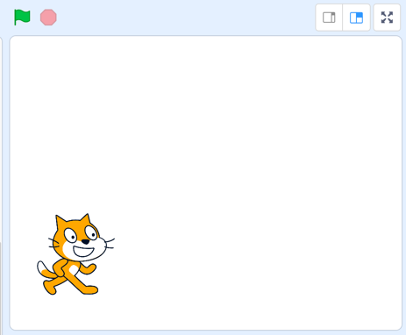

1. **Find Some Images to Use as Slides (Backdrops)**

The Slideshow that you create will have different Slides, which will be the **backdrops** in Scratch. In this step, you should find some images related to the topic that you chose, which you would to like to use for the different Slides. The topic chosen for the example Slideshow is the city of Sydney, so the screenshots and examples will involve pictures and information related to Sydney.

Where possible, you should use images and music in Scratch that are licenced under a [Creative Commons](https://creativecommons.org/) licence. Some of the Creative Commons licences allow for images and music to be used and modified for non-commercial purposes and without acknowledging the original authors.

To find the images of Sydney used in the example slideshow, we used the <https://search.creativecommons.org/> website. This has links to other websites (such as Google image search) that you can use to search for images that are licenced under a Creative Commons licence. We first clicked on the “Google Images” button and then searched for “Sydney” to find these images.

We found three images, downloaded them and named them **sydney_1**, **sydney_2** and **sydney_3**, as shown below, when downloading them. Note that I used a mac computer when creating this tutorial, so these images may look different on a Windows computer.

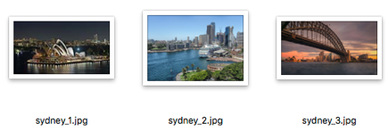

You should aim to find three or more images that are related to your chosen Slideshow topic to download. Once you have downloaded these images, you will then upload these images to Scratch in the next step.

1. **Upload the Backdrops and Delete “backdrop1”**

Scratch allows you to create your own Sprites and Backdrops through the Paint editor. You can also upload images that you have found on the internet, such as the images that you downloaded in Step 2.

In the step, you will upload the images as **backdrops** for the **Stage**.

Firstly, make sure that you have the Stage selected, as we want to add **backdrops** to the project. **Backdrops** are only able to be changed from the Stage (backdrops cannot be uploaded when a Sprite is selected). When the Stage is selected, the Stage label should be blue and there should be a blue glow around the Stage section, as shown in the image below.

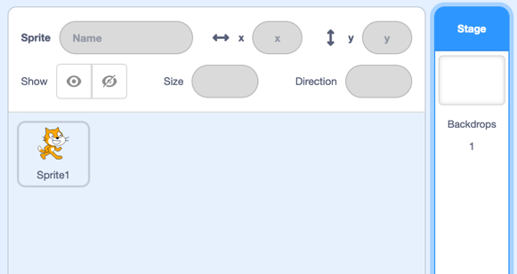

Now, you should select the **Backdrops** tab for the Stage, which is highlighted in orange in the image below.



You may notice that there is already a **backdrop** there – a blank white image called **backdrop1** – you should leave that there for now. Next, you should upload the images that you downloaded in the last step. You can do this by first hovering over the “*Choose Backdrop”* button (highlighted by a green rectangle in the image below), which is at the bottom of the **Backdrops** tab and thenclicking the “*Upload Backdrop*” button, which is highlighted by a red rectangle in the image below.



When you click this button, an open file window will appear. You should select each of the images you downloaded in the last step, to use as Slides in your Slideshow, and upload them. If you need help with uploading images, [there’s a video that walks through this process here](https://www.youtube.com/watch?v=e_KIAkX4kiU). That video shows how to upload a backdrop in the previous version of Scratch (Scratch 2.0) but the steps will be similar for Scratch 3.

Once you have uploaded the images, you should be able to see each of them as backdrops, along with the blank white backdrop called “backdrop1”. An example of the Backdrops tab that has the three images of Sydney in it is shown in the image below.

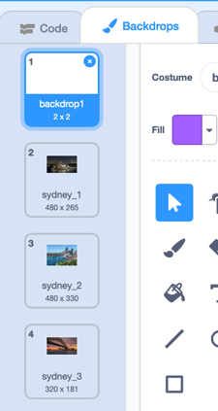

Note that the blue rectangle around “backdrop1” means that that is the selected **Backdrop** and so the Stage background will only be white. You probably don’t want a blank Slide in your Slideshow, so you should now remove that “backdrop1” Backdrop. To do this, you can click on the *x* on the top-right corner of the Backdrop, which is highlighted by an orange rectangle in the image below.



After you delete “backdrop1”, another Backdrop will be selected, and your Stage will now look different. You should now only have the images that you have uploaded. For example, in the image below only the images of Sydney are in the Backdrops tab now.

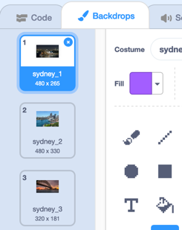

1. **Add Blocks to Switch Between the Slides**

Next, we want to add blocks that will make the Slides (the **Backdrops**) change. The first step is to add blocks that start the Slideshow from the first Slide, when the *green flag* is clicked. As we are going to have the Cat Sprite speak over the Slides as the Slideshow plays, these blocks should be added to the Cat Sprite’s Code tab.

First, make sure that the Cat Sprite (and not the Stage) is selected, as shown in the image below.

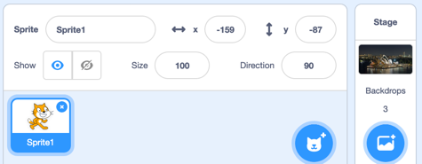

In the *Code* tab, you can then add the following blocks to make the Slideshow “reset” when the *green flag* is clicked. Note that the backdrop name may not be “sydney_1” for you.

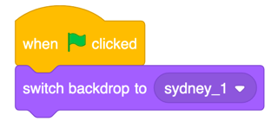

Now, whenever the *green flag* is clicked, the backdrop will change to the first Slide.

Next, you will want to add some blocks that change the backdrops and also have the Sprite (the Cat) explain the topic. For example, in the blocks below the Cat will say: “This slideshow is about the Australian city called Sydney” and then the backdrop will change to the second picture of Sydney.

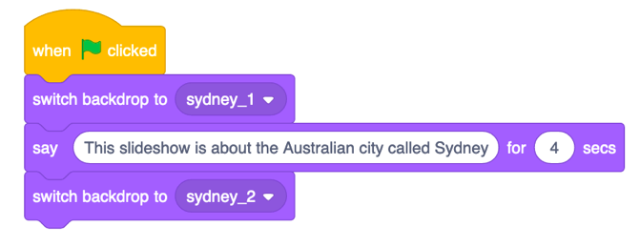

You can use a similar approach to the above blocks to create your Slideshow. You could also use *events* and *user input* to make the Slides change. For example, you could add a *when space key pressed* block to make the Slideshow change to the next Slide. The blocks that I used for my final Slideshow project are shown below.

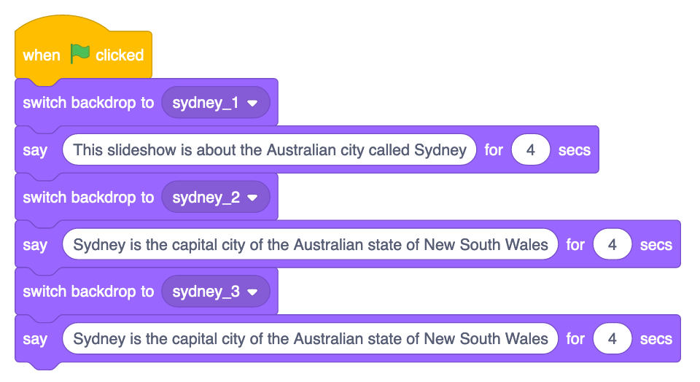

1. **Share the Project and Add it to the Homework Studio**

Once you have completed the previous steps to create the scene, you should share the project and add it to the “STEAM 2019 Week 5 Homework” *Class Studio*. The key steps to complete this task are 1) to share the Project, and 2) add the project to the Studio.

To share the project, you can click the *Share* button when you are within the *Editor* view (the view that has all of the Sprites and blocks). The *Share* button, which is at the top-right corner of the *Editor* view, is highlighted by the red rectangle in the image below:



After clicking on the *Share* button, you will be taken to the Project page, where you can add your project to the studio. To do this, click on the *Add to Studio* button. Next, click the plus icon next to the *STEAM 2019 Week 5 Homework* Studio, which is highlighted by the red rectangle in the image below:



Once you have clicked on the plus icon next to the Studio name, you will notice that the label for the Studio name turns green and a tick appears. Click the *“Okay”* button and the project should be added to the Studio. You can check that the project has been added correctly by going back to the “STEAM 2019 Week 5 Homework” Studio and checking that it is in there. If you cannot see the “STEAM 2019 Week 5 Homework” Studio, this could be because you are logged into your personal or Teacher Account. If you are logged into your personal or Teacher Account, you can skip this step and let me know this in the email you send me about the homework. After you have completed this last task, please email me and let me know, so that I can record that you have finished it.