# University of Newcastle Coding & STEAM 2019

## Week 6 Homework Tasks

**We would prefer that you complete this activity while logged in your Student Account (the account name and password that I sent to you).** If you do complete the homework with your personal or Teacher Account, that is okay but please let me know this through email.

**Your task this week is to remix a project in Scratch**. You can choose one of these five projects in the list below:

* [Teens at the Castle](https://scratch.mit.edu/projects/10128197/)
* [Dance Party](https://scratch.mit.edu/projects/10128067/)
* [Hide and Seek](https://scratch.mit.edu/projects/10128368/)
* [Wizard Spells](https://scratch.mit.edu/projects/11829803/)
* [Cookie Bird](https://scratch.mit.edu/projects/229557976/)

Instead of choosing one of these five projects to remix, you can choose another project that you find through [Scratch’s Explore feature](https://scratch.mit.edu/explore/projects/all) instead, if you would like to.

**After choosing one of those projects, you should then remix it**. You can do this by clicking the *“Remix”* button on the project page, which is highlighted by the red rectangle in the image below.



Alternatively, you can remix a project from the editor view by clicking the *“See inside”* button and then clicking the *“remix”* button at the top of the page.

If you are logged into your Scratch account, this will take a copy of the project, which you can make your own changes to.

**Next, you should make four changes to the remixed project**. These can be any change you like. For example, you may change a Sprite’s colour, change the backdrop or add some new Sprites to the project. You can see some examples of some changes that I made to the Cookie Bird project on the next page, which may help you come up with some ideas for changes you can make in your remixed project.

**You should take note of the four changes that you make to the project because you will need to put these in the** [**Week 6 Homework Form**](https://forms.gle/bjfiP3rWeERMxmBE7) **that you will have to complete as part of the homework task.**

**After you have made the four changes to the project and are happy with the remix you have made, you should share the project and add it to the “*STEAM Week 6 Homework”* Class Studio.** Please note that, to see the “STEAM Week 6 Homework” Class Studio, you should be logged into your Student Account. If you complete the activity in your personal or Teacher account, please let me know so that I can check your project.

**Finally, you should complete the** [**Week 6 Homework Form**](https://forms.gle/bjfiP3rWeERMxmBE7). The form has a few different questions in it. First, there are questions about the project that you chose to remix. Second, there is a question for you to explain the four changes that you made in your remix of the project you chose. The form also has some spaces with questions about identifying how **Sequences**, **Loops**, **Events** and **Parallelism** (some of the *Computational Concepts*) are used in the project you remixed. For each of these questions, if the particular concept (for example, **Sequences**) is used in the project, you should give an example of how that concept is used. For example, in the Cookie Bird project above, you could respond to the question *“Are Events used in the Scratch project you remixed? If so, how?”,* with the response *“An example of an event is that when the green flag is clicked, then the Bat Sprite will begin animating and moving up and down on the Stage”.*

**When you submit the Week 6 Homework Form, I will automatically receive an email and will check your homework task.** So, you will not have to email me when you have completed the homework task this week, unless you completed the project in your personal or Teacher account. I will email you once I have checked the homework and let you know that I have recorded that you have completed the homework task.

On the next two pages, I have included an example of a project (Cookie Bird) being remixed and have shown four changes that I made to the remixed project.

## Cookie Bird Remixing Example

This section has been included to show you some ways that you can make changes to projects. You do not have to make these changes yourself (or change the Cookie Bird project); these are included simply as an example of four changes that could be made to a project.

First, I remixed the Cookie Bird project, which creates a copy of the project for me to change. A screenshot of the original project is shown below.

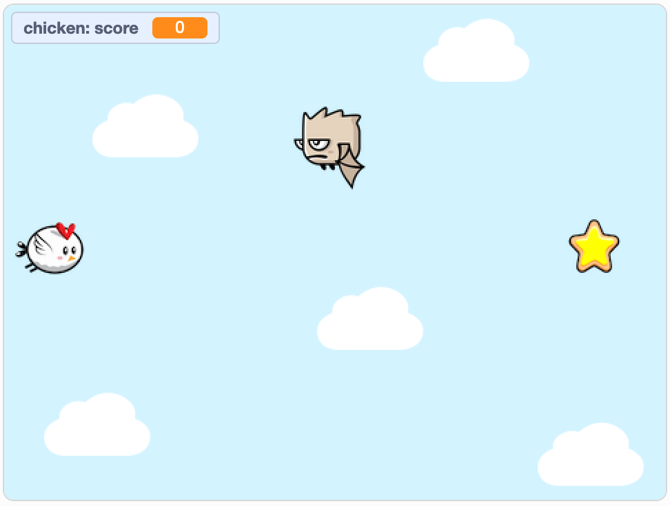

The first change I made to the project was to change the Backdrop to the “Woods” image, from the Scratch library.

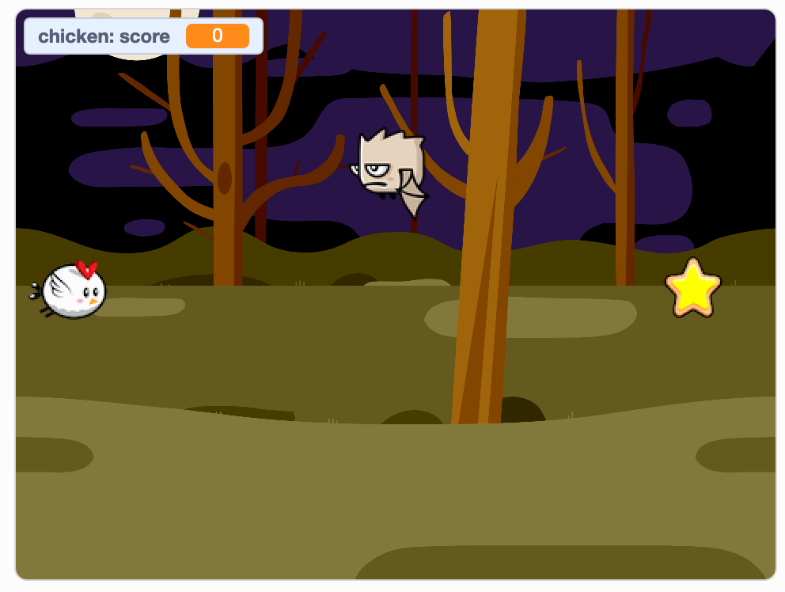

The second change I made was to the Cookie Sprite. I changed the Sprite’s costume to look like a Fortune Cookie (from the Scratch library), rather than a Star.

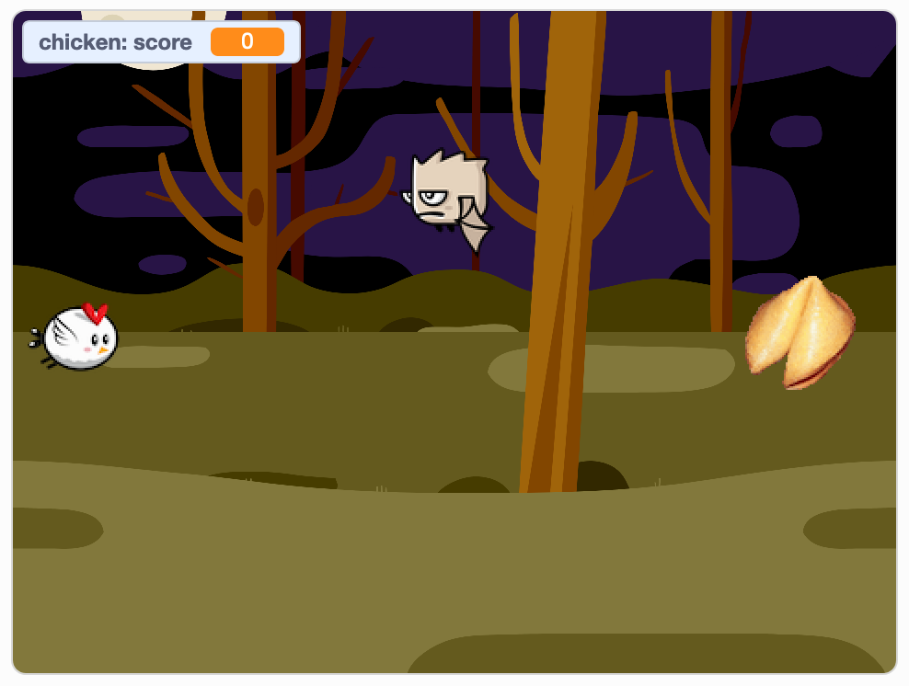

The third change I made was to duplicate the Bat Sprite, so that there were now 2 Bat Sprites on the Stage. I also had to add some blocks to make the Bat sprites appear at different spots on the Stage.

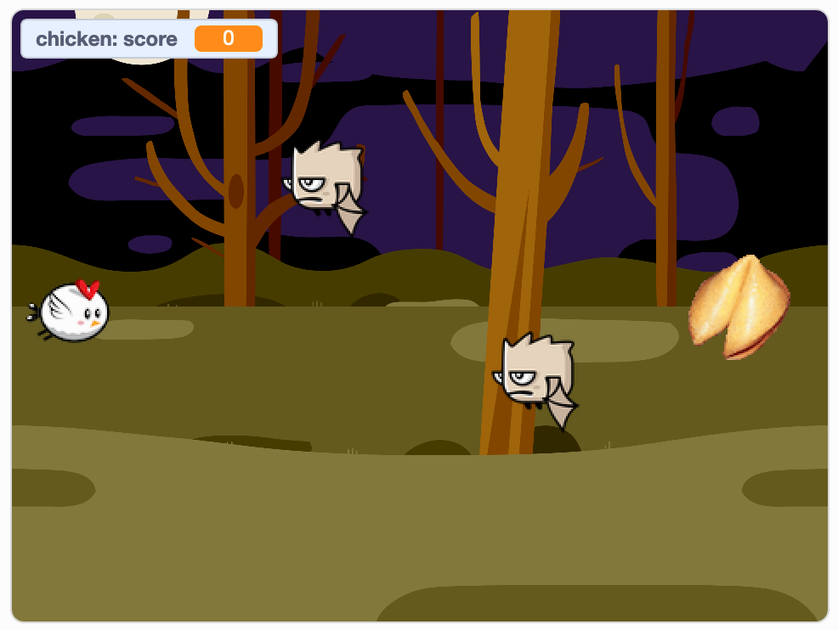

Finally, the fourth change I made was to add blocks that made the Cookie Bird change “levels” after the Chicken reaches the Cookie. I added some blocks (including the *switch backdrop* block) to make the Backdrop change to the Space image, to make it so that the “level” changes.

