9/28/09
Agenda:
>>Recursion
>>Call Stack
>>Complexity/Efficiency
>>Sorting
>>GDB!

Recursion (versus iterative, which runs through and stops)
- elegant, more literal translation—sometimes (can follow the logic better)
  - when a program calls on itself
  - carries out a task by repeating smaller, similar tasks
  - keeps “track” of a previous state

Example: Mathematical Factorial
-Recursive:

unsigned int
factorialr(unsigned int numr)
{
//base case!
if(numr <=1)
return 1;
else
return numr * factorial(numr -1);
}

-Iterative:
unsigned int
factoriali (unsigned int numi)
{
int total;
for(total = 1; numi>0; numi--)
{
total=total*numi;
}
return total;
}

Think, if num = 5….. 5! = 5*4!, 4! = 4*3!, 3! = 3*2!, 2! = 2*1!, 1! = 1*0!, 0! = 1.
(Show the recursive thinking)

Let’s see how Recursive Functions work…..
- For Recursive, recall The Call Stack
  - When a function is called, it gets its own space, called a “frame,” in memory
  - Frames stack on top of each other (like stack of dirty dishes that pile up)
  - Top one = “active frame;” when it gets resolved, it poofs & next frame = active.

| | (Draw a stack frame—bottom up!)
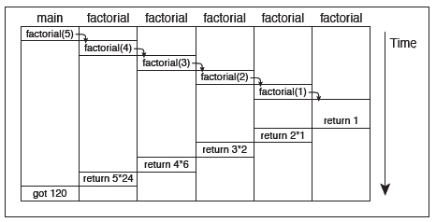
| foo() |
| | |_foo() args__|
| |
| main() |
| |
|_main() args_|

To write a recursive function:
- Figure out when to stop (base case)
- Figure out what’s repeating (recursion), how the output of one relates to the next
- Write it.

Example: Write a function to sum the digits of an integer
.: Base case: when at last digit
.: Recursion: sum digit x with x-1

int sum_digits (unsigned int number)
{
//base case: at the last digit
if(number/10 == 0 )
return number;

//recursion: returns (the one’s digit/remainder) + (put int with last digit cut off back
into function)
else
return number%10 + sum_digits(number/10);
}

- Disadvantages:
  - Space
  - Time
    - Have to resolve frames
    - Ex: factorial for smaller numbers: table
Linear search: O(n) – number @ end,
θ(n/2) – on avg, find it halfway thru
Ω(1) – find it on first try

BubbleSort: O(n²) – have to go thru line n times, each going thru is n
θ(n²), Ω(n)-have to go thru line once to check order

Complexity/Efficiency
Big O – Worst Case
Theta – Expected Case
Omega – Best Case

n – size of input
f(n) is the time it takes to run the operations, proportional to n but independent of n

We care more about the order of the function; throw out constant values.
(Like in calculus where we take the limit as n goes to infinity)

Lots of Big O types: constant < log < linear < polynomial < exponential < factorial
Big O functions can be combined:
O(f + g) = maximum of O(f), O(g)
O(f * g) = O(f) * O(g)

Ex:
g:
for(i=0; i<n; i++)
{
for(j=0; j<n; j++)
{
//do stuff that’s in constant time
}
}

f:
for(i=0; i<n; i++)
{
//do stuff that’s in constant time
}

f= O(n); g=O(n²); f+g = O(n²) + O(n)

Recursive functions -> Harder to tell!
In general:
O(log n) when divides data in half, does recursion on only that half
– like binary search
O(n log n) when divides data in half, does recursion on both halves, then combines the halves.
– like mergesort (log n for the recursion * n for combining—remember Malan running
fingers forward on board?)
O(n²) when takes an element, and does something with it involving the rest of the data before repeating
– like selection sort or bubble sort (compares the selected value against others), but usually
implemented iteratively, not recursively

Sorting
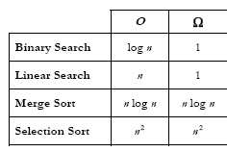
Selection Sort - O(n²) for best, worst, exp
1) Look for smallest number in unsorted part
2) Switch it with the first slot of unsorted
3) Repeat

Ex: (Ask for five numbers out of order?!)
| 3 5 2 6 4
2 | 5 3 6 4
2 3 | 5 6 4
2 3 4 | 6 5
2 3 4 5 | 6 (6 is only value left, done)

Insertion Sort - O(n²) for worst, exp
1) Look for smallest number in unsorted part
2) Put it in front, push rest down
3) Repeat

Ex:
| 3 5 2 6 4
2 | 3 5 6 4
2 3 | 5 6 4
2 3 4 | 5 6
2 3 4 5 | 6 (6 only value left, done)

Bubble Sort – numbers “bubble” up and down to respective places
1) Go down numbers, if two adjacent numbers are out of order, swap ‘em
2) When at end of list, repeat if swaps were made

Ex:
3 5 2 6 4 ----- (5, 2), (6, 4)
3 2 5 4 6 ----- (3, 2), (5, 4)
2 3 4 5 6 ----- no swaps -> 2 3 4 5 6

Merge Sort
Sort (list of n)
If n < 2, return.
Else
Sort left half.
Sort right half.
Merge sorted halves.

O(n log n) because divide each set in half -> log n levels
At each level, n comparisons are made to merge

GDB!!! Debugging!
To run:
name@nice (~): gdb <executable>
<executable> is your compiled file, like mario, not mario.c

name@nice (~): gdb <executable> core
will restore the conditions at the time of core dump, post mortem examination

name@nice (~): gdbtui <executable>
takes over terminal, show source code too

Handy GDB Commands! (by Rose Cao)
To begin, type one of the following into the command line:
gdb <executable> - where <executable> is the program
gdb <executable> core - to see a snapshot of the program when it segfaulted
gdbtui <executable> - to see the source code too

Nifty gdb commands:
break main - sets a breakpoint at main(), right before entering the program
break <function_name> - sets a breakpoint right before executing the function
break <line#> - sets a break right before line# gets executed
info break - lists all the breakpoints
delete <#> - deletes breakpoint numbered <#>
clear <function_name> - deletes breakpoint at <function_name>

run - runs the program, stopping when it hits a breakpoint
run <argv[1]> - runs the program with a command line argument, can have more than one
step - goes to the next line, steps “into” a function
step <#> - goes down <#> steps
next - goes to next line, skipping functions it might encounter
next <#> - goes down <#> lines, skipping encountered functions
continue - continues executing code until it hits a breakpoint or exits

list - spits out lines of code above and below where the program is currently (stopped) at
print <var_name> - prints the value of a variable
print/x <var_name> - prints the value of a variable, but in hex
x <var_name> - examines <var_name>, like the print command
x/s <var_name> - examines <var_name> displayed as a string, can use /#c for num of chars to show
backtrace - shows a list of running functions
help - for help on gdb commands
kill - stops the program being executed
quit - quit/exit gdb
(Blue font means it’s important and you’ll probably use it often. ☺ )

Typing Shortcuts:
b = break
i = info
d = delete
r = run
s = step
n = next
c = continue
l = list
p = print
bt = backtrace
k = kill
q = quit
Adapted from Alex Chang’s compiled handout

Recursion Practice:
>> Write a function to print the characters of a string:
void print_chars(char strng[], int size)
{
// Only one character to print, so print it!
if (size == 0)
printf("%c\n", strng[size]);
//print chars after func ends
else
{
print_chars(strng, size-1); //to pass in an array!
printf("%c", strng[size]);
}
}

>>Write a function to countdown (print) from a number to one and back up.
void print_recur(int num)
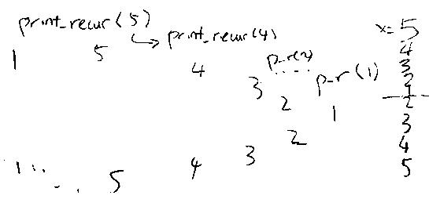
{
if(num == 1 ) //base case!
{
printf(“%d\n”, num);
return num;
}
else
{
printf(“%d\n”, num); //printing the first set
print_recur(x-1);
>>What’s this do?
bool
even(unsigned int n)
{
return (n==0) ? true : odd(n-1);
}

bool
odd(unsigned int n)
{
return (n==0) ? false : even(n-1);
}

printf(“%d\n”, num); //printing the second set
}
}

>>What does fs(4) return?
How many happy faces does it print?
int fs (int num)
{
printf(“^_^\n”);
if(num ==0)
return 0;
>>What does this function do?
int mystery(int num1, int num2)
{
if (y==0)
return 1;
else
return x*mystery(x, y-1);
}
Calculates x^{y}.
else if (n==1)
return 1;
else
return (fs(num-1) + fs(num-2));
}
3, 9

>>Write a recursive function to print the digits of an integer.
See sum_digits, except without the summing and a printf.

