**Implementation of Our ChemCam Simulation:-**

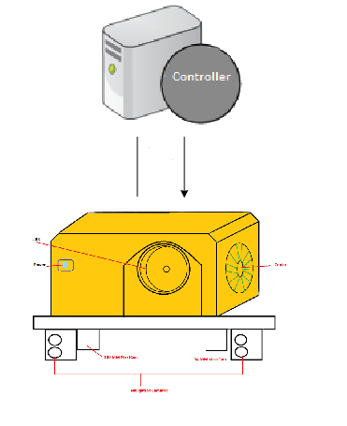

**Two-Way Communications**:-

We have two modules for our program. The first module is the Controller that sends list of commands to the Agent, and listens for report sent back from the Agent. The second module is the Agent that listens for commands, processes and sends the result back to the Controller.

**Implementation of Our Agent Processing Queue**:-

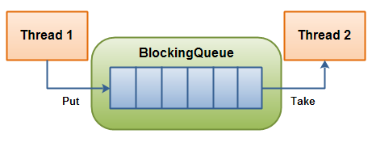

**A Blocking Queue with one thread putting into it, and another thread taking from it.**

* Thread 1 is the Agent’s server thread, which puts a list of commands and queue number into the blocking queue.
* Thread 2 is the Agent’s client thread, which takes a list of commands and queue number from the blocking queue and processes the commands. It then sends the report back to the controller.

**How to compile and run:**

* **Clone** this down to your pc
* **Add the library** /libs/gson-2.3.1.jar to your build path.
* **For Eclipse IDE:** run the /ChemCamSimulator/src/chemcam/Main.java
* **For Netbeans IDE:** Click Run drop down option and pick Run Project (ChemCamSimulator)
* **The GUI** should be very self-explanatory. There are 4 buttons:
  + Clear button is to clear command editor.
  + Send button is to send commands, after you are done editing them.
  + Load is to load predetermined text file. The file should be here <wherever-you-cloned>\ChemCamSimulator\src\chemcam\data\commands.txt
  + Save button is to save the commands that you have edited to anywhere you want.
* There are of course checks in place to make sure you are not sending bogus command or incomplete commands list to the agent.
* There's also a **drop down menu** for you to select predetermined commands. Checks are also in place for this functionality.

**Commands**:-

* **CCAM_COOLER_ON:** It is used to turn on the cooler.
* **CCAM_COOLER_OFF:** It is used to turn off cooler.
* **CCAM_POWER_ON:** It is used to turn on the system.
* **CCAM_POWER_OFF:** It is used to turn off the system.
* **CCAM_SET_FOCUS:** It is used to focus the identified object.
* **CCAM_LASER_ON:** It is used to turn on laser beam.
* **CCAM_LASER_OFF:** It is used to turn off laser beam.
* **CCAM_CWL_WARM:** It is used to warm CWL(continuous-wave laser).
* **CCAM_LIBS_WARM:** It is used to warm LIBS.
* **CCAM_FIRE_LASER:** It is used to fire the laser beam to focused object.