The three SAM instruments are supported by a sample manipulation system (SMS) and a Chemical Separation and Processing Laboratory (CSPL) that includes high conductance and micro valves, gas manifolds with heaters and temperature monitors, chemical and mechanical pumps, carrier gas reservoirs and regulators, pressure monitors, pyrolysis ovens, and chemical scrubbers and getters. The Mars atmosphere is sampled by CSPL valve and pump manipulations that introduce an appropriate amount of gas through an inlet tube to the SAM instruments. The solid phase materials are sampled by transporting finely sieved materials to one of 74 SMS sample cups that can then be inserted into a SAM oven and thermally processed for release of volatiles. The SAM mechanical configuration and a top level schematic of its sample flow configuration are illustrated below.

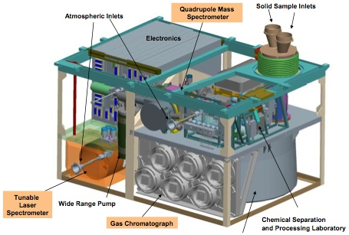

**The illustration of the mechanical configuration of SAM shows the three instruments and several elements of the Chemical Separation and Processing Laboratory.**

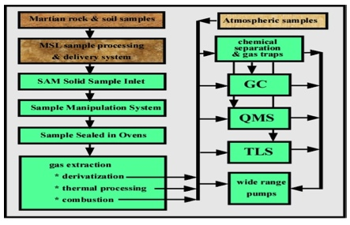

**The path of solid and gas samples delivered by MSL subsystems to the SAM instruments is shown. Arrows designate the direction of gas and solid transport.**