

**TITLE:**

Implementation of Network File System [ NFS ]

**AIM:**

To implement Network File System [ NFS ] to show

1. Mouting, unmounting of a file system
2. Addition and Deletion of Files

**OBJECTIVE:**

To understand the concept of Network File System [ NFS ]

**THEORY:**

Describe NFS

NFS (Network File System):

NFS is a distributed file system protocol that allows clients to access files and directories stored on remote servers over a network. It enables seamless file sharing and collaboration among users across different platforms and operating systems. NFS provides a way for clients to access remote files as if they were stored locally, abstracting away the complexities of network communication and storage management.

Mounting and Unmounting of Remote Files:

Mounting:

Step 1: Identify the remote file system to mount. This typically involves determining the network address or hostname of the NFS server and the path to the shared directory.

Step 2: Choose a local directory on the client system where you want to mount the remote file system. Ensure that the directory exists and is empty, as mounting will overlay its contents with the contents of the remote file system.

Step 3: Use the mount command to mount the remote file system. For example:

mount -t nfs <NFS_server>:/

Step 4: After executing the mount command, the remote file system will be accessible through the specified local directory. Users can navigate to this directory to access files and directories stored on the NFS server as if they were stored locally.

Unmounting:

Step 1: Ensure that no processes or applications are actively accessing files or directories within the mounted NFS file system.

Step 2: Navigate out of the mounted directory to ensure that no active file handles are open.

Step 3: Use the umount command to unmount the NFS file system. For example:

umount <local_mount_point>

Explain mouting and unmounting of remote files

Give all steps to accomplish the NFS

**INPUT:**

Addition or deletion of a file in the file system

**OUTPUT:**

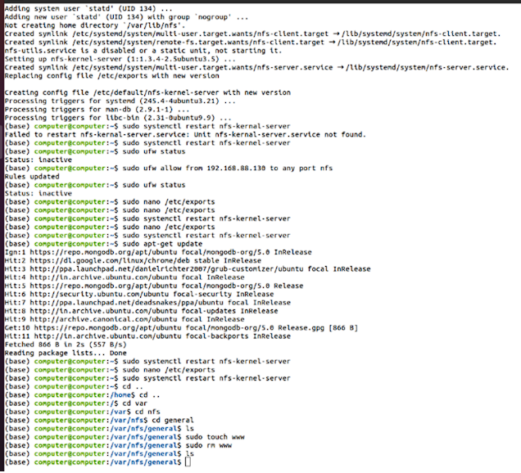

**CONCLUSION:**

The NFS was accomplished for file related functionalities

**PLATFORM:**

Linux

**LANGUAGE:**

C language.

FAQs

1. Explain mounting and un-mounting of files

Answer

Mounting: In computing, mounting refers to the process of making a file system available for access within a directory hierarchy of another file system. When a file system is mounted, its contents become accessible to the operating system and applications as if they were part of the local file system. This allows users to access files and directories stored on remote servers or storage devices as if they were stored locally. Mounting typically involves specifying the source of the file system (e.g., device or network location) and the target mount point (directory) where the file system will be attached.

Un-mounting: Un-mounting is the process of detaching a mounted file system from the directory hierarchy, thereby making its contents inaccessible to the operating system and applications. Un-mounting is necessary before removing or disconnecting storage devices, terminating network connections, or performing maintenance tasks on the file system. It ensures data integrity and prevents data corruption by ensuring that no active processes or applications are accessing the file system before it is un-mounted.

1. What are the other file systems like the NFS?

Answer

Other file systems similar to NFS include:

CIFS/SMB (Common Internet File System / Server Message Block): CIFS/SMB is a file sharing protocol used primarily by Windows operating systems. It allows users to access files and printers shared by remote servers or devices on a network. Samba is an open-source implementation of the CIFS/SMB protocol for Unix-like operating systems.

AFS (Andrew File System): AFS is a distributed file system developed at Carnegie Mellon University. It provides features such as global file namespaces, access control lists (ACLs), and file caching to improve performance and scalability in distributed computing environments.

DFS (Distributed File System): DFS is a file system that allows users to access files and directories stored on multiple servers as if they were part of a single logical file system. DFS provides fault tolerance, load balancing, and transparent failover capabilities to improve reliability and availability in distributed environments.

1. What communication protocols are used for NFS?

Answer

NFS typically uses the following communication protocols for accessing remote files over a network:

NFS Protocol: The NFS protocol itself defines the communication protocol used between NFS clients and servers. It specifies the format of NFS requests and responses, as well as the rules for accessing files and directories on remote servers.

TCP/IP (Transmission Control Protocol / Internet Protocol): NFS can operate over TCP/IP, which is the standard networking protocol suite used on the Internet and most local area networks. TCP/IP provides reliable, connection-oriented communication between NFS clients and servers, ensuring data integrity and delivery.

UDP (User Datagram Protocol): NFS can also use UDP for communication in environments where low-latency and high-throughput are more important than reliability. UDP is a lightweight, connectionless protocol that is well-suited for streaming media and real-time applications. However, UDP does not provide the reliability and error correction features of TCP, so NFS over UDP may be less suitable for critical data and file access operations.