

**TITLE:**

Installation of VMWare workstation on a windows or Ubuntu server platform as per requirement.

**AIM:**

To Install VMWare workstation on a windows or Ubuntu server platform

**OBJECTIVE:**

To understand the concept VMWare and its working

**THEORY:**

Cloud computing refers to the delivery of computing services over the internet, allowing users to access and utilize resources such as storage, processing power, and applications without the need for on-premises infrastructure. These services are typically provided by large-scale data centers operated by cloud service providers like Amazon Web Services (AWS), Microsoft Azure, and Google Cloud Platform (GCP).

Key components and characteristics of cloud computing:

On-demand self-service: Users can provision and manage computing resources, such as server instances or storage, without human intervention from the service provider.

Broad network access: Services are available over the network and can be accessed through standard mechanisms like web browsers or mobile devices.

Resource pooling: Providers serve multiple users with shared resources to optimize efficiency and scalability. Resources are dynamically assigned and reassigned according to demand.

Rapid elasticity: Resources can be rapidly scaled up or down to accommodate changes in demand. This scalability ensures that users have access to the resources they need without delays.

Measured service: Cloud systems automatically monitor and optimize resource usage, providing transparency for both providers and users. Users typically pay for the resources they consume on a pay-as-you-go or subscription basis.

Cloud computing offers several benefits, including:

Cost-effectiveness: Users can avoid upfront infrastructure costs and pay only for what they use.

Scalability: Resources can be scaled up or down quickly to meet changing demand.

Flexibility: Users can access resources from anywhere with an internet connection.

Reliability: Cloud providers typically offer high levels of reliability and uptime through redundancy and failover mechanisms.

Virtualization is the process of creating a virtual (rather than actual) version of something, such as a server, storage device, network, or operating system. In computing, virtualization typically refers to the creation of virtual machines (VMs) or virtual environments that emulate the functionality of physical hardware.

Virtual Machines (VMs): A VM is a software emulation of a physical computer that runs its own operating system (guest OS) and applications as if it were a separate physical machine. Multiple VMs can run on a single physical server, each isolated from one another and sharing the underlying hardware resources.

Working of virtualization and its key components:

Hypervisor: Also known as a virtual machine monitor (VMM), the hypervisor is software that creates and manages VMs on physical hardware. It abstracts the underlying hardware resources and allows multiple VMs to run concurrently, each with its own virtualized hardware components.

Virtualization Layer: This layer sits between the hardware and the operating systems or applications running on VMs. It provides a level of abstraction that enables VMs to access and utilize the underlying physical resources without direct interaction with the hardware.

Types of Virtualizations:

Full Virtualization: The guest OS runs unmodified on the VM, and the hypervisor handles all interactions with the underlying hardware.

Para-virtualization: The guest OS is aware that it is running in a virtual environment and communicates with the hypervisor to optimize performance.

Hardware-assisted Virtualization: Utilizes hardware support from the CPU (e.g., Intel VT-x, AMD-V) to improve virtualization performance and efficiency.

Benefits of Virtualization:

Server Consolidation: Multiple virtual servers can run on a single physical server, reducing hardware costs, and improving resource utilization.

Isolation and Security: VMs are isolated from one another, enhancing security by preventing one VM from impacting others.

Flexibility and Scalability: VMs can be easily provisioned, migrated, and scaled to meet changing workload demands.

Disaster Recovery and High Availability: Virtualization enables easy backup, replication, and restoration of VMs, improving resilience and business continuity.

VMware is a leading provider of virtualization software and services. Their flagship product, VMware vSphere, is a comprehensive platform for virtualizing data centers and running cloud infrastructures.

Working of VMware:

Hypervisor Technology: At the core of VMware's virtualization solutions is their hypervisor technology. VMware offers two primary hypervisors:

VMware ESXi: A bare-metal hypervisor that runs directly on the physical server hardware without the need for a separate operating system. ESXi provides a lightweight and efficient virtualization layer that abstracts the underlying hardware and manages VMs.

VMware Workstation and VMware Fusion: These are Type-2 or hosted hypervisors, which run on top of an existing operating system. They are typically used for desktop virtualization, allowing users to run multiple operating systems and applications on a single physical machine.

Virtual Machines (VMs): VMware allows users to create and manage virtual machines, which are isolated instances of operating systems and applications running on virtualized hardware. Each VM has its own virtualized CPU, memory, storage, and network interfaces, providing flexibility and scalability.

VMware vCenter Server: vCenter Server is a centralized management platform that enables administrators to efficiently manage and monitor their virtualized infrastructure. It provides features such as:

Resource Management: Allocating and optimizing CPU, memory, storage, and network resources across VMs and hosts.

High Availability: Ensuring the availability of VMs by automatically restarting them on healthy hosts in the event of a failure.

VMware vMotion: Live migration of running VMs between hosts with zero downtime, allowing for workload balancing and hardware maintenance.

VMware Cloud Services: VMware offers a range of cloud services and solutions, including VMware Cloud on AWS, VMware Cloud Foundation, and VMware Cloud Director. These services enable organizations to extend their on-premises VMware environments to the cloud, providing flexibility, scalability, and agility.

**INPUT:**

Decide the installation environment parameters

**OUTPUT:**

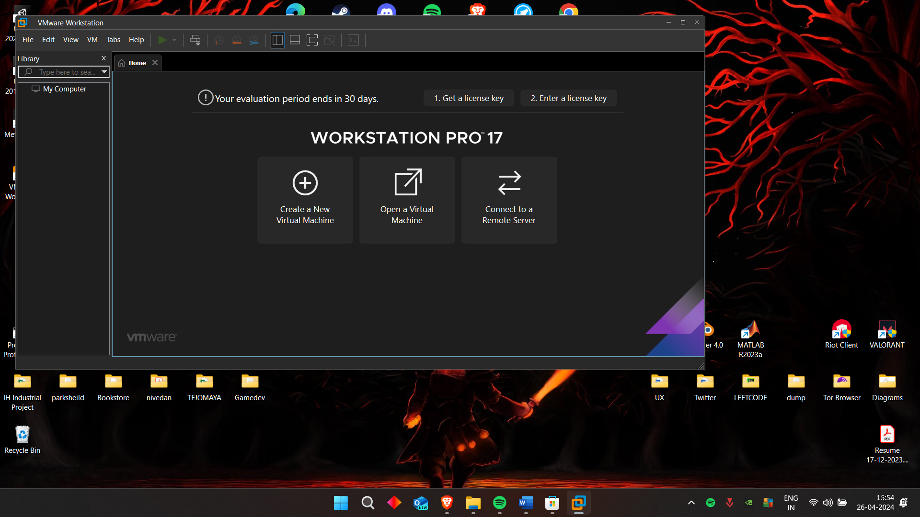

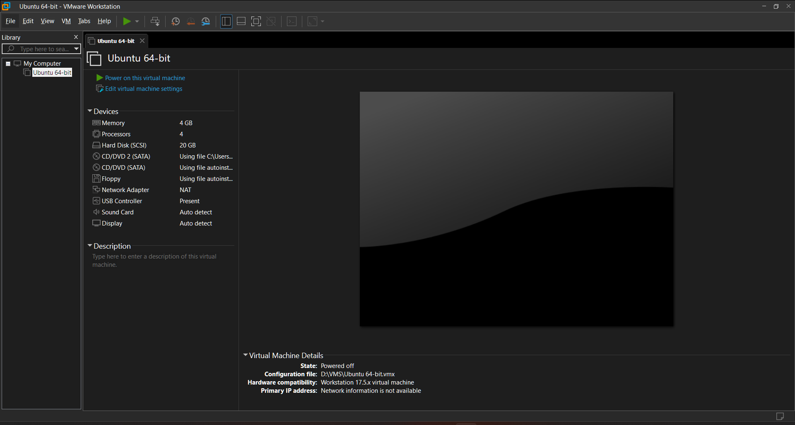

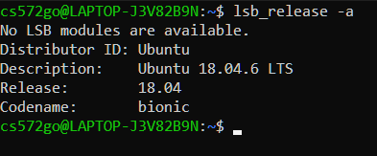

**CONCLUSION:**

The VMWare installation was accomplished.

**PLATFORM:**

Linux

**LANGUAGE:**

C language.

FAQs

1. Explain the types of virtualizations.

Answer:

Virtualization comes in various forms:

* Server Virtualization: Divides a physical server into multiple virtual servers, each running its own operating system.
* Desktop Virtualization: Runs multiple virtual desktops on a single physical machine, providing users with remote access to desktop environments.
* Network Virtualization: Abstracts network resources, enabling the creation of virtual networks that operate independently of physical infrastructure.

1. What are the VMWare applications

Answer

VMware offers several applications:

* VMware vSphere: A comprehensive virtualization platform for data centers.
* VMware Workstation: Enables desktop virtualization for developers and IT professionals.
* VMware Fusion: Like Workstation but for macOS users.
* VMware Cloud on AWS: Integrates VMware software with AWS cloud services.

1. Give example of a Virtual Server

Answer:

An example of a Virtual Server is a virtual machine running on VMware vSphere, hosted on a physical server. This virtual server operates independently of other virtual servers on the same hardware and can run its own operating system and applications. Users can provision, manage, and scale virtual servers dynamically to meet their computing needs efficiently.