**e-Yantra CS684 Project Proposal - 2016**

**System Requirement Specifications (SRS)**

**Title: rāgam (ˈrɑːɡɑːm)**

**Project Members: Bharat Reddy, Diptesh Kanojia, and Vinod Saini**

**Abstract (5 mks):**

Our project aims to develop a device which should essentially be able to stream music from a laptop or a mobile device, and route the streaming audio to speakers connected to the device (preferably standard 3.5mm audio jack). Initially we aim to stream music files with lower bit rate, and later optimize the device to receive high quality music. Additionally, in our project we would try to downsample the music and stream it over an FM Radio frequency. Later, We aim to make the product portable and cost-effective for the Indian market.

**Introduction/Motivation (5mks):**

Wired speakers with 3.5mm jack have been used to play music at concerts and home. As we know that, wired devices have to connected through wires all the time and a small disruption in connection leads to unpleasing experience. Wireless solutions (like bluetooth, wifi) can be used to get rid of wiring problem. There are bluetooth based music streaming available in the market, but it reduces the audio quality. There are WiFi based solution which are either not available in India or costly (Sonos, Gramofon).

The cost of a Bose SoundTouch 10- wireless music system which is enabled with wifi and bluetooth is 200 USD (approx 14000 Rs). Chromecast has been a wonderful product which transmits video/audio wirelessly, but it has been limited to mobile based applications. A python based hack is available for streaming music from PC, but there is a lag in audio/video broadcasting. We will be providing a solution to existing music system where the speakers can be plugged with the devices which has WiFi connectivity and we can easily broadcast the audio from anywhere within the limited range with high quality (320Kbps).

**Literature Survey/Prior Artwork (10mks):**

Trippy: A small wifi dongle to connect 3.5mm jack speaker to any wifi based devices to stream audio. The product was available on witworks for crowdfunding which did not raise enough to be launched in the market. The technical specification of the product was: Micro USB charging point, size: 85 mm diameter 20 mm height, Wi-fi hotspot mode at 802.11 b/g/n, supported audio codec: MP3 FLAC, WAV, 1000 mAh LiPo battery which could run for 5 hours without charging. This product is an app based platform where the device is connected through the app, which can’t be used to broadcast audio from PC/ TV.   
ChromeCast Audio, WiFi enabled speakers have been there in the market, but do not prove to be cost-effective / seamlessly working.

Sonos Play:1, Bose SoundTouch 10 are enabled with wifi technology, but it comes with a higher cost. Gramofon has been an interesting solution to turn existing music system into wifi music player, but it has been limited to the clouds (internet radio stations, online music services).

**Problem Statement (15mks):**

* To develop a device which can stream audio from PC / Mobile to speakers.
* The device should make use of Wi-Fi wireless protocol to receive data.
* It should be able to stream higher bitrate audio (usually 320 Kbps).
* The device should be able to perform without any lags whatsoever.
* Additionally, the device can be made to transmit music over FM frequency thus making it accessible over a large range (across rooms).

**Hardware requirements (15mks):**

1. Raspberry Pi / Arduino (primarily testing)
2. Wireless router (primarily testing)
3. PC / Laptop / Mobile Device (programming and testing)
4. USB sound card (good quality)
5. FM Transmitter and Receiver
6. Wires to connect (Power, LAN, Audio cable etc.)
7. Power Sockets with Electric Supply!

**Software requirements (15mks):**

1. Python / CPP (Writing API to transmit audio)
2. RaspbianOS / JessieOS / Energia (Arduino)

**Implementation (30mks):**

We would send the data from PC through WiFi router by connecting our device to the router. Our device, when connected to the router would get an IP through router DHCP, and should be able to listen on a particular port for audio stream.

The PC should be able to stream to that port through the router (router today are muPnP enabled). The device should have a sound card module connected for better quality, and should be able to interface with it, after which, the streamed music should be played on the sound card to the standard target 3.5mm audio jack.

The audio jack would have a 2 channel speakers connected to it, using which we should be able to listen to the audio.

* We would have to configure the RPi to receive audio through router.
* We would have to write APIs on PC to stream audio being played through WiFi protocol

For implementing a FM module, we should be able to transmit the audio to an FM frequency, which should be accessible over a short range (in the house).

Pictorially, the implementation diagram would be something like this:

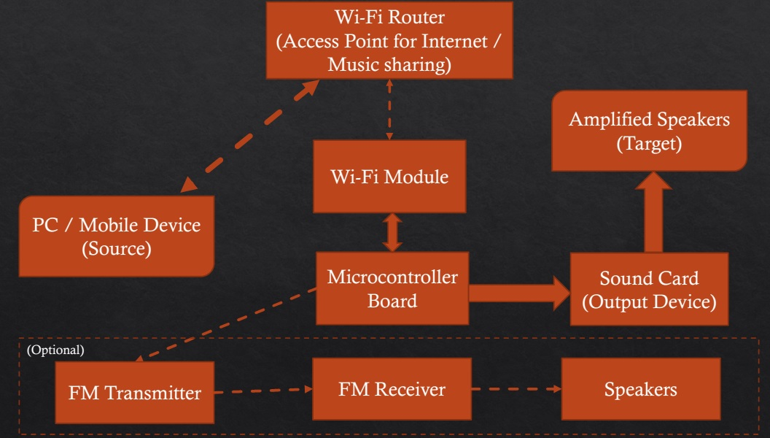

**Feasibility (10mks):**

Based on our literature survey, it is quite feasible to implement this idea. There has been some amount of work done in this area where audio is transmitted via mobile based applications. We might face some problem with high quality audio transmission due to allocated bandwidth for other communication. One way to deal with this problem is to have a predefined bandwidth for audio streaming which should not be compromised while streaming. As our plan is to use Raspberry with wifi module, which may increase the cost of the device, but it can be reduced if a dedicated device is used for the required functionalities.

**References:**

Links:

[http://make.witworks.com/preorder/trippy](http://make.witworks.com/preorder/trippy#comments) [5th September 2016]

<https://gramofon.com/> [15th September 2016] <https://www.bose.com/en_us/products/speakers/wireless_speakers/soundtouch-10-wireless-system.html> [15th September 2016]