Week-3 PSOSM 2023

- Consider the below response:
“To this segment, consumer privacy is very important; they feel that they have been victims of privacy invasions, they are pessimistic about the future of privacy protection, and about a third of them favour creating a general federal regulatory agency on consumer privacy.”

To which of the three Westin Privacy categories is "they" in the above sentence most likely to fall?
- Fundamentalists
- Pragmatists
- Unconcerned
- None of the above

2. Which of the following features is used by the credibility model- TweetCred?
- Tweet links
- Tweet Author
- Tweet network
- Tweet meta data

3. Cronbach’s alpha
- determines the statistical significance of a research study.
- assess the reliability and internal consistency of a questionnaire.
- analyze the effect size of an intervention.
- calculate the standard deviation of a sample population.

4. Suppose we have five tweets (TW1, TW2, TW3, TW4, and TW5) with their relevances based on user feedback or relevance labels:
TW1: Highly relevant tweet (Relevance = 2)
TW2: Moderately relevant tweet (Relevance = 1)
TW3: Not relevant tweet (Relevance = 0)
TW4: Relevant tweet (Relevance = 1)
TW5: Highly relevant tweet (Relevance = 2)

Now, let's assume the ranking algorithm generates a ranked list of tweets:

Rank 1: TW5 (Highly relevant tweet)
Rank 2: TW1 (Highly relevant tweet)
Rank 3: TW3 (Not relevant tweet)
Rank 4: TW2 (Moderately relevant tweet)
Rank 5: TW4 (Relevant tweet)

What would be NDCG@5 for this ranked list of tweets?

- 0.5
- .513
- .975
- None of the above

Solution:
Step 1: Calculate DCG@5 (Discounted Cumulative Gain at rank 5).
Step 2: Calculate IDCG@5 (Ideal Discounted Cumulative Gain at rank 5).
Step 3: Divide DCG@5 by IDCG@5 to get NDCG@5.

Step 1: Calculate DCG@5 DCG@5 = rel1 + rel2/log2(2) + rel3/log2(3) + rel4/log2(4) + rel5/log2(5)

Given relevances: rel1 = 2 (for TW5) rel2 = 2 (for TW1) rel3 = 0 (for TW3) rel4 = 1 (for TW2) rel5 = 1 (for TW4)

DCG@5 = 2 + 2/log2(2) + 0/log2(3) + 1/log2(4) + 1/log2(5) DCG@5 = 2 + 2/1 + 0 + 1/2 + 1/2 DCG@5 = 4 + 0.5 + 0.5 DCG@5 = 5

Step 2: Calculate IDCG@5 (Ideal DCG@5) To calculate IDCG@5, we consider the ideal ranking based on relevance:

Ideal ranking: TW5 (Highly relevant tweet) > TW1 (Highly relevant tweet) > TW2 (Moderately relevant tweet) > TW4 (Relevant tweet) > TW3 (Not relevant tweet)

IDCG@5 = rel1 + rel2/log2(2) + rel3/log2(3) + rel4/log2(4) + rel5/log2(5)
For ideal ranking: rel1 = 2 (for TW5) rel2 = 2 (for TW1) rel3 = 1 (for TW2) rel4 = 1 (for TW4) rel5 = 0 (for TW3)
IDCG@5 = 2 + 2/log2(2) + 1/log2(3) + 1/log2(4) + 0/log2(5) IDCG@5 = 2 + 2/1 + 1/1.585 + 1/2 + 0 IDCG@5 = 2 + 2 + 0.63 + 0.5 IDCG@5 = 5.13
Step 3: Calculate NDCG@5 NDCG@5 = DCG@5 / IDCG@5
NDCG@5 = 5 / 5.13
NDCG@5 ≈ 0.975 (rounded to three decimal places)
So, the NDCG@5 for the ranked list of tweets is approximately 0.975.

Read through the report “Privacy in India: Attitudes and Awareness V 2.0” at https://cdn.iiit.ac.in/cdn/precog.iiit.ac.in/research/privacyindia/PI_2012_Complete_Report.pdf
And answer the following questions [5-7].

5. How many participants have changed their default settings on their social network?
- 75%
- 60%
- 50%
- 25%

6. What is the primary purpose of a Focus Group Discussion (FGD) in the above report?

- To conduct one-on-one interviews with participants.
- To collect quantitative data through surveys and questionnaires.
- To observe participants' behaviours in a controlled environment.
- To facilitate group discussions and gather qualitative insights.

7. “When you hear the word privacy, what comes to mind”. Which is the most common respondent answer according to the above report?
- Information Privacy
- Bodily privacy
- Communication privacy
- Territorial privacy

8. Consider the below graph and choose the correct option:
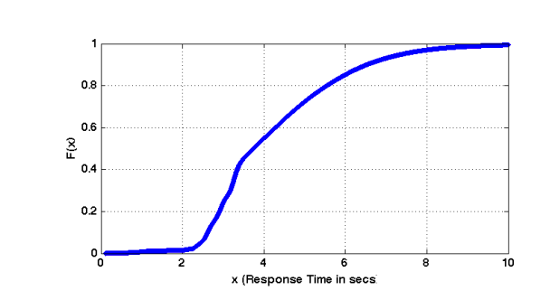

- For 82% of the users, the response time was less than 2 seconds, and for 99%, the response time was under 10 seconds.
- For 99% of the users, the response time was less than 6 seconds, and for 100%, the response time was under 10 seconds.
- For 82% of the users, the response time was less than 6 seconds, and for 99%, the response time was under 10 seconds.
- None of the above

9. What is the Likert scale?

- rating scale in surveys and questionnaires
- gives the score for any real-time tweets
- Interannotator agreement
- None of the above

10. TweetCred is
- a real-time web-based system to automatically evaluate the credibility of content on Twitter.
- a real-time app-based system to automatically evaluate the score of tweets on Twitter.
- a real-time app-based system to automatically assess the quality of content on Twitter.
- None of the above

