|  |  |
| --- | --- |
| Cornell logo | Standard Operating Procedure CIT Academic & Service Management Systems |
| Name | Description | Author | Date | Version |
| media-001 | Connecting to Media3 via SFTP | Tony Lombardo | 03/18/2019 | 0.001 |

Greetings,

You have been granted access to the Academic Technologies web space for the site ewb.engineering.cornell.edu. Please read the following message carefully as it contains important information on how to maintain your site.

You may have already received a confirmation e-mail regarding resetting your Media3 password. It looks something like this:

Welcome

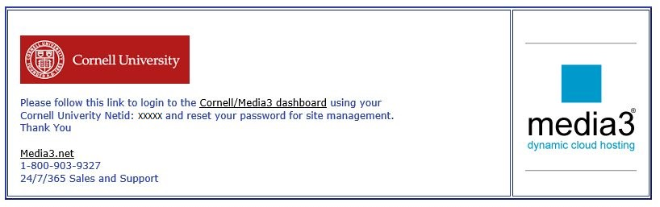

Once you have your account information, you will need the following information to get started transferring files to the Media3 server:

* User name : your NetID (this will be used as your login ID for the Media3 server)
* Password : your server password (will be different than your NetID password)
* Remote host : cu-actech-02.mediathree.com

It will look something like this if you are using FileZilla:

FileZilla



Since you have never connected before, you may see this message and will need to trust this connection to the serve. It is OK to trust on first on first use in this case.

First Trust

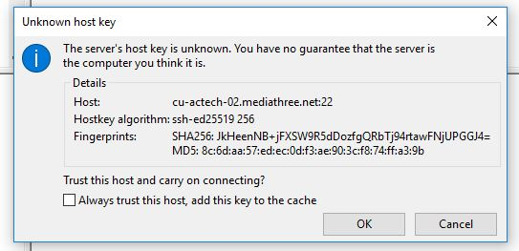

Once connected your site folders will look something like this:

Folders

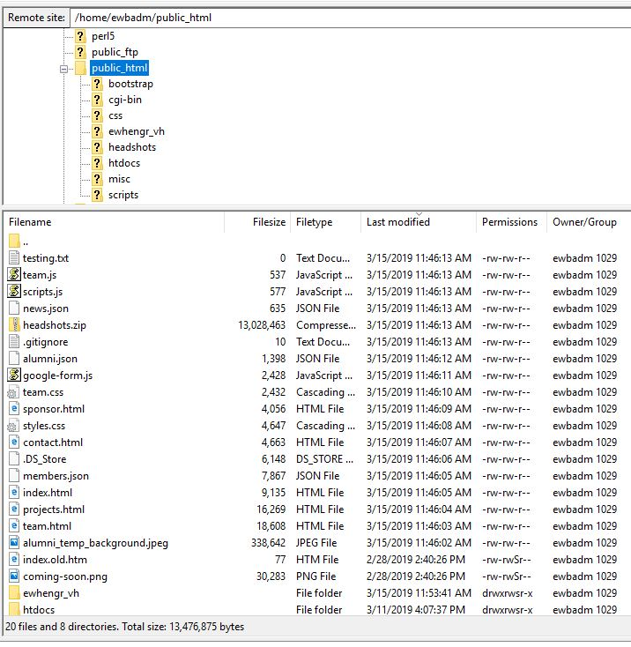

Here are a few useful notes about file names:

1. They are case sensitive.
2. Your HTML files should end with ".html" or ".htm".
3. The main file for your site should be called index.html or index.htm.
4. Please do not put spaces in your file names.
5. Please do not use punctuation in file names. (periods or hyphens and underscores are fine).

If you have any questions, please write to [acadtech@cornell.edu](mailto:acadtech@cornell.edu).

Thank you, The Academic Technologies Support Team [acadtech@cornell.edu](mailto:acadtech@cornell.edu) web: acadtech.cit.cornell.edu