**Online Radio Broadcasting (Internet Radio)**

**1.0 Introduction**

Online radio broadcasting also known as internet radio, web radio, net radio, streaming radio, e-radio, IP-radio is the transmission of digital audio service on the Internet. Broadcasting of digital audio on the Internet is referred to as webcasting which was believed to be a technology that would revolutionize the field of radio transmission beyond the traditional over-the-air radio stations. Since its emergence in 1993, it has steadily grown in popularity to a means of broadcasting audio service to larger audience in different parts of the world without restriction of space, frequency and environmental factors.

The last two decades have seen a proliferation of internet radio as a result of advancement in technology and reduction in the cost of internet services such as connectivity, infrastructure, bandwidth, software applications and tools e.tc.

**2.0 Forms of Internet Radio Stations**

1. *Traditional broadcast station with stream programming*

These are radio stations with studio and broadcast license that deliver terrestrial radio service in addition with webcasting in reaching more audience. FUNAAB falls into this category as an organization with a running terrestrial radio station.

1. *Internet-only station*

These are radio stations that exist only on the internet without over-the-air service (terrestrial radio service).

**3.0 Why run an Internet radio?**

There are a number of benefits to running an Internet radio, below are some of the gains that can be derived from running an online radio.

1. *Global coverage/reach*

Since Internet radio does not operate on air-wave frequency but the Internet which is global, the radio service is delivered and available globally. This means reception of the service from the radio station is not affected by geographical location and weather condition. Listeners can tune in and listen as they move from place to place, while the quality of the transmission remains the same.

1. *Large/diverse listening audience (International audience)*

Internet radio is not restricted by geographical space or laws. It offers the potentials of reaching a more culturally diverse audience.

1. *No license required*

Unlike terrestrial radio, you don’t need to go through the rigor of obtaining license and the biting cost of acquiring one to commence setup and transmission. That is not to say that a license may not be necessary to protect oneself against copyright infringements particularly for internet radio that will be playing commercial music.

1. *Simpler and easy to run*

With the production of advanced broadcasting equipments and softwares, it is now possible to run automated programmes 24/7, scheduled to run without having a person online to manage it.

1. *Low startup and running costs*

Starting up an Internet radio does not required the cost of setting up a studio and purchasing all relevant equipments, and acquisition of license fees to begin transmission. With low cost and minimal required equipments, an Internet radio is as good as ready to begin transmission and reaching everywhere the internet can be accessed.

**4.0 Technologies required for Internet radio**

1. *Computer*

A desktop or laptop computer (Mac or PC) with high processing capability will be suitable for the task.

1. *Internet*

Since internet radio runs on the internet, there is need to have a strong and reliable internet connection to broadcast to the streaming server from which point the radio service transmits the digital audio online.

1. *Streaming Service*

Streaming service is the hosting platform which is used to seamlessly connect the broadcast audio and transmits it on the internet. There are a myriads of streaming platforms available on the internet, below are some of them:

* Airtime pro (<https://www.airtime.pro/>)
* Radio.co (<https://radio.co/>)
* Voscast (<https://www.voscast.com/>)

1. *Microphone + accessories*

Any good studio microphone with its accessories.

1. Headset

**5.0 Broadcast software**

There are number of streaming software tools for broadcasting live audio data from your local computer. These tools help in streaming the broadcast data on the local computer system to the online streaming service in an optimized manner to present a seamless broadcast.

* Butt
* Mixxer
* Ladiocast
* Altacast
* Rocket Broadcaster

**6.0 Recommended Streaming Service (Airtime Pro)**

The streaming service of choice we recommend is Airtime pro. It is one of the best services on internet radio streaming. It offers a number of features which makes internet radio broadcast easy and rewarding in terms of quality of service.

**7.0 Features of Streaming Service**

Below are features of Airtime pro:

1. *Media Management*

This facility manages the audio files uploaded and stored on the server. The files could be used in creating playlist

* 1. Intelligent Library

This helps in organization, searching through the collection of files, drag and drop to create playlist and schedule a show.

* 1. Smart Blocks

This provides an avenue to speed up programming of shows online.

* 1. Media Builder

This enable the creation of playlist, tracks edit and preview, cue in/out and fade in/out points for tracks and playlists, automatic cut-off shows longer than scheduled length using intuitive drag and drop and visual control.

1. *Show Scheduling*
   1. Program Calendar

The program calendar is a comprehensive, robust and intuitively designed calendar that presents various time (day, week, month) views. The colour-coded schedule events help in finding and navigating through shows.

* 1. Show linking and repeating

This useful in creating recurring shows that share the same template.

1. *Live Broadcast Solutions*
   1. Live Show Editing

Changes and new content can be introduced to live broadcast without causing any interruption to the live show. This allows upload and dropping of content into the show that’s currently on air.

* 1. *Live Broadcast*

There are two modes of broadcast on Airtime pro, schedule and live. Schedule mode uses pre-recorded audio files to run shows, while the live mode is real-time broadcast from a physical location.

1. *Built-in Microsite*
   1. Radio home

For radio stations that do not have their dedicated website, Airtimepro provides a radio page from where the public can listen to the radio station.

* 1. Mobile friendly

Airtime pro automatically create radio page for every account that is mobile optimized to be displayed on mobile devices.

1. *Widget for website*
   1. Embeddable player widget

Integrating radio broadcast on a website has never been any easier. Airtime pro offers a simple, yet powerful player widget that delivers radio station to listeners.

* 1. Embeddable Schedule widget

This widget automatically generates a listing of shows in a calendar format.

* 1. Podcasting

There is a built-in podcast to make available recorded programmes on the radio website/page to reach more listeners.

* 1. Subscribe and broadcast

Listeners can subscribe to podcasts directly and automatically have access to download files.

1. *Reporting*
   1. Playout history

A detailed analytics of the programmes featured can be generated and exported into different formats (CSV, PDF, Print).

* 1. Listener Statistics

This is analytics presents hourly statistics of where listeners are listening from.

1. *Support*

Airtime pro expert team provide service supports to clients in providing answers to questions and resolving issues.

1. *DJ Management*

Airtime pro offers an advanced management interface to manage the different categories of users managing shows online.

**8.0 Pricing plans of streaming service**

Below is a snapshot of the pricing plan available on Airtime pro. The University can start with any of the smaller plans and upgrade as the need arises.

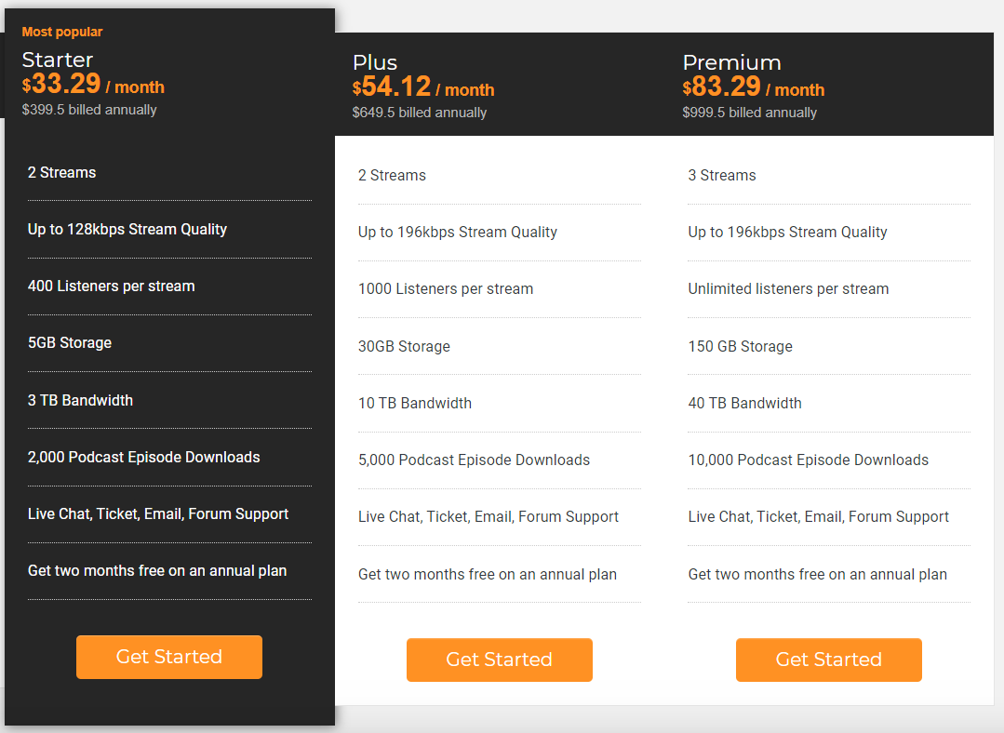

Source: <https://www.airtime.pro/pricing/>