**Data Collection**

The data for the project is primarily sourced from the field by enumerators interacting with respondents in different locations, filling questionnaires as provided by the respondents. The choice of primary source of data is to get authentic, practical and high-quality of data input in the analysis and computational process of the project, considering variations in factors that may affect changes in trends and circumstances. The coverage of the research is across twelve (12) northerns states in Nigeria.

The data collection process was carried out electronically using modern technologies employing the use of electronic devices (phones, tablets) and the Internet. This is a progression from the conventional mode of questionnaire delivery, filling by respondents, collection, collation, computation and analysis. This method has been known to be prone to a number of weaknesses and challenges which undermine the results of data collected, some these challenges/weaknesses are:

1. A number of questionnaires get lost and never get sent back.
2. Respondents do not have a guide answering through the questions.
3. Respondents may not get to answer questions properly.
4. The quality of the data is compromised.

With the introduction of an electronic medium of collection, these shortcomings are addressed and the entire process is improved. Electronic data collection offers a litany of options from proprietary to open, easy-to-use to complex applications e.t.c. Some of the options available and considered are Google forms, Survey monkey, Open data kit (ODK). ODK was chosen because it offers an edge in overcoming some of the limitations that may be experienced in the use of electronic data collection.

**Advantages of Open Data Kit (ODK)**

1. Hard copy questionnaire/survey can be replicated electronically
2. Questionnaires can be delivered with or without Internet connectivity (online/offline modes).
3. Questions on questionnaires can be adjusted in one place and updated version available and accessible to enumerators.
4. It offers real-time monitoring and aggregation of submissions remotely.
5. User-friendly interface, usage and operation.
6. Capability to capture varying types and degree of data e.g. geo-location, pictures, videos e.t.c.
7. Automatic recording of discrete information about the collection such as phone number, email, username, device information, start time, end time e.t.c.
8. It offers data security and confidentiality.
9. It overcomes the limitation of physical space, time and location

**ODK form Creation**

In order to deliver an ODK survey, an ODK form has to be created that bear the questions that are to be delivered. The electronic questionnaire was created on <https://build.getodk.org/>

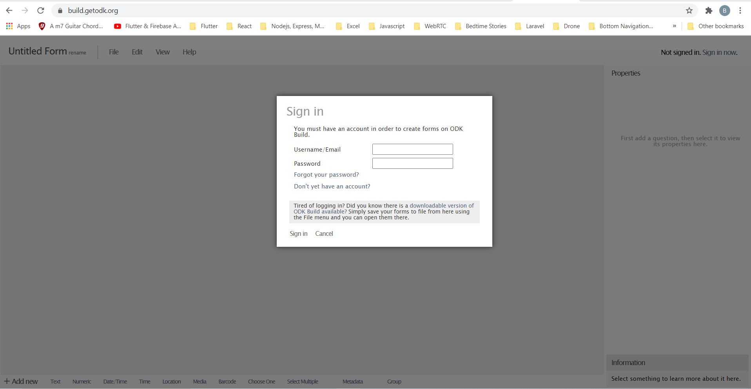Log into build.getodk.org

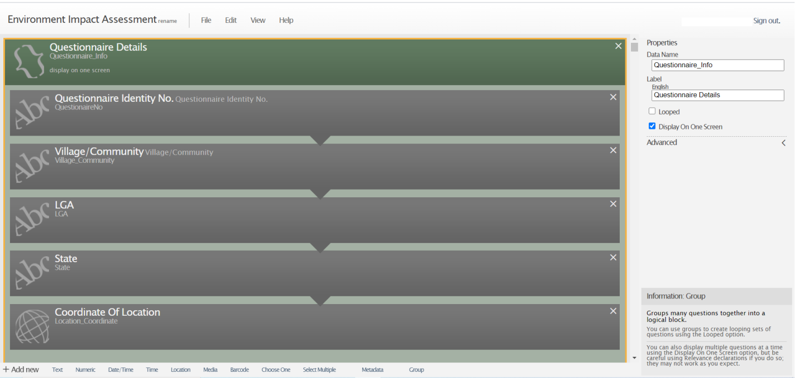ODK build form

**Aggregation Server**

Kobotoolbox.org was used as the aggregation server in deploying the designed and developed electronic questionnaire to enumerators and collection of submissions. The aggregation server hosts the updated version of the questionnaire which can be downloaded on devices/gadgets that have the right credentials to access the server using an ODK collect app.

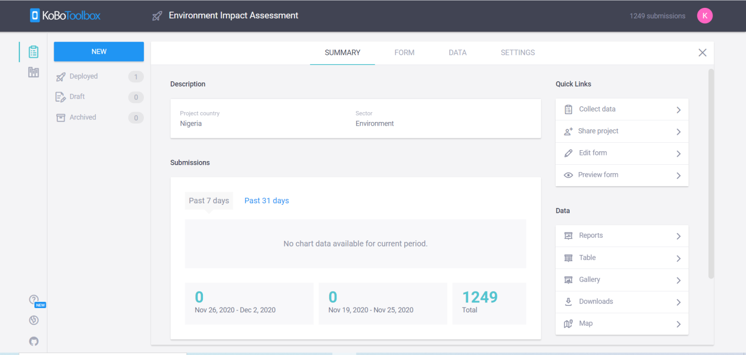Summary page on server

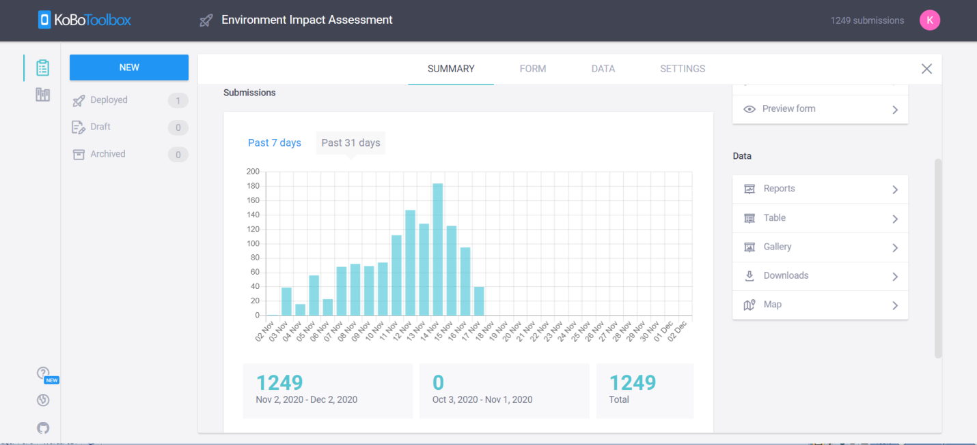Summary page of server activities

**Project Deployment**

The aggregation server can host a number of questionnaires, but the ones that are accessible for download on ODK collect are the ones that have been deployed. Changes that are made on an ODK form on the server are not rendered and available until they are saved and deployed.

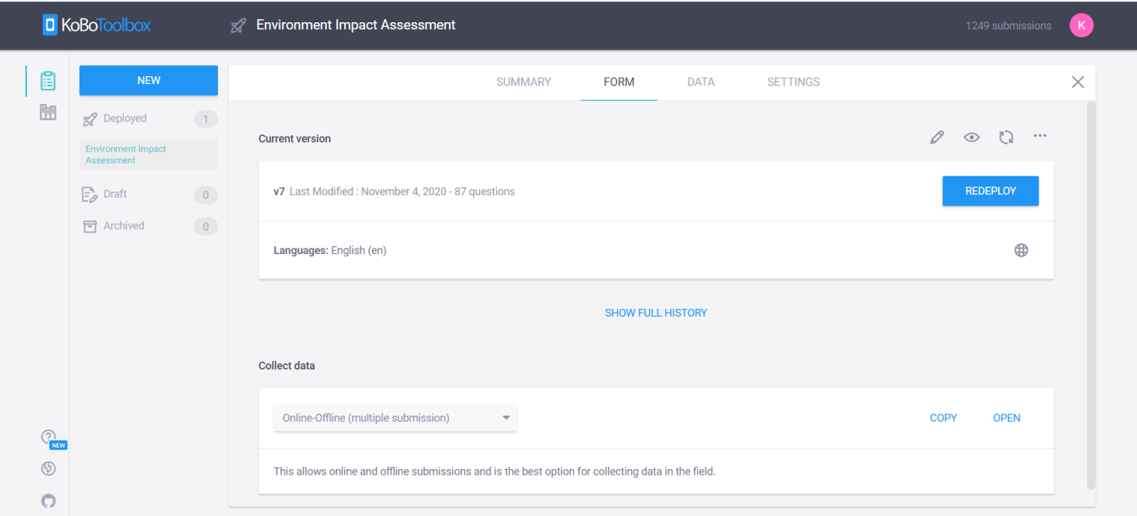

**Data Submissions**

Filled questionnaires on an enumerator’s device using ODK collect mobile app are storage on the offline on the device and submitted to the aggregation server when there is Internet connection to make the upload of the data to the server.

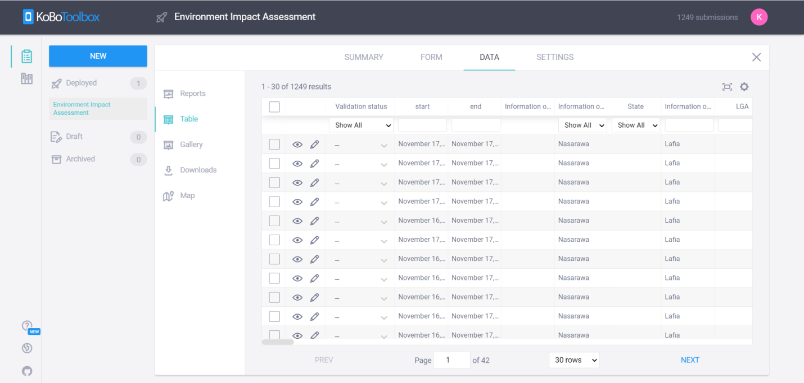Table view of submissions

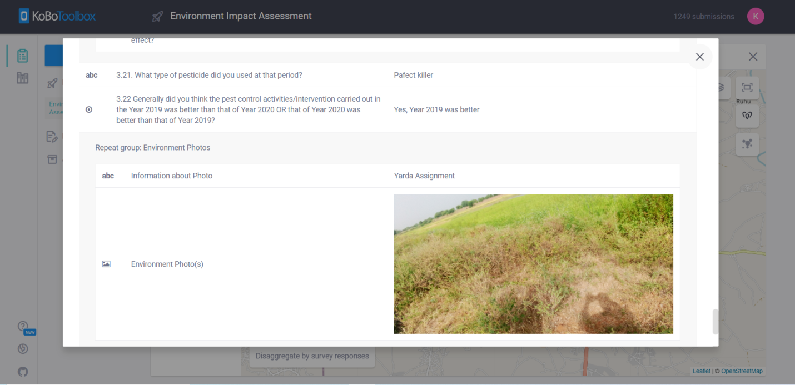Record view of submission

**Gallery**

Multimedia files such as pictures and videos which are captured and submitted to the server are stored and displayed in a gallery. The files in the gallery can be navigated from one record to another.

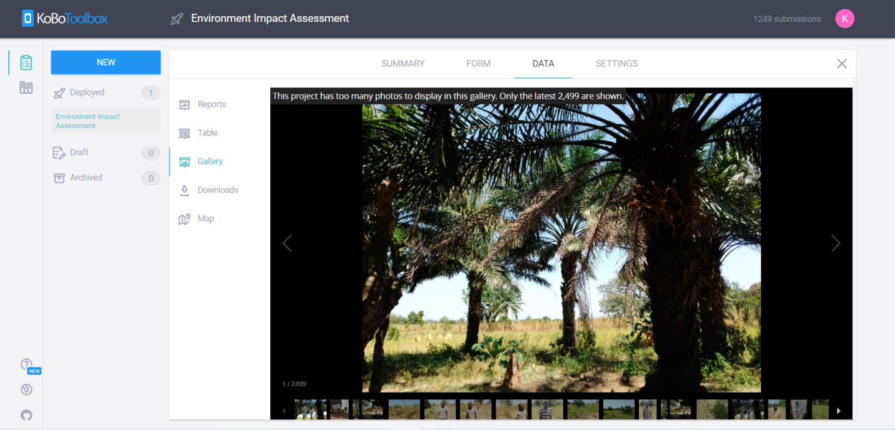Uploaded images in gallery

**Statistics/Reports**

The aggregated server provides various statistics of the form, submissions, files and map. This gives a quick overview and information of the activities going on in the field, users’ involved and locations where these activities are being carried out.

Data captured are graphically represented in values, frequency, percentages, charts.

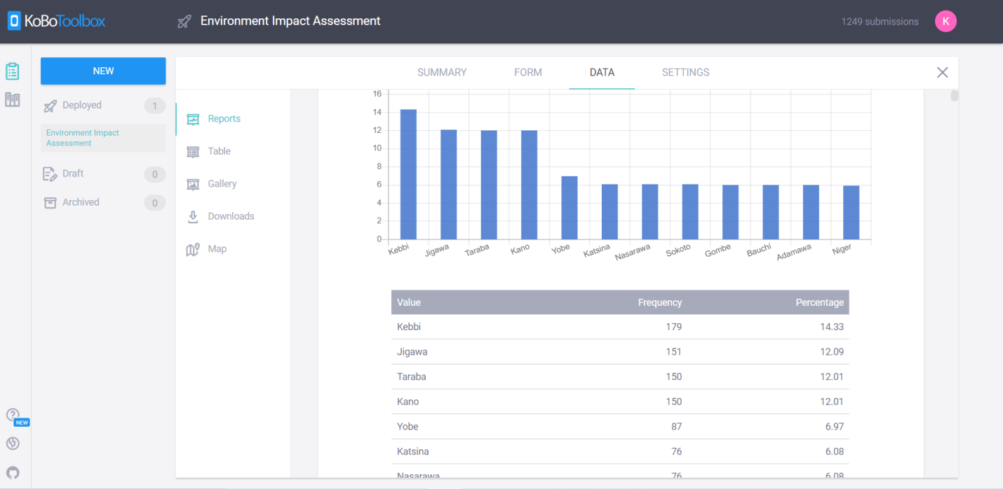Reports

**Map**

The map displays spots from where data have been captured using the geo-cordinates feature. The number on each spot is the number of submissions from that location.

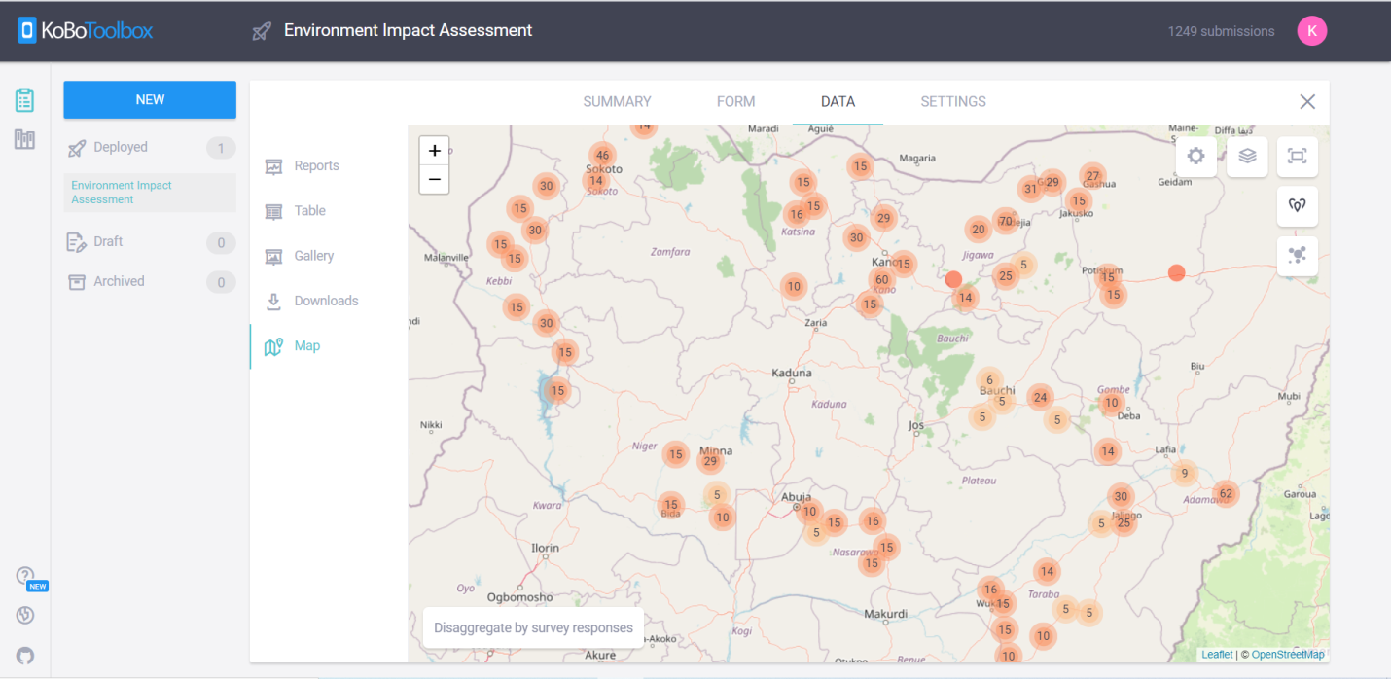Map showing submissions

**Downloads**

The ODK form (Questionnaire) and data submitted by enumerators can be downloaded from the aggregation server. The import and export features of the aggregation server provide the needed flexibility in uploading ODK forms and downloading ODK forms and submitted data. Submitted data can be downloaded in different formats. Some of the formats are XLS, CSV, Media Attachment (Zip), GPS Coordinates (KML), Excel Analyzer, SPSS Labels.

The download page also keeps a history of exported data.

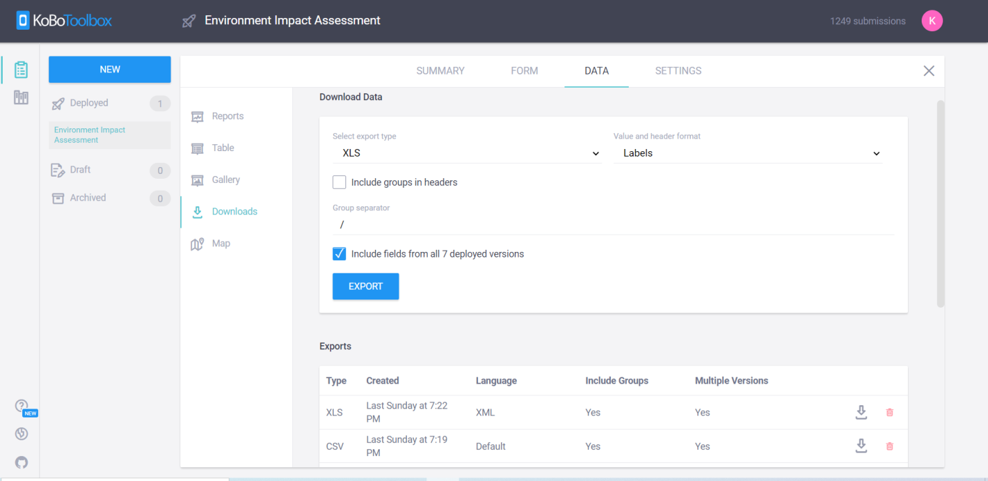Download page

**ODK Collect Mobile App**

The ODK Collect is the mobile application which is installed on mobile devices for the collection of responses. ODK Collect runs on both Android and iOS powered devices. There are different aspects of the app which is used to fetch form from the aggregation server, fill form, edit saved form, upload filled finalized form e.t.c.

1. Fill Blank Form

The is used to fill a blank form for each response.

1. Edit Saved form

Each form filled is saved. The saved form can be reviewed and edited as the enumerator or research due fit.

1. Send Finalized Form

A finalized form is one that requires no further editing and ready for upload to the server when there is internet connectivity.

1. View Send Form

This provides a view of all responses that have been uploaded to the server from the device.

1. Get Blank Form

This is used to fetch blank form(s) from the aggregation server the device is connected to.

1. Delete Saved Form

This is used to delete blank or saved form.

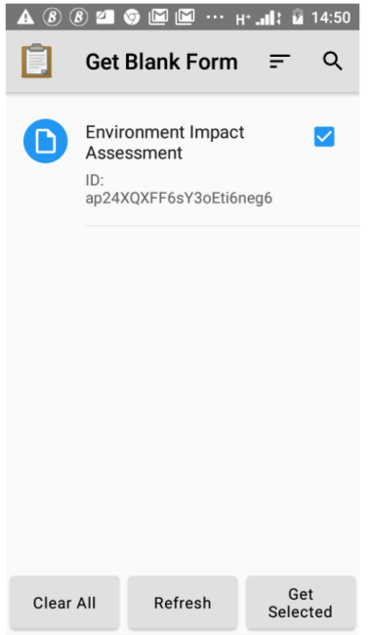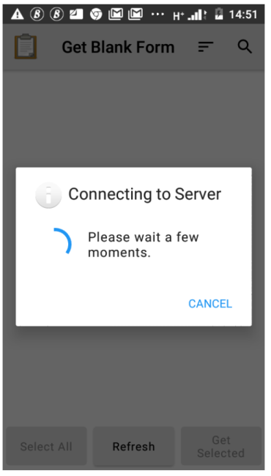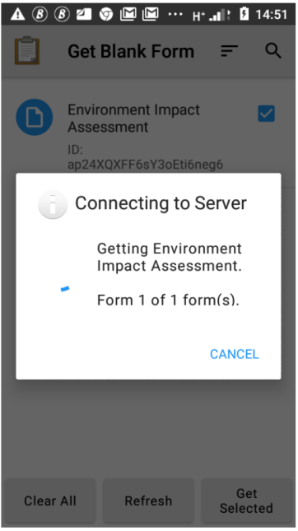

Downloading blank form from aggregation server

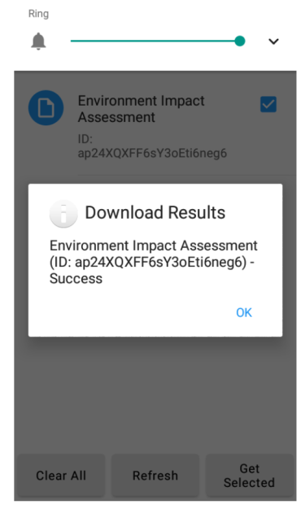

Blank form downloaded from aggregation server

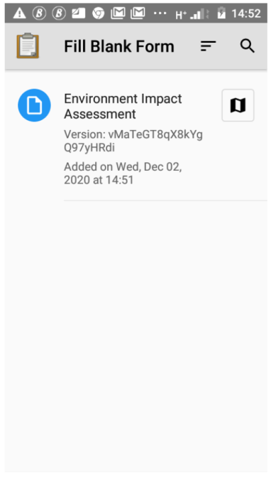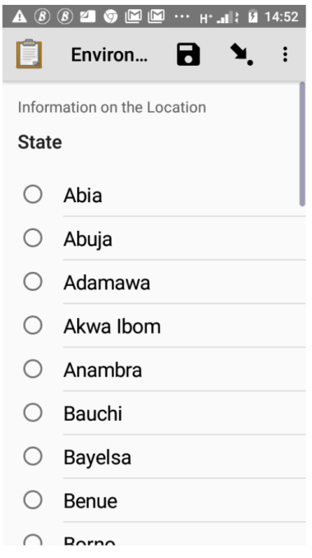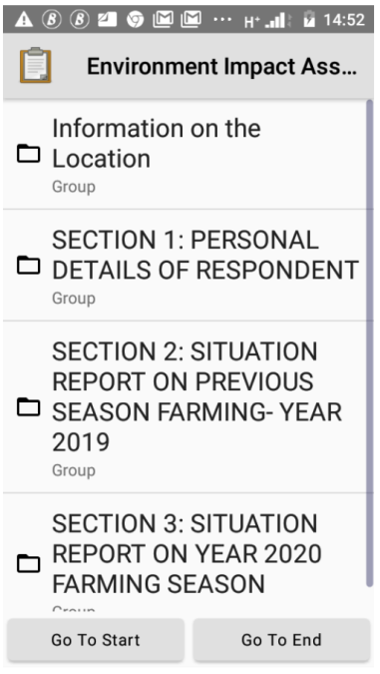  
Filling of blank form