Quiz 3 Review

Define/give an example of each of the following.

* Object
* Class
* Instance
* Instance variable/method
* Class variable/method
* Constructor
* Visibility keywords
* Inheritance
* Subclass
* Superclass
* Overloading
* Overriding
* Object-Oriented Programming
* Encapsulation

The following program compiles correctly. What does the main program (in D) print?

public class A {

private int z = 2;

public void f () {

this.g ();

}

public void g () {

System.out.println ("A: " + z);

}

public int h () {

return z;

}

}

public class B extends A {

private int z = 15;

public void g () {

System.out.println ("h:" + h() + " z:" + z);

}

}

public class C extends A {

private int z = 42;

public void f () {

this.g ();

}

}

public class D {

public static void main (String[] args) {

A c1 = new C();

C c2 = new C();

A b1 = new B();

B b2 = new B();

c1.f ();

c2.f ();

b1.f ();

b2.f ();

}

}

Consider the hierarchy of classes shown in the following diagram.

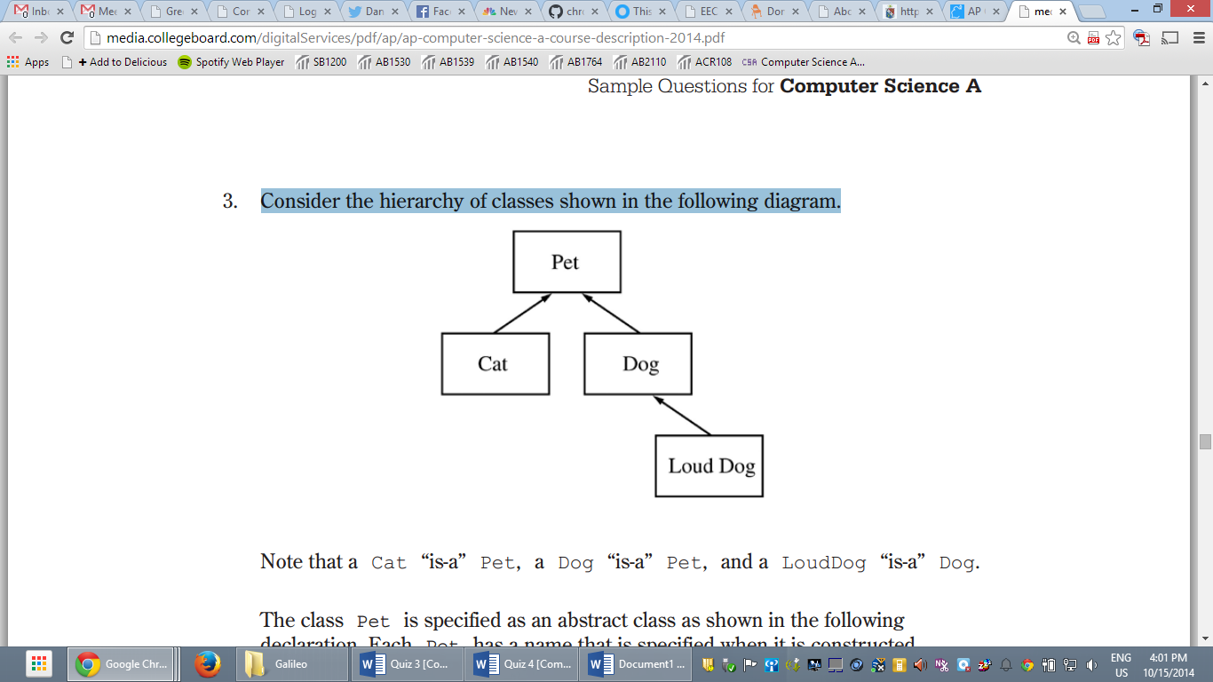

Note that a Cat “is-a” Pet, a Dog “is-a” Pet, and a LoudDog “is-a” Dog.

The class Pet is specified as a class as shown in the following declaration. Each Pet has a name that is specified when it is constructed.

public class Pet

{

private String name;

public Pet(String petName) {

name = petName;

}

public String getName() {

return name;

}

public String speak() {

return "I am a pet.";

}

}

The subclass Dog has the partial class declaration shown below.

public class Dog extends Pet

{

private String dog-sound;

public Dog(String petName)

{ /\* implementation not shown \*/ }

public String speak()

{ /\* implementation not shown \*/ }

}

1. Given the class hierarchy shown above, write a complete class declaration for the class Cat, including implementations of its constructor and method(s). The Cat method speak returns "meow" when it is invoked.
2. Assume that class Dog has been declared as shown at the beginning of the question. If the String dog-sound is returned by the Dog method speak, then the LoudDog method speak returns a String containing dog-sound repeated two times. Given the class hierarchy shown previously, write a complete class declaration for the class LoudDog, including implementations of its constructor and method(s).