**BUG REPORT FORM**

|  |  |  |  |
| --- | --- | --- | --- |
| **SUBMITTED BY** | | **DATE** | |
| Cagatay Sahin | | 19.10.2024 | |
|  |  |  |  |
| **ISSUE TITLE** | | **FILE ATTACHMENT(S)** | |
| Product-category mismatch on Amazon Turkey. | | There are screenshots on page 2. | |
|  |  |  |  |
| **REPRODUCIBILITY** | | **TIME OF OCCURRENCE** | |
| 1. Go to Amazon website. 2. Click “Computers” in the navbar. 3. Click Desktop PCs in the menu (left) 4. Click Mini PCs in sub-menu. |  |  |  |
| **EXACT URL** | | **BUILD VERSION** | |
| [Amazon Türkiye](https://www.amazon.com.tr/) | |  | |
|  |  |  |  |
| **ACTION PERFORMED** | | **ERROR MESSAGE** | |
|  | |  | |
| **EXPECTED RESULT** | | **ACTUAL RESULT** | |
| There is no sub menu in Mini PCs so all things about Mini PC parts. This products must be separated. This error impacts user experience. | | Here is the “Mini PCs” category or the products must be in Computer Parts & Accessories menu, but there are PC accessory products. The “Mini PC accessories” sub-menu should be exist. | |
|  |  |  |  |
| **FREQUENCY** | **X** | **PRIORITY** | **X** |
| Every Time | **X** | Critical |  |
| Hardly Ever |  | High |  |
| Occasionally |  | Medium |  |
| Once |  | Low |  |
|  |  |  |  |
| **STATUS DESCRIPTION** | | **FIXED BY** | |
|  | | John Doe (johndoe@example.com) | |

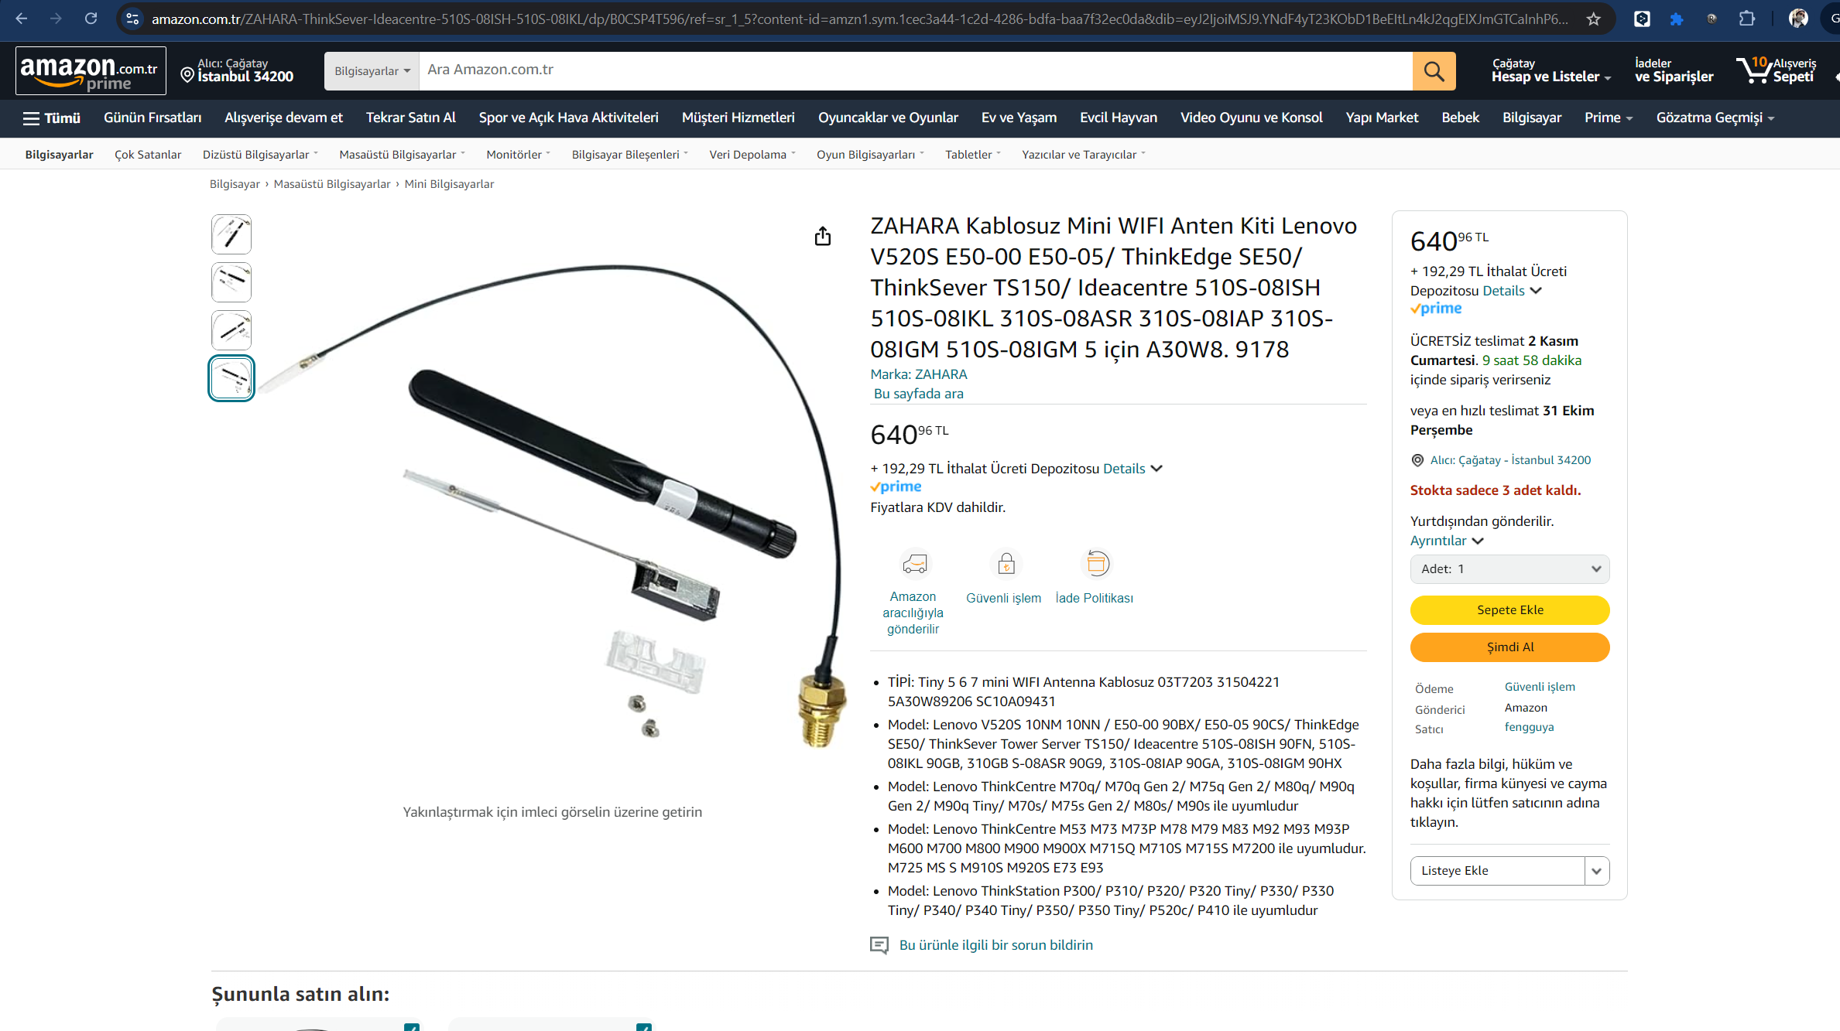metin, elektronik donanım, elektronik cihaz, multimedya içeren bir resim

Açıklama otomatik olarak oluşturuldu